Questions – Neuro phys – Hyatt

- Which neurotransmitter is found at all preganglionic neurons of the sympathetic nervous system?
  - Norepinephrine
  - Acetylcholine
  - Epinephrine
  - Dopamine

- Which troponin provides the binding site for calcium?
  - Troponin I
  - Troponin C
  - δTroponin M
  - Troponin T

- Which two characteristics determine nerve fiber conduction velocity?

- Which nerve fibers are responsible for transmitting sensations of touch and pressure?
  - Aα
  - Aβ
  - Aγ
  - C
- Label the following components in the synthesis of catecholamines:
C
B
A
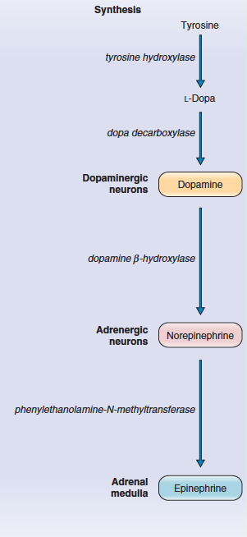
D
E
F

Answers:
- Which neurotransmitter is found at all preganglionic neurons of the sympathetic nervous system?
  - Norepinephrine
  - Acetylcholine
  - Epinephrine
  - Dopamine
Answer: acetylcholine. Also present at all pre-ganglionic PNS neurons and preganglionic to the adrenal gland.

- Which troponin provides the binding site for calcium?
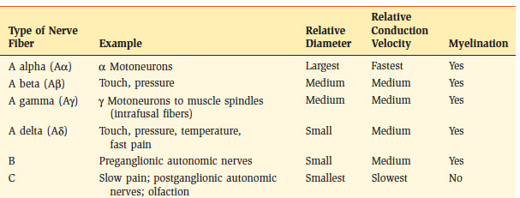
  - Troponin I
  - Troponin C
  - δTroponin M
  - Troponin T
Answer: troponin C

- Which two characteristics determine nerve fiber conduction velocity?
Diameter of fiber
myelenation

- Which nerve fibers are responsible for transmitting sensations of touch and pressure?
  - Aα
  - Aβ
  - Aγ
  - C
  - Answer B

