Pulmonary hypertension

Questions:
1) Pulmonary hypertension is defined as elevated pulmonary artery pressure
a. >15 mmHg
b. >20 mmHg
c. >30 mmHg
d. >45 mmHg
2) True or False: In the Pulmonary artery cGMP is inactivated by phosphodiesterase 5

3) True or False: Cor Pulmonale is right ventricular hypertrophy secondary to abnormal pulmonary structure or function

4) The most common cause of Pulmonary hypertension is
a. Pulmonary arterial hypertension
b. Pulmonary venous hypertension
c. Pulmonary disease
d. Thromboembolic disease
5) True or False: The most common clinical sign associated with PH is cough.

6) True or False: The most common physical exam finding with PH is a heart murmur

7) What is the McConnell sign?

Questions:
1) Pulmonary hypertension is defined as elevated pulmonary artery pressure
a. >15 mmHg
b. >20 mmHg
c. >30 mmHg
d. >45 mmHg
2) True or False: In the Pulmonary artery cGMP is inactivated by phosphodiesterase 5
3) True or False: Cor Pulmonale is right ventricular hypertrophy secondary to abnormal pulmonary structure or function
4) The most common cause of Pulmonary hypertension is
a. Pulmonary arterial hypertension
b. Pulmonary venous hypertension
c. Pulmonary disease
d. Thromboembolic disease
5) True or False: The most common clinical sign associated with PH is cough.
6) True or False: The most common physical exam finding with PH is a heart murmur
7) What is the McConnell sign?
- McConnell's sign is a distinct echocardiographic feature of acute massive pulmonary embolism. It is defined as a regional pattern of right ventricular dysfunction, with akinesia of the mid free wall and hyper contractility of the apical wall.

- Pulmonary hypertension (PH) has been echocardiographically defined as pulmonary arterial systolic pressure greater than approximately 30 mm Hg. Pulmonary hypertension is a description of a physiological condition
- In studies of dogs with mitral valve disease, prevalence of PH has been reported to be as low as 14% and as high as 31%. Typical physical examination abnormalities include heart murmurs of mitral and/or tricuspid insufficiency, split or abnormally loud second heart sounds, pulmonary crackles, increased bronchovesicular pulmonary sounds, cyanosis, and ascites
Mild Moderate Severe
- TR peak systolic velocity (m/s) R 2.8 to < 3.5 3.5–4.3 >4.3
- TR systolic gradient (mm Hg) R 31.4 to < 50 50–75 >75

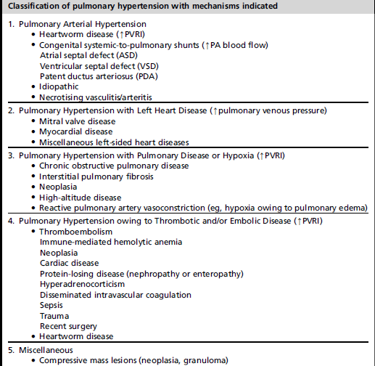
Pulmonary Hypertension Pathophysiology
- Alveolar hypoxia
  - Induces pulmonary vasoconstriction
  - Shunts blood towards areas that are better ventilated
  - Small pulmonary arteries & arterioles are the main sites of vasoconstriction & increased resistance during hypoxia
  - Chronic hypoxemia may lead to vascular remodeling
- Prostaglandins
  - Actively synthesized, metabolized, & released by the lungs
  - PGI₂ & PGE₁: vasodilation, (-) platelets, (-) vascular hypertrophy/remodeling
  - PGF₂ & PGA₂: vasoconstriction
- Thromboxane
  - TXA₂: vasoconstriction, (+) platelets
- Nitric Oxide
  - Released by vascular endothelium
  - Produced from L-arginine and oxygen by NOS
  - NO (+) GC increases cGMP (+) vascular relaxation
  - cGMP is inactivated by phosphodiesterase (PDE5)
  - Vasodilation, (-) platelets, (-) smooth muscle cell hypertrophy
- Endothelin (ET)
  - Released by vascular endothelium
  - Vasoconstriction
  - (+) growth factor smooth muscle cell proliferation
  - (+) vascular remodeling
  - Elevated in PH
  - ET levels correlate with severity of PH and poor prognosis
- Serotonin
  - Vasoconstriction
  - (+) smooth muscle cell hypertrophy & hyperplasia
- Angiotensin II
  - Vasoconstriction
  - (+) cell proliferation, extracellular protein matrix synthesis, smooth muscle cell migration
- Altitude
  - Vasoconstriction
  - Chronic hypoxia
  - Sea level PO2: 150 mmHg
  - 3000 – 5500 m PO2: 90 mmHg
  - 5500 – 8400 m PO2: 40 – 80 mmHg

