Mechanics of breathing – pgs 95-108

- Muscles of respiration
Inspiration is active.
- Diaphragm is most important. Supplied by the phrenic nerve from cervical segments 3,4, 5.
- External intercostal muscles - slope downward and forward. Supplied by intercostal nerves.
- Accessory muscles of inspiration include scalene (elevate first two ribs), sternomastoids (raise sternum), alae nasi (flare nostrils). There is minimal activity in these muscles during quiet breathing.

Expiration is passive during quiet breathing.
- During exercise and voluntary hyperventilation expiration becomes active.
- Most important muscles are those of abdominal wall (rectus abdominis, internal and external obliques, transvers abdominis).
- Internal intercostal muscles assist active expiration

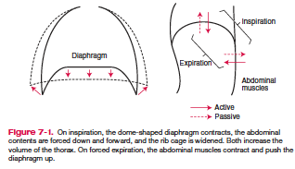

- Elastic properties of the lung
Pressure-Volume curve.

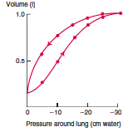
- Curve is non-linear and becomes flatter at high expanding pressures.
- Lung volume at any given pressure during deflation is larger than during inflation.

Compliance: slope (ΔV/ΔP) of the pressure-volume curve or volume change per unit pressure change.
- Reduced compliance caused by pulmonary fibrosis, alveolar edema, if lung remained unventilated for a long period of time with low volume, or if pulmonary venous pressure is increased and lung is engorged with blood.
- Increased compliance occurs with asthma, normal aging, and pulmonary emphysema.

Surface tension: the force acting across an imaginary line 1cm long in the surface of the liquid
- Surfactant is a phospholipid secreted by type II alveolar epithelial cells.
  - Lowers the surface tension in the alveoli, which increases compliance of the lung and reduces the work of expanding it with each breath
  - Promotes alveolar stability
  - Helps alveoli dry (prevents transudation of fluid)

- Regional differences in Ventilation.
- Intrapleural pressure is less negative (higher) near the base of the lung than at the apex.
- The base of the lung is poorly expanded compared to the apex, but better ventilated.
- At low lung volumes - intrapleural pressure at base exceeds airway (atmospheric) pressure. The lung at the base is not being expanded but compressed and ventilation is not possible until local intrapleural pressure falls below atmospheric pressure.

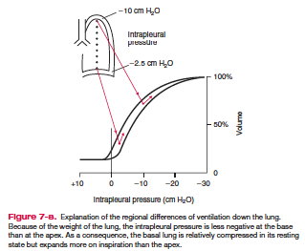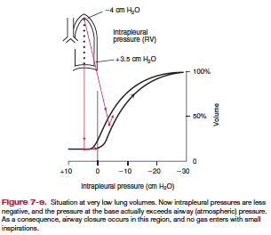

- Elastic properties of chest wall
Relaxation Pressure-Volume Curve
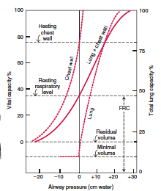
- Elastic properties of both the lung and chest wall determine their combined volume
- Lung retracts at all volumes above minimal volume

Questions
- What is the most important muscle of inspiration?
  - External intercostal muscles
  - Internal intercostal muscles
  - Diaphragm
  - Rectus abdominis

- True or False. Paralysis of intercostal muscles seriously affects breathing.

- True or False. Lung volume at any given pressure during deflation is larger than during inflation.

- Name some conditions that can result in reduced pulmonary compliance

- Which group of conditions result in increased compliance?
  - Asthma, normal aging, pulmonary emphysema
  - Normal aging, alveolar edema, increased venous pressure
  - Pulmonary emphysema, normal aging, atelectasis

- What are the role(s) of surfactant?

- Pressure near the base of the lung is ____________________(higher/lower) than at the apex.

- True or False. The base of the lung is poorly expanded compared to the apex, but better ventilated.

Questions and answers
- What is the most important muscle of inspiration?
  - External intercostal muscles
  - Internal intercostal muscles
  - Diaphragm

- True or False. Paralysis of intercostal muscles seriously affects breathing.
Paralysis of intercostal muscles does not seriously affect breathing because the diaphragm is so effective.

- True or False. Lung volume at any given pressure during deflation is larger than during inflation.

- Name some conditions that can result in reduced pulmonary compliance
  - pulmonary fibrosis
  - alveolar edema
  - if lung remained unventilated for a long period of time with low volume
  - if pulmonary venous pressure is increased and lung is engorged with blood

- Which group of conditions result in increased compliance?
  - Asthma, normal aging, pulmonary emphysema
  - Normal aging, alveolar edema, increased venous pressure
  - Pulmonary emphysema, normal aging, atelectasis
Changes in elastic recoil that occur in the lung with age and in emphysema are presumable caused by changes in this elastic tissue.

- What are the role(s) of surfactant?
  - Lowers the surface tension in the alveoli, which increases compliance of the lung and reduces the work of expanding it with each breath
  - Promotes alveolar stability
  - Helps alveoli dry (prevents transudation of fluid)

- Pressure near the base of the lung is ____________________(higher/lower) (or less negative) than at the apex.

- True or false. The base of the lung is poorly expanded compared to the apex, but better ventilated.

