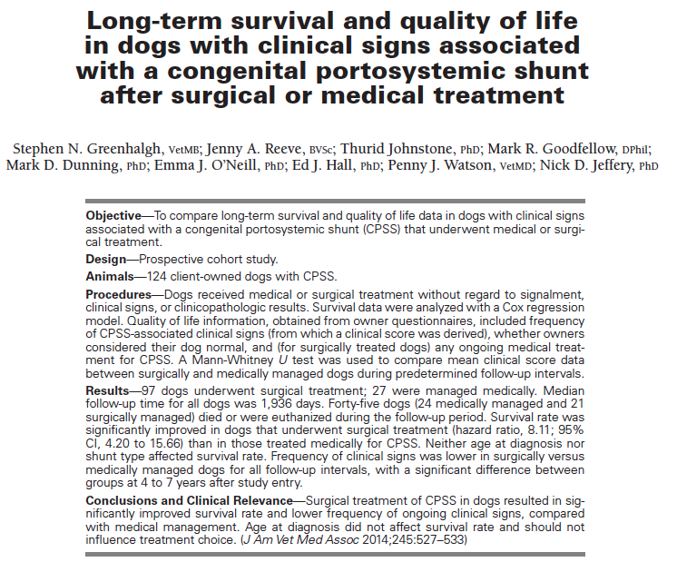
- Why was the study done? Because convincing evidence for the treatment (surgical vs medical) for congenital PSS is lacking.
- Goal: To compare survival and quality of life in dogs treated for congenital PSS with medical vs surgical management.
- Hypothesis: Survival rate and quality of life (as assessed by persistence of clinical signs) of dogs with congenital PSS would be affected by the choice of medical versus surgical management.
- Background: In 2010, same authors reported long-term survival for either medical or surgical management, but surgical intervention was associated with a better chance of long-term survival.
- Type of study: Prospective cohort study
- Material and Methods: From June 2002 to October 2007 – 3 referral centers – Treatment decision (medical vs surgical) was made by the owner following discussion with the clinician – Medical management: diet, ATM, synthetic disaccharides. – Sx: ameroid constrictor, cellophane band or ligature, complete ligation – Survival data – Quality of life data - questionnaires (frequency of clinical signs, need for medical treatments in surgically treated dogs, dog normal or not).
- Most important results: n = 97 (surgery) vs n = 27 (medical)
  - Survival
    - Medical
      - 24/27 (89%) died or were euthanized
      - Median survival time: 836 days.
    - Surgical
      - 21/97 (22%) died or were euthanized
      - Median survival time – not available since large number of dogs still alive at the time of the last follow-up
      - Survival was significantly greater in surgically treated dogs
      - Survival was not associated with age at diagnosis or shunt type (but only small number of dogs with intra-hepatic PSS (14)).
  - Quality of life
    - Medical vs surgical: Frequency of clinical signs was lower in surgically versus medically managed dogs for all follow-up intervals, with a significant difference between groups at 4 to 7 years after study entry.
- Conclusion: Treatment choice influenced survival rate and frequency of clinical signs in dogs with PSS, with better survival and lower frequency of clinical signs in surgically treated dogs. Age at diagnosis did not affect survival.
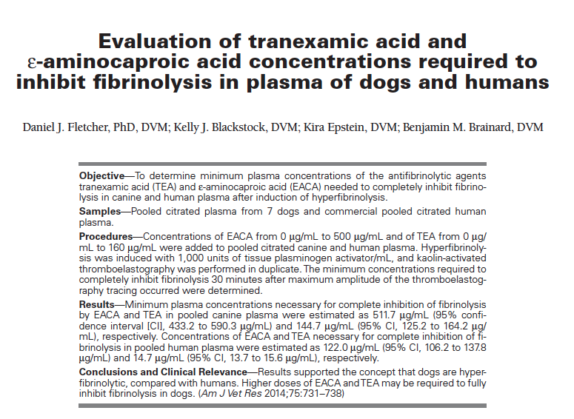
- Why was the study done? Effective plasma concentrations of antifibrinolytic agents in dogs are unknown and doses have been extrapolated from data in humans. However, there is strong evidence that dogs have greater fibrinolysis response than humans. Consequently, it is possible that dogs treated with antifibrinolytic agents do not achieve effective plasma concentration when administration regimens are based on human data.
- Goal: To determine minimum plasma concentrations of TEA and EACA needed to completely inhibit fibrinolysis in canine blood after induction of hyperfibrinolysis and to compare these concentrations between dogs and humans.
- Hypothesis: Higher minimum concentration of TEA and EACA would be required to inhibit fibrinolysis in dogs than humans.
- Type of study:
- Material and Methods: Pooled citrated plasma of 7 dogs and commercial pooled human plasma – normal coagulation function – initial tPA dose-response analysis selection of a tPA concentration of 1000 U/ml for their assays - EACA (0 µg/ml - 500 µg/mL) and TEA (0 µg/ mL - 160 µg/mL) were added to pooled citrated canine and human – evaluation of the EPL for every concentration of ECA and TEA - determination of the minimum concentration of EACA and TEA required to completely inhibit fibrinolysis (EPL = 0%) 30 minutes after MA of the TEG tracing (kaolin-activated TEG) – evaluation of
TEG coagulation and the TEG clot formation
and lysis velocity variables
- Most important results:
The minimum effective plasma concentrations of EACA (511.7 mcg/ml in dogs vs 122.0 in humans) and TEA (144.7 mcg/ml in dogs vs 14.7 in humans) were
greater for canine plasma than for human plasma, with
nonoverlapping 95% confidence intervals.
TEG analysis revealed that canine plasma
was relatively hypercoagulable, compared with human plasma, and had shorter R and K times, steeper
α angle, higher MRTG, and shorter TMRTG with
comparable MA and G.
- Conclusion: Doses of antifibrinolytic agents in dogs are extrapolated from human data due to the lack of pharmacokinetic and pharmacodynamic data in dogs. The data presented
in this study suggest that this may result in suboptimal plasma concentrations. In fact,
results in this study support the concept that dogs are hyperfibrinolytic compared with humans. Higher doses of EACA and TEA may be required to fully
inhibit fibrinolysis in dogs.

