Bench-to-bedside review: Nitric oxide in critical illness
Key Points
- NO acts as a second messenger by activating soluble guanylate cyclase and participating in signal transduction pathways involving cyclic GMP, but also operates independently of guanylate cyclase
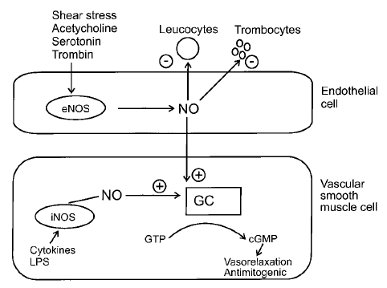

- At least three distinct isoforms of NOS are known, including neuronal nitric oxide synthase (nNOS, NOS1), inducible nitric oxide synthase (iNOS, NOS2), and endothelial nitric oxide synthase (eNOS, NOS3) enzymes.
  - Whereas iNOS activity depends on transcription, eNOS and nNOS are constitutively expressed and are activated by elevated intracellular calcium
  - iNOS gene expression is modulated by inflammatory mediators, such as the cytokines TNFα, IFNγ, and lipopolysaccharide, which activate transcription factors such as NFκB or activator protein 1
  - iNOS isoform generates much larger quantities of NO (nanomolar range) than constitutive NOS isoforms (picomolar range)

- NO regulates the cytoplasmic redox balance and also signal transduction, either by regulating cytoplasmic and mitochondrial calcium signals or by post-translational modification of intracellular proteins.

  - In the heart nNOS is present in presynaptic nerves and the cardiomyocyte sarcoplasmic reticulum, eNOS is localized in caveolae of endothelial cells and in myocytes at the T-tube sarcoplasmic reticulum, and iNOS is induced in the myocyte cytoplasm.
  - NO localization allows for potential modulation of intracellular calcium concentrations through interaction with ryanodine receptors, which are also localized to T-tubules
  - Although eNOS exists as a homodimer that produces NO from L-arginine, under certain conditions it can become uncoupled to become a monomer that produces not NO, but the oxidative free radical superoxide. The resultant oxidative stress from O2. production can further promote NOS uncoupling, a forward feedback loop that can magnify the amount of oxidative stress within the cell

- Although systemic NO production is upregulated in sepsis, in specific tissues, NO production may be heterogeneous (ie, relatively deficient) because of several factors.
  - Variation in the extent of expression of inducible nitric oxide synthase (iNOS) and consumption of NO by reactive oxygen radicals in ischemic tissues may lead to a relative paucity of NO in microcirculatory beds despite a total body excess.
  - In turn, this may lead to the known pathologic shunting of oxygenated blood from susceptible tissues, which characterizes the heterogeneous tissue perfusion of sepsis
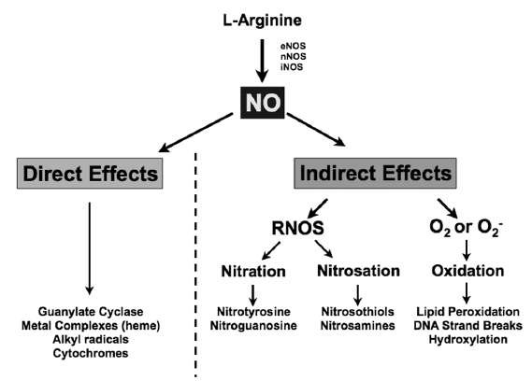

Role of toll-like receptors in the development of sepsis
Key Points
- The innate immune system is able to detect pathogens via a limited number of pattern-recognition receptors (PRRs). PRRs recognize conserved motifs that are expressed by pathogens but are absent in higher eukaryotes; these microbial components are known as pathogen-associated molecular patterns (PAMPs).
  - Working in concert with several intracellular protein kinases, these TLRs recognize and respond to a myriad of highly conserved microbial molecules. Importantly, TLR signalling is tightly regulated to avoid detrimental inflammatory responses; as such, several negative regulators of TLRs have been identified including MyD88 short, interleukin-1 receptor-associated kinase (IRAK) M, ST2, single immunoglobulin interleukin-1-receptor-related molecule (SIGIRR), and Toll-interacting protein (TOLLIP).

- TLRs are a family of transmembrane receptors consisting of an extracellular leucine-rich repeat domain that interacts with relevant pathogen-associated molecular patterns and an intracellular Toll/IL-1 receptor domain, which is involved in signaling.
  - Toll-like receptors 1, 2, 4, 5, and 6 mainly recognize bacterial products, whereas TLR-3, TLR-7, and TLR-8 are specific for viral detection.
  - Toll-like receptor 9 seems to be involved in both microbial and viral recognition
  - TLR-4 was the principal receptor for LPS that mediates the activation of nuclear factor kappa-beta and the synthesis of proinflammatory cytokines

- PRRs may warn the host of danger in general by their ability to recognize endogenous mediators released during injurious processes, such as trauma, ischemia, or necrosis. Such endogenous danger signals have been called “alarmins” or danger-associated molecular patterns (DAMPs).
  - Toll-like receptor 4 was shown to be involved in the recognition of extra domain A-containing fibronectin, fibrinogen, polysaccharide fragments of heparan sulfate, oligosaccharides of hyaluronic acid, oxidized low-density lipoprotein, several heat shock proteins (HSPs), surfactant protein A in the lung epithelium, neutrophil elastase and high-mobility group box 1 protein (HMGB-1)
  - Critical in early inflammatory responses to infection. Involved in development of adaptive immunity, TLR agonists circulate in sepsis, TLR polymorphisms and infection.

Questions:
- NO is synthesized from and oxygen by the enzyme ______________________________

- List the three types of nitric oxide synthase

- Which two forms are the constitutive forms

- Severe sepsis is associated with expression of iNOS and nitric oxide production

- TLRS are
  - PAMPS
  - PRRs
  - MDs
  - DAMPS

- 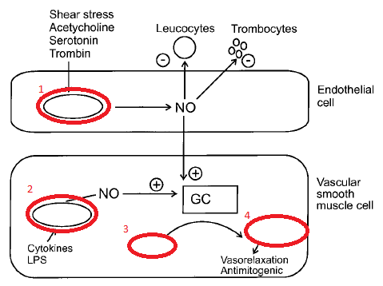
- Toll-like receptors were first discovered in
  - Mice
  - Rabbits
  - Fruit flies
  - Primates

- What are alarmins

- Which receptor is the principal receptor for LPS that mediates the activation of nuclear factor kappa-beta and the synthesis of pro-inflammatory cytokines
  - TLR -1
  - TLR -2
  - TLR -4
  - Salmo salar

Questions:
- NO is synthesized from L-arginine and oxygen by the enzyme nitric oxide synthase (NOS)
- List the three types of nitric oxide synthase
  - INOS, eNOS, nNOS
- Which two forms are the constitutive forms
  - Enos nnos
- Severe sepsis is associated with increased expression of iNOS and increased nitric oxide production
- TLRS are
  - PAMPS
  - PRRs
  - MDs
  - DAMPS
- Toll-like receptors were first discovered in
  - Mice
  - Rabbits
  - Fruit flies
  - Primates
- What are alarmins
  - The term “alarmin” is proposed to categorize such endogenous molecules that signal tissue and cell damage. Intriguingly, effector cells of innate and adaptive immunity can secrete alarmins via nonclassical pathways and often do so when they are activated by PAMPs or other alarmins. Endogenous alarmins and exogenous PAMPs therefore convey a similar message and elicit similar responses; they can be considered subgroups of a larger set, the damage-associated molecular patterns (DAMPs).
- Which receptor is the principal receptor for LPS that mediates the activation of nuclear factor kappa-beta and the synthesis of pro-inflammatory cytokines
  - TLR -1
  - TLR -2
  - TLR -4
  - Salmo salar

