Neurophysiology:

The nervous system is composed of two divisions:
- Central nervous system (CNS)
  - Which includes the brain and the spinal cord
  - The major divisions of the CNS are:
    - Spinal cord
    - Brain stem (medulla, pons, and midbrain)
    - Cerebellum
    - Diencephalon (thalamus and hypothalamus)
    - Cerebral hemispheres (cerebral cortex, white matter, basal ganglia, hippocampal formation, and amygdala)

- Peripheral nervous system (PNS)
  - which includes sensory receptors, sensory nerves, and ganglia outside the CNS

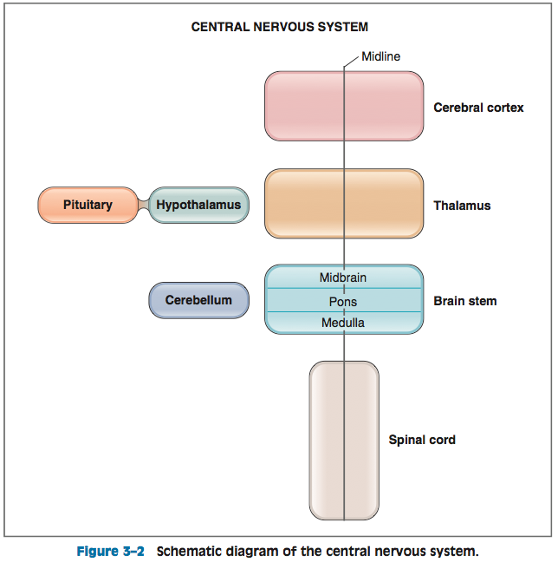
Spinal cord:
- Paired spinal nerves that contain both sensory (afferent) nerves and motor (efferent) nerves.
  - Sensory nerves carry information to the spinal cord from the skin, joints, muscles, and visceral organs in the periphery via dorsal root and cranial nerve ganglia.
  - Motor nerves carry information from the spinal cord to the periphery and include both somatic motor nerves, which innervate skeletal muscle, and motor nerves of the autonomic nervous system, which innervate cardiac muscle, smooth muscle, glands, and secretory cells
Brain stem:
- The medulla, pons, and midbrain are collectively called the brain stem.
- Ten of the 12 cranial nerves (CN III–XII) arise in the brain stem.
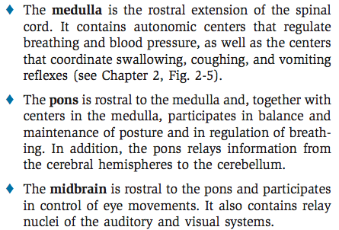

Cerebellum:
- Lies dorsal to the pons and medulla
- Functions of the cerebellum:
  - Coordination of movement
  - Planning and execution of movement
  - Maintenance of posture
  - Coordination of head and eye movements
- Integrates sensory information about position from the spinal cord, motor information from the cerebral cortex, and information about balance from the vestibular organs of the inner ear

Thalamus and hypothalamus:
- Together, the thalamus and hypothalamus form the diencephalon
  - Thalamus processes almost all sensory information going to the cerebral cortex and almost all motor information coming from the cerebral cortex to the brain stem and spinal cord
  - Hypothalamus contains centers that regulate body temperature, food intake, and water balance. The hypothalamus is also an endocrine gland that controls the hormone secretions of the pituitary gland
    - The hypothalamus secretes releasing hormones and release-inhibiting hormones into hypophysial portal blood that cause release (or inhibition of release) of the anterior pituitary hormones.
    - The hypothalamus also contains the cell bodies of neurons of the posterior pituitary gland that secrete antidiuretic hormone (ADH) and oxytocin.

Cerebral hemispheres:
- Consist of the cerebral cortex, an underlying white matter, and three deep nuclei (basal ganglia, hippocampus, and amygdala).
- The functions of the cerebral hemispheres are perception, higher motor functions, cognition, memory, and emotion.
  - Cerebral cortex
    - Is the convoluted surface of the cerebral hemispheres and consists of four lobes: frontal, parietal, temporal, and occipital.
    - Cerebral cortex receives and processes sensory information and integrates motor functions

Sensory pathways:
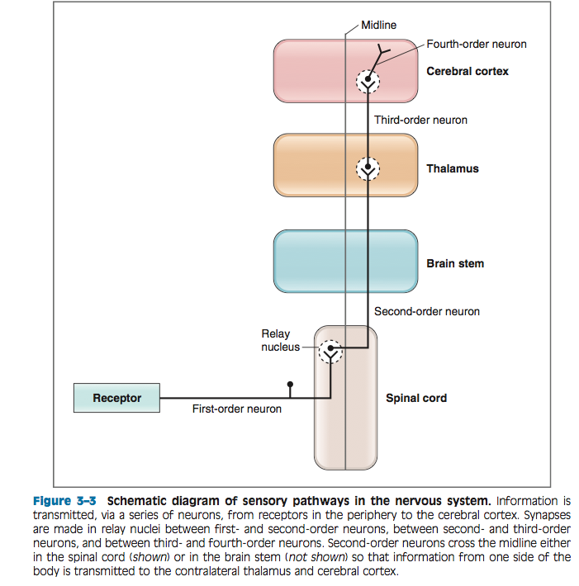
1. Sensory receptors.
- Sensory receptors are activated by stimuli in the environment.
- The basic function of the receptors is the same: to convert a stimulus (e.g., sound waves, electromagnetic waves, or pressure) into electrochemical energy.
- The conversion process, called sensory transduction, is mediated through opening or closing specific ion channels.
  - Opening or closing ion channels leads to a change in membrane potential, either depolarization or hyperpolarization, of the sensory receptor. Such a change in membrane potential of the sensory receptor is called the receptor potential.
- After transduction and generation of the receptor potential, the information is transmitted to the CNS along a series of sensory afferent neurons, which are designated as first-order, second-order, third- order, and fourth-order neurons

2. First-order sensory afferent neurons.
- The first- order neuron is the primary sensory afferent neuron; in some cases (somatosensory, olfaction), it also is the receptor cell. When the sensory receptor is a specialized epithelial cell, it synapses on a first- order neuron.
- When the receptor is also the primary afferent neuron, there is no need for this synapse.
- The primary afferent neuron usually has its cell body in a dorsal root or spinal cord ganglion. (Exceptions are the auditory, olfactory, and visual systems.)
Then there are 3rd, 4th and 5th order neurons….

Cross over of these neurons occurs in the brain stem.
Sensory receptors:
- With all receptors - an environmental stimulus is transduced into an electrical signal in the sensory receptor.
- Receptors are classified by the type of stimulus that activates them.
  - The five types of receptors are:
    - Mechanoreceptors
    - Photoreceptors
    - Chemoreceptors
    - Thermoreceptors
    - Nociceptors
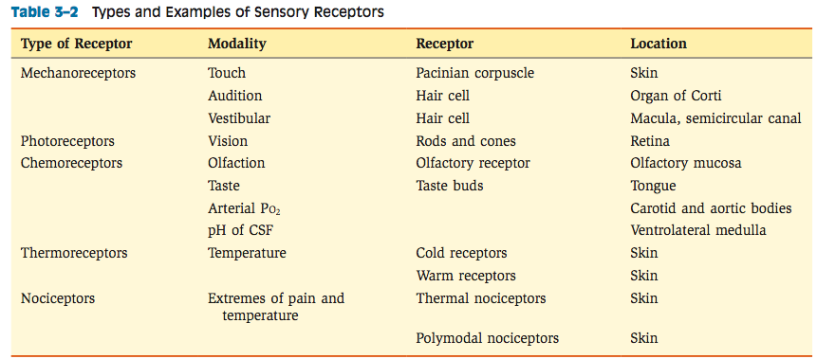

Sensory transduction and receptor potentials:
- Sensory transduction is the process by which an environmental stimulus (e.g., pressure, light, chemicals) activates a receptor and is converted into electrical energy.
- The conversion typically involves opening or closing of ion channels in the receptor membrane, which leads to a flow of ions (current flow) across the membrane. Current flow then leads to a change in membrane potential, called a receptor potential, which increases or decreases the likelihood that action potentials will occur.

The following series of steps occurs when a stimulus activates a sensory receptor:
1. The environmental stimulus interacts with the sensory receptor and causes a change in its properties. A mechanical stimulus causes movement of the mechanoreceptor. Photons of light are absorbed by pigments in photoreceptors on the retina, causing photoisomerization of rhodopsin (a chemical in the photoreceptor membrane). Chemical stimulants react with chemoreceptors, which activate Gs proteins and adenylyl cyclase. In each case, a change occurs in the sensory receptor.
2. These changes cause ion channels in the sensory receptor membrane to open or close, which results in a change in current flow. If ionic current flow is inward (i.e., positive charges move into the receptor cell), then depolarization occurs. If current flow is outward (i.e., positive charges move out of the cell), then hyperpolarization occurs. The resulting change in membrane potential, either depolarization or hyperpolarization, is called the receptor potential or generator potential. The receptor potential is not an action potential. Rather, the receptor potential increases or decreases the likelihood that an action potential will occur, depending on whether it is depolarizing or hyperpolarizing. Receptor potentials are graded electronic potentials, whose amplitude correlates with the size of the stimulus.
3. If the receptor potential is depolarizing, it moves the membrane potential toward threshold and increases the likelihood that an action potential will occur. Because receptor potentials are graded in amplitude, a small depolarizing receptor potential still may be subthreshold and, therefore, insufficient to produce an action potential. However, a larger stimulus will produce a larger depolarizing receptor potential, and if it reaches or exceeds threshold, action potentials will occur. If the receptor potential is hyperpolarizing (not illustrated), it moves the membrane potential away from threshold, always decreasing the likelihood that action potentials will occur.

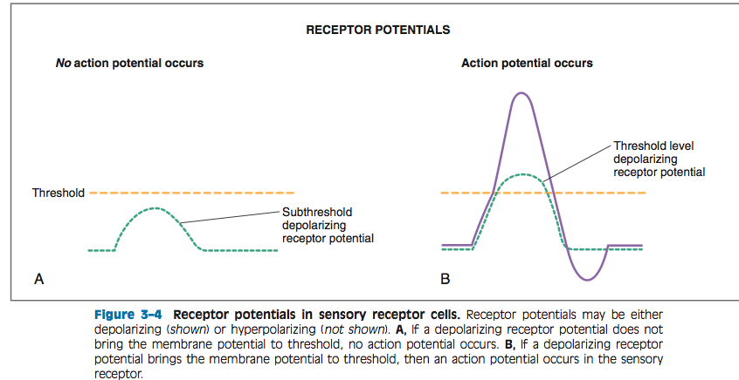

Sensory receptor adaptation:
- Adaptation is observed when a constant stimulus is applied for a period of time. Initially, the frequency of action potentials is high, but as time passes, this frequency declines even though the stimulus continues
    - The pattern of adaptation differs among different types of receptors.
      - Phasic, meaning they adapt rapidly to the stimulus (e.g., pacinian corpuscles)
        - These receptors adapt rapidly to a constant stimulus and primarily detect onset and offset of a stimulus and a changing stimulus. The phasic receptor responds promptly at the onset of the stimulus with a depolarizing receptor potential that brings the membrane potential above threshold. A short burst of action potential follows. After this burst, the receptor potential decreases below the threshold level, and although the stimulus contin- ues, there are no action potentials (i.e., there is silence). When the stimulus is turned off, the recep- tor is once again activated, as the receptor potential depolarizes to threshold, causing a second short burst of action potentials.

      - Tonic, meaning they adapt slowly to the stimulus (e.g., Merkel’s receptors).
Which detect steady pressure. Tonic mechanoreceptors are designed to encode duration and intensity of stimu- lus. The tonic receptor responds to the onset of the stimulus with a depolarizing receptor potential that brings the membrane to threshold, resulting in a long series of action potentials. The receptor potential remains depolarized for a longer portion of the stimulus period, and the action potentials continue. Once the receptor potential begins to repolarize, the rate of action potentials declines and eventually there is silence. Tonic receptors encode stimulus intensity

Excitable tissue – Nerve Ganong Ch 4:
Objectives:
Excitable Tissue: Nerve
Morphology
Excitation and Conduction
Ionic Basis of Excitation and Conduction
Nerve Fiber Types and Function
Summary:
Glial cells:
- Microglia
  - Arise from macropahges
- Macroglia
  - Oligodendrocytes
    - From myelin around axons in CNS
  - Schwann cells
    - Form myelin around axons in PNS
  - Astrocytes
    - Astrocytes, which are found throughout the brain, are of two subtypes.
      - Fibrous astrocytes, which contain many intermediate filaments, are found primarily in white matter.
      - Protoplasmic astrocytes are found in gray matter and have a granular cytoplasm.
        - They produce substances that are tropic to neurons, and they help maintain the appropriate concentration of ions and neurotransmitters by taking up K+ and the neurotransmitters glutamate and γ-aminobutyrate (GABA).
        - They do not generate action potentials
    - Both types send processes to blood vessels, where they induce capillaries to form the tight junctions making up the blood–brain barrier.
    - They also send processes that envelop synapses and the surface of nerve cells.

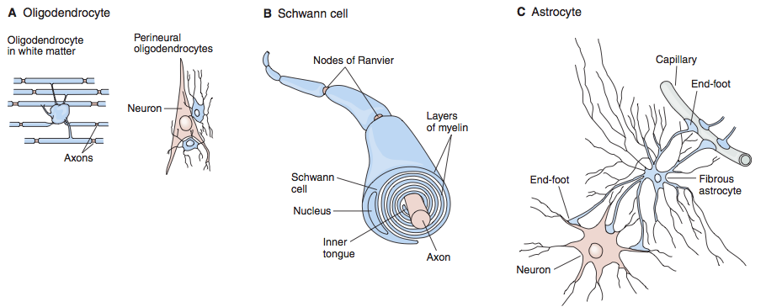

Neurons:

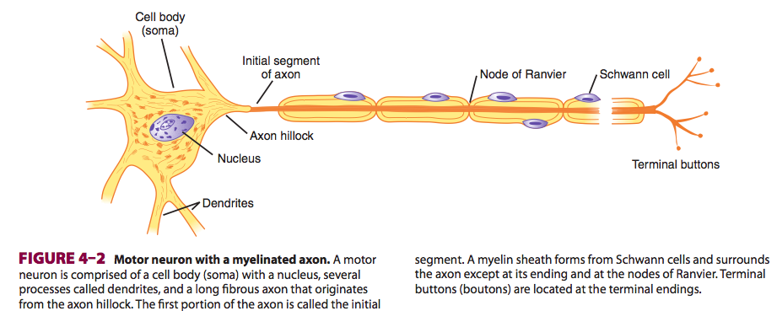
From a functional point of view, neurons generally have four important zones:
(1) a receptor, or dendritic zone, where multiple local potential changes generated by synaptic connections are integrated
(2) a site where propagated action potentials are generated (the initial segment in spinal motor neurons, the initial node of Ranvier in cutaneous sensory neurons); (3) an axonal process that transmits propagated impulses to the nerve endings
(4) the nerve endings, where action potentials cause the release of synaptic transmitters.

Myelin, a protein–lipid complex that is wrapped around the axon (in some nerves)
- In the peripheral nervous system, myelin forms when a Schwann cell wraps its membrane around an axon up to 100 times. The myelin is then compacted when the extracellular portions of a membrane protein called protein zero (P0) lock to the extracellular portions of P0 in the apposing membrane. Various mutations in the gene for P0 cause peripheral neuropathies
- The myelin sheath envelops the axon except at its ending and at the nodes of Ranvier, periodic 1-μm constrictions that are about 1 mm apart

Unmyelinated nerves - nerve surrounded by Schwann cells without the wrapping of the Schwann cell membrane that produces myelin around the axon.
In the CNS of mammals, most neurons are myelinated, but the cells that form the myelin are oligodendrocytes rather than Schwann cells

Axonal transport:
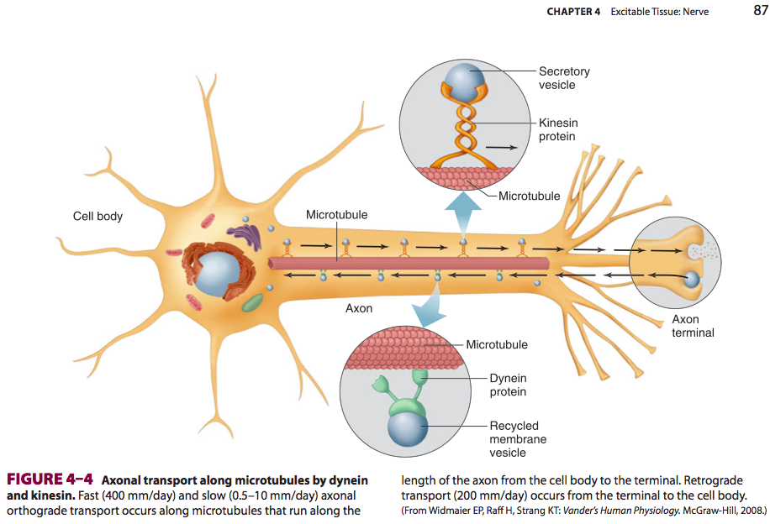
- The apparatus for protein synthesis is located for the most part in the cell body, with transport of proteins and polypeptides to the axonal ending by axoplasmic flow. Thus, the cell body maintains the functional and anatomic integrity of the axon; if the axon is cut, the part distal to the cut degenerates (wallerian degeneration).

Excitation and Conduction:
- A hallmark of nerve cells is their excitable membrane.
- Nerve cells respond to electrical, chemical, or mechanical stimuli.
- Two types of physicochemical disturbances are produced:
  - local, nonpropagated potentials called, depending on their location synaptic, generator, or electrotonic potentials
  - propagated potentials, the action potentials (or nerve impulses)
    - They are due to changes in the conduction of ions across the cell membrane.
    - The electrical events in neurons are rapid, being measured in milliseconds (ms); and the potential changes are small, being measured in millivolts (mV)

- Conduction is an active, self-propagating process, and the impulse moves along the nerve at a constant amplitude and velocity

Resting membrane potential:
- A membrane potential results from separation of positive and negative charges across the cell membrane
- In neurons, the concentration of K+ is much higher inside than outside the cell, while the reverse is the case for Na+.
- This concentration difference is established by Na, K ATPase. The outward K+ concentration gradient results in passive movement of K+ out of the cell when K+-selective channels are open. Similarly, the inward Na+ concentration gradient results in passive movement of Na+ into the cell when Na+-selective channels are open.
- In neurons, the resting membrane potential is usually about –70 mV, which is close to the equilibrium potential for K+
  - Because there are more open K+ channels than Na+ channels at rest, the membrane permeability to K+ is greater.
  - Consequently, the intracellular and extra- cellular K+ concentrations are the prime determinants of the resting membrane potential, which is therefore close to the equilibrium potential for K
Ionic fluxes during the action potential:
- In response to a depolarizing stimulus, some of the voltage-gated Na+ channels open and Na+ enters the cell and the membrane is brought to its threshold potential (step 2) and the voltage-gated Na+ channels overwhelm the K+ and other channels.
- The entry of Na+ causes the opening of more voltage-gated Na+ channels and further depolarization, setting up a positive feedback loop. The rapid upstroke in the membrane potential ensues (step 3).
- The membrane potential moves toward the equilibrium potential for Na+ (+60 mV) but does not reach it during the action potential (step 4), primarily because the increase in Na+ conductance is short-lived.
- The Na+ channels rapidly enter a closed state called the inactivated state and remain in this state for a few milliseconds before returning to the resting state, when they again can be activated. In addition, the direction of the electrical gradient for Na+ is reversed during the overshoot because the membrane potential is reversed, and this limits Na+ influx; also the voltage-gated K+ channels open. These factors contribute to repolarization.
- The opening of voltage-gated K+ channels is slower and more prolonged than the opening of the Na+ channels, and consequently, much of the increase in K+ conductance comes after the increase in Na+ conductance (step 5). The net movement of positive charge out of the cell due to K+ efflux at this time helps complete the process of repolarization.
- The slow return of the K+ channels to the closed state also explains the after-hyperpolarization (step 6), followed by a return to the resting membrane potential (step 7).
- Thus, voltage-gated K+ channels bring the action potential to an end and cause closure of their gates through a negative feedback process.
- The peak of the action potential normally occurs at +30mv

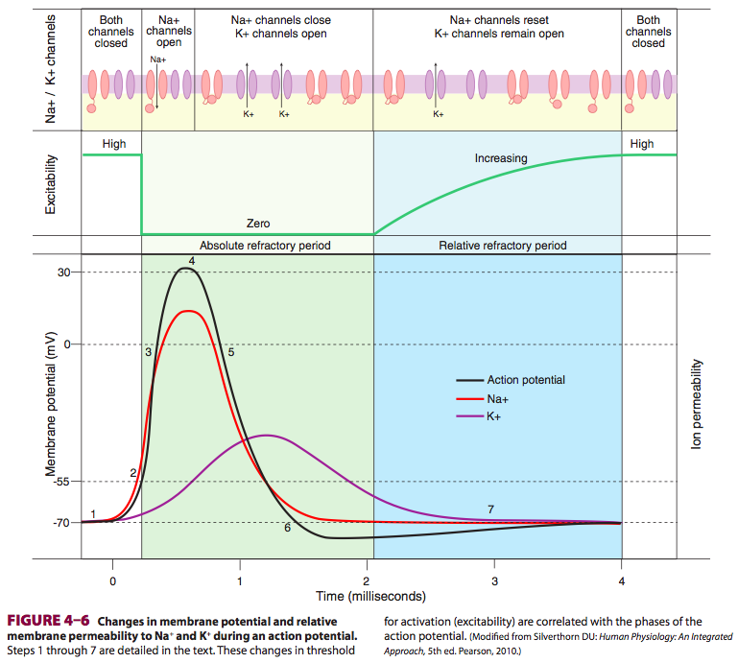
- Decreasing the external Na+ concentration reduces the size of the action potential but has little effect on the resting membrane potential
- In contrast, since the resting membrane potential is close to the equilibrium potential for K+, changes in the changes in the external concentration of this ion can have major effects on the resting membrane potential.
  - If the extracellular level of K+ is increased (hyperkalemia), the resting potential moves closer to the threshold for eliciting an action potential, thus the neuron becomes more excitable.
  - If the extracellular level of K+ is decreased (hypokalemia), the membrane potential is reduced and the neuron is hyperpolarized.

- A decrease in extracellular Ca2+ concentration increases the
excitability of nerve and muscle cells by decreasing the amount of depolarization necessary to initiate the changes in the Na+ and K+ conductance that produce the action potential.
- Conversely, an increase in extracellular Ca2+ concentration can stabilize the membrane by decreasing excitability.

- Hyperpolarizing responses elevate the threshold, and depolarizing potentials lower it as they move the membrane potential closer to the firing level
- The refractory period is divided into an absolute refractory period, corresponding to the period from the time the firing level is reached until repolarization is about one-third complete, and a relative refractory period, lasting from this point to the start of after-depolarization.
- During the absolute refractory period, no stimulus, no matter how strong, will excite the nerve, but during the relative refractory period, stronger than normal stimuli can cause excitation.

Conduction of the action potential:
- The nerve cell membrane is polarized at rest, with positive charges lined up along the outside of the membrane and negative charges along the inside. During the action potential, this polarity is abolished and for a brief period is actually reversed
- The spatial distribution of ion channels along the axon plays a key role in the initiation and regulation of the action potential.
  - Voltage-gated Na+ channels are highly concentrated in the nodes of Ranvier and the initial segment in myelinated neurons.
- Myelinated axons: This “jumping” of depolarization from node to node is called saltatory conduction.

Excitable tissue – Muscle: CH 5
Objectives:
Excitable Tissue: Muscle
Skeletal Muscle
Morphology
Electrical Phenomena and Ionic Fluxes
The Contractile Response
Energy Sources and Metabolism
Properties of Muscles
Cardiac Muscle
Morphology
Electrical Properties
Mechanical Properties
Metabolism
Pacemaker Tissue
Smooth Muscle
Morphology
Visceral Smooth Muscle
Multi-Unit Smooth Muscle
Summary:
- Muscle cells respond to stimuli by activating a contractile mechanism.
- Myosin – contractile protein
- Actin- cytoskeletal protein
- Smooth muscle lacks cross-striations and can be further subdivided into two broad types: unitary (or visceral) smooth muscle and multiunit smooth muscle
  - The type found in most hollow viscera is functionally syncytial and contains pacemakers that discharge irregularly.

Skeletal muscle:
- Each muscle fiber is a single cell that is multinucleated, long, cylindrical, and surrounded by a cell membrane, the sarcolemma
  - The muscle fibers are made up of myofibrils, which are divisible into individual filaments.
    - These myofilaments contain several proteins that together make up the contractile machinery of the skeletal muscle.
- The contractile mechanism in skeletal muscle largely depends on the proteins myosin-II, actin, tropomyosin, and troponin. Troponin is made up of three subunits: troponin I, troponin T, and troponin C.

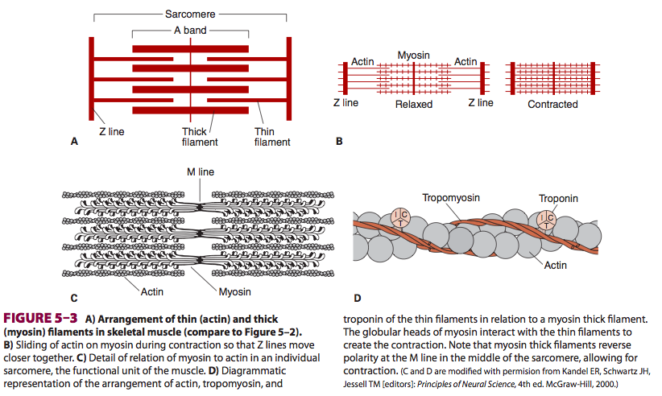

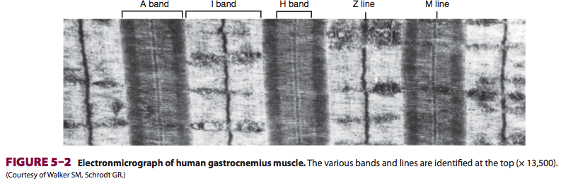
- The area between two adjacent Z lines is called a sarcomere.
- The thick filaments are made up of myosin
- The thin filaments are made up of actin, tropomyosin, and troponin.
- The thick filaments are lined up to form the A bands, whereas the array of thin filaments extends out of the A band and into the less dense staining I bands.
- The lighter H bands in the center of the A bands are the regions where, when the muscle is relaxed; the thin filaments do not overlap the thick filaments.
- Z lines anchor thin filaments

- Myosin: has two globular heads and a long tail. The heads of the myosin molecules form cross-bridges with actin. Myosin contains heavy chains and light chains, and its heads are made up of the light chains and the amino terminal portions of the heavy chains. These heads contain an actin-binding site and a catalytic site that hydrolyzes ATP.

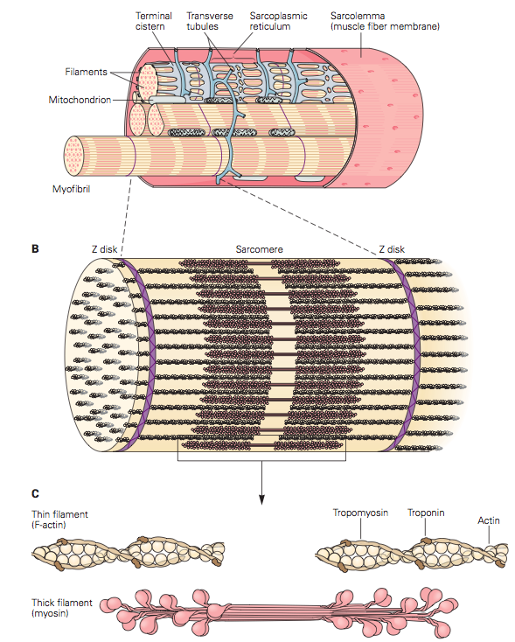

- The thin filaments are polymers made up of two chains of actin that form a long double helix.
- Tropomyosin molecules are long filaments located in the groove between the two chains in the actin
- Each of the three troponin subunits has a unique function:
  - Troponin T binds the troponin components to tropomyosin
  - Troponin I inhibits the interaction of myosin with actin
  - Troponin C contains the binding sites for the Ca2+ that helps to initiate contraction

Sarcotubular system:
- Sarcotubular system, which is made up of a T system and a sarcoplasmic reticulum.
- T system of transverse tubules, which is continuous with the sarcolemma of the muscle fiber, forms a grid perforated by the individual muscle fibrils
- The space between the two layers of the T system is an extension of the extracellular space. The sarcoplasmic reticulum, which forms an irregular curtain around each of the fibrils, has enlarged terminal cisterns in close contact with the T system at the junctions between the A and I bands.
- The T system, which is continuous with the sarcolemma, provides a path for the rapid transmission of the action potential from the cell membrane to all the fibrils in the muscle. The sarcoplasmic reticulum is an important store of Ca2+ and also participates in muscle metabolism.
Electrical phenomenon and ion fluxes:
- The resting membrane potential of skeletal muscle is about –90 mV.
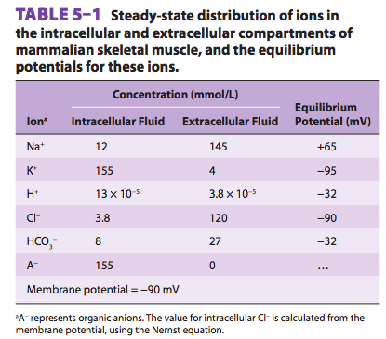
- As in nerves, depolarization is largely a manifestation of Na+ influx, and repolarization is largely a manifestation of K+ efflux.

Excitation contraction coupling:
- Muscle fiber membrane depolarization normally starts at the motor end plate, the specialized structure under the motor nerve ending.
- The action potential is transmitted along the muscle fiber and initiates the contractile response.
- The process by which the contraction of muscle is brought about is a sliding of the thin filaments over the thick filaments.
- The width of the A bands is constant, whereas the Z lines move closer together when the muscle contracts and farther apart when it relaxes
- The action potential is transmitted to all the fibrils in the fiber via the T system

The process by which depolarization of the muscle fiber initiates contraction is called excitation–contraction coupling.
In resting muscle, troponin I is bound to actin and tropomyosin and covers the sites where myosin heads interact with actin. Also at rest, the myosin head contains tightly bound ADP. Following an action potential, cytosolic Ca2+ is increased and free Ca2+ binds to troponin C. This binding results in a weakening of the troponin I interaction with actin and exposes the actin binding site for myosin to allow for formation of myosin/actin cross-bridges. Upon formation of the cross-bridge, ADP is released, causing a conformational change in the myosin head that moves the thin filament relative to the thick filament, comprising the cross-bridge “power stroke.” ATP quickly binds to the free site on the myosin, which leads to a detachment of the myosin head from the thin filament. ATP is hydrolyzed and inorganic phosphate (Pi) released, causing a “re-cocking” of the myosin head and completing the cycle.

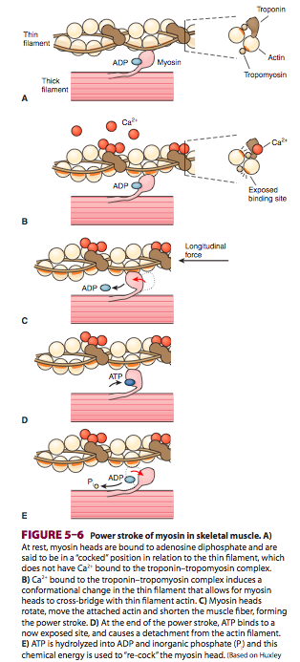
Action potential:
- The action potential is transmitted to all the fibrils in the fiber via the T system
- It triggers the release of Ca2+ from the terminal cisterns, the lateral sacs of the sarcoplasmic reticulum next to the T system.
- Depolarization of the T tubule membrane activates the sarcoplasmic reticulum via dihydropyridine receptors (DHPR)
- DHPR are voltage-gated Ca2+ channels in the T tubule membrane.
- In cardiac muscle, influx of Ca2+ via these channels triggers the release of Ca2+ stored in the sarcoplasmic reticulum (calcium-induced calcium release) by activating the ryanodine receptor (RyR).
- The RyR is a ligand- gated Ca2+ channel with Ca2+ as its natural ligand.
- In skeletal muscle, Ca2+ entry from the extracellular fluid (ECF) by this route is not required for Ca2+ release. Instead, the DHPR that serves as the voltage sensor unlocks release of Ca2+ from the nearby sarcoplasmic reticulum via physical interaction with the RyR. The released Ca2+ is quickly amplified through calcium-induced calcium release.
- Ca2+ is reduced in the muscle cell by the sarcoplasmic or endoplasmic reticulum Ca2+ ATPase (SERCA). The SERCA pump uses energy from ATP hydrolysis to remove Ca2+ from the cytosol back into the terminal cisterns, where it is stored until released by the next action potential.

Note that ATP provides the energy for both contraction (at the myosin head) and relaxation (via SERCA).

Types of contraction:
- Isometric: contraction to occur without an appreciable decrease in the length of the whole muscle.
- Isotonic: contraction against a constant load with a decrease in muscle length is isotonic (“same tension”).

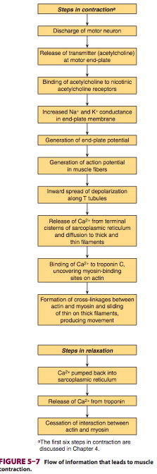
Muscle types (skeletal):
- Type I (or SO for slow-oxidative)
- Type IIA (FOG for fast-oxidative-glycolytic)
- Type IIB (FG for fast glycolytic)

Motor unit:
The smallest possible amount of muscle that can contract in response to the excitation of a single motor neuron is not one muscle fiber but all the fibers sup- plied by the neuron.
Each single motor neuron and the muscle fibers it innervates constitute a motor unit.

Cardiac Muscle:
- Large numbers of elongated mitochondria are in close contact with the muscle fibrils.
- The muscle fibers branch and interdigitate, but each is a complete unit surrounded by a cell membrane.
- Where the end of one muscle fiber abuts on another, the membranes of both fibers parallel each other through an extensive series of folds. These areas, which always occur at Z lines, are called intercalated disks
  - They provide a strong union between fibers, maintaining cell-to-cell cohesion, so that the pull of one contractile cell can be transmitted along its axis to the next.
- Gap junctions: provide low-resistance bridges for the spread of excitation from one fiber to another. They permit cardiac muscle to function as if it were a syncytium
- The T system in cardiac muscle is located at the Z lines
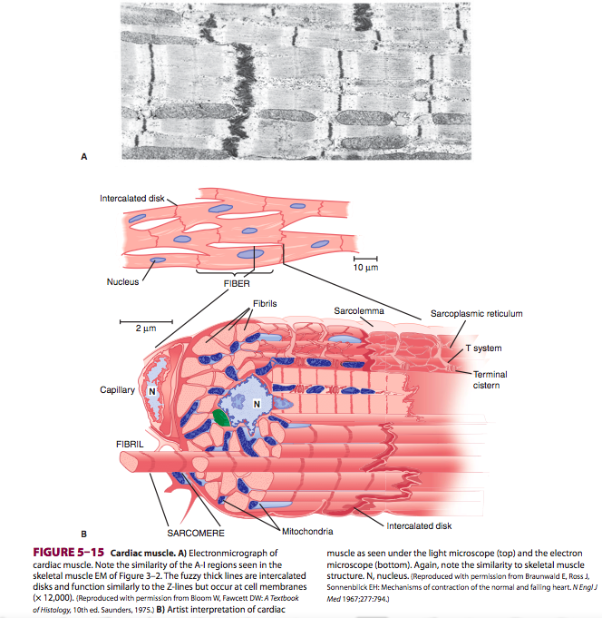

- Resting membrane potential for cardiac muscle cells is about –80 mV.
- As in other excitable tissues, changes in the external K+ concentration affect the resting membrane potential of cardiac muscle, whereas changes in the external Na+ concentration affect the magnitude of the action potential.
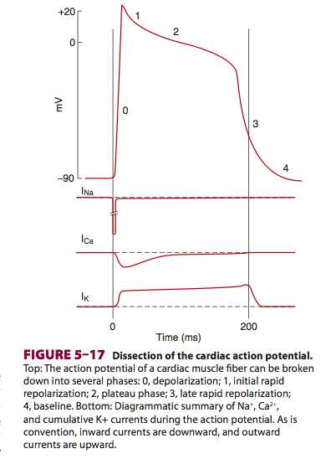

- The initial rapid depolarization and the overshoot (phase 0) are due to opening of voltage-gated Na+ channels
- The initial rapid repolarization (phase 1) is due to closure of Na+ channels and opening of one type of K+ channel.
- The subsequent prolonged plateau (phase 2) is due to a slower but prolonged opening of voltage-gated Ca2+ channels.
- Final repolarization (phase 3) to the resting membrane potential (phase 4) is due to closure of the Ca2+ channels and a slow, delayed increase of K+ efflux through various types of K+ channels.

  - Cardiac myocytes contain at least two types of Ca2+ channels (T- and L-types), but the Ca2+ current is mostly due to opening of the slower L-type Ca2+ channels.

- During phases 0 to 2 and about half of phase 3 (until the membrane potential reaches approximately –50 mV during repolarization), cardiac muscle cannot be excited again; that is, it is in its absolute refractory period. It remains relatively refractory until phase 4. Therefore, tetanus of the type seen in skeletal muscle cannot occur.

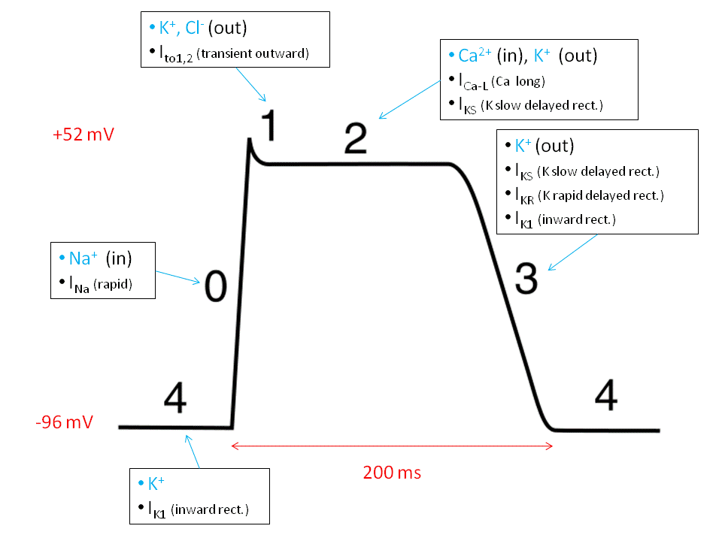

Excitation contraction coupling:

- Similar to skeletal muscle except….
  - However, it is the influx of extracellular Ca2+ through the voltage-sensitive DHPR in the T system that triggers calcium-induced calcium release through the RyR at the sarcoplasmic reticulum.
  - Because there is a net influx of Ca2+ during activation, there is also a more prominent role for plasma membrane Ca2+ ATPases and the Na+/Ca2+ exchanger in recovery of intracellular Ca2+ concentrations.

Correlation between muscle fiber length and tension:
- In the body, the initial length of the fibers is determined by the degree of diastolic filling of the heart, and the pressure developed in the ventricle is proportional to the volume of the ventricle at the end of the filling phase (Starling’s law of the heart).
- The developed tension increases as the diastolic volume increases until it reaches a maximum, then tends to decrease.
  - However, unlike skeletal muscle, the decrease in developed tension at high degrees of stretch is not due to a decrease in the number of cross-bridges between actin and myosin, because even severely dilated hearts are not stretched to this degree. The decrease is instead due to beginning disruption of the myocardial fibers.
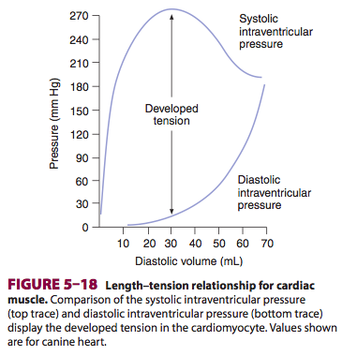
- Positive ionotropic effect of catecholamines is mediated via innervated β1-adrenergic receptors, cyclic AMP, and their effects on Ca2+ homeostasis.
- Cyclic AMP activates protein kinase A, and this leads to phosphorylation of the voltage- dependent Ca2+ channels, causing them to spend more time in the open state. Cyclic AMP also increases the active transport of Ca2+ to the sarcoplasmic reticulum, thus accelerating relaxation and consequently shortening systole. This is important when the cardiac rate is increased because it permits adequate diastolic filling

Cardiac glycosides:
- Work to inhibit the Na-K ATPase in cell membranes of the cardiomyocytes.
- The block of the Na, K ATPase in cardiomyocytes would result in an increased intracellular Na+ concentration. Such an increase would result in a decreased Na+ influx and hence Ca2+ efflux via the Na+-Ca2+ exchange antiport during the Ca2+ recovery period.
- The resulting increase in intracellular Ca2+ concentration in turn increases the strength of contraction of the cardiac muscle.
- With this mechanism in mind, these drugs can also be quite toxic. Overinhibition of the Na, K ATPase would result in a depolarized cell that could slow conduction, or even spontaneously activate. Alternatively, an overly increased Ca2+ concentration could also have ill effects on cardiomyocyte physiology.
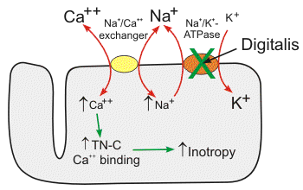
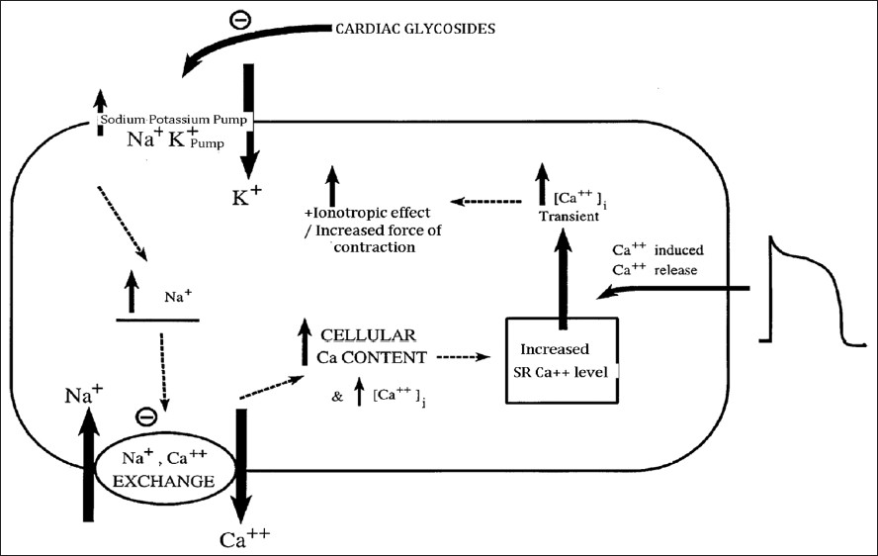

Metabolism:
- Mammalian hearts have an abundant blood supply, numerous mitochondria, and a high content of myoglobin, a muscle pigment that can function as an O2 storage mechanism.

Smooth Muscle:
- In general, smooth muscle can be divided into:
  - unitary (or visceral) smooth muscle
  - multiunit smooth muscle
- Unitary smooth muscle occurs in large sheets, has many low-resistance gap junctional connections between individual muscle cells, and functions in a syncytial fashion. Unitary smooth muscle is found primarily in the walls of hollow viscera.
- Multiunit smooth muscle is made up of individual units with few (or no) gap junctional bridges. It is found in structures such as the iris of the eye, in which fine, graded contractions occur. It is not under voluntary control, but it has many functional similarities to skeletal muscle.
- Blood vessels have both unitary and multi- unit smooth muscle in their walls.
- Unitary smooth muscle is characterized by the instability of its membrane potential and by the fact that it shows continuous, irregular contractions that are independent of its nerve supply.
- The membrane potential has no true “resting” value
  - But in periods of relative quiescence values for resting potential are on the order of –20 to –65 mV.
  - There are slow sine wave-like fluctuations a few millivolts in magnitude and spikes that sometimes over- shoot the zero potential line and sometimes do not.
Molecular basis of contraction:
- Depending on the activating stimulus, Ca2+ increase can be due to influx through voltage- or ligand-gated plasma membrane channels, efflux from intracellular stores through the RyR, efflux from intracellular stores through the inositol trisphosphate receptor (IP3R) Ca2+ channel, or via a combination of these channels.
- SMCs lack of troponin
  - Thus prevents Ca2+ activation via troponin binding.
  - Rather, myosin in smooth muscle must be phosphorylated for activation of the myosin ATPase
- In smooth muscle, Ca2+ binds to calmodulin, and the resulting complex activates calmodulin-dependent myosin light chain kinase. This enzyme catalyzes the phosphorylation of the myosin light chain on serine at position 19, increasing its ATPase activity.
- Myosin is dephosphorylated by myosin light chain phosphatase in the cell.
- Unitary smooth muscle is unique in that, unlike other types of muscle, it contracts when stretched in the absence of any extrinsic innervation. Stretch is followed by a decline in membrane potential, an increase in the frequency of spikes, and a general increase in tone.

Smooth muscle relaxation:
- NO directly activates a soluble guanylate cyclase to produce another second messenger molecule, cyclic guanosine monophosphate (cGMP). This molecule can activate cGMP-specific protein kinases that can affect ion channels, Ca2+ homeostasis, or phosphatases, or all of those mentioned, leading to smooth muscle relaxation

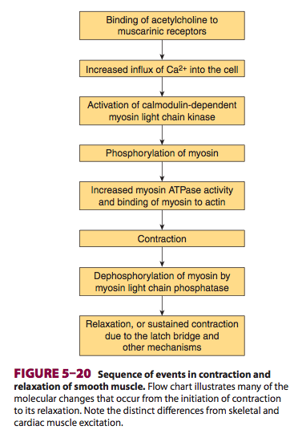

Synaptic and Junctional Transmission: CH6
- Synapses
  - These are the junctions where the axon or some other portion of one cell (the presynaptic cell) terminates on the dendrites, soma, or axon of another neuron or, in some cases, a muscle or gland cell (the postsynaptic cell).
- Cell-to-cell communication occurs across either a chemical or electrical synapse.
  - At chemical synapses, a synaptic cleft separates the terminal of the presynaptic cell from the postsynaptic cell. An impulse in the presynaptic axon causes secretion of a chemical that diffuses across the synaptic cleft and binds to receptors on the surface of the postsynaptic cell. This triggers events that open or close channels in the membrane of the postsynaptic cell.
  - In electrical synapses, the membranes of the presynaptic and postsynaptic neurons come close together, and gap junctions form between the cells Like the intercellular junctions in other tissues, these junctions form low-resistance bridges through which ions can pass with relative ease.
- The neuromuscular junction, the specialized area where a motor nerve terminates on a skeletal muscle fiber
- The ends of the presynaptic fibers are generally enlarged to form terminal boutons or synaptic knobs
- The postsynaptic density is an ordered complex of specific receptors, binding proteins, and enzymes induced by postsynaptic effects.
- Inside the presynaptic terminal are many mitochondria, as well as many membrane-enclosed vesicles, which contain neurotransmitters.
  - There are three kinds of synaptic vesicles:
- Small, clear synaptic vesicles that contain acetylcholine, glycine, GABA, or glutamate
- Small vesicles with a dense core that contain catecholamines
- Large vesicles with a dense core that contain neuropeptides

- The vesicles and the proteins contained in their walls are synthesized in the neuronal cell body and transported along the axon to the endings by fast axoplasmic transport
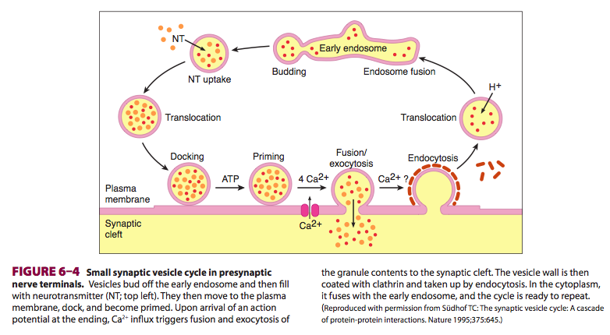
- voltage-gated Ca2+ channels are very close to the release sites at the active zones.
- In addition, the transmitter must be released close to the postsynaptic receptors to be effective on the postsynaptic neuron
- Several deadly toxins that block neurotransmitter release are zinc endopeptidases that cleave and hence inactivate proteins in the fusion-exocytosis complex. Clinical Box 6–1 describes how neurotoxins from bacteria called Clostridium tetani and Clostridium botulinum can disrupt neurotransmitter release in either the CNS or at the neuromuscular junction
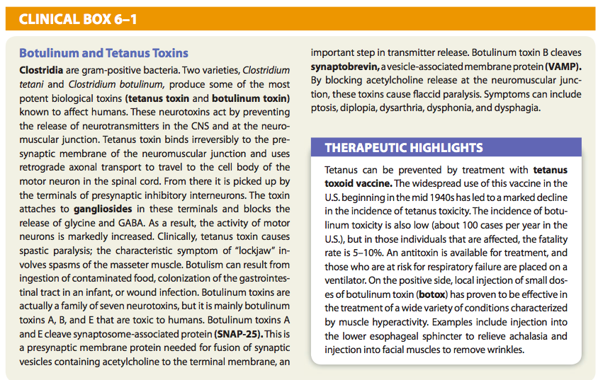

Electrical events in post synaptic neurons:
- Once an impulse reaches the presynaptic terminals, a response can be obtained in the postsynaptic neuron after a synaptic delay. The delay is due to the time it takes for the synaptic mediator to be released and to act on the receptors on the membrane of the postsynaptic cell
- Excitatory postsynaptic potential (EPSP)
  - The EPSP is produced by depolarization of the post- synaptic cell membrane immediately under the presynaptic ending. The excitatory transmitter opens Na+ or Ca2+ channels in the postsynaptic membrane, producing an inward current.
- Inhibitory postsynaptic potential (IPSP)
  - Also exist
  - Can be produced by a localized increase in Cl− transport.
  - When an inhibitory synaptic knob becomes active, the released transmitter triggers the opening of Cl− channels in the area of the postsynaptic cell membrane under the knob. Cl– moves down its concentration gradient. The net effect is the transfer of negative charge into the cell, so that the membrane potential increases.
  - The decreased excitability of the nerve cell during the IPSP is due to movement of the membrane potential away from the firing level. Consequently, more excitatory (depolarizing) activity is necessary to reach the firing level.

Electrical transmission:
- At synaptic junctions where transmission is electrical, the impulse reaching the presynaptic terminal generates an EPSP in the postsynaptic cell that, because of the low-resistance bridge between the two, has a much shorter latency than the EPSP at a synapse where transmission is chemical.

Generation of an action potential in the post synaptic neuron:
- When the level of depolarization reaches the threshold voltage, a propagated action potential will occur.
- In motor neurons, the portion of the cell with the lowest threshold for the production of an action potential is the initial segment, the portion of the axon at and just beyond the axon hillock.
- Two passive membrane properties of a neuron affect the ability of postsynaptic potentials to summate to elicit an action potential
  - The time constant of a neuron determines the time course of the synaptic potential
    - The longer the time constant, the greater is the chance for two potentials to summate to induce an action potential
  - Length constant of a neuron determines the degree to which a depolarizing current is reduced as it spreads passively
    - Affect the amplitude of two EPSPs produced by different presynaptic neurons in a process called spatial summation.
    - If a neuron has a long length constant, the membrane depolarization induced by input arriving at two points on the neuron can spread to the trigger zone of the neuron with minimal decrement. The two potentials can summate and induce an action potential
Inhibition:
- Postsynaptic inhibition occurs when an inhibitory transmitter (eg, glycine, GABA) is released from a presynaptic nerve terminal onto the postsynaptic neuron.
- Another type of inhibition occurring in the CNS is presynaptic inhibition, a process mediated by neurons whose terminals are on excitatory endings, forming axoaxonal synapses
  - Three mechanisms of presynaptic inhibition have been described.
- First, activation of the presynaptic receptors increases Cl– conductance, and this has been shown to decrease the size of the action potentials reaching the excitatory ending. This in turn reduces Ca2+ entry and consequently the amount of excitatory transmitter released.
- Voltage-gated K+ channels are also opened, and the resulting K+ efflux also causes a decrease in Ca2+ influx.
- Finally, there is evidence for direct inhibition of transmitter release independent of Ca2+ influx into the excitatory ending

- The first transmitter shown to produce presynaptic inhibition was GABA.
  - Acting via GABAA receptors, GABA increases Cl– conductance.
  - GABAB receptors are also present in the spinal cord and appear to mediate presynaptic inhibition via a G protein that produces an increase in K+ conductance.
- Other transmitters also mediate presynaptic inhibition by G protein-mediated effects on Ca2+ channels and K+ channels.

- Conversely, presynaptic facilitation is produced when the action potential is prolonged and the Ca2+ channels are open for a longer period.

Neuromuscular junction:
- As the axon supplying a skeletal muscle fiber approaches its termination, it loses its myelin sheath and divides into a number of terminal boutons
- The terminal contains many small, clear vesicles that contain acetylcholine, the transmitter at these junctions. The endings fit into junctional folds, which are depressions in the motor end plate, the thickened portion of the muscle membrane at the junction
- The space between the nerve and the thickened muscle membrane is comparable to the synaptic cleft at neuron-to-neuron synapses.
- The whole structure is known as the neuromuscular junction. Only one nerve fiber ends on each end plate
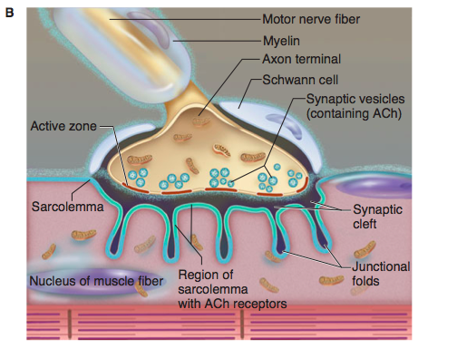
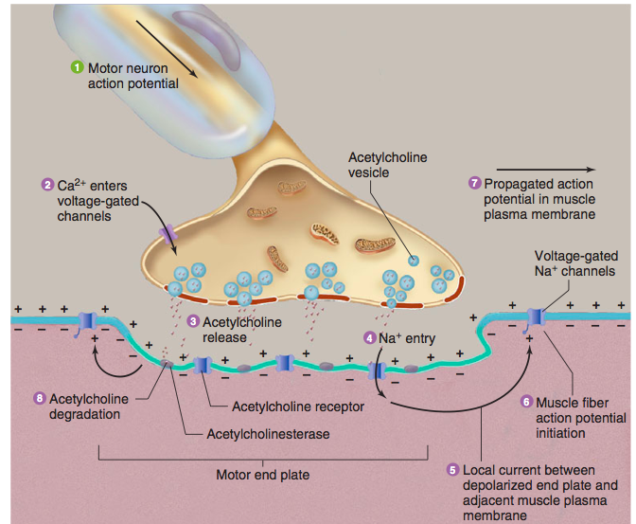

Sequence of events:
- The impulse arriving in the end of the motor neuron increases the permeability of its endings to Ca2+
- Ca2+ enters the endings and triggers a marked increase in exocytosis of the acetylcholine-containing synaptic vesicles
- The acetylcholine diffuses to nicotinic cholinergic (NM) receptors that are concentrated at the tops of the junctional folds of the membrane of the motor end plate.
- Binding of acetylcholine to these receptors increases the Na+ and K+ conductance, and the resultant influx of Na+ produces a depolarizing potential, the end plate potential.
- The current sink created by this local potential depolarizes the adjacent muscle membrane to its firing level.
- Action potentials are generated on either side of the end plate and are conducted away from the end plate in both directions along the muscle fiber.
- The muscle action potential, in turn, initiates muscle contraction
- Acetylcholine is then removed from the synaptic cleft by acetylcholinesterase, which is present in high concentration at the neuromuscular junction
Quantal NT (Ach) release:
- Small quanta (packets) of acetylcholine are released randomly from the nerve cell membrane at rest. Each produces a minute depolarizing spike called a miniature end plate potential, which is about 0.5 mV in amplitude. The size of the quanta of acetylcholine released in this way varies directly with the Ca2+ concentration and inversely with the Mg2+ concentration at the end plate. When a nerve impulse reaches the ending, the number of quanta released increases by several orders of magnitude, and the result is the large end plate potential that exceeds the firing level of the muscle fiber.
- The number of quanta released decreases with successive repetitive stimulation this accounts for the fatigue in MG patients

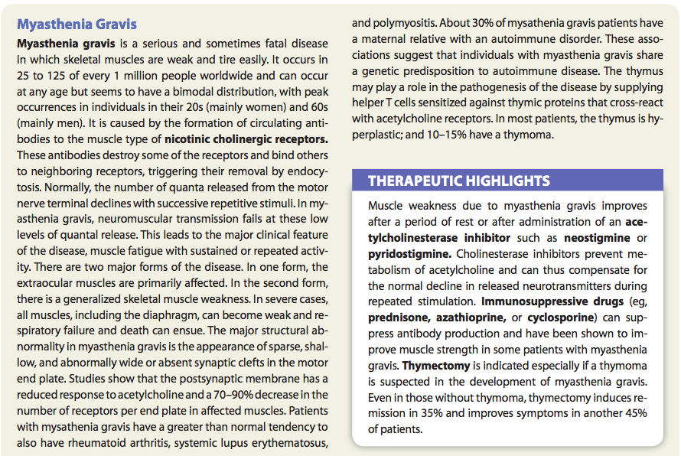

Questions:

1. Describe the concept of sensory transduction as it pertains to sensory pathways.

2. What comprises the blood brain barrier?

3. Draw the nerve cell action potential with is ion channel changes over time.

4. With respect to the neuronal action potential, in the presence of hypokalemia, the membrane potential is reduced and the neuron is hyperpolarized. T or F?

5. Draw and label the steps of the cardiomyocte action potential (including ion fluxes)

Questions with answers:

1. Describe the concept of sensory transduction as it pertains to sensory pathways.
Answer:
- When sensory receptors convert a stimulus (e.g., sound waves, electromagnetic waves, or pressure) into electrochemical energy.
- Is mediated through opening or closing specific ion channels.
  - Opening or closing ion channels leads to a change in membrane potential, either depolarization or hyperpolarization, of the sensory receptor. Such a change in membrane potential of the sensory receptor is called the receptor potential.

2. What comprises the blood brain barrier?
Answer: Astrocyte processes projected to blood vessels, where they induce capillaries to form the tight junctions making up the blood–brain barrier

3. Draw the nerve cell action potential with is ion channel changes over time.

4. With respect to the neuronal action potential, in the presence of hypokalemia, the membrane potential is reduced and the neuron is hyperpolarized. T or F?
Answer: True

5. Draw and label the steps of the cardiomyocte action potential (including ion fluxes)
Answer:
- The initial rapid depolarization and the overshoot (phase 0) are due to opening of voltage-gated Na+ channels
- The initial rapid repolarization (phase 1) is due to closure of Na+ channels and opening of one type of K+ channel.
- The subsequent prolonged plateau (phase 2) is due to a slower but prolonged opening of voltage-gated Ca2+ channels.
- Final repolarization (phase 3) to the resting membrane potential (phase 4) is due to closure of the Ca2+ channels and a slow, delayed increase of K+ efflux through various types of K+ channels.

