Neurophysiology Questions

- Where in neurons are action potential’s generated
  - Cell body (soma)
  - Axon
  - Axon hillock
  - Synapse
- The myelin sheath:
  - Is made by oligodendrocytes in the PNS
  - Is made by Schwann cells in the CNS
  - Slows the nerve impulse traveling along axons
  - Enables faster conduction velocity
- True or False: Nerve fibers classified as Aα are larger in diameter and faster in conduction than those fibers classified as C fibers
- Glucose in the CNS is transported by:
  - Simple diffusion
  - GLUT 1
  - Facilitated diffusion
  - Na+‐dependent symport carrier
- True or False: The choroid plexus produces CSF
- A local anesthetic, such as lidocaine, prevents generation of action potential by inactivating:
  - Receptors for GABA
  - Nongated Na+ channels
  - Voltage‐gated Ca2+ channels
  - Voltage‐gated Na+ channels
- What triggers depolarization phase of an action potential?
  - Na+ moves into the cell
  - Na+ moves out of the cell
c. Increased permeability to K+ ions
d. K+ moves into the cell

- Hypokalemia induces __________ of the neuronal membrane and makes neurons __________.
  - Hyperpolarization, more excitable
  - Hyperpolarization, less excitable
  - Depolarization, more excitable
  - Depolarization, less excitable
- Which of the following is an excitatory neurotransmitter?
  - Glycine
  - Acetylcholine
  - GABA
  - Leucine
- True or False: Adrenergic β receptors are coupled to G protein, which directly stimulates adenylyl cyclase
- What is the mechanism of action of the Botulinum toxin.

- Fill in the blank

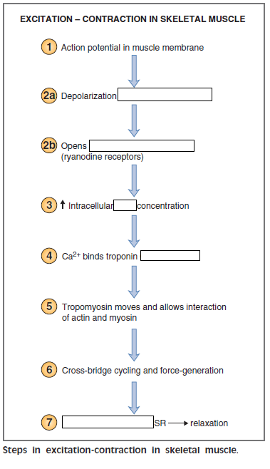

Neurophysiology Questions

- Where in neurons are action potential’s generated
  - Cell body (soma)
  - Axon
  - Axon hillock
  - Synapse
- The myelin sheath:
  - Is made by oligodendrocytes in the PNS
  - Is made by Schwann cells in the CNS
  - Slows the nerve impulse traveling along axons
  - Enables faster conduction velocity
- True or False: Nerve fibers classified as Aα are larger in diameter and faster in conduction than those fibers classified as C fibers
- Glucose in the CNS is transported by:
  - Simple diffusion
  - GLUT 1
  - Facilitated diffusion
  - Na+‐dependent symport carrier
- True or False: The choroid plexus produces CSF
- A local anesthetic, such as lidocaine, prevents generation of action potential by inactivating:
  - Receptors for GABA
  - Nongated Na+ channels
  - Voltage‐gated Ca2+ channels
  - Voltage‐gated Na+ channels
- What triggers depolarization phase of an action potential?
  - Na+ moves into the cell
  - Na+ moves out of the cell
c. Increased permeability to K+ ions
d. K+ moves into the cell

- Hypokalemia induces __________ of the neuronal membrane and makes neurons __________.
  - Hyperpolarization, more excitable
  - Hyperpolarization, less excitable
  - Depolarization, more excitable
  - Depolarization, less excitable
- Which of the following is an excitatory neurotransmitter?
  - Glycine
  - Acetylcholine
  - GABA
  - Leucine
- True or False: Adrenergic β receptors are coupled to G protein, which directly stimulates adenylyl cyclase
- What is the mechanism of action of the Botulinum toxin.
Blocks ACh release from presynaptic terminals.
- Fill in the blank
- 