ECC Mock Exam Key – May 2015

- The mode of continuous renal replacement therapy that is diagrammed below is...

  - CVVH (continuous venovenous hemofiltration)
  - CVVHD (continuous venovenous hemodialysis)
  - CVVHDF (continuous venovenous hemodiafiltration)
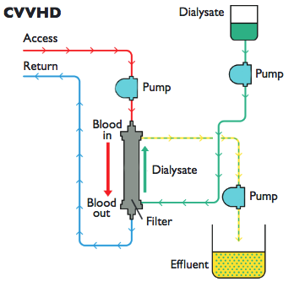
  - SCUF (slow continuous ultrafiltration)

- The mode depicted above works primarily by…
  - Convection
  - Diffusion
  - Diffusion and convection
  - Ultrafiltration

Citaton for questions 1 and 2: Compendium 2008 CRRT – This diagram is CVVHD – works by diffusion

- Which of the following drugs can be removed by conventional CRRT or intermittent hemodialysis?
  - Ibuprofen
  - Marajuana
  - Ethylene glycol
  - Morphine

Only water soluble substances can be removed without the use of charcoal or other nonconventional dislysis techniques. Ch 28 hemodialysis In: Urology of small animals (Bartges)

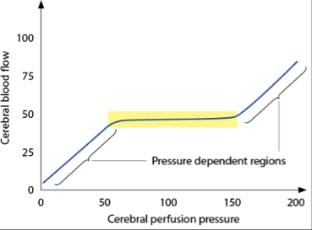
- Autoregulation maintains appropriate cerebral perfusion pressure over a wide range conditions. What determines the cerebral perfusion pressure in the indicated (starred) regions?

  - Arterial blood pressure
  - Baroreceptors
  - Chemoreceptors
  - Cerebral blood flow

CBF passively follows arterial pressure, and is less responsive to changes in O2 delivery out side of the autoregulation zone. Platt Small animal neuro emergencies. TBI chapter

- Contusions suffered from traumatic brain injury can have a primary site of impact directly under the site of trauma; and a second site of impact, on the opposite side of the brain. What is the term for this second site of impact?
  - Coup
  - Counter coup
  - Counting coup
  - Chicken coup
  - Coup d’etat

Platt Small animal neuro emergencies. TBI chapter

- Please name a condition for which slow continuous ultrafiltration would be useful.
Congestive heart failure
The ultrafiltrate is not replaced, and the blood becomes more concentrated. SCUF has been used to treat congestive heart failure patients who do not respond to medical management.
Acierno, Mark J, and Vera Maeckelbergh. 2008. “Continuous Renal Replacement Therapy.” Compendium (Yardley, PA) 30(5): 264–72.
- In RRT, why is diffusion better suited for smaller molecules?

Because smaller molecules have more kinetic activity
Source: Dr. Eatroff ‘s presentation

- Please choose the correct statement regarding motor unit diseases.
Answer: C = Coral snake venom blocks the action of acetylcholine on the postsynaptic receptors.

Botulism toxins block the presynaptic release of acetylcholine.
Coral snake venom causes postsynaptic blockade of acetylcholine receptors
Tetanospasmin blocks the presynaptic release of acetylcholine.
Myasthenia gravis causes a reduction in the number of functional postsynaptic acetylcholine receptors.

- Transformation of norepinephrine to epinephrine requires the presence of an enzyme only presents in the adrenal medulla. This enzyme is…
  - Dopamine-β hydroxylase
  - Tyrosine hydroxylase
  - Phenylethanolamine-N-methyltransferase
  - Amino acid decarboxylase

REVIEW OF MEDICAL PHYSIOLOGY – GANONG: Chapter 7

10. Please complete :
a. Antibodies to Osp A are markers for vaccination
b. Antibodies to Osp C indicate early infection
c. Antibodies to Osp F indicate chronic infection

- Anticoagulation effects of CRRT are monitored by
  - ACT
  - PT
  - PTT

Reference: Aceirno et al. Continuous Renal Replacement Therapy. Compendium May 2008

- The ability of CRRT to remove a substance such as a toxin or drug from the blood depends on:
  - Circulating concentration of drug only
  - Amount that is protein bound and ionic nature
  - Protein binding, size and volume of distribution
  - Size and ionic nature
Reference: Aceirno et al. Continuous Renal Replacement Therapy. Compendium May 2008

- Nerve fibers ________ are most susceptible to hypoxia, while group _______ nerve fibers are most susceptible to local anesthetics
a. B, C
b. B, A
c. A, C
d. A, C
Reference: Ganong's Review of Medical Physiology
Chapter 4. General Principles & Energy Production in Medical Physiology

- What is the main excitatory transmitter in the CNS? Name the two major types of receptors.
The amino acid glutamate
Glutamate receptors: metabotropic (G protein-coupled receptors) and
ionotropic (ligand-gated ion channels receptors, including kainite, AMPA,
and NMDA).
Reference: Ganong's Review of Medical Physiology
Chapter 7. General Principles & Energy Production in Medical Physiology

- Case: 4 Yr Newfoundland was presented with collapsing and vomiting. Neurologic examination reveled the following:
Mental status: normal
Gait: can barely walk for a few steps then collapses (repeatable)
GP: normal when supported well
CN: appear normal, but megaesophagus on rads
Reflexes: normal
Where does this patient neurolocalize?
- Neurolocalization: neuromuscular (NMJ)
Reference: Neurolocalization presentation (Madden)
- Principle cells in the cortical collecting tubule reabsorb Na⁺ and Cl⁻ and excrete K⁺ in part under the influence of aldosterone? T or F?

Answer: True

- Where is the major site of ammonia production in the nephron?
A. Proximal tubule
B. Loop of Henle
C. Distal tubule
D. Collecting tubule

Answer: A

- Low Cl⁻ levels sensed at the macula densa is a stimulus for renin secretion. T or F?

Answer: True

- ____________% of bicarbonate is normally reabsorbed in the proximal tubule?
A. 15%
B 50%
C. 75%
D. 90%

Answer: 90%

- SIADH (SIAD) is characterized by water retention, which leads to both hyponatremia and volume expansion. As a result, this disorder is initially associated with enhanced Na+ excretion. T or F?

Answer: True

Ref: Rose and Post

21.
Patients with SRMA may also have vasculitis and inflammation present in the
a. Pancreas
b. Kidneys
c. Heart
d. Thymus

Chapter 20 Infectious and Inflammatory Diseases of the CNS. Small Animal Neurological Emergencies

22.
True or False: Adrenergic β receptors are coupled to G protein, which directly stimulates adenylyl cyclase
Medical Physiology Ganong Edition 24

23.
____10____ of the 12 Cranial Nerves arise in the brainstem.
Small Animal Neurological Emergencies. Performing an neurologic exam

24.
A 2 year old Great Dane presents for weakness. Your neurologic exam shows the following
Mentation – normal
Spinal reflexes – delayed forelimb withdrawals
Palpation – normal
CN exam – normal
Gait – Short and choppy in forelimbs. Long strides in pelvic limbs
You neurolocalize this patient as
a. C1-C5
b. C6-T2
c. T3 – L3
d. L4 – S3

25.
A 4yo FS poodle presents for evaluation of possible seizure like activity. During the seizure the dog does not lose consciousness and has repetitive jaw movement similar to chewing gum. This is a form of ___________ seizure
a. Generalized
b. Focal motor
c. Focal autonomic
d. Focal sensory
Small Animal eurological Emergencies. Seizures

26. A 4 year-old intact male Jack Russell Terrier is presented to you with evidence of head trauma. The dog is stuporous, has miotic pupils that are responsive to light, is hemiparetic and has an abnormal breathing pattern cycle characterized by progressively deeper and sometimes faster breathing, followed by a gradual decrease culminating in temporary apnea. You suspect the dog has traumatic brain injury secondary to the head trauma. Based on the above information, what is the most likely localization of the intracranial lesion?

a) Cerebrum
b) Diencephalon
c) Pons
d) Medulla

References:
- Freeman C, Platt S. Head Trauma, Chapter 20. In: Platt S, Garosi L. Small Animal Neurologic Emergencies. 2012 pg 363-382; 373
- Knipe MF. Deteriorating Mental Status, Chapter 80. In: Silverstein & Hopper. SACCM 2nd Ed. 2014 pg 419-421; 421

Region | Consciousness | Pupils | Eye movement | Motor function | Breathing
Cerebrum | Obtunded - stuporous | Normal | Normal | Hemiparesis | Normal
Diencephalon | Obtunded - stuporous | Small but reactive | Normal | Hemi to tetraparesis | Cheyne-Stokes
Midbrain | Stuporous - comatose | Dilated | VL strabismus | Decerebrate | Hyperventilation
Pons | Comatose | Dilated | Absent oculovestibular | Decerebrate | Apneustic
Medulla | Comatose | Dilated | Absent | Decerebrate | Ataxic
All brainstem | Comatose | Dilated | Absent | Decerebrate | Absent

* * * * * * * * * *

27. What was the principle conclusion of the following study?

Chesnut RM et al. A Trial of Intracranial-Pressure Monitoring in Traumatic Brain Injury. N Engl J Med 2012; 367:2471-2481

a) The number of days of brain-specific treatments was significantly higher in the pressure-monitoring group
b) The duration of ICU stay was significantly longer in the pressure-monitoring group
c) There was a significantly higher incidence of serious adverse events in the pressure-monitoring group
d) There was no significant difference in the composite outcome status measure between the two groups

There was no significant between-group difference in the primary outcome, a composite measure based on percentile performance across 21 measures of functional and cognitive status (score, 56 in the pressure-monitoring group vs. 53 in the imaging–clinical examination group; P=0.49). Six-month mortality was 39% in the pressure-monitoring group and 41% in the imaging–clinical examination group (P=0.60). The median length of stay in the ICU was similar in the two groups (12 days in the pressure-monitoring group and 9 days in the imaging–clinical examination group; P=0.25), although the number of days of brain-specific treatments (e.g., administration of hyperosmolar fluids and the use of hyperventilation) in the ICU was higher in the imaging–clinical examination group than in the pressure-monitoring group (4.8 vs. 3.4, P=0.002). The distribution of serious adverse events was similar in the two groups.
28. You are managing a 3 year-old female spayed mixed-breed dog with evidence of head trauma after being hit by a car. Based on the following study, what percentage of similarly affected dogs will develop seizures after hospital discharge?

Friedenberg SG et al. Seizures following head trauma in dogs: 259 cases (1999-2009). J Am Vet Med Assoc. 2012; 241(11):1479-83.

a) 1.4 %
b) 3.5 %
c) 6.8 %
d) 10 %

Results—3.5% of dogs with head trauma developed in-hospital seizures, and 6.8% of dogs with head trauma for which follow-up information was available developed seizures after hospital discharge, compared with an epilepsy rate of 1.4% in our hospital. Dogs that developed in-hospital seizures were significantly more likely to have been hit by a car or experienced acceleration-deceleration injury. Additionally, 10% of dogs with traumatic brain injury had in-hospital seizures. No visit or patient characteristics were significantly associated with the development of out-of-hospital seizures.

* * * * * * * * * *

29. You are managing a 3 year-old female spayed DSH on intermittent hemodialysis for AKI following lily ingestion. The cat is anuric and has a urea concentration of 317 mg/dL. What urea reduction ratio and treatment intensity would be most appropriate for this cat?

a) URR ≤0.1, at 0.01 URR/hr
b) URR ≤0.3, at 0.05 URR/hr
c) URR ≤0.5, at 0.07 URR/hr
d) URR ≤0.7, at 0.1 URR/hr

Reference:
Cowgill LD, Francey T. Chapter 29. Hemodialysis and Extracorporeal Blood Purification. In: Dibartola SP ed. Fluid, Electrolyte and Acid-Base Disorders in Small Animal Practice, 4th ed. 2012. pg 680-714

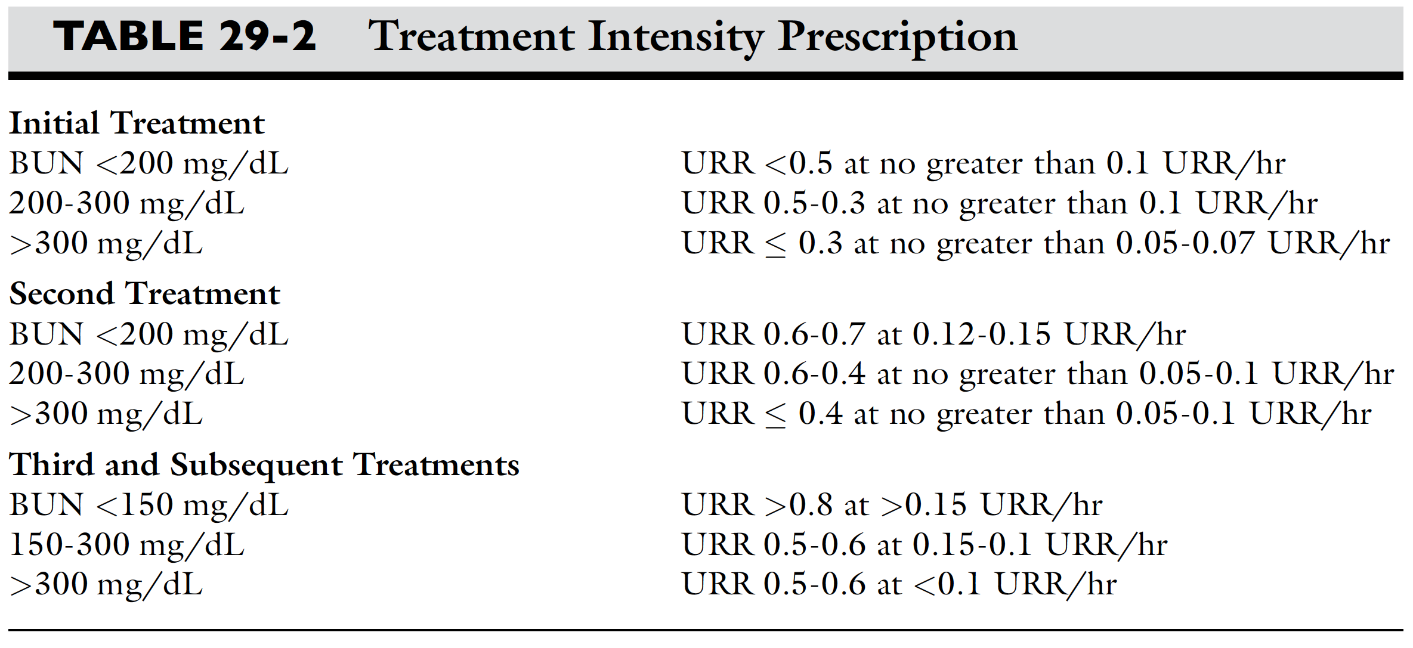

* * * * * * * * * *

30. What technique would allow you to safely achieve a high URR and rate of reduction while minimizing the risk of dialysis disequilibrium syndrome?

a) High-flux dialyzer
b) Reduced time on-bypass
c) Sodium profiling
d) Decreased dialysate temperature

Reference:
Cowgill LD, Francey T. Chapter 29. Hemodialysis and Extracorporeal Blood Purification. In: Dibartola SP ed. Fluid, Electrolyte and Acid-Base Disorders in Small Animal Practice, 4th ed. 2012. pg 680-714

* * * * * * * * * *

31. You are continuing to manage the same 3 year-old female spayed DSH on intermittent hemodialysis for AKI following lily ingestion. Prior to the latest treatment the cat’s urea concentration was 120 mg/dL. Following the treatment her urea concentration is 27 mg/dL. What is the cat’s urea reduction ratio?

a) 22.5 %
b) 34.4 %
c) 68.8 %
d) 77.5 %

Reference:
Cowgill LD, Francey T. Chapter 29. Hemodialysis and Extracorporeal Blood Purification. In: Dibartola SP ed. Fluid, Electrolyte and Acid-Base Disorders in Small Animal Practice, 4th ed. 2012. pg 680-714

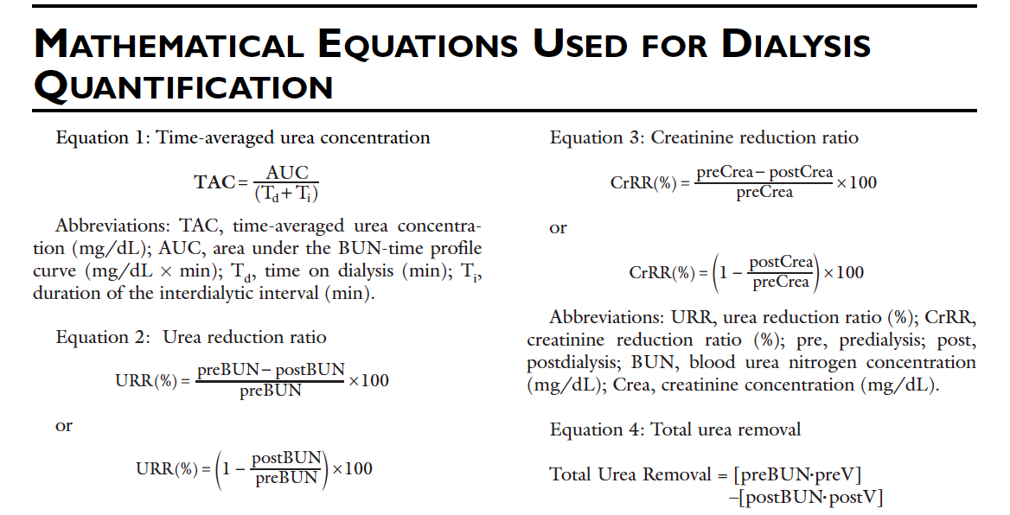

* * * * * * * * * *

32. What autoimmune condition is an indication for continuous renal replacement therapy?

a) Myxedema coma
b) Pemphigus foliaceus
c) Immune-mediated neutropenia
d) Myasthenia gravis

References:
Massicotte C. Chapter 85. Diseases of the Motor Unit. In: Silverstein & Hopper Small Animal Critical Care Medicine. 2nd edition, 2014. Pg 442-447

Palm CA. Chapter 206. Apheresis. In: Silverstein & Hopper Small Animal Critical Care Medicine. 2nd edition, 2014. Pg 1062-1063

- Which of the following describes the effect of strychnine on its target neurotransmitter?
  - Antagonizes the binding of glycine
  - Inhibits the release of acetylcholine
  - Anticholinesterase
  - Inhibits gamma-aminobutyric acid
  - Marrs TC, Maynard RL. Neurotransmission systems as targets for toxicants: a review. Cell Biol Toxicol (2013) 29:381–396.

- Which of the following describes the effect of the neurotoxin implicated in tick paralysis on its target neurotransmitter?
  - Antagonizes the binding of glycine
  - Inhibits the release of acetylcholine
  - Anticholinesterase
  - Inhibits gamma-aminobutyric acid
  - Otranto D, Dantas-Torres F, Tarallo VD, Ramos RA, Stanneck D, Baneth G, Caprariis D. Apparent tick paralysis by Rhipicephalus sanguineus (Acari: Ixodidae) in dogs. Veterinary Parasitology 188 (2012) 325–329.

- Which of the following describes the effect of Clostridium botulinum on its target neurotransmitter?
  - Antagonizes the binding of glycine
  - Inhibits the release of acetylcholine
  - Anticholinesterase
  - Inhibits gamma-aminobutyric acid
  - Uriarte A, Thibaud JL. Blot S. Botulism in 2 urban dogs. Can Vet J 2010;51:1139–1142.

- Which of the following describes the effect of Penitrem A on its target neurotransmitter?
  - Antagonizes the binding of glycine
  - Inhibits the release of acetylcholine
  - Anticholinesterase
  - Inhibits gamma-aminobutyric acid
  - Eriksen GS, Jaderlund KH, Moldes-Anaya A, Schonheit J, Bernhoft A, Jaeger G, Rundgerget T, Skaar I. Poisoning of dogs with tremorgenic Penicillium toxins. Medical Mycology February 2010, 48, 188–196.

- Which of the following describes our current understanding of the pathophysiology of polyradiculoneuritis in dogs?
  - Immune-mediated segmental demyelination and degeneration of axons.
  - Autoantibodies to nicotinic acetylcholine receptors of skeletal muscle impair action potential transmission from nerve to muscle.
  - Immune-mediated inflammation of appendicular muscles.
  - Immune disorder characterized by inflammation of the leptomeninges and associated arteries.
  - B is acquired myasthenia gravis; C is polymyositis; and D is steroid responsive meningitis. Holt N, Murray M, Cuddon PA, Lappin MR. Seroprevalence of various infectious agents in dogs with suspected acute canine polyradiculoneuritis. J Vet Intern Med 2011;25:261–266.

38. A 3 year old male castrated Labrador hunting dog presents to you with an acute onset of central blindness, seizures, tetraparesis and head pain. He has never been on tick preventative and the client has removed numerous ticks from the dog over the last 6 months. Your top differential is infectious meningoencephalitis. Which of the following tick borne diseases is an unlikely cause of infectious meningoencephalitis in dogs?
a. Ehrlichia canis
b. Borrelia burgdorferi
c. Babesia spp.
d. Rickettsia rickettsia

39. MRI of the dog shows multiple hyperitensities throughout the grey and white matter on T2-weighted images with vasogenic edema of the white matter. These lesions appear to enhance with the administration of contrast. Cisternal CSF is collected and submitted for culture, PCR, and infectious disease titers, but your initial cytology shows a mononuclear pleocytosis and total protein of 32 mg/dl. What is the most likely diagnosis?
a. Bacterial meningoencephalitis
b. SRMA
c. GME
d. Hydrocephalus

Acute SRMA is usually neutrophilic, bacterial suppurative, hydrocephalus is non-inflammatory

Schatzberg and Ngiem, Infectious and inflammatory diseases of the CNS

40. Which of the following dialysate solution additives has been associated with complications leading to reduced efficacy in human patients undergoing peritoneal dialysis and should be avoided when making peritoneal dialysis solutions for veterinary patients?
a. acetate
b. lactate
c. bicarbonate
d. calcium
Causes sclerosing peritonitis and reduces ultrafiltration
Bersenas, Clinical review of PD, JVECC

