Microvascular function in shock:

Intro:

- Vessels less than 100 to 150 μM in diameter
- Effective tissue perfusion requires intact local and systemic microvascular function
- Distribution of cardiac output involves local intrinsic autoregulation and extrinsic regulation mediated by autonomic tone and humoral factors
- Blood flow to individual organs may be affected by system- wide changes in microarteriolar tone or by local alterations in metabolic activity
- Blood flow within organs also requires microvascular regulation to match blood flow to areas of highest metabolic activity

INTRINSIC CONTROL – AUTOREGULATION

- Thought to occur through two mechanisms:
- Rapid alterations of microvascular tone, that are, mediated though endothelial stretch receptors so that sudden changes in perfusion pressure can be compensated by opposing changes in vascular resistance in order to maintain perfusion
- Increases in metabolic activity within tissues and organs are thought to cause local elevation of various metabolites (CO2, H+, etc.), resulting in vasodilation and increased perfusion to match substrate demand

EXTRINSIC CONTROL OF VASCULAR TONE

- Primarily exerted through the autonomic nervous system
  - Parasympathetic release of acetylcholine to blood vessels results in nitric oxide and cyclic guanosine monophosphate (cGMP) generation in endothelial cells and vascular smooth muscle leading to vascular relaxation
  - Increases of sympathetic tone cause local norepinephrine release, activation of vascular alpha-adrenoreceptors, and increased vascular tone
- Basal control of blood pressure and flow resides in the activity of the renin-angiotensin system

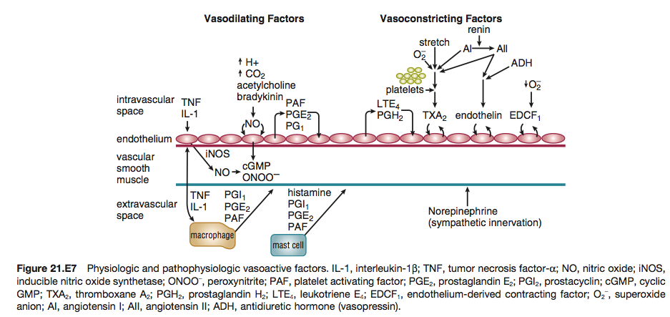

KEY POINT #1: Alterations in microvascular function are effected through pre- and post capillary sphincters that are sensitive to both intrinsic and extrinsic control mechanisms

MALDISTRIBUTION OF FLOW:

- Opening of either non-nutrient capillary sphincters (micro-anatomic shunts) or increased flow to hypometabolic tissues (functional shunts) will result in a suboptimal distribution of substrate supply with increased MVo2
- Failure to dilate sphincters supplying metabolically active tissues may result in ischemia and anaerobic metabolism with lactate production
- Increased precapillary tone as seen with sympathetic stimulation results in increased blood pressure systemically and decreased hydrostatic pressure locally
  - Decreased hydrostatic pressure favors redistribution of volume from the interstitium to the circulation
- Increased post capillary tone (relative to precapillary) results in vascular pooling of blood and loss of fluid to the interstitium (due to increased hydrostatic pressure)

Blood flow to organ systems:
- Brain: autoregulation 50-150mmHg
- Coronary: autoregulation 40-100mmHg
- Mesenteric/renal blood flow: becomes pressure dependent below 60 mm Hg

DURING SHOCK:

- Extrinsic blood flow regulatory mechanisms overwhelm the autoregulatory response of most vascular beds
- Blood flow to the heart and brain are well preserved due to dominant local autoregulation of flow
- Persistence of inadequate matching of tissue substrate demand and delivery after resuscitation of shock can lead to continued ischemia/hypoxia of some tissues

DURING SEPSIS/SPETIC SHOCK:

- Organ blood flow is disturbed at higher MAPs, suggesting a primary defect of microvascular function
- Cerebral and coronary autoregulation remain intact
- Animal models demonstrate that all other vascular beds (splanchnic, renal, skeletal, cutaneous) exhibit decreased vascular resistance, with flow in these beds becoming increasingly dependent on cardiac output
  - This suggests both an active vasodilatory process and failure of extrinsic control of blood flow

KEY POINT # 2: In sepsis, vasodilatation and autoregulatory failure of the microvasculature may be responsible for mismatches of oxygen delivery and demand, resulting in anaerobic glycolysis with lactate production despite increased mixed venous oxygen saturation

Key point #3: During both irreversible hemorrhagic shock and septic shock, peripheral vascular failure results in worsened matching of tissue demand and substrate supply, leading to failure of all organs and death
Among the responsible mechanisms are:
- Tissue acidosis
- Catecholamine depletion and mediator-related vascular resistance to catecholamines
- Release of vasodilating and vasoconstricting arachidonic acid metabolites
- Decreased sympathetic tone due to altered central nervous system perfusion
- Pathologic generation of nitric oxide by vascular smooth muscle cells

KEY POINT # 4: In addition to vasomotor dysfunction, shock is associated with other microvascular pathology:
Including:
- Disruption of endothelial cell barrier integrity
  - During shock, capillary permeability increases, resulting in a loss of plasma proteins into the interstitium
  - Endothelial injury, through the action of neutrophil-generated free radicals and nitric oxide/peroxynitrite generation, may account for this phenomenon
  - The release of vasoactive intermediaries such as histamine, bradykinin, PAF, leukotrienes, and TNFα appear to drive this pathologic process
  - Injury is initiated by leukocyte-endothelial cell interactions via adhesion molecules (integrins, selectins) that allow emigration of neutrophils to the tissues
  - With the loss of plasma proteins, the plasma oncotic pressure drops, interstitial edema develops, and circulating volume falls

- There is also evidence of intravascular hemagglutination of red cells, white cells, and platelets in almost all shock syndromes
- This may be due to primary microvascular clotting leading to microthrombi
- Alternately, clotting may occur as a consequence of primary endothelial damage due to circulating cytokines, free radicals produced by reperfusion and neutrophils, or complement activation

- Decreased deformability of erythrocytes due to membrane free radical injury may also play a role in microcirculatory alterations in hemorrhagic and septic shock

MECHANISMS OF CELLULAR INJURY DURING SHOCK:

The pathogenesis of the cellular dysfunction is a combination:
(1) Ischemia
(2) Inflammation
(3) Free radical injury

- In all forms of shock decreased oxygen delivery to target organs, with resultant cellular ischemia
- At the cellular level lack of oxygen prevents the mitochondrial citric acid cycle from functioning, and pyruvate accumulates
  - Failure of aerobic respiration requires shunting of pyruvate into the lactic acid pathway in order to recycle NAD and allow glycolysis to continue
  - The loss of the aerobic citric acid cycle results in a large decrease in ATP production (net 2 molecules of ATP per molecule of glucose, versus a theoretical net of 38 molecules of ATP per glucose molecule)
  - In addition, shunting to the lactic acid pathway results in the accumulation of hydrogen ions

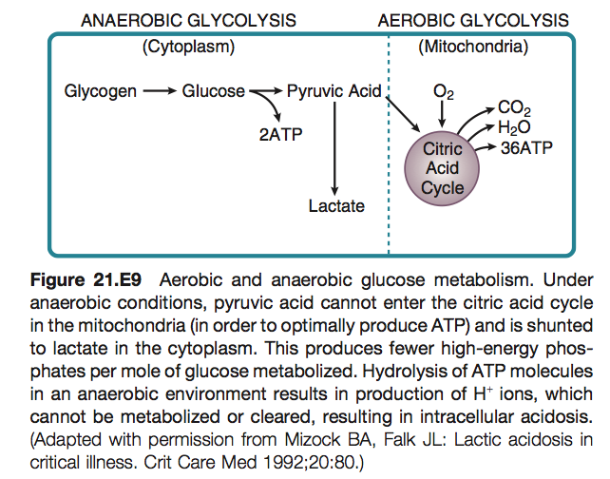
KEY POINT # 5: Thus, loss of perfusion results in a rapid decrease in cellular energy stores, with inadequate ATP regeneration rates. As ATP is the primary source of energy in the cell, energy-dependent cellular systems cease functioning
- This includes:
  - Energy-dependent enzymes
  - Maintenance of transmembrane gradients including electrical potential
  - Mitochondrial function,
  - Carbohydrate metabolism
  - The glycolysis pathway itself, which requires two ATP molecules to prime each glucose molecule at the entry point into the pathway

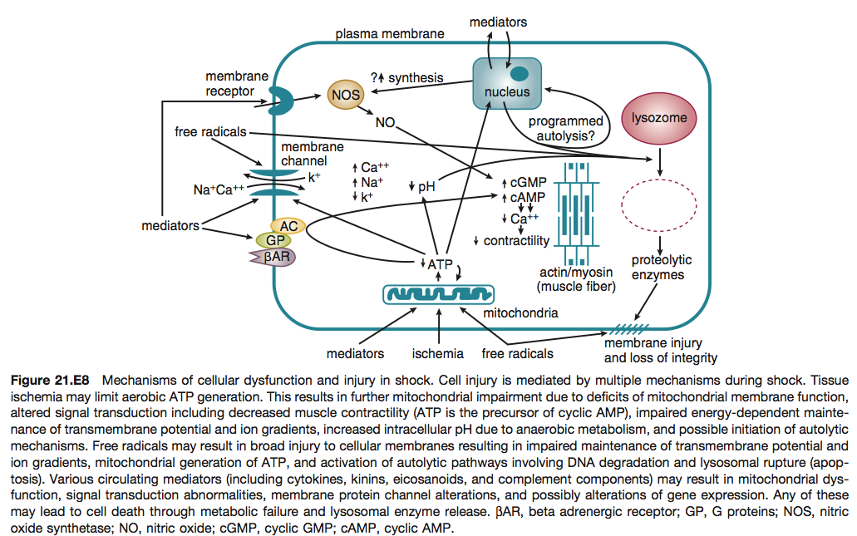

- With the loss of energy-dependent cell maintenance functions, ultrastructural breakdown, including mitochondria, occurs
- The combination of worsening acidosis and loss of energy stores results in a positive feedback loop of worsening shock, organ failure, and eventual death

Inflammation is a major contributor to the development of septic shock and its effects on cellular and organ dysfunction
- Other forms of shock also activate the inflammatory cascade
- The resulting cellular and tissue dysfunction, and thus hypermetabolic state, contributes to organ dysfunction and failure
- The inflammatory cascade in sepsis can be roughly broken down into:
- Initiation
- Transduction
- Release of inflammatory mediators
- Initiation of the inflammatory cascade in sepsis is thought to rely largely on the innate immune response
  - Pathway evolved to recognize non-self molecular signatures, produced by pathogens
    - Pathogen-associated molecular patterns (PAMPs), and they are recognized by a series of receptors known as pattern recognition receptors (PRRs).
  - In addition, signature host proteins can also be released extracellularly in response to cellular damage, and these proteins, also called alarmins, are known as damage- associated molecular patterns (DAMPs), and these too may be recognized by PRRs.
  - Known PRRs include
    - (1) Toll-like receptors (TLRs)
    - (2) C-type lectin receptors (CLRs)
    - (3) Nucleotide oligomerization domain (NOD)-like receptors (NLRs)
    - (4) Retinoic acid inducible gene I-like receptors (RLRs)
  - Different TLR families on the cell surface recognize various bacterial lipoproteins, lipopolysaccharides, or flagellins, with sources that may be bacterial, viral, or protozoan. In contrast, TLR families located in endosomal lumens recognize ssRNA, dsRNA, and modified CpG-DNA, which may be of viral or bacterial origin
  - CLRs are presented on the cell surface, and being lectins, they recognize polysaccharides present in yeast and fungi, mycobacteria, and viruses
  - NLRs and RLRs are intracellular and require that their ligands be present in the cytoplasm of the cell
- Once initiated by recognition of PAMPs or DAMPs, the inflammatory cascade involves a large number of protein, kinase, and second messenger cascades
  - These cascades can lead to the activation of transcription factors or to the post- transcriptional or posttranslational activation of inflammatory mediators
- The NLRs act via formation of a multiprotein complex, termed the inflammasome
  - Central to this cascade are the caspases, a family of cysteine proteases
  - Once activated, caspase 1 in turn activates the inflammatory cytokine IL-1β, allowing its release from the cell
  - Similarly, caspase1 is also responsible for the activation and release of other cytokines, including IL-18
  - In this way, the NLR’s prime function is to regulate inflammatory mediator release through a posttranslation system

- At the center of these cascades is transcriptional regulation of inflammatory cytokines and mediators
- The transcription factor NF-κB sits at the end of many of these cascades and plays a crucial role in the regulation of expression of many of these factors
  - NF-κB is present in an inactive form in the cytoplasm, in complex with repressor proteins. When the repressors, known as IκB proteins, are phosphorylated and subsequently degraded, NF-κB is released and transported into the nucleus where it can act on its target sequences
  - Inflammatory mediators under the control of NF-κB include cytokines such as TNFα, IL-1β and IL-6, enzymes involved in inflammation such as iNOS, and others
- (TNFα) is a 51-kD trimeric peptide produced by macrophages in response to a variety of inflammatory stimuli including bacterial antigens and other cytokines
  - Circulating levels of TNFα are transiently elevated soon after the onset of shock (particularly septic shock)
  - Among the many effects of TNFα are:
    - Release of IL-1β, IL-6, IL-8, PAF, leukotrienes, thromboxanes, and prostaglandins
    - Stimulation of production and activity of polymorphonuclear leukocytes
    - Promotion of immune cell adhesion to endothelium
    - Activation of coagulation and complement systems
    - Direct endothelial cell cytotoxicity
    - Depression of myocardial contractility
    - Fever production by the hypothalamus

Other substances involved in the inflammatory process include IL-1β, which can potentiate the in vivo effects of TNFα; IL-2, which can cause hemodynamic abnormalities in humans; IL-6, which is involved in the acute phase response and has been implicated in septic myocardial depression; interferon-gamma, which promotes the release of other cytokines, enhances adhesion of immune cells, and promotes macrophage activation; IL-10, which is an anti- inflammatory cytokine that limits macrophage generation of pro-inflammatory cytokines; TGFβ, which is another anti- inflammatory cytokine that, in addition to limiting macro- phage pro-inflammatory responses, also blocks the effects of proinflammatory cytokines on target cells; endothelin-1, a cytokine that strongly promotes vasoconstriction, particularly in the renal vascular bed, possibly resulting in renal hypoperfusion and decreased glomerular filtration rate; PAF, which stimulates TNFα, thromboxane, and leukotriene release, stimulates free radical formation, and alters micro- vascular permeability; leukotrienes, which release other arachidonic acid metabolites, alter vascular endothelial permeability, and may mediate vascular and myocardial depression in shock; thromboxanes, which may contribute to altered microvascular vasomotor and permeability function; prostaglandins, which produce fever, induce vasodilatation, and inhibit thrombus formation; and complement fragments C3a and C5a, which constrict vascular smooth muscle, release histamine, and promote chemotaxis.

KEY POINT #6: Both sepsis and trauma are associated with generalized, systemic activation of the inflammatory response. Resulting cell injury and hypermetabolism may culminate in organ failure

NOTE: myocardial depression is characterized by biventricular dilatation and reduced ventricular ejection fractions

Nitric oxide (NO), has a vital role in normal intracellular signal transduction
- Endothelial cells, through a constitutive nitric oxide synthetase, produce picomolar quantities of nitric oxide in response to a number of vasodilatory mediators such as acetylcholine and bradykinin
  - This NO diffuses to adjacent smooth muscle and activates guanylate cyclase to produce cyclic GMP, which affects vascular relaxation
- Nitrovasodilators bypass nitric oxide synthetase to relax smooth muscle directly though the guanylate cyclase pathway
- During septic shock, an inducible NO synthetase capable of producing nanomolar quantities of NO is generated in vascular smooth muscle

- An alternative pathway by which NO may play a role in the cardiovascular pathophysiology of shock and sepsis:

  - Peroxynitrite (ONOO-), a highly reactive oxidant, is produced from the interaction of superoxide (OH-) and nitric oxide (NO-)
  - It is known to react rapidly with proteins, lipids, and DNA during sepsis and shock states
  - Peroxynitrite inactivates mitochondrial aconitase disrupting the Krebs cycle and otherwise interferes with ATP production and utilization
  - It also generates DNA strand breaks leading to poly-ADP ribose synthetase (PARS) activation that may itself have significant pathophysiologic effects
  - Peroxynitrite, like NO, also activates guanylate cyclase in vascular tissues
    - In the periphery, the result may be cellular energetic failure, vascular contractile dysfunction (vasodilation), and reperfusion injury

KEY POINT #7: NO plays a role in shock by upregulation of iNos and through the formation of peroxynitrite

Free radical injury induced by reperfusion or neutrophil activity is another mechanism of organ injury during hemorrhagic and septic shock as well as burns and myocardial infarction
- During tissue ischemia, oxygen deficiency leads to accumulation of ATP degradation products including adenosine, inosine, and hypoxanthine
- With resuscitation and reperfusion of ischemic areas, oxygen drives the generation of superoxide (O2−), the most common precursor of reactive oxidants, by xanthine oxidase, in endothelial cells
- Most of the superoxide is converted, either spontaneously or through superoxide dismutase, to hydrogen peroxide (H2O2−)
  - This further reacts to produce tissue-damaging hydroxyl radicals (or other highly reactive free radicals)
  - These radicals interact with critical cell targets such as the plasma membrane, lipid membranes of organelles, and various enzymes, resulting in cell lysis and tissue injury
- Oxidant activity, directly and through endothelial damage, attracts and activates neutrophils, resulting in amplification of superoxide generation by a neutrophil NADPH-oxidase and in further tissue damage due to neutrophil protease release
- Injured tissue may release xanthine oxidase into the circulation, resulting in systemic microvascular injury

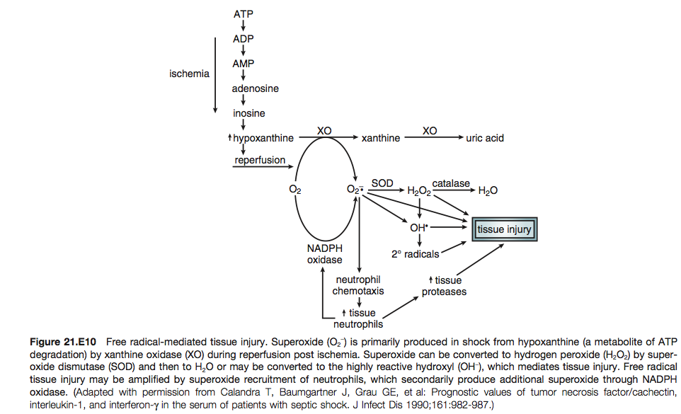

Free radical damage likely also plays a role in tissue damage during sepsis and septic shock
- Following activation by inflammatory mediators and during phagocytosis, polymorphonuclear leukocytes undergo a respiratory burst during which they consume oxygen and generate both superoxide and hydrogen peroxide through a membrane-associated NADPH-oxidase
- Macrophages similarly produce oxygen radicals upon activation
- Activation also enhances adhesion and tissue migration of leukocytes so that both vascular endothelial and parenchymal tissue damage may result

KEY POINT #8: Free radical injury may play an important role in the development of organ failure following shock

The production of adhesion molecules by endothelial cells and inducible nitric oxide synthetase by vascular smooth muscle during shock requires active up-regulation of gene expression
- Both events are thought to be key to the development of MODS following shock in humans

Whatever the initiating event or events, progressive cell metabolic failure occurs.

- Mitochondrial activity continues to deteriorate, subcellular organelles are damaged, and the intracellular (and possibly, systemic) release of lysosome hydrolytic enzymes occurs, accelerating cell death and organ failure

Questions with answers:
- Please list the 2 mechanisms by which intrinsic autoregulation of microvascular tone is thought to occur.

- Nitrovasodilators bypass nitric oxide synthetase to relax smooth muscle directly though the guanylate cyclase pathway. T or F?

- In sepsis, vasodilatation and autoregulatory failure of the microvasculature are responsible for mismatches of oxygen delivery and demand, resulting in anaerobic glycolysis with lactate production despite increased mixed venous oxygen saturation. T or F?

- Please describe the 2 mechanisms by which Nitric Oxide (NO) plays a role in microvascular dysfunction in shock.

- List some of the consequences that occur secondary to ATP depletion at the cellular level

Questions with answers:
- Please list the 2 mechanisms by which intrinsic autoregulation of microvascular tone is thought to occur.
Answer:
Rapid alterations of microvascular tone, that are, mediated though endothelial stretch receptors so that sudden changes in perfusion pressure can be compensated by opposing changes in vascular resistance in order to maintain perfusion
Increases in metabolic activity within tissues and organs are thought to cause local elevation of various metabolites (CO2, H+, etc.), resulting in vasodilation and increased perfusion to match substrate demand

- Nitrovasodilators bypass nitric oxide synthetase to relax smooth muscle directly though the guanylate cyclase pathway. T or F?
Answer: True

- In sepsis, vasodilatation and autoregulatory failure of the microvasculature are responsible for mismatches of oxygen delivery and demand, resulting in anaerobic glycolysis with lactate production despite increased mixed venous oxygen saturation. T or F?
Answer: True

- Please describe the 2 mechanisms by which Nitric Oxide (NO) plays a role in microvascular dysfunction in shock.
Answer:
  - Upregulation of iNos NO diffuses to adjacent smooth muscle and activates guanylate cyclase to produce cyclic GMP, which affects vascular relaxation
  - Formation of peroxynitrite

- List some of the consequences that occur secondary to ATP depletion at the cellular level
Answer: Dysfunction of:
  - Energy-dependent enzymes
  - Maintenance of transmembrane gradients including electrical potential
  - Mitochondrial function
  - Carbohydrate metabolism
  - The glycolysis pathway itself, which requires two ATP molecules to prime each glucose molecule at the entry point into the pathway

