Journal Feline Medicine and Surgery 2013 – Lower respiratory tract endoscopy in the cat – Diagnostic approach to bronchial disease

Key points:
- Endoscopy of the feline airway is a valuable tool for aiding in diagnosis of feline respiratory disease. Bronchoscope is primarily used for airway-centered disease. Combing with BAL is superior to blind BAL due to the added benefit of visualization of the airway. Felines are especially at risk for complications. Those in severe respiratory distress are not ideal candicates for bronchoscopy without stabilization. Prevention of bronchoconstriction with pretreatment with terbutaline is recommended. Oxygen must be supplemented through a tracheal catheter, or in between endoscopic evaluations. Knowledge of the anatomy is crucial.
- Cytology and histopathology are needed for diagnosis as the gross appearance is not sufficient for definitive diagnosis. Fluid analysis could reveal suppurative, eosinophilic pyogranulomatous, hemorrhagic, or neoplastic inflammation that may aid in diagnosis. Culture should be submitted from a pooled sample. Common lower airway pathogens include: e. coli, Bordetella, Pasteurella, Staph, Strep, Pseudomonas, and Mycoplasma. Cytology alone may not identify bacterial cause. Mycoplasma requires specific medium or testing by PCR based method.

Questions:

1. You are performing an endoscopy on several cats with signs of respiratory disease. Cause you’re that good and you like to make a lot of money. What is your observation for the next several images (individually)?

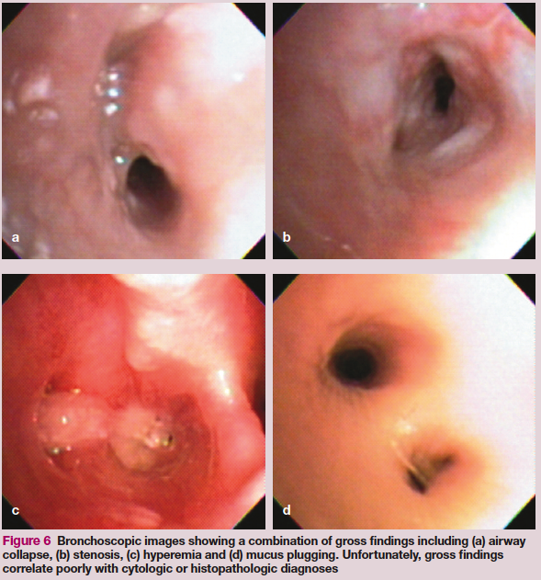

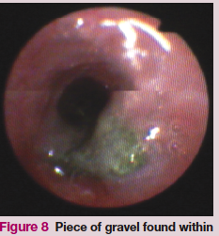
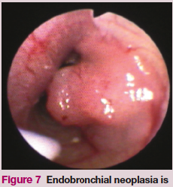

2. You perform a BAL on the cat in figure C above. Here is your cytology. What is your conclusion?
A: This cytology is consistent with suppurative inflammation. A causative agent could be Mycoplasma.
B: This cytology is consistent with suppurative septic inflammation. Bacterial pneumonia is suspected.
C: This is consistent with pyogranulomatous inflammation and is due to a chronic disease such as Histoplasma.
D: This is hemorrhagic inflammation, and causes such as heartworm should be considered.

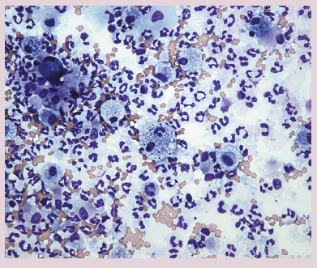

3. This cytology was collected from the cat in figure D. What is your conclusion?
A: Eosinophils predominate, highly suggestive for infection with Aelurostrongylus.
B: Eosinphils with corresponding clinical signs of cough, wheeze, is suggestive of feline bronchial disease.
C: A fecal floatation and heartworm antigen test should be performed as the only additional diagnostics.
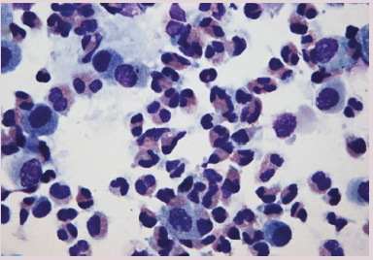
D: Eosinophils of up to 30% can be considered normal and nonspecific.

4.

2.

Summary:

Indications: Laryngoscopy is indicated for cats with upper airway obstruction clinical signs, stertor, stridor, gagging, voice change, inspiratory noise/effort. Tracheoscopy may be required as well. Radiographs may be helpful in determining which region needs scoping. Bronchoscopy indications: acute or chronic coughing, airway collapse, bronchiectasis, foreign body aspiration, tachypnea or respiratory difficulty attributed ot the lung parenchyma. Bronchoscopy with BAL is indicated for airway-oriented disease, with limited usefulness in interstitial lung disease due to a lack of cellular infiltration into the airways. Brochoscopy with BAL is superior to blind BAL due to the ability to visualize the airway.
Pre-diagnostics: Thoracic +/- cervical radiographs, SPO2 measurement (should exceed 95%, less than that should consider ABG evaluation), evaluation of the resp rate and effort.
Terbutalline administered before the procedure, immediately before BAL reduces risk of life threatening bronchoconstriction. Might be more effective than albuterol due to impaired albuterol delivery into the constricted airways. It is uncertain if inhaled medications will alter airway sampling.
Be prepared for a tracheostomy if needed with upper airway obstructions.
Evaluate the larynx and laryngeal function immediately in induction to evaluate for disease or obstruction. This should be done under a light plane of anesthesia to avoid falsely affecting laygneal function. Evaluate the laryngeal function in conjunction with the phase of respiratory cycle, as paradoxical movement of the arytenoids can be mistaken for normal movement. Abduction should correspond with inspiration.
Collect several samples form any lesion to ensure diagnostic quality. Some disease can be detected on cytology of BAL or brush samples including lymphoma and carcinomas.
Use care with the use of spring loaded mouth gags – this has been associated with cortical blindness in cats due to compression of blood vessels.
Maintain oxygenation by: 1. Placing a 16 gauge catheter down trachea and attach to a jet ventilator. 2. Pass an open ended red rubber to the mid thoracic trachea and attach to low flow O2 (<1 L/min), or 3. An endotracheal tube can be inserted for stabilization and removed for endoscopic evaluation. Pre-O2 prior to or in between procedures. Apply topical lidocaine to the arytenoids.
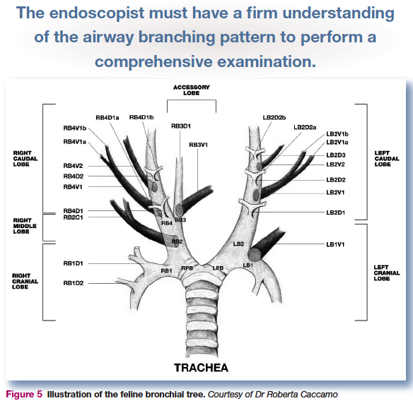
BAL: Prior to performing BAL, remove and clean/flush endoscope, then reintroduce trying to minimize oropharyhgeal contamination. Gently advance distal tip of the flexible endoscope deep into the terminal airways. Instill 3-5mls of warm sterile saline into each lavage site (up to 10-20ml/cat). Agitate the tip of the catheter after instillation and suction.
Foreign body removal: systematically eval all branches for foreign material, mucoid or purulent material, etc. Use the endoscope tools to facilitate removal.
Post-op: reintubate and oxygenate
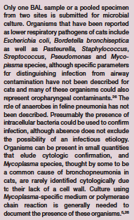
Complications: airway obstruction. Can be fatal. Endoscopy should not be undertaken in some patients if the risk is too great or the patient too unstable.

