Oura, T., Rozanski, E. A., Buckley, G., & Bedenice, D. (2012). Low tidal volume ventilation in healthy dogs. Journal of Veterinary Emergency and Critical Care (San Antonio, Tex. : 2001), 22(3), 368–71.
- In human medicine, low VT (6 ml/kg) = preferred technique in patients with ARDS; associated with improved survival rate.
Specific guidelines in human
medicine from ARDSnet include trying to limit plateau
pressure to less than 30 cm H2O in patients with ARDS. Strategies to minimize lung damage associated with IPPV in dogs have not been evaluated to date.
- Normal VT in dogs = 10-15 ml/kg
- Predictable effects of lower VT include CO2 retention with subsequent respiratory acidosis and hypoxemia. A reduction in VT will also increase the patient’s relative dead space ventilation (V_{DS}); VT = V_{A}+V_{DS}
  - Hypercarbia is a predictable biochemical change associated with low VT ventilation, and is either ignored if possible (eg, permissive hypercapnea), treated by small increases in the VT if the plateau pressure is low enough, or treated with sodium bicarbonate to increase the pH to a more physiological range (?)
- V_{DS} = V_{anatomic dead space} + V_{alveolar dead space}
  - Can be calculated with the Bohr equation: $\frac{Vd}{Vt}$=$\frac{PaCO2-PeCO2}{PaCO2}$
- Anatomic dead space is fixed; approximately 1/3 of normal VT. When decreasing VT, even if maintaining constant minute ventilation (MV = VT * RR), there is an increased proportion of each breath not available for gas exchange.
- The aim of the study what to evaluate the effect of varying the VT in healthy ventilated dogs.
- Dogs (5 healthy Beagle dogs) were anesthetised and randomly mechanically ventilated with VT of 6, 8, 10, 12, and 15 mL/kg while maintaining a constant minute volume (by increasing the RR). They evaluated ABG, static compliance; airway pressures, SpO2 and they calculated V_{DS} for every VT (6, 8, 10, 12, and 15 ml/kg).
- Results:
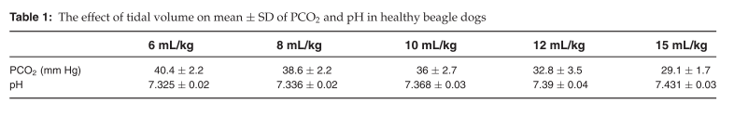
- Strong correlation between VT and
PaCO2 (r = –0.87) and VT and pH (r = 0.83).
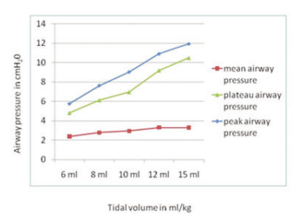
- Static compliance increased
significantly from 21.3 cmH2O at 6 mL/kg VT to 24.5 mL/cm H2O at 15 mL/kg. Neither calculated dead space fraction nor pulse oximetry was significantly affected by changes in VT.
- Conclusion:
  - Low VT (6 mL/kg) was well tolerated in healthy dogs, and there was no evidence of clinically significant acidosis due to CO2 retention or hypoxemia.

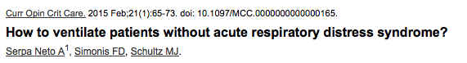
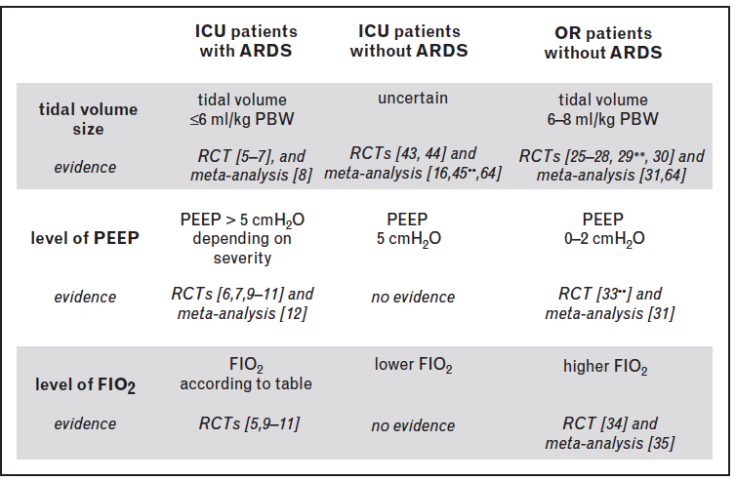

Questions
1. What is the normal VT in healthy dogs?
A. 6-8 ml/kg
B. 8-10 ml/kg
C. 10-15 ml/kg
D. 15-10 ml/kg

2. Name the predictable effect of low VT on the acid-base status.
3. Name 3 strategies to correct this acid-base disturbance.

4. True or False: In this study, increasing VT from 6 to 15 ml/kg was associated with an increase in airway pressures.

5. What is the explanation proposed for the change in airway pressures associated with increased VT?

Questions & Answers
1. What is the normal VT in healthy dogs?
C. 10-15 ml/kg

2. Name the predictable effect of low VT on the acid-base status.
Respiratory acidosis

3. Name 3 strategies to correct this acid-base disturbance.
1. Small increased in VT (if Pplat is low enough)
2. Sodium bicarbonate (?)
3.Do nothing: permissive hypercapnea

4. In this study, increasing VT from 6 to 15 ml/kg was associated with an increase in airway pressures. True.

5. What is the explanation proposed for the change in airway pressures associated with increased VT? The most likely explanation is recruitment of previously atelectatic lung lobes.

Stillion, J. R., & Letendre, J.-A. (2015). A clinical review of the pathophysiology, diagnosis, and treatment of pyothorax in dogs and cats. Journal of Veterinary Emergency and Critical Care (San Antonio, Tex. : 2001).
Questions

1. Based on current evidence, which route of infection seems to be the most common in cats with pyothorax?
A. Bite wound
B. Foreign body migration
C. Parapneumonic spread
D. Previous thoracocentesis

2. True or False: As up to 50% of cats diagnosed with pyothorax present with a normal or low body temperature.

3. True or False: Bigger is better when it comes to thoracostomy tubes for the management of pyothorax.

4. Regarding thoracic lavage, recovery of ____ or more of the volume infused is expected.
A. 25%
B. 50%
C. 75%
D. 100%

5. Please choose the correct statement:
A. Intrapleural administration of streptokinase has been shown to improve outcome in people treated for pyothorax.
B. Addition of heparin to lavage fluid has been shown to improve long-term survival in dogs treated for pyothorax.
C. Intrapleural administration of tissue plasminogen activator has been shown to improve fluid drainage.
D. Intrapleural administration of tissue plasminogen activator and DNAse has been shown to reduce the need for surgery.

Questions & Answers

1. Based on current evidence, which route of infection seems to be the most common in cats with pyothorax?
C. Parapneumonic spread

2. As up to 50% of cats diagnosed with pyothorax present with a normal or low body temperature. True.

3. Bigger is better when it comes to thoracostomy tubes for the management of pyothorax. False

4. Regarding thoracic lavage, recovery of ____ or more of the volume infused is expected.
C. 75%

5. Please choose the correct statement:
D. Intrapleural administration of tissue plasminogen activator and DNAse has been shown to reduce the need for surgery.

