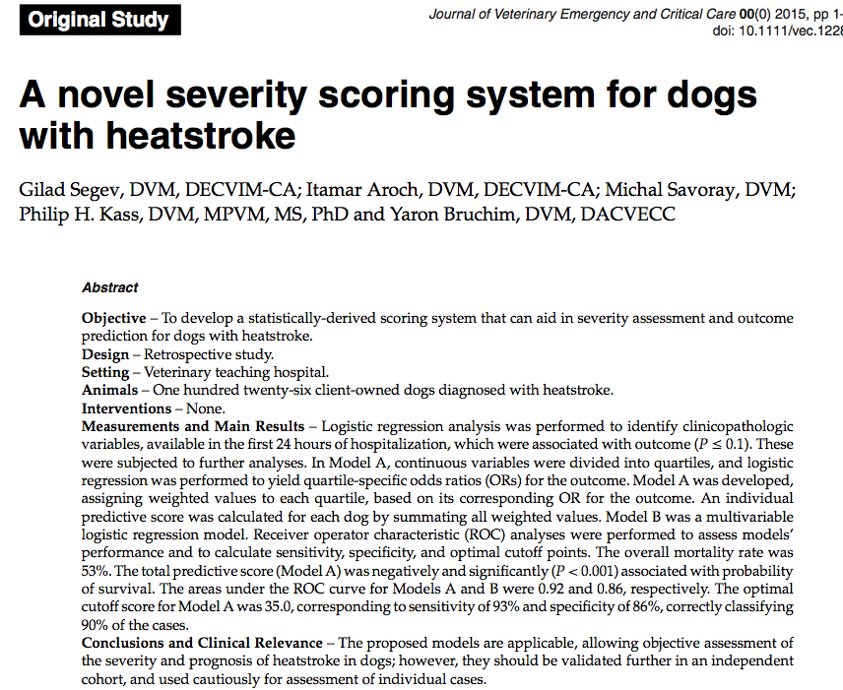

Summary:

Intro:

Heatstroke in dogs is a severe syndrome, characterized by core body temperatures >41°C (105.8°F) and central nervous system depression or seizures.
Heatstroke carries a guarded to poor prognosis, with reported mortality rates in dogs of 50% and 64%.
Several risk factors for death have been identified in dogs with heatstroke, including obesity, prolonged (>90 min) duration from the occurrence of heat insult to the provision of veterinary care, hypoglycemia (<2.6 mmol/L [47 mg/dL]), azotemia (creatinine concentration >132.6 umol/L [1.5 mg/dL]) at 24 hours of hospitalization, and the occurrence of DIC, AKI, ventricular arrhythmias, seizures, or altered mental status.
Peripheral nucleated red blood cell (nRBC) concentrations in dogs with heatstroke have been reported to be higher in nonsurvivors than in survivors, and the total nRBC count was associated with outcome.
The aim of this study was to develop a scoring system for dogs with heatstroke, which may be useful for assessing disease severity and prognosis.
Methods:
Stage-I analysis: Selection of variables
The association of continuous and categorical variables with the outcome was tested using logistic regression analysis and chi-square tests, respectively.
Stage-II analysis: Generation of weighting factors
For Model A, continuous variables, selected in Stage-I analysis, were divided into those in which results were within or out of (ie, decreased below or increased above) their corresponding reference intervals (RIs). The abnormal range of each selected variable (ie, the range of the results that were above RI) was partitioned into quartiles, which were then treated as categorical variables.
Stage-III analysis: Construction of the model
A predictive model was generated, based on the above- identified variables.
The weighted values for each quartile was assigned a numerical value, equal to the exact OR determined in Stage-II analysis.
Assessment of the models
For Model A, in each dog, the actual clinical value of each variable was compared to the quartile ranges set in Stage-II analysis, for assignment of the weighted value for that particular variable. The final individual predictive score of each dog was calculated as the sum of all the weighted values included in the model. The relationship of this final predictive score with the outcome was examined using logistic regression analysis. For Model B, the probability of survival was calculated based on the multivariate model.
Receiver operating characteristic (ROC) analysis was performed to determine the performance of the final predictive score and the multivariate analysis for predicting the outcome at different cutoff points, with corresponding sensitivity and specificity.
Results:

- Brachycephalic dogs were significantly overrepresented in the study population
- There was no difference in the mortality rate between brachycephalic and nonbrachycephalic dogs (47% vs. 55%, respectively)
- There was no difference in the mortality rate between dogs with environmental or exertional heatstroke (54% and 52% respectively)
- The median rectal temperature at presentation (n = 119) was 39.3°C (range, 35.0–43.0°C), with no difference between survivors and nonsurvivors
- The median heart rate at presentation was 140/min (range, 75–250/min), and was significantly higher in nonsurvivors
- The overall mortality rate was 53%
- Risk factors (for death) identified in Stage-I analysis included tachycardia on initial presentation to the HUVTH, prolonged PT or aPTT, hypoglycemia (defined as a blood glucose concen- tration <66 mg/dL (<3.66 mmol/L), mental status score, increased body condition score, and presence of acute collapse, shock, seizures, petechiae, DIC, AKI, or respiratory abnormalities
- The median final predictive score, calculated by sum- mating the weighted value for each category in Model A, was 36.0 (range, 13.0–79.0). Higher scores were associated with decreased probability of survival
- The ROC curve area under the curve (AUC) of the final predictive score as a predictor of the outcome was 0.92 with an optimal cutoff point of 35.0, corresponding to sensitivity and specificity of 93% and 86%, respectively, and correctly classified 90% of the cases
- The ROC curve AUC of Model B as a predictor of the outcome was 0.86. Optimal cutoff probability was 0.45, corresponding to a sensitivity and specificity of 83% and 81%, respectively, and correctly classifying 82% of the dogs.

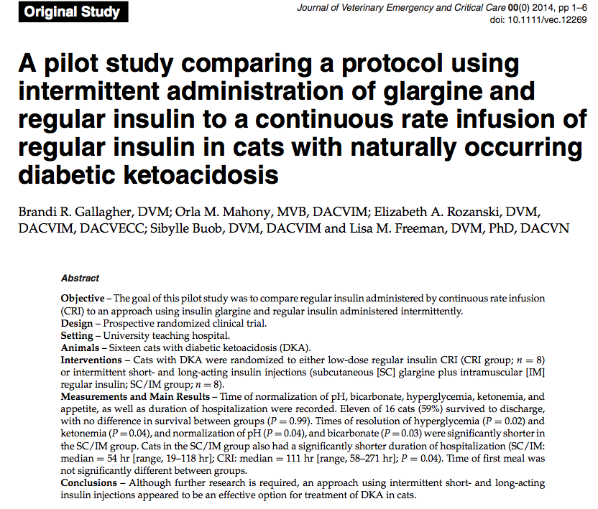

Key points:

- In dogs, one study reported their results comparing regular and lispro insulins administered by CRI for the treatment of DKA.14 In that study, the median time to resolution of biochemical parameters associated with DKA was significantly shorter in dogs in the lispro group compared to those in the regular insulin group. Finally, a recently published study evaluated the effects of intramuscular (IM) glargine administration in cats with DKA (with or without SC glargine).15 In that study, all 15 cats survived and were discharged from the hospital

- Cats in the regular insulin CRI group followed the normal dosing (1U/kg/day) as a sliding scale

- Cats in the SC/IM group received glargine at a dose of 0.25 U/kg SC every 12 hr. In addition, these cats re- ceived an additional 1 unit of regular insulin IM up to every 6 hours if the blood glucose was > 14 mmol/L [>250 mg/dL] at those time points.
- Insulin was not administered at other time points regardless of blood glucose concentration. If blood glucose was below 14 mmol/L [250 mg/dL] at the time of the evaluations performed every 2–4 hr, dextrose was added to the IV fluids (2.5% dextrose if blood glucose was 4.4– 13.8 mmol/L [80–249 mg/dL] and 5.0% dextrose plus a bolus of 50% dextrose [0.5 mL/kg body weight] for glucose <4.4 mmol/L [80 mg/dL]
- The primary endpoint of this study was established as the time until normalization of pH, which was defined as venous pH = 7.35–7.44.
- Secondary endpoints included duration of hospitalization, time until the cat’s first meal (ie, any oral intake of food), time until resolution of hyperglycemia (defined as glucose < 14 mmol/L [<250 mg/dL]) and ketonemia (defined as ketones <2.55 mmol/L on the portable ketometer),18 and time to normalization of bicarbonate (defined as bicarbonate = 18–24 mmol/L).

- Results:
  - Eleven of the 16 cats (69%) survived to discharge
  - Median time to death was 24 hours
  - No difference in survival between groups
  - There were no significant differences between groups for the number of cats that achieved each endpoint, but there were significantly shorter times to normalization of pH and bicarbonate, as well as times to resolution of hyperglycemia and ketonemia in the SC/IM group
  - Time of first meal was not significantly different between groups.
  - Cats in the SC/IM group also had a significantly shorter duration of hospitalization

