Lidocaine IRI Madden

Lidocaine is theorized to ameliorate the negative effects of ROS, prevent tissue lipid peroxidation, and subsequent end organ damage by the following mechanisms:
- Na⁺/Ca²⁺ exchange inhibition
- (2) ROS scavenging of both superoxide and hydroxyl radical resulting in cytoprotection
- (3) Prevention of deleterious leukocyte–endothelial cell interactions

Lidocaine and Na1/Ca21 Exchange Inhibition:
- Various models of myocardial reperfusion injury have shown that pretreatment of ischemic tissues with lidocaine and other Na⁺/Ca²⁺ exchange inhibitors reduces the formation of ventricular dysrhythmias and infarct size
  - It was theorized that decreased Na⁺ and Ca²⁺ accumulation in cardiac tissue was at least, in part, responsible for these beneficial effects
- In various rat models of myocardial ischemia/ reperfusion, pre-ischemic treatment with lidocaine resulted in
  - (1) Enhancement of post-ischemic contractile recovery
  - (2) Decrease in ventricular dysrhythmias
  - (3) Suppression of tissue Na⁺, K⁺, Ca²⁺, and Mg²⁺ accumulation
  - (4) Attenuation of the release of creatine kinase and ATP metabolites in a dose dependent manner.
- Lidocaine has also been shown to protect neuronal tissue from ischemic damage by similar mechanisms
- Current theories of brain ischemia/reperfusion injury include release of intracellular Ca²⁺ and neurotoxic chemicals such as glutamate, which then promote ROS generation from neuronal tissue
- Increased intracellular Ca²⁺ in ischemic neuronal tissue is postulated to activate phospholipases, which leads to the dissolution of lipid membranes and the subsequent release of free fatty acids and arachidonic acid (AA) metabolites. These AA metabolites (prostaglandins, leukotrienes, thromboxanes, PAF) and more ROS generation lead to increased vascular permeability, PMN activation, and initiate local vascular endothelial injury.
  - Rat models of brain ischemia, lidocaine was shown to inhibit increases of cytosolic Ca²⁺ and intracellular glutamate
- Also since cytosolic Ca²⁺ has been theorized to be necessary as a co-factor for the conversion of XD to XO it is possible that the phenomenon of Ca²⁺ exchange inhibition by lidocaine causes a decrease in the formation of superoxide radicals through the preservation of myocardial and neuronal XD

Key Point: Therefore, the use of lidocaine as a stabilizing treatment during shock may prevent injury to the heart and brain during the reperfusion period, through the preservation of XD and a concomitant decrease in superoxide radical formation

ROS and lidocaine-induced cytoprotection:
- Lidocaine may be involved in mechanisms of reperfusion injury through the blocking of Na⁺ channels and subsequent reduction of superoxide radical formation
- IV bolus infusion of 2.2 mg/kg lidocaine, followed by constant rate infusion of 66 mg/ kg/min to 5 dogs before decompression in a similar experimental GDV model reduced gastric and cardiac ultrastructural cell damage by 40%
- Since it is postulated that ROS formation and PMN infiltration are responsible for the myocardial injury and subsequent dysrhythmias that occur in GDV patients, it is possible that administration of lidocaine before reperfusion ameliorates this injury in both experimental and clinical settings
- Recent experiments have demonstrated that lidocaine is an effective hydroxyl radical scavenger, while also decreasing superoxide release from granulocytes
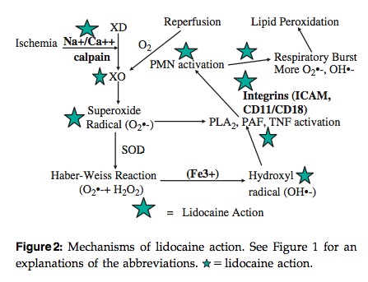

Key Point: lidocaine protects organs from ROS injury via scavenging of the hydroxyl radical and decreasing production of superoxide from granulocytes of certain species

Lidocaine and endothelial dysfunction:
- Once ROS have been generated, their presence in ischemic tissues begins a vicious cycle of PMN activation and expression of PMN chemoattractants and inflammatory cytokines leading to even more neutrophil infiltration of ischemic tissues
- Accumulation of activated PMNs in ischemic tissue leads to physical disruption of the endothelial and epithelial barriers, widening of endothelial and epithelial intracellular tight junctions, increase in tissue permeability (caused by lipid peroxidation), and cell death
- Lidocaine has been shown to reduce the release of these inflammatory cytokines (PAF, PLA2, IL-6, IL-8) from macrophages and PMNs
- It has also been shown to reduce PMN adhesion to endothelial surfaces in vivo, and inhibits upregulation of PMN CD11/CD18 in vitro
- With regard to sepsis, lidocaine significantly inhibited leukocyte–endothelial cell adhesion and macromolecular leakage in rat postcapillary venules, suggesting that the drug may have a role in preventing endothelial damage in sepsis
- In order to ascertain the role of lidocaine as an inhibitor of PLA2 in acute respiratory distress syndrome, the drug was administered to rabbits before induction of acute lung injury.
  - Pretreatment with lidocaine attenuated the amount of his- topathologic lung injury, the amount of PMN accumulation, and decreased the peripheral neutrophil and platelet counts.

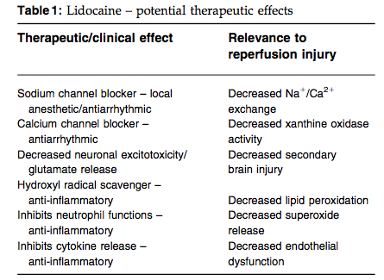

Summary:
Intravenous lidocaine, if administered before reperfusion, prevents Na⁺/Ca²⁺ accumulation decreases neuronal excitotoxicity, decreases the formation of ROS (superoxide, hydroxyl radical), and prevents ROS-induced PMN infiltration, cytokine induced PMN adhesion, and endothelial dysfunction in both in vivo and in vitro models

Questions:

1. Please list the 3 mechanisms by which lidocaine is theorized to ameliorate the negative effects of ROS, prevent tissue lipid peroxidation, and subsequent end organ damage

2. Current theories of brain ischemia/reperfusion injury include release of intracellular ____________________and neurotoxic chemicals such as____________________, which then promote ROS generation from neuronal tissue

3. Cytosolic Ca²⁺ has been theorized to be necessary as a co-factor for the conversion of XD to XO, thus it is possible that the phenomenon of Ca²⁺ exchange inhibition by lidocaine causes a decrease in the formation of superoxide radicals through the preservation of myocardial and neuronal XD. T or F?

4. Lidocaine protects organs from ROS injury via scavenging of ____________________and decreasing production of ___________________ from granulocytes.

5. Complete the table:

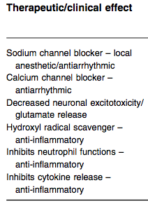
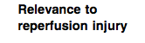

Questions with answers:

1. Please list the 3 mechanisms by which lidocaine is theorized to ameliorate the negative effects of ROS, prevent tissue lipid peroxidation, and subsequent end organ damage

Answer:
- Na⁺/Ca²⁺ exchange inhibition
- (2) ROS scavenging of both superoxide and hydroxyl radical resulting in cytoprotection
- (3) Prevention of deleterious leukocyte–endothelial cell interactions

2. Current theories of brain ischemia/reperfusion injury include release of intracellular ____________________and neurotoxic chemicals such as____________________, which then promote ROS generation from neuronal tissue

Answer:
- Ca²⁺
- Glutamate

3. Cytosolic Ca²⁺ has been theorized to be necessary as a co-factor for the conversion of XD to XO, thus it is possible that the phenomenon of Ca²⁺ exchange inhibition by lidocaine causes a decrease in the formation of superoxide radicals through the preservation of myocardial and neuronal XD. T or F?

Answer: True

4. Lidocaine protects organs from ROS injury via scavenging of ____________________and decreasing production of ___________________ from granulocytes.
Answers:
- Hydroxyl radical
- Superoxide

5. Complete the table:
