Cricothyrotomy

Main Points
- In humans cricothyrotomy (CTT) is the method of choice during cannot intubate cannot ventilate situations. Typically tracheostomy is performed in dogs and cats.

- There are no major vessels and nerves in the area of the cricothyroid membrane. The right and left cricothyroid arteries transverse the cranial part of the membrane, and thus it is recommended to incise the caudal part of the cricothyroid membrane close to the cranial border of the cricoid cartilage, which is also away from the vocal cords.

- CTT can be performed by surgical or needle technique

Needle CTT
- Technique
  - The indentation between the thyroid and cricoid cartilages is palpated with the index finger of the non-dominant hand. A kinkresistant CTT tube, or a large-bore iv catheter may be used to penetrate the subcutis and the cricothyroid membrane after skin incision.
  - Confirm intratracheal position - when air can easily be drawn through the needle with a syringe, capnography can also be used.
  - Secure CTT tube in place (sutures, staples)
- In needle CTT, small diameter uncuffed tubes are used; thus, during ventilation, thoracic wall movement cannot be seen and the effect of ventilation must be monitored by haemoglobin saturation
- Needle CTT is a fast procedure giving access to tracheal lumen in one to two minutes.

Surgical CTT
- Technique
- Equipment needed: scalpel, curved haemostat, tracheal tube
- One step (stab incision through both skin and cricothyroid membrane is made in one movement) or two step procedure
    - Two-step procedure may provide a more controlled perforation of the cricothyroid membrane and may create a better seal around the CTT tube
- May take slightly longer to perform but has the advantage, that it allows a larger diameter CTT tube or a regular endotracheal tube to be passed

- Less complications with CTT over TT
  - Pneumothorax and mediastinal damage less likely to occur – as crycothyroid ligament is more cranial than intertracheal ligaments
  - Damage to esophagus is more likely during TT as there is no cartilage in dorsal part of trachea. In contrast the wide and solid cricoid cartilage located dorsally.
  - Bleeding after penetrating the cricothyroid membrane is minimal due to the fibrous nature of the membrane

- Data regarding the use of CTT in live cats are not available. The data on feline cadavers seem promising, but further studies are needed.
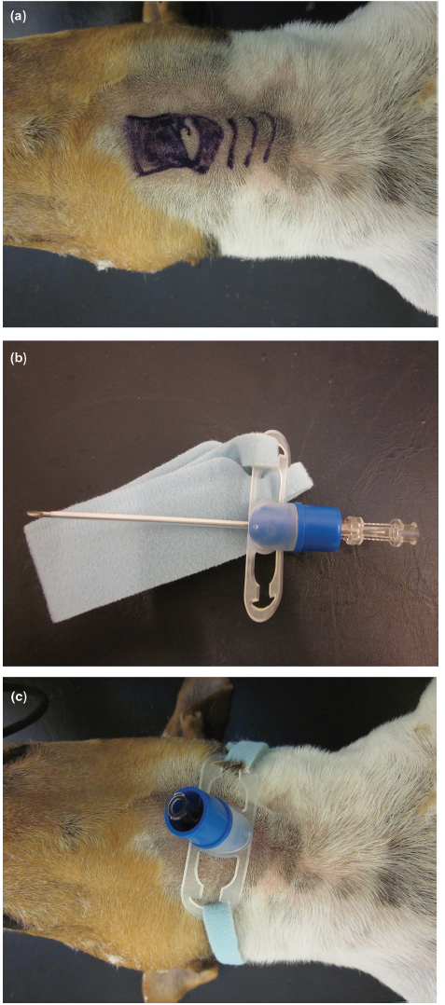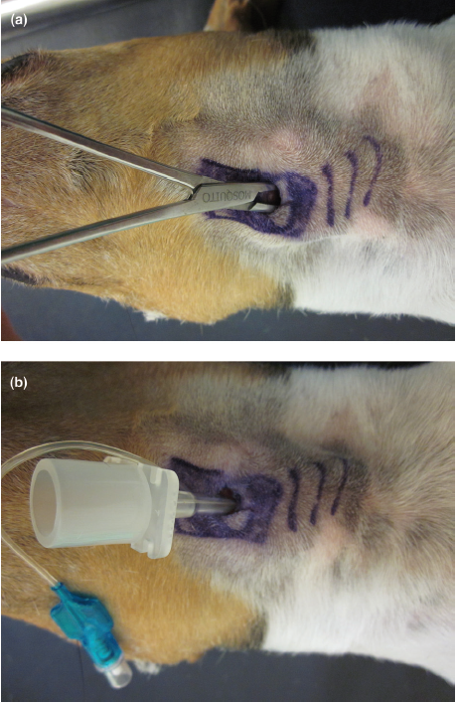
Questions
- Fill in the blanks. The arteries transverse the _____________ (cranial/caudal) part of the cricothyroid membrane, and thus it is recommended to incise the _______________ (cranial/caudal) part of the cricothyroid membrane close to the ___________ (cranial/caudal) border of the cricoid cartilage.

- True or False. An endotracheal tube approximately 3/4 the size for endotracheal intubation seems appropriate for surgical CTT intubation.

- Why is damage to the esophagus more likely during TT?

- True or False. Complication rates are greater during surgical CTT compared to needle CTT.

Questions and Answers
- The right and left cricothyroid arteries transverse the cranial part of the membrane, and thus it is recommended to incise the caudal part of the cricothyroid membrane close to the cranial border of the cricoid cartilage, which is also away from the vocal cords

- True or False. An endotracheal tube approximately 3/4 the size for endotracheal intubation seems appropriate for surgical CTT intubation.
An endotracheal tube approximately half the size for endotracheal intubation seems appropriate for surgical CTT intubation.

- Why is damage to the esophagus more likely during TT?
Damage to esophagus is more likely during TT as there is no cartilage in dorsal part of trachea. In contrast the wide and solid cricoid cartilage located dorsally.

- True or False. Complication rates are greater during surgical CTT compared to needle CTT.
False. No studies to investigate this.

Laryngeal Paralysis in Dogs

Main Points
- Disease is usually an acquired condition and affects older dogs. It is usually progressive. Clinical signs include voice change, inspiratory stridor and dyspnea. Diagnosed by transoral laryngeal exam under light plane of anesthesia. Most common surgical procedure: unilateral arytenoid lateralization. Increased risk of aspiration pneumonia.
- Dysfunction of caudal laryngeal nerves, terminations of the recurrent laryngeal nerves. Results in loss of arytenoid abduction by the cricoarytenoideus dorsalis muscle and inability to constrict glottis or relax vocal folds.
- Acquired form results from trauma or iatrogenic injury to recurrent larungeal nerves during thyroidectomy, compression of nerves by mediastinal or cervical mass, or idiopathic (part of general peripheral neuropathy). Hypothyroidism and myasthenia gravis have also been reported in dogs with laryngeal paralysis.

Questions
- True or False. Medical treatment for hypothyroidism or laryngeal paralysis can restore laryngeal nerve function.

- What is the most common complication of unilateral arytenoid lateralization
  - Aspiration pneumonia
  - Suture failure
  - Return of clinical signs
  - Sudden death

- True or False. The use of metoclopramide post operatively reduces the risk of aspiration pneumonia.

- MST after UAL is typically
  - <1 year
  - 1-5 years
  - >5 years

- ______% of dogs have improvement of respiratory signs and improved exercise tolerance post operatively
  - 50%
  - 30%
  - 90%
  - 70%

- Which is an early sign of laryngeal paralysis?
  - Syncope
  - Cardiac murmur
  - Voice change
  - Cyanosis

Questions and Answers
- True or False. Medical treatment for hypothyroidism or laryngeal paralysis can restore laryngeal nerve function.

- What is the most common complication of unilateral arytenoid lateralization
  - Aspiration pneumonia
  - Suture failure
  - Return of clinical signs
  - Sudden death

- True or False. The use of metoclopramide post operatively reduces the risk of aspiration pneumonia.

- MST after UAL is typically
  - <1 year
  - 1-5 years
  - >5 years

- ______% of dogs have improvement of respiratory signs and improved exercise tolerance post operatively
  - 50%
  - 30%
  - 90%
  - 70%

- Which is an early sign of laryngeal paralysis?
  - Syncope
  - Cardiac murmur
  - Voice change
  - Cyanosis

