- Skeletal muscle, brain, heart, skin, gastrointestinal, and red blood cells produce the most lactate under normal conditions

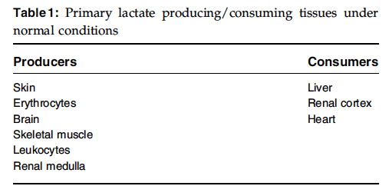

- The liver and kidneys are responsible for the majority of lactate clearance, metabolizing 50% and 20–30%, of the lactate produced.

- Lactate is freely filtered by the glomerulus but is almost completely reabsorbed in the proximal tubule.
- Lactate metabolism in the cortex of the kidney continues until there is a 90% decrease in renal blood flow at which time renal lactate production occurs.

In contrast to the liver, acidosis increases renal lactate clearance.
- Renal lactate clearance increases from16% at a pH of 7.45 to 44% at a pH of 6.75.
- The increased renal lactate metabolism is accomplished by increased production of glucose from lactate via gluconeogenesis.

- Lactate that is produced by cellular metabolism is the levorotatory isomer, also known as L-lactate.
- The D-lactate isomer is formed by bacterial glucose metabolism.

Lactated Ringer’s solution is a balanced electrolyte solution containing lactate as a buffer.
- The lactate in this fluid is metabolized to glucose or oxidized to water and CO2.
- Both of these processes result in the consumption of hydrogen ions and an overall alkalinizing effect.

Lactic acidosis has commonly been divided into 2 categories, Types A and B
- Type A lactic acidosis is most common and consists of increased lactate production due to tissue hypoxia with normal mitochondrial function.
- Tissue hypoperfusion is the most common cause of Type A lactic acidosis
- Type B lactic acidosis results under conditions of adequate oxygen delivery but altered mitochondrial function or carbohydrate metabolism
- Subdivision B1 consists of disease processes believed to be creating lactic acidosis not due to hypoperfusion but possibly due to decreased lactate clearance.
- Subdivision B2 consists of drugs/toxins that interfere with oxidative phosphorylation.
- Subdivision B3 consists of mitochondrial defects
- Conditions associated with type B acidosis: diabetes mellitus, liver disease, neoplasia, and sepsis

- Type-B lactate elevation in dogs has been documented as the result of activated charcoal administration
- The increase in lactate was most likely due to the hepatic metabolism of propylene glycol to pyruvate and lactate.

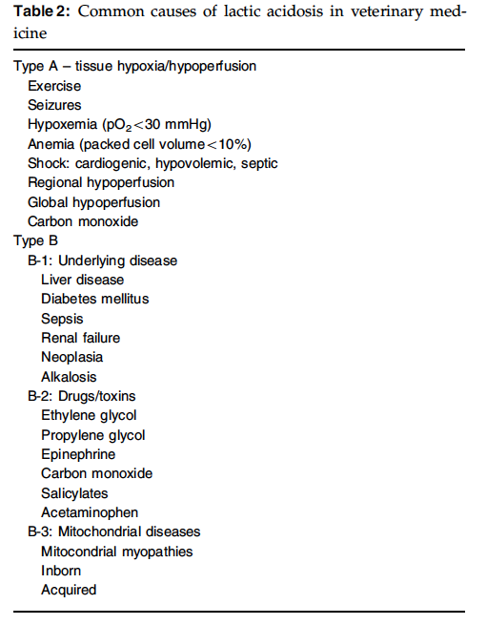

Questions
- True or False. The liver and kidneys are responsible for the majority of lactate clearance; kidneys are responsible for metabolizing 50% of lactate produced.

- Lactate is freely filtered by the glomerulus but is almost completely reabsorbed in the_____________.
  - proximal tubule
  - distal tubule
  - collecting ducts

- True or False. In contrast to the kidney, acidosis increases hepatic lactate clearance.

- Describe differences between Lactate A and B and one condition associated with each

- Explain why administering LRS does not result in metabolic acidosis.

Answers
- True or False. The liver and kidneys are responsible for the majority of lactate clearance; kidneys are responsible for metabolizing 50% of lactate produced.
The liver and kidneys are responsible for the majority of lactate clearance, metabolizing 50% and 20–30%, respectively, of the lactate produced.

- Lactate is freely filtered by the glomerulus but is almost completely reabsorbed in the_____________.
  - proximal tubule
  - distal tubule
  - collecting ducts

- True or False. In contrast to the kidney, acidosis increases hepatic lactate clearance.
In contrast to the liver, acidosis increases renal lactate clearance. Renal lactate clearance increases from
16% at a pH of 7.45 to 44% at a pH of 6.75.
The increased renal lactate metabolism is accomplished by increased production of glucose from lactate via gluconeogenesis.

- Describe differences between Lactate A and B and one condition associated with each
Type A lactic acidosis is most common and consists of increased lactate production due to tissue hypoxia with normal mitochondrial function.
Tissue hypoperfusion is the most common cause of Type A lactic acidosis

Type B lactic acidosis results under conditions of adequate oxygen delivery but altered mitochondrial function or carbohydrate metabolism
Subdivision B1 consists of disease processes believed to be creating lactic acidosis not due to hypoperfusion but possibly due to decreased lactate clearance.
Subdivision B2 consists of drugs/toxins that interfere with oxidative phosphorylation.
Subdivision B3 consists of mitochondrial defects
Conditions associated with type B acidosis: diabetes mellitus, liver disease, neoplasia, and sepsis

- Explain why administering LRS does not result in metabolic acidosis.
Lactated Ringer’s solution is a balanced electrolyte solution containing lactate as a buffer.
The lactate in this fluid is metabolized to glucose or oxidized to water and CO2.
Both of these processes result in the consumption of hydrogen ions and an overall alkalinizing effect.

