Lactate and shock state: the metabolic view

Key Points
- Situations where hyperlactataemia is predominantly a reflection of tissue hypoperfusion
- Shock states induced by low cardiac output should theoretically be accompanied by a hypoxic hyperlactataemia.
- Cardiogenic shock, as demonstrated previously, is associated with hyperlactataemia with a very high lactate/pyruvate ratio
- Situations where hyperlactataemia reflects a metabolic adjustment, such as in sepsis
- If septic shock hyperlactataemia was indeed induced by tissue hypoxia caused by hypoperfusion, then
  - Hyperlactataemic septic patients should display collapsed oxygen delivery, which should be corrected with increased O2 transport
  - Tissue PO2 should be low
  - ATP levels should be decreased
  - And it has been shown that the splanchnic area in general consumes lactate and that splanchnic production is uncommon and in no case quantitatively sufficient to explain systemic hyperlactataemia

- Accelerated aerobic glycolysis is induced by endogenous/exogenous catecholamine and inflammatory state
- Pyruvate production and oxidation are increased in septic patients
- Epinephrine via β2-adrenoceptor stimulation, increases cAMP production, inducing the stimulation of glycogenolysis and glycolysis (ATP production) as well as activation of the Na/K-ATPase pump, which in turn will consume this ATP, thereby producing ADP.
- This generated ADP via phosphofructokinase stimulation will reactivate glycolysis and hence generate more pyruvate and thereafter lactate.
- Muscle lactate, produced under the effect of epinephrine and released into the bloodstream, is utilized by the liver to produce glucose through neoglucogenesis.
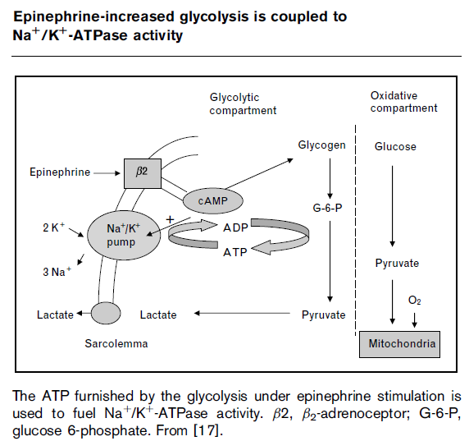
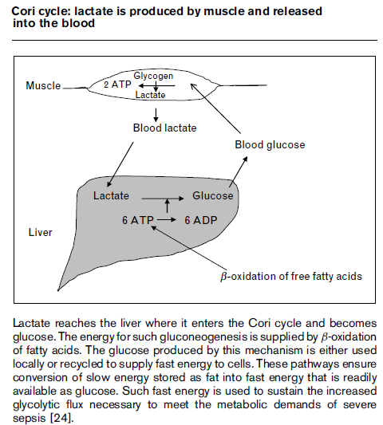
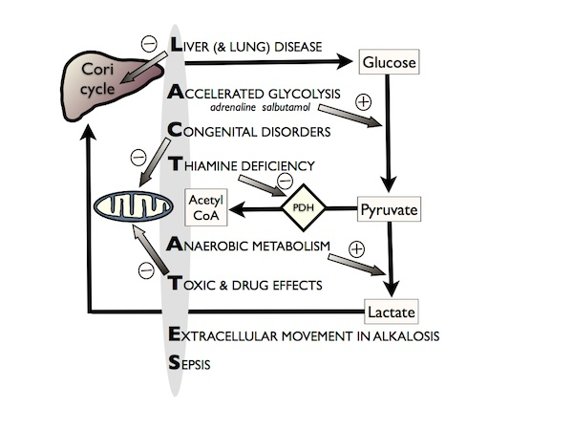

Questions:
- Which situation results in hyperlactataemia is predominantly a reflection of tissue hypoperfusion
  - Septic shock
  - Cardiogenic shock
  - Severe dehydration
  - Oliguria

- 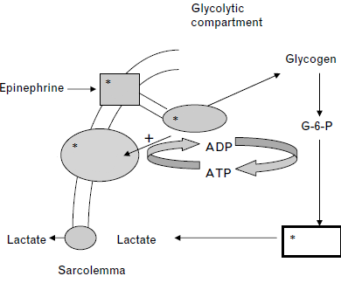

- Muscle lactate, produced under the effect of epinephrine and released into the bloodstream, is utilized by the liver to produce _______________________
- Name three organ systems that can immediately utilize Lactate as an energy source during shock

