Lactate and The Shock State: a Metabolic Review – Part I

Discuss the hypothesis that that lactate formation during sepsis is not due to hypoxia

Key point # 1: Lactataemia reflects a balance between production and utilization of lactate. Consequently, for the same etiological mechanism producing an increase in lactate, one can either observe hyperlactataemia (if metabolism decreases) or normolactataemia. Understanding this concept is vital, notably to avoid treating solely a numerical value of lactate

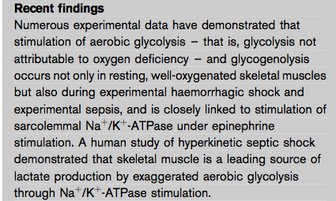

Lactate metabolism:

In physiological conditions, lactate is produced by:
- Muscles (25%)
- Skin (25%)
- brain (20%)
- intestine (10%)
- red blood cells (20%), which are devoid of mitochondria

Lactate is metabolized by liver and kidney

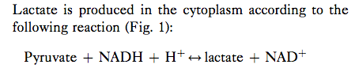
- This reaction favors lactate formation, yielding a 10-fold lactate/pyruvate ratio
- Lactate therefore increases when production of pyruvate exceeds its utilization by the mitochondria
- Pyruvate is essentially produced via glycolysis; hence any increase in glycolysis, regardless of its origin, can increase lactataemia

Pyruvate is essentially metabolized by the mitochondrial aerobic oxidation path- way via the Krebs cycle:

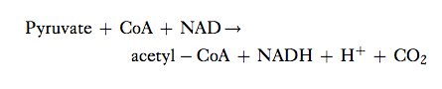

Generated lactate can be:
- Transformed into oxaloacetate or alanine via the pyruvate pathway
- Utilized directly by periportal hepatocytes (60%) to produce glycogen and glucose (Cori cycle)
- Metabolized in kidney (30%), with the cortex classically acting as the metabolizer by neoglucogenesis and the medulla as a producer of lactate
  - The threshold of renal excretion is 5 – 6 mmol/l, meaning that, physiologically speaking, lactate is not excreted in the urine

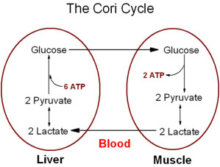

Formation of lactate in cases of tissue hypoxia:

- By definition, hypoxia blocks mitochondrial oxidative phosphorylation, thereby inhibiting ATP synthesis and reoxidation of NADH
- This leads to a decrease in the ATP/ADP ratio and an increase of the NADH/NAD ratio
- A decrease in the ATP/ADP ratio induces both an accumulation of pyruvate, which cannot be utilized by way of phosphofructokinase stimulation, and a decrease in pyruvate utilization by inhibiting pyruvate carboxylase, which converts pyruvate into oxaloacetate
- An increased NADH/NAD ratio also increases pyruvate by inhibiting pyruvate dehydrogenase and hence its conversion into acetyl-CoA

Key Point # 2: The increase in lactate production in an anaerobic setting is the result of an accumulation of pyruvate which is converted into lactate stemming from alterations in the redox potential

- This conversion allows for the regeneration of some NAD⁺, enabling the production of ATP by anaerobic glycolysis, although clearly less efficient from an energy standpoint (two molecules of ATP produced compared with 36)
- It is important to consider that the modification of the redox potential induced by an increase in NADH/NAD ratio activates the transformation of pyruvate into lactate and consequently increases the lactate/pyruvate ratio

Key Point # 3: anaerobic energy metabolism is characterized by hyperlactataemia associated with an elevated lactate/pyruvate ratio, greater glucose utilization and low energy production

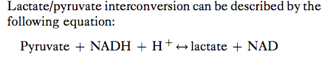

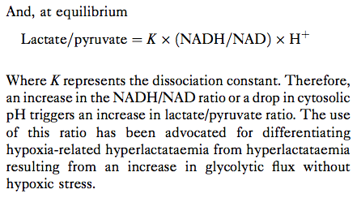

- It has been demonstrated that this ratio is very high (40+/- 6) in comparison with controls (8+/- 2) in cardiogenic shock patients with low cardiac output, with these patients representing a clinical model of tissue hypoxia
- A definite increase of this ratio has also been demonstrated in patients with refractory septic shock characterized by elevated catecholamine dosages, low blood pressure, metabolic acidosis and normokinetic state
- It has also been demonstrated for equal concentrations of lactate, septic patients, with the exception of refractory septic-shock patients, have higher pyruvate levels, thus implying a mechanism other than hypoxia.
- In the end, the prognostic value of the lactate/pyruvate ratio was no better than that of lactate and failed to provide any additional information

Questions:

1. Please draw and explain the Cori cycle

2. Generated lactate transformed into _____________________or ___________________ via the pyruvate pathway (Krebs cycle)

3. Please draw the lactate/pyruvate interconversion equation

4. Pyruvate is essentially produced via glycolysis; hence any increase in glycolysis, regardless of its origin, can increase lactataemia. T or F?

5. The increase in lactate production in an anaerobic setting is the result of an accumulation of pyruvate which is converted into lactate stemming from alterations in the redox potential. T or F?

Questions with answers:

1. Please draw and explain the Cori cycle
Answer:

2. Generated lactate transformed into _____________________or ___________________ via the pyruvate pathway
Answer: oxaloacetate, alanine

3. Please draw the lactate/pyruvate interconversion equation
Answer:

4. Pyruvate is essentially produced via glycolysis; hence any increase in glycolysis, regardless of its origin, can increase lactataemia. T or F?
Answer: True

5. The increase in lactate production in an anaerobic setting is the result of an accumulation of pyruvate which is converted into lactate stemming from alterations in the redox potential. T or F?
Answer: True

