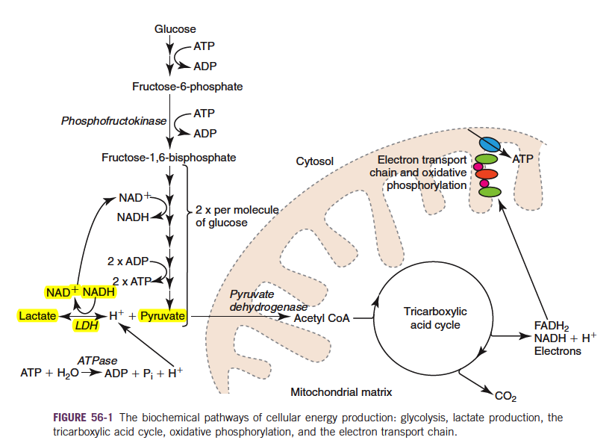
Lactate – SCCM 2nd ed

Questions:
- Under normal aerobic conditions a small quantity of pyruvate is converted to lactate, catalyzed by the enzyme _________________.

- The production of lactate from pyruvate in states of cellular oxygen deficiency allows glycolysis to continue due to recycling of _____________ to allow fructose-6-phosphate to be converted to pyruvate.

- Correct the false statement: Acidosis from increased lactate production is due to production of lactic acid.

- What 4 organs produce the majority of lactate under resting conditions?

- What mechanism predominates in lactate consumption in health?
  - Metabolization by the renal cortex
  - Excretion by the proximal tubule
  - Utilization by the heart
  - Metabolization by the liver

- What changes in the metabolism of lactate consumption in disease (vs health)?
  - Liver metabolism of lactate ceases when hypovolemia sets in
  - Skeletal muscle, cardiac muscle and brain tissue increase lactate uptake
  - Renal metabolization increases significantly
  - Excess lactate is excreted in the urine owing to the low renal threshold for lactate.

- Whole blood lactate refers to what?
.

- Give one example of each type of Type II hyperlactatemia.

- What is the Warburg’s effect?
  - Persistence of hyperlactatemia in sepsis and SIRS despite aggressive correction of hypoperfusion.
  - Malignant cells preferentially utilizing glycolytic pathways for energy production despite oxygen availability leading to hyperlactatemia.
  - Enhanced nitric oxide production leading to inappropriate vasodilation of endothelial smooth muscle.
  - Reduced erythrocyte flexibility in states of hypoperfusion leading to sequestration, microvascular perfusion deficits, and early removal by the reticuloendothelial system.

- D-hyperlactatemia has been shown to occur in what veterinary conditions?

Amswers
- Under normal aerobic conditions a small quantity of pyruvate is converted to lactate, catalyzed by the enzyme ___lactate dehydrogenase______________.

- The production of lactate from pyruvate in states of cellular oxygen deficiency allows glycolysis to continue due to recycling of NAD+ to allow fructose-6-phosphate to be converted to pyruvate.

- Correct the false statement: Acidosis from increased lactate production is due to production of lactic acid.
Acidosis results from reduced H+ consumption, not lactate production. Nevertheless, 1 mmol/L lactate is assoc with 1mmol/L production of H+ ions and concomitant reduction of SBE by 1 mmol/L.

- What 4 organs produce the majority of lactate under resting conditions?
Skeletal muscle
Skin
Brain
rBCs

- What mechanism predominates in lactate consumption in health?
  - Metabolization by the renal cortex
  - Excretion by the proximal tubule
  - Utilization by the heart
  - Metabolization by the liver

- What changes in the metabolism of lactate consumption in disease (vs health)?
  - Liver metabolism of lactate ceases when hypovolemia sets in
  - Skeletal muscle, cardiac muscle and brain tissue increase lactate uptake
  - Renal metabolization increases significantly
  - Excess lactate is excreted in the urine owing to the low renal threshold for lactate.

- Whole blood lactate refers to what?

The sum of intraerythrocytic and plasma lactate.
Once in plasma, lactate equilibrates with the intracellular space of erythrocytes.

- Give one example of each type of Type II hyperlactatemia.

Type I – hyperlactatemia without concurrent metabolic acidosis

Type II – hyperlactatemia with concurrent metabolic acidosis.

Type A – increased O2 demand
decreased oxygen delivery

Type B1 – associated with underlying disease

Type B2 – toxins, drugs

Type B3 – inborn errors of metabolism
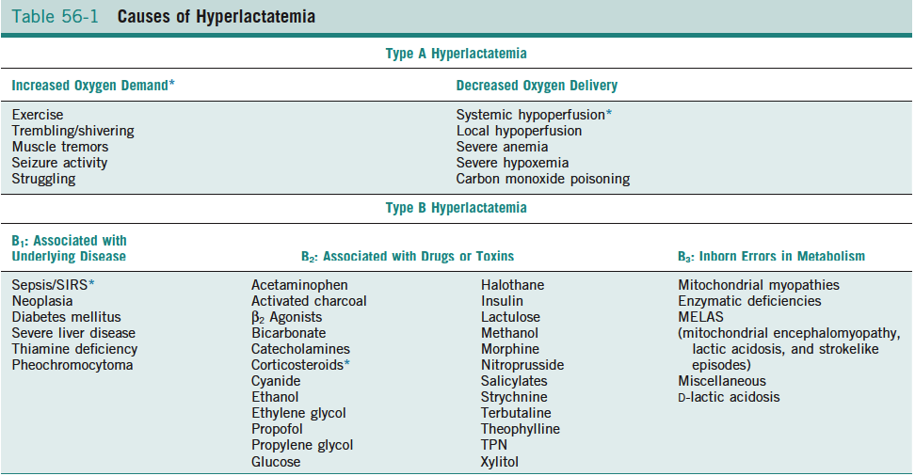

- What is the Warburg’s effect?
  - Persistence of hyperlactatemia in sepsis and SIRS despite aggressive correction of hypoperfusion.
  - Malignant cells preferentially utilizing glycolytic pathways for energy production despite oxygen availability leading to hyperlactatemia.
  - Enhanced nitric oxide production leading to inappropriate vasodilation of endothelial smooth muscle.
  - Reduced erythrocyte flexibility in states of hypoperfusion leading to sequestration, microvascular perfusion deficits, and early removal by the reticuloendothelial system.

- D-hyperlactatemia has been shown to occur in what veterinary conditions?
Cats with DKA
Propylene glycol intox
EPI with bacterial dysbiosis
Cats with GI disease have higher D-lactate levels.

