King – Textbook of Respiratory Disease of Dogs and Cats – Chapter 18 : Tracheal Washes
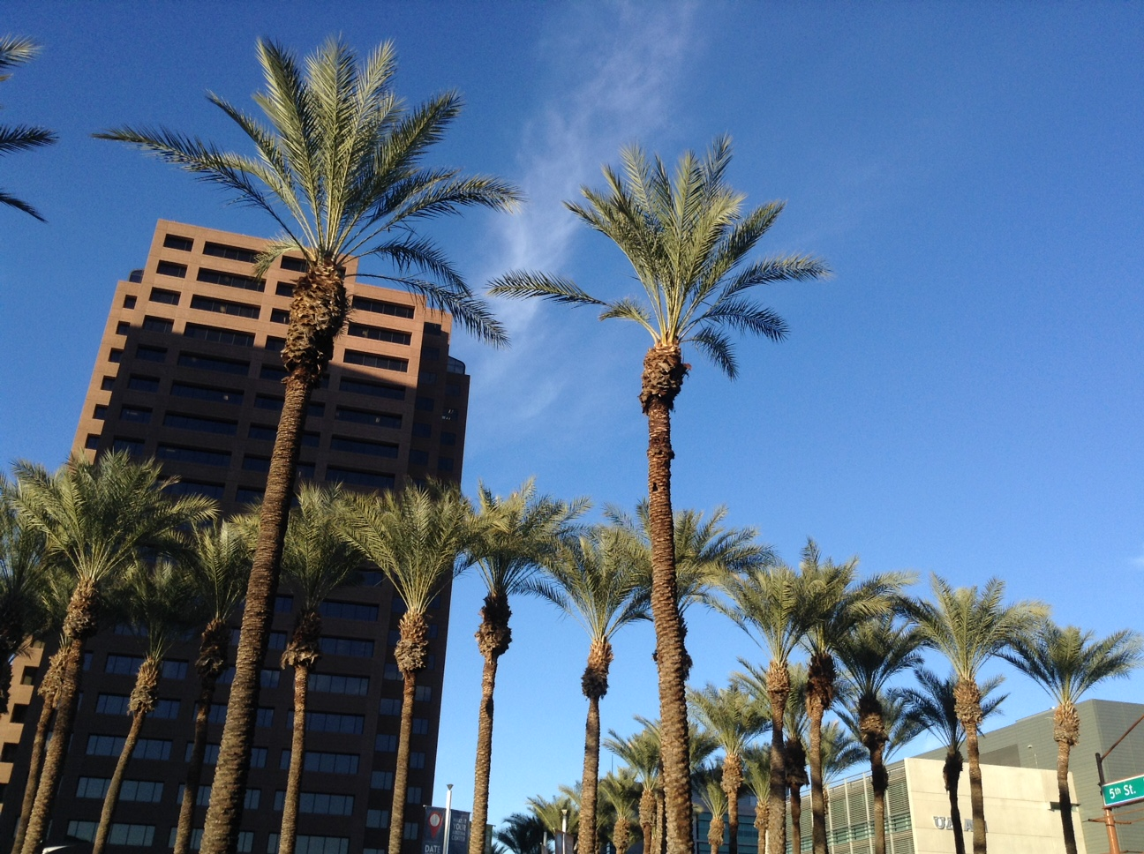

 | Indications | Contra-  indications | Side effects | Advantages | Disadvantages
TTW | -Large airways sampling | -Severe skin disease (neck)  -Coagulopathy  -Not able to restraint  -+/-mega-esophagus  -+/-tracheal collapse | -Irritation of the trachea / constriction  -Hemorrhage  -Tracheal laceration | -Less invasive (vs BAL)  -Simple  -No special training  -No expensive material/ equipment  -Cough is preserved (smaller airways) | -Less sensitive/less specific (vs BAL)
ETW | -Same |  | -Irritation of the trachea/ constriction | -Same | -Same  -Oral contamination  -General anesthesia (cough suppression)

Questions :
1. Name an advantage of TTW over ETW.

2. True or False : Healthy cats and dogs have sterile tracheobronchial tree and lungs. Therefore, a positive culture result is indicative of infection.

3. Please choose the correct statement :
a) When mechanical suction is used, pressure should not exceed 170 mm Hg.
b) ETW is used to sample small airways when an alveolar lung disease is suspected.
c) TTW is performed under deep sedation or general anesthesia.
d) At least 50% of the instilled saline should be retrieved

4. True or False : In healthy animals, cytology of the tracheal wash sample contain a majority of neutrophils, occasional macrophages and rare lymphocytes.

5. In humans, isolation of greater than _______ CFU/ml of bacteria is supportive of infection.

Questions & Answers

1. Name an advantage of TTW over ETW.
Not performed under general anesthesia – cough is preserved ; may be possible to sample smaller airways.
Less risk oral contamination.

2. False : Healthy cats and dogs have sterile tracheobronchial tree and lungs. Therefore, a positive culture result is indicative of infection.
Normal bacterial flora : < 10³ CFU/ml

3. Please choose the correct statement :
a) When mechanical suction is used, pressure should not exceed 170 mm Hg.
b) ETW is used to sample small airways when an alveolar lung disease is suspected.
False : larger airways, less helpful for interstitial or alveolar lung disease
c) TTW is performed under deep sedation or general anesthesia.
False : If general anesthesia is needed, better to do ETW. Light sedation if patient is fractious or uncooperative : ideally reversible agent or agent that does not suppress cough reflex (ketamine)
d) At least 50% of the instilled saline should be retrieved
Only 0.5-2.0 ml ; the fluid is quickly absorbed by the bronchopulmonary tree.

4. False : In healthy animals, cytology of the tracheal wash sample contain a majority of neutrophils, occasional macrophages and rare lymphocytes.
Respiratory epithelial cells, occasional inactive macrophages, small amount of mucus, rare neutrophils and lymphocytes

5. In humans, isolation of greater than 10⁵ CFU/ml of bacteria is supportive of infection.

SUMMARY
- Minimally invasive
- Large airways : trachea and primary bronchi ; less helpful for interstitial or alveolar lung dz
- Cytology (infectious agents, inflammatory cells, neoplastic cells) and cultures
- ETW or TTW ; may be able to sample smaller airways with TTW (no sedation cough reflex is not suppressed)
- Tracheal washes : less sensitive, less specific (fewer pure cultures) than BAL ; simple, less invasive, no special training or expensive equipment, screening test.
- Primary lung tumors originating from the the airway are more likely to exfoliate in the tracheal wash vs metastatic neoplasia (in the interstitium).
- ETW or TTW ?
  - ETW : small dogs and cats, patients who cannot be restrained, patients who need GA, more oral contamination
  - TTW : CI if coagulopathy, severe skin disease on the ventral neck ; caution in patients with megaesogaphus/tracheal collapse
  - TTW : risks of tracheal injury
- Side effects :
  - Airway constriction/irritation and worsening of CS (pre-treatment with a bronchodilator)
  - TTW : SQ emphysema/pneumomediastinum, tracheal injury, esophageal perforation, ET hemorrhage, cardiac arrhythmia, inoculation of infection into the needle tract, bronchial foreign body (
  - If mechanical suction is used : tracheal mucosal injury, regional pulmonary atelectasis, CV instability, hypoxia (> 100-170 mm Hg)
- TTW – material and technique
  - Aseptic technique – local analgesia with lidocaine
  - Through-the-needle long IV catheter (19-22G ; 8-24 inch) or 3.5Fr red rubber tube placed through a 14G needle or through an 14G over-the-needle IV KT
  - Sterile 0.9% saline : 3-5 ml for small dogs/cats ; 10-20 ml for large dogs
  - Sternal recumbency with dorsiflexion of the neck ; or lateral recumbency with the diseased lung down.
  - KT inserted through the cricothyroid ligament or distal to the larynx, on the midline, between 2 rings. Bevel down.
  - Only small amount of instilled fluid may be retrieved (0.5-2 ml) : the remaining fluid will be absorbed by the bronchopulmonary tree.
  - Up to 1 ml/kg of saline can be injected into the airway at one time without causing signs of respiratory distress – recommendation has not been validated
- ETW – material and technique
  - GA to allow sterile intubation
  - Short acting anesthesia (propofol)
  - Sternal recumbency or lateral recumbency with diseased lung down
  - Sterile red rubbed tube through the ETT
  - Manual aspiration or mechanical suction device with sterile collection container
- Results
  - Tracheobronchial tree and lungs are not sterile
  - 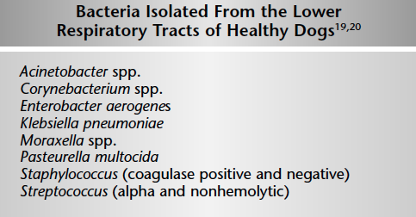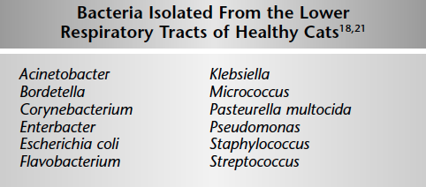
  - These bacteria are in low number : <10³ CFU/ml, no CS, no xrays finding, no cytological evidence of inflammation ; in humans : > 10⁵ = supportive of infection
  - With tracheal wash, use of saline = dilution of the sample
  - Normal tracheal washes : respiratory epithelial cells, occasional inactive macrophages, small amount of mucus, rare neutrophils and lymphocytes.

