Board review – Respiratory – PAH

JVIM 2006: Retrospective evaluation of sildenafil citrate as a therapy for PH in dogs
JVIM 2010 Clinical efficacy of sildenafil in treatment of pulmonary arterial hypertension in dogs

Key points:
- Sildenafil is a phophodiesterase-5 inhibitor that results in increased concentrations of cyclic guanosine monophosphate, which subsequently results in nitric-oxide mediated vasodilation. Sildenafil decreases pulmonary arterial pressure and pulmonary vascular resistance, and may have effects on vascular remodeling. Sildenafil is specific to the pulmonary vasculature and should produce little to no decrease in systemic blood pressure.

- Bach et all (Retrospective evaluation of sildenafil citrate as a therapy for pulmonary hypertension in dogs) found that in 13 dogs with pulmonary hypertension – a median decrease of 16.5mmHg in the pulmonary arterial pressure was recorded. MST was 91 days (all dogs), 175 days (10 dogs discharged from hospital).

- Brown et al (JVIM 2010, clinical efficacy of sildenafil in tx of PAH in dogs) found that sildenafil decreases pulmonary arterial pressure from baseline in dogs with PAG and is assoc with improved quality of life and activity when compared to placebo.

Questions:
- Label the following diagram showing the mechanism of action of sildenafil on pulmonary vasculature.
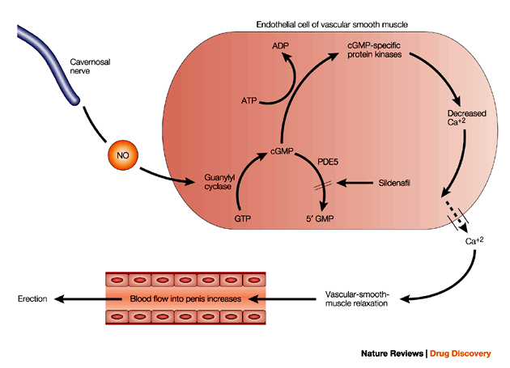

A
C

B

- Which of the following patients would the addition of sildenafil be most appropriate?
  - A 14 year old shih tzu with left sided congestive heart failure, mitral and tricuspid insufficiency with a pulmonary arterial gradient of 5mmHg.
  - A west highland white terrier with congestive heart failure and a pulmonary arterial gradient of 15mmHg.
  - A Chihuahua with chronic bronchitis and a pulmonary aterial gradient of 50mmHg
  - A great dane with DCM being treated with pimobendan.
- Sildenafil is a phosphodiesterase _____ inhibitor, whereas pimobendan is a phosphodiesterase _____ inhibitor.

- Why is sildenafil used for pulmonary hypertension?

- What is the normal pulmonary artery pressure at rest?

Answers:
- Label the following diagram showing the mechanism of action of sildenafil on pulmonary vasculature.

- Which of the following patients would the addition of sildenafil be most appropriate?
  - A 14 year old shih tzu with left sided congestive heart failure, mitral and tricuspid insufficiency with a pulmonary arterial gradient of 5mmHg.
  - A west highland white terrier with congestive heart failure and a pulmonary arterial gradient of 15mmHg.
  - A Chihuahua with chronic bronchitis and a pulmonary aterial gradient of 50mmHg
  - A great dane with DCM being treated with pimobendan.
- Sildenafil is a phosphodiesterase ___5__ inhibitor, whereas pimobendan is a phosphodiesterase ___3__ inhibitor.
- Why is sildenafil used for pulmonary hypertension?
  - Highly selective
  - Little systemic effects
  - Decreases pressure gradient
  - Improves QOL
- What is the normal pulmonary artery pressure at rest?
  - <25 mm/s

Bach et al Retrospective evaluation of sildenafil citrate as a therapy for PH in dogs JVIM 2006
Purpose – describe the clinical characteristics and outcome of dogs with PH treated with sildenafil. Retrospective.

Normal pulmonary artery pressure is <25mm/s at rest. Measured by: PAC, Doppler echo in the absence of pulmonary stenosis, modified Bernoulli equation.
Previous survival of 3-3.5 days.
Causes: congestive heart failure, pulmonary thromboembolic disease (heartworm, Cushings, PLN, PLE), chronic pulmonary disease (chronic bronchitis, pulm fibrosis)
Sildenafil citrate- highly selective phosophodiesterase 5 inhibitor – results in increased concentrations of cyclic guanosine monophosphate, which results in NO-mediated vasodilation. Sildenafil decreases pulm artery pressure and pulmonary vascular resistance in people, and may have effects on vascular remodeling.
N=13 dogs: chronic pulmonary disease, chronic valvular heart disease with mitral regurgitation and left sided congestive hert failure, pulmonary overcirculation from PDA resulting in R to L shunt, PTE. Unidentified in 5 dogs. Sildenafil administered at ~1.9mg/kg q8-24 hours. Some had concurrent drugs (ACEi, furosemide, amlodipine, theophylline, phenobarbital, antibitoics.
6 of 8 dogs had recution of PAPs after sildenafil therapy 9median of 16.5 mmHg). BP dropped by median of 33mmHg systolic.
Outcome: 3 euth within 1 day d/t refractory disease. MST for those not euth in 1 day: 175 days (range 28-693 days), was not correlated with admit PAPs
Adverse effects – cutaneous flushing

Brown et al Clinical efficacy of sildenafil in tx of pulmonary arterial hypertension in dogs. JVIM 2010
Randomized placebo controlled cross over study
N=13, disease secondary to CHF
Sildenafil significantly reduced pulmonary artery pressure from baseline and when compared to placebo, also quality of life and activity level increased. Dogs were more likely to be withdrawn from the placebo group than the sildenafil group

