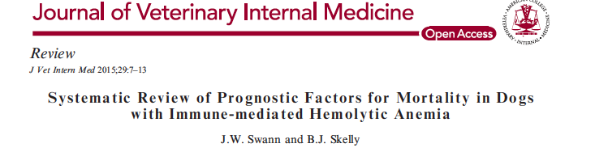

Aim: The aim of the current study was to systematically evaluate the current evidence relating to identification of prognostic factors for mortality in dogs with primary IMHA by using the QUIPS tool.

Quality in Prognosis Studies (QUIPS) - tool containing 30 questions arranged into 6 domains to provide a comprehensive assessment of the quality of a study

Animals: Three hundred and eighty client-owned dogs with spontaneous primary idiopathic IMHA reported in 6 previous studies.

Methods: The online databases of PubMed, ISI Web of Science, and CAB Abstracts were searched from 1980 to October 2013 using the following search terms: (dog OR dogs OR canis OR canine OR canidae) AND (IMHA OR AIHA OR hemolytic anemia OR hemolysis OR immune-mediated hemolytic anemia). Search tools were employed to identify articles and a validated appraisal tool was used to assess the quality of individual studies by considering inclusion and exclusion criteria, measurement of prognostic, outcome and confounding variables, and statistical methods.

The articles included in the study used data from 380 dogs with primary IMHA to produce models investigating prognostic factors for mortality, with a median sample size of 56 (range, 20–222).

The studies reported data from dogs that were presented for treatment of IMHA between 1988 and 2010. Two studies collected data prospectively, whereas 4 studies were retrospective cohort studies.

Results: Few studies evaluated prognostic indicators for IMHA in dogs, and all of these suffered from methodologic flaws in at least 1 major area. Fifteen different variables were identified as prognostic indicators, with 2 variables identified by >1 study.

Assessment of quality: None of the studies had a high risk of bias in domains assessing measurement of prognostic factors or outcome variables, but high risks of bias were observed in all other domains for at least 1 study.

Because of the small number of cases included in many of the studies, confidence intervals also were wide, and the true clinical validity of each prognostic factor therefore is difficult to estimate.

Articles were excluded if they did not evaluate potential confounding factors in the context of a multivariable model, either by Cox proportional hazards analysis or multivariable logistic regression.
Many studies evaluated prognostics factors for mortality in IMHA, but typically only considered individual factors without accounting for the effects of multiple variables.

Conclusions and Clinical Importance: There are few pieces of high-quality evidence available to enable estimation of prognosis for dogs presenting with primary IMHA

Three studies identified icterus or hyperbilirubinemia as a significant prognostic factor.

Numerous immunosuppressive and antithrombotic medications have been studied for treatment of the disease, but there is no consensus regarding the optimal regimen that should be employed.

Questions
- Most common immune mediated disease of dogs is
  - Immune mediated hemolytic anemia
  - Immune mediated thrombocytopenia
  - Immune mediated polyarthritis

- Name three tests that identify the presence of antibodies specific for erythrocyte antigens used to diagnose IMHA

- The following has been identified as as a significant prognostic factor in multiple studies
  - Hematuria
  - Icterus
  - Spherocytosis

- Consensus regarding the optimal immunosuppressive and antithrombotic drugs to treat IMHA includes
  - Mycophenolate mofetil, aspirin
  - Cyclosporine, aspirin
  - Prednisone, clopidigrel
  - No consensus has been proposed

Answers
- Most common immune mediated disease of dogs is
  - Immune mediated hemolytic anemia
  - Immune mediated thrombocytopenia
  - Immune mediated polyarthritis

- Name three tests that identify the presence of antibodies specific for erythrocyte antigens used to diagnose IMHA
Saline agglutination test, observation of spherocytes on a blood smear, Coombs’ test

- The following has been identified as as a significant prognostic factor in multiple studies
  - Hematuria
  - Icterus
  - Spherocytosis

- Consensus regarding the optimal immunosuppressive and antithrombotic drugs to treat IMHA includes
  - Mycophenolate mofetil, aspirin
  - Cyclosporine, aspirin
  - Prednisone, clopidigrel
  - No consensus has been proposed

