Burton et al. Degenerative Left Shift in Cats. JVIM 2014

Retrospective study
- Criteria for inclusion into the study (108 cats) included a CBC performed within 24 hours of presentation to the hospital that showed an immature granulocyte count higher than that of mature neutrophils, defined as a DLS.
- Controls (322 cats) chosen based on the final diagnosis of cases and matched to within 1 year of the corresponding case. Controls were excluded from the study if DLS at any stage of hospitalization.

Main Points
- Degenerative left shift occurs when immature neutrophils outnumber mature neutrophils. The intravascular distribution of neutrophils in cats is unique. 70% of total blood neutrophils reside in the marginated neutrophil pool, compared to 50% in both dogs and humans.
- Cases more likely to die or be euthanized in hospital compared to controls - 56% (n = 60/108) of cases versus 33% (n = 107/322) of controls.
Hospitalized cats with DLS have 1.57-times higher risk of death or euthanasia compared to those without DLS.

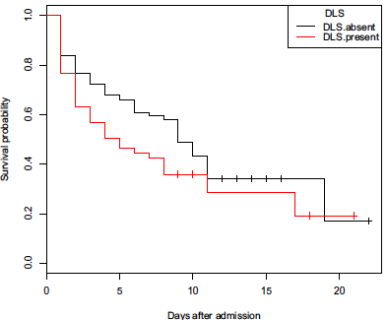
Median time in hospital
-5 days for cats with DLS
-9 days for cats without DLS

Kaplan Meier curve demonstrates lower survival probability over most of hospitalization.

- Among the 5 disease categories (septic, peritonitis, pyothorax, FeLV, wounds), only FeLV remained a significant predictor in the multivariate model. FeLV also was the most significant univariate predictor.
- Purebred (including purebred cross) cats had a 1.3-fold lower risk of death or euthanasia than other groups (domestic short-, medium-, and long-hair cats). The purebred group only represented 16 of the 108 cases and owner willingness to treat may have also affected results.

Questions
- Define degenerative left shift.

- True or False. Median time in hospital for cats with DLS was longer than hospitalization time for those without DLS.

- Which disease category was found to be a significant predictor of outcome.
  - Septic
  - Peritonitis
  - FeLV
  - Pyothorax
  - Wounds

- True or False. Purebred cats had higher risk of euthanasia than other groups.

Questions and answers
- Define degenerative left shift.
Degenerative left shift occurs when immature neutrophils outnumber mature neutrophils. The intravascular distribution of neutrophils in cats is unique.

- True or False. Median time in hospital for cats with DLS was longer than hospitalization time for those without DLS.
- Which disease category was found to be a significant predictor of outcome.
  - Septic
  - Peritonitis
  - FeLV
  - Pyothorax
  - Wounds

- True or False. Purebred cats had higher risk of euthanasia than other groups.

