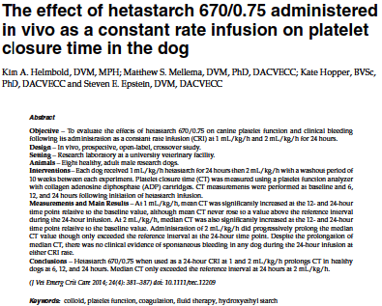

Objective: evaluate the effects of HES solutions after CRI on platelet function, describe any clinical evidence of spontaneous bleeding
Hypothesis: A greater total daily dose of HES would be required to prolong CT in healthy dogs compared to bolus delivery
8 healthy male hound cross dogs. Cross over, dogs receiving 1 or 2ml/kg/hr CRI infusion of HES 670/0.75 for 24 hours. Not randomized. Sedated for placement of jugular catheter for administration and sampling purposes.

Results:
Normal to slightly prolonged aPTT was noted. Normal platelets, slightly decreased HCT, normal PT, fibrinogen, mild hypoglobulinemia.
Platelet CT increased from baseline to end infusion (0 hours to 24 hours) at both 1ml/kg/hr and 2ml/kg/hr
For 1ml/kg/hr: mean CT at 12 and 24 hours wee significantly increased compared to baseline. (6hr NSD)
Mean values did not rise above the upper limit of normal for the reference interval for the PFA-100.
For 2ml/kg.hr: median CT values for 12 and 24 hour were significantly increased compared to baseline. 6 hour was NSD from 0 but significantly lower than 24. Median CT exceeded the reference range at only the 24 hour time point.
Discussion:
aPTT prolongation considered clinically insignificant.
No clinical evidence of bleeding.
HES 670.0.75 can be safely administered at up to 2ml/kg/hr in canine patients with normal platelet function. Limiting it to 24ml/kg/day for patients requiring invasive surgery, with diminished platelet function, or predisposed to bleeding at critical sites is advised.
--Did not address how long it took to normalize after cessation of CRI.
--No challenge to bleeding.
--Healthy dogs, not representative of ill dogs.
--They note decreased HCT possibly due to acepromazine, but the HCT values were not different between catheter placement and removal. Is the lack of difference due to ace initially and exanguination?

Key points:
---Median platelet closure time (CT) of HES 670/0.75 exceeded the reference interval only when used at 24 hours in the 2ml/kg/hr group.
---No clinical bleeding seen
---Apparently safe to give to canine patients at 2ml/kg/hr (in patients with normal platelet function).

Questions:
1. Platelet closure time was abnormal in which of the following treatment groups at which time point?
A. 2ml/kg/hr at 24 hours
B. 2ml/kg/hr at 6 hours
C. 1ml/kg/hr at 24 hours
D. 1ml/kg/hr at 16 hours

2. Which of the following hemostatic abnormalities have nor been associated with HES solution infusions?
A. decreased concentrations of vonWillebrand factor
B. decreased FVIII concentrations
C. Impaired fibrin polymerization
D. Decreased platelet aggregation
E. Decreased VII concentrations

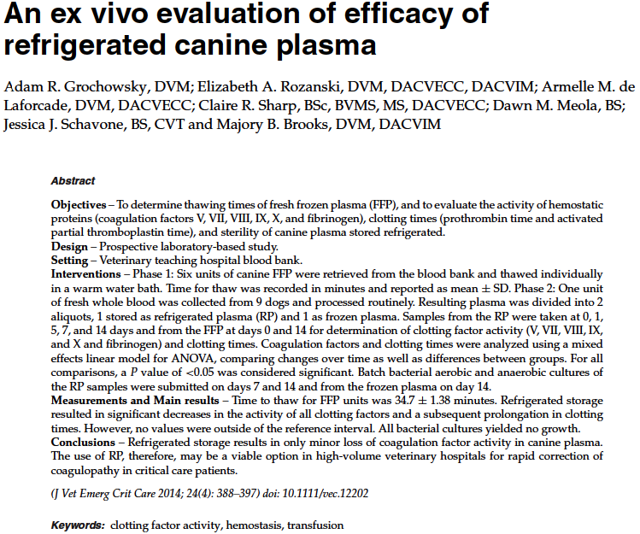

Goals: determine length of time for 1 unit of frozen FFP using a water bath, to evaluate the coagulation stability of canine plasma during a 2 week period of refrigeration, and to evaluation units of RP for the growth of bacteria.

Key points:
---All units req more than 30 minutes to thaw (~35 minutes)
--PT: lengthened between days 0-14. All PT measurements remained within reference ranges.
---PTT: lengthened significantly between days 0-14. All PPT measurements remained within the reference range.
---Fibrinogen: concentration decreased significantly between 0-14 days
---Clotting factor analysis: support that plasma may be stored in the refrigerator for up to 14 days without clinically relevant loss of factor activity or bacterial contamination. There were significant degredation of fibrinogen and increases in coagulation times, however the values were within the reference range at all time intervals.
---Did not study the clinical efficacy of stored units.

Questions:
- True/False: According to this study, the degradation of factor V was significant enough to recommend against the use of refrigerated plasma in patients with coagulopathy.
- Which of the following coagulation values were significantly different between time 0 and day 14? Choose all that apply.
  - Factor V
  - Factor VII
  - PT
  - PTT
  - Factor X
- True/False: Bacterial contamination did not appear to be an issue in this study of refrigerated plasma units.

