Ischemia and Reperfusion

Ischemia and reperfusion injury contributes to pathology in a wide range of conditions
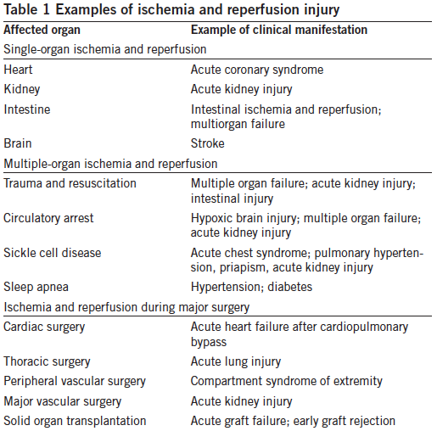

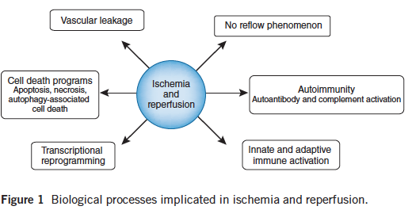

Ischemia and reperfusion leads to the activation of cell death programs, including apoptosis, autophagy-associated cell death and necrosis

The ischemic period in particular is associated with significant alterations in the transcriptional control of gene expression (transcriptional reprogramming).

Reperfusion injury is characterized by autoimmune responses, including natural antibody recognition of neoantigens and subsequent activation of the complement system (autoimmunity).

With a few exceptions, such as bacterial translocation after intestinal injury, ischemia and reperfusion typically occurs in a sterile environment.
This sterile immune response involves signaling events through pattern-recognition molecules such as Toll-like receptors (TLRs), recruitment and activation of immune cells of the innate and adaptive immune system and activation of the complement system

Innate immune responses
- TLR4 activation may be enhanced by oxidative stress, which is generated by ischemia and reperfusion and is known to prime inflammatory cells for increased responsiveness to subsequent stimuli.
- TLR2 expression on epithelia is induced by hypoxia or inflammation, and renal TLR2 signaling contributes to acute kidney injury and inflammation during ischemia and reperfusion
- Approaches using TLR inhibitors remain promising.
- Depletion of conventional dendritic cells increases sterile inflammation and tissue injury in the context of hepatic ischemia and reperfusion injury. Protection afforded by dendritic cells depends on their production of the anti-inflammatory cytokine interleukin-10 (IL-10), resulting in attenuated levels of tumor necrosis factor-a, IL-6 and reactive oxygen species (ROS).
- The accumulation of granulocytes has to be tightly controlled, as too few granulocytes may not allow for adequate tissue repair, whereas too many granulocytes can promote uncontrolled inflammation and tissue injury

Adaptive immune response
- T cells accumulate during ischemia and reperfusion
- In contrast, Treg cells appear to have a protective role of in ischemia and reperfusion
- Treg cell–dependent production of IL-10 decreases tumor necrosis factor

Innate autoimmunity, complement, platelets and coagulation
- Neoepitopes expressed on ischemic tissues are targets for natural antibody binding during the reperfusion phase with subsequent complement activation, neutrophil recruitment and tissue injury
- Excessive platelet aggregation and release of platelet-derived mediators can exacerbate tissue injury following ischemia and reperfusion.

Questions
1. True or False. The reperfusion period in particular is associated with significant alterations in the transcriptional control of gene expression (transcriptional reprogramming).

2. _________activation may be enhanced by oxidative stress.
a. TLR4
b. TLR3
c. TLR2

3. True or False. Neoepitopes expressed on ischemic tissues are targets for natural antibody binding during the reperfusion phase with subsequent complement activation, neutrophil recruitment and tissue injury

4. Fill in the blank. The protective function of dendritic cells depends on production of __________?

5. Which type of cells of the adaptive immune system appear to have a protective role in ischemia and reperfusion
a. Cytotoxic T cells
b. B cells
c. Helper or regulatory T cells

Answers
1. True or False. The reperfusion period in particular is associated with significant alterations in the transcriptional control of gene expression (transcriptional reprogramming).

The ischemic period in particular is associated with significant alterations in the transcriptional control of gene expression (transcriptional reprogramming).
Ischemia is associated with an inhibition of oxygen-sensing prolylhydroxylase (PHD) enzymes because they require oxygen as a cofactor.

2. _________activation may be enhanced by oxidative stress.
a. TLR4
b. TLR3
c. TLR2

3. True or False. Neoepitopes expressed on ischemic tissues are targets for natural antibody binding during the reperfusion phase with subsequent complement activation, neutrophil recruitment and tissue injury

4. Fill in the blank. The protective function of dendritic cells depends on production of __________?

Protection afforded by dendritic cells depends on their production of the anti-inflammatory cytokine interleukin-10 (IL-10), resulting in attenuated levels of tumor necrosis factor-a, IL-6 and reactive oxygen species (ROS).

5. Which type of cells of the adaptive immune system appear to have a protective role in ischemia and reperfusion
a. Cytotoxic T cells
b. B cells
c. Helper or regulatory T cells

