The effect of using an impedance threshold device on hemodynamic parameters during cardiopulmonary resuscitation in dogs

Gareth J. Buckley, MA, VetMB, MRCVS, DACVECC; Andre Shih, DVM, DACVA; Fernando L. Garcia-Pereira, DVM, DACVA and Carsten Bandt, DVM, DACVECC

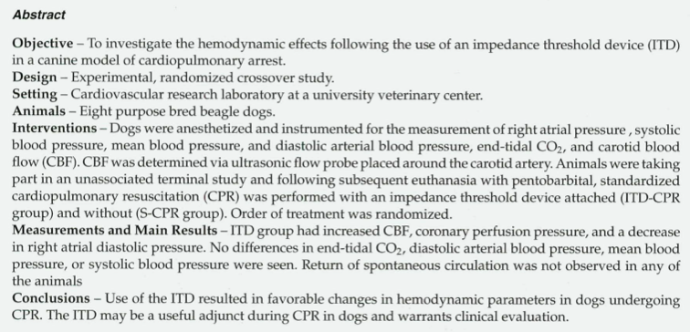

Device rationale and how it works:

- The chest wall needs to fully recoil after each compression in order to decrease intrathoracic pressure (ITTP) and thereby maximize venous return.
- Standard manual chest compressions, however, produce coronary and cerebral perfusion, that is, 20%-30% of normal.
- Several adjunctive CPR techniques and devices may improve hemodynamics by manipulation of ITTP and thus provide additional blood flow.
- Several adjunctive CPR techniques and devices may improve hemodynamics by manipulation of ITTP and thus provide additional blood flow.
- (CPP), and hence the blood supply to the myocardium, is determined by the difference between aortic diastolic pressure and right atrial pressure (RAP)
  - Hence, interventions should be aimed at increasing aortic pressure and minimizing increases in RAP to maximize perfusion.
- During conventional CPR with positive pressure ventilation, both chest compression and ventilation contribute to an abnormally high ITTP, restricting venous return, and increasing RAP due to transmural transmission of ITTP of the atrium
- The impedance threshold device (ITD) can be attached between the endotracheal tube and the breathing circuit
- The device prevents air inflow via the endotracheal tube during chest recoil until a certain "cracking pressure" is reached, usually -12 cm H2O for the devices used during CPR. In practice, this means that a more negative pressure is generated in the chest during chest wall recoil, as the ITD will not allow airflow into the endotracheal tube during the first part of chest wall recoil.

Recover guideline:
- ITD have been shown to improve hemodynamics in anesthetized dogs by increasing venous return due to decreased intrathoracic pressure.
- While some experimental studies in non- target species have demonstrated a benefit of these devices during CPR, the largest clinical trial to date failed to demonstrate any improvement in ROSC or survival to discharge in people in CPA with the use of an ITD
- In addition, because the device requires chest wall recoil to generate a “cracking pressure” of at least −12 cm H2O, use is not feasible in small dogs or cats weighing less than 10 kg because they are unlikely to be capable of generating those types of pressures from elastic recoil alone.
- Therefore, the use of an ITD to enhance circulation is reasonable in animals > 10 kg (IIa-B), but studies to date have not demonstrated a survival advantage with their use.
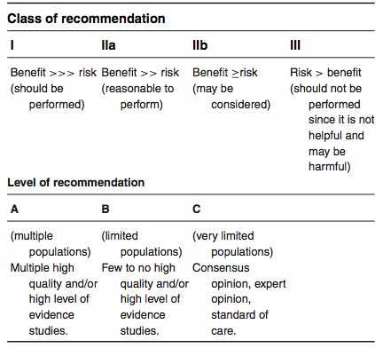
Findings of the paper:
- ITD group had increased carotid blood flow, coronary perfusion pressure, and a decrease in right atrial diastolic pressure
- No differences in end-tidal CO2, diastolic arterial blood pressure, mean blood pressure, or systolic blood pressure were seen
- Return of spontaneous circulation was not observed in any of the animals
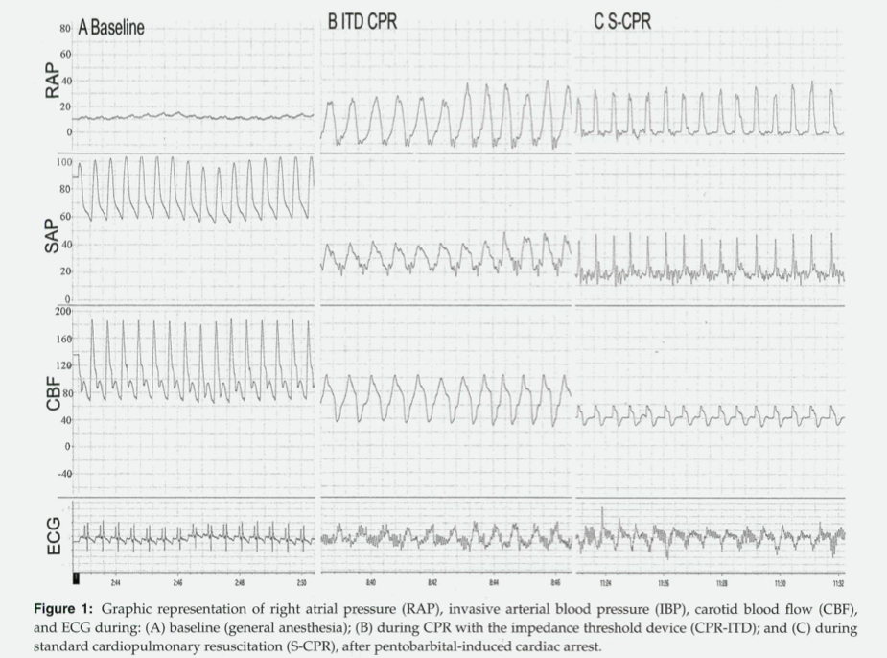
- Conclusions - Use of the ITD resulted in favorable changes in hemodynamic parameters in dogs undergoing CPR. The ITD may be a useful adjunct during CPR in dogs and warrants clinical evaluation.

