Use of Impedance Threshold Device (ITD) during hemorrhagic shock in dogs

RECOVER guideline recommendation for ITD
Recover guideline does recommend the use of Impedance Threshold Device (ITD) to enhance circulation in animals >10kg. They report that studies have not demonstrated a survival advantage with their use (Recovery guideline published in 2012, do not refer to Buckley study)

ITDs have been shown to improve hemodynamics in anesthetized dogs by increasing venous return due to decreased intrathoracic pressure (Vigani 2011)

Aufderheide et al 2011 NEJM study, a largest clinical trial, failed to demonstrate any improvement in ROSC or survival to discharge in people in CPA with the use of an ITD

In addition, because the device requires chest wall recoil to generate a “cracking pressure” of at least −12 cm H2O, use is not feasible in small dogs or cats weighing < 10 kg because they are unlikely to be capable of generating those types of pressures from elastic recoil alone.

Therefore, the use of an ITD to enhance circulation is reasonable in animals > 10 kg, but studies to date have not demonstrated a survival advantage with their use

Brief discussion of the rationale for the intervention (ITD) and how it works
Impedance threshold devices (ITDs) are noninvasive, disposable, small plastic devices that fit on the endotracheal tube.

They are composed of a one-way valve with a set opening pressure referred to as “cracking pressure”
- Depending upon the set cracking pressure, ITDs are designed for use in cardiopulmonary resuscitation (eg, high cracking pressure) or for spontaneous breathing (eg, low cracking pressure)
- A high cracking pressure of −12 cm H2O (ResQPod) may be useful in CPR
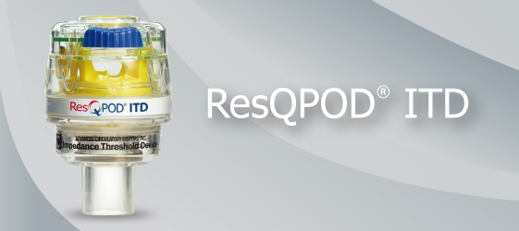
- The ResQGarda is a new ITD designed with a low cracking pressure (eg, −7 cmH2O) to be used in spontaneously breathing human patients to aid in the treatment of hypovolemia
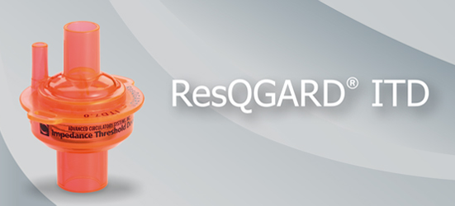 https://www.youtube.com/watch?v=f-0F8tXEjdw

ITD could be useful for treatment of hypovolemic shock, reducing total amount of fluid required for resuscitation

The ITD increases venous return by harnessing the energy involved in spontaneous ventilation

In the spontaneously breathing patient, the ITD creates a momentary transient inspiratory resistance and creates an even greater negative intrathoracic pressure and greater transthoracic gradient from the extrathoracic to intrathoracic great veins, resulting in increased venous return into the right atrium each time the patient takes a breath.

An increase in airway resistance leads to a reduction in pleural pressure and increases systemic venous return, improving CO without the need for fluid administration

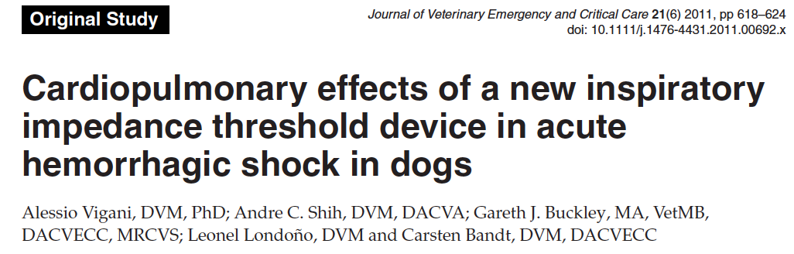

ITD is valuable in the initial treatment of hypotension secondary to hypovolemia in dogs

Study concluded that the ITD improved cardiac index (CI) and arterial blood pressure in hypotensive dogs by an increase in respiratory resistance. The major drawback of ITD use consisted of a significant decrease in respiratory compliance

- The use of the ITD during spontaneous ventilation enhanced arterial blood pressure and CI during acute hemorrhagic shock. Since there was no change in SVR or HR, the improvement in CI was likely secondary to the decrease in intrathoracic pressure resulting in improved venous return and consequently cardiac output (CO) and finally blood pressure (This is why it improved SAP and MAP but not DAP)

- During hemorrhage, the use of ITD correlated with a significantly higher DO2 compared to no ITD (difference in DO2 can be explained by the higher CO in the ITD group)

- This investigation suggests that the ITD does not affect hemodynamic values in normotensive, euvolemic patients

Methods
- 8 healthy dogs were anesthetized and a hemorrhagic hypovolemic state was obtained by actively withdrawing blood using a 60-mL syringe connected to a 3-way stopcock, until the MAP was stable at 40±5 mm Hg (hypovolemia)
- Cardiopulmonary variables, lactate, gastric tonometry, and peripheral perfusion were recorded with and without the ITD in place

Results
- There were no significant changes in any of the parameters (direct systolic,mean, diastolic arterial pressure, CVP, CI, HR, SVR, SV, SVR, DO2, and GBF) when using ITD vs no ITD in euvolemic dogs
- Significant increase in respiratory resistance (ResR) and decrease in respiratory compliance (RC) with the ITD versus without ITD, during baseline euvolemic dogs.
- When euvolemic state was compared to hypovolemic state without ITD there was a significant decrease in SAP, MAP, DAP, CI and DO2
- During hemorrhagic hypovolemic state, the use of ITD significantly increased CI by 37.9% and DO2 by 70.6%
- The ITD improved SAP by 34%, and MAP by 29% but not DAP
- There was an increase in ResR by 560% and a decrease in compliance by 40% with ITD

Recommendation about the intervention (ITD)
Useful in trauma patients with hemorrhagic shock (previously euvolemic) that need to be intubated - could improve CO without the need for large volume fluid administration. Not useful in awake patients

The energy available for breathing can be significantly diminished in ill and injured patients. ITD should be avoided in animals with pulmonary disease or injury, respiratory distress, or any compromise to the chest wall integrity

In humans trauma patients ITD is more easily used
