Hemodialysis Questions

Questions:

1. What is the difference between hemodialysis and hemofiltration?

2. What are the 4 distinct treatment modalities of CRRT?

3. Briefly describe the concepts of the following:
- SCUF
- CVVH
- CVVHD
- CVVHDF

4. Describe the equation Kt/V

5. List some complications associated with the use of CRRT

6. List indications for dialysis

Questions with answers:

1. What is the difference between hemodialysis and hemofiltration?

- Hemodialysis: dialysate may be circulated through the dialyzer to allow diffusive clearance
- Hemofiltration: fluid may be removed from the patient to allow convective clearance

2. What are the 4 distinct treatment modalities of CRRT?
- Slow continuous ultrafiltration (SCUF)
- Continuous venovenous hemofiltration (CVVH)
- Continuous venovenous hemodialysis (CVVHD)
- Continuous venovenous hemodiafiltration (CVVHDF)

3. Briefly describe the concepts of the following:
SCUF
- Purely convective modality in which blood enters the dialyzer, is divided into thousands of strawlike semipermeable membranes, and is exposed to a positive transmembrane pressure.
- Ultrafiltrate is forced out of the blood into the intermembrane space and is then discarded as effluent, and the hemoconcentrated blood is returned to the patient.
- SCUF is used in human medicine for patients with non-diuretic responsive congestive heart failure.
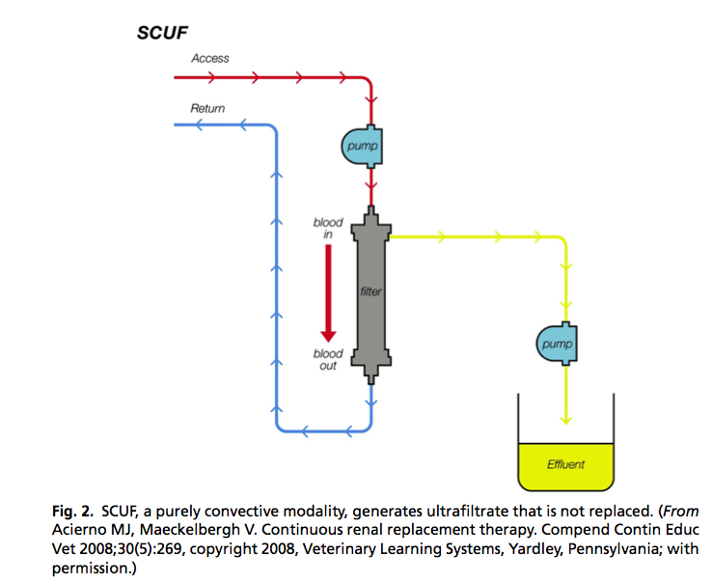

CVVH
- Purely convective modality in which blood enters the dialyzer, is divided into thousands of strawlike semipermeable membranes, and then exposed to a positive transmembrane pressure
- However, in CVVH, a sterile balanced electrolyte solution is used to replace the ultrafiltrate.
- The electrolyte solution can be added before or after the dialyzer, but in either case it is called the replacement fluid.
- When the replacement fluid is added before the dialyzer (predialyzer configuration), the patient blood is diluted and then convection within the dialyzer restores the blood to its normal physiologic volume.
- When the replacement fluid is added after the dialyzer (postdialyzer configuration), the blood is first hemoconcentrated within the dialyzer and then a sterile balanced electrolyte solution is added before the blood is returned to the patient.
- The benefit of operating in postdialyzer configuration is that it is efficient; however, as the blood becomes increasingly concentrated within the dialyzer, there is a risk of sludging and clotting
- Although the predialyzer configuration has a lower risk of clotting, it is much less efficient.
- A filtration fraction [(ultrafiltrate rate mL/min 100)/(blood flow rate mL/min x [1-hematocrit value])] of 25% to 30% can be achieved before the risk of clotting significantly increases
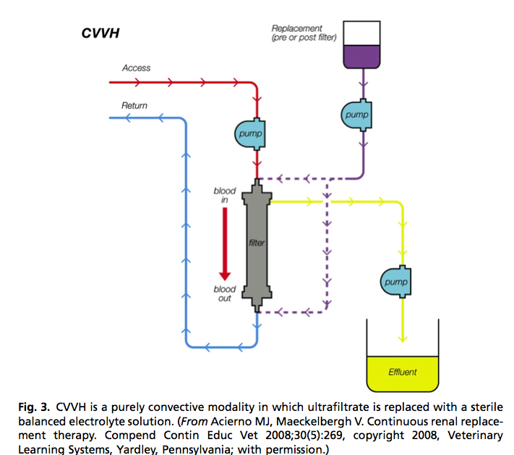
CVVHD
- A diffusive therapy that closely resembles IHD
- Blood enters the dialyzer and is divided into thousands of strawlike semipermeable membranes that are bathed in a solution (dialysate) that flows countercurrent to the blood flow.
- Toxins that are in high concentration in the blood diffuse across the membrane and enter the dialysate, whereas substances in a high concentration in the dialysate (eg, bicarbonate) diffuse into the blood.
- The exhausted dialysate is then disposed of as effluent.
- Although CVVHD is similar to IHD, the slow dialysate flow rates of CVVHD allow the use of prepackaged sterile dialysate
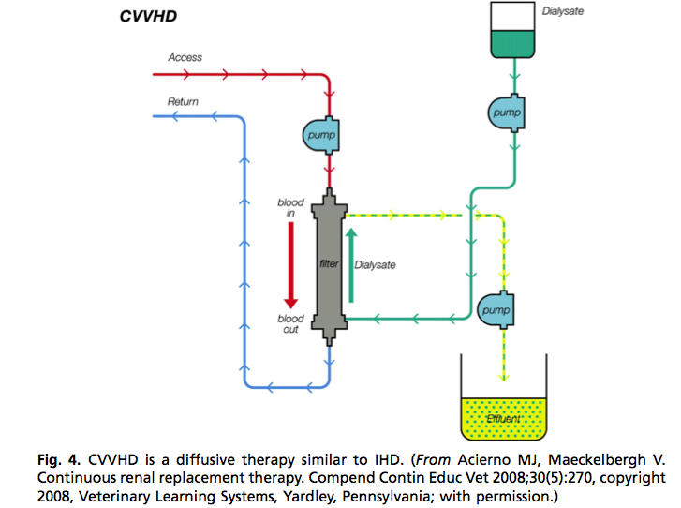
CVVHDF
- Combines the diffusive characteristics of CVHD with the convective properties of CVVH
- Blood enters the dialyzer and is divided into thousands of strawlike semipermeable membranes, which are bathed in the dialysate, while the blood is exposed to a positive transmembrane pressure.
- Diffusion guides the movement of smaller uremic toxins and electrolytes, whereas the positive transmembrane pressure facilitates the movement of fluid and larger molecules.
- A sterile balanced electrolyte solution is used to replace the ultrafiltrate.
- Because the amount of convection and diffusion can be adjusted independently, this modality offers the greatest treatment flexibility.
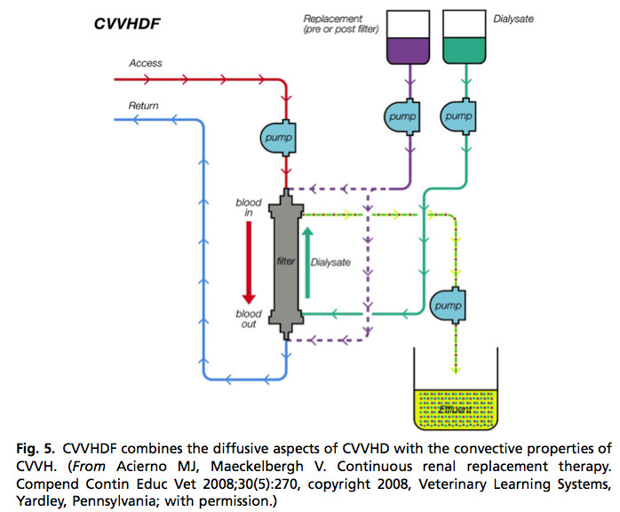

4. Describe the equation Kt/V
- A commonly used measure of CRRT treatment adequacy.
- It represents the urea clearance over time, normalized for the patient’s volume of distribution.
- K represents urea clearance in milliliters per minute.
- Total solute removal per period (Kt) is the product of clearance (K in milliliters per minute) and time (t in minutes) that the patient receives treatment per day.
- Kt is then normalized by dividing urea clearance over time by the patient’s volume of distribution (V in milliliters).
- Urea is approximately equally distributed in all body fluid compartments
- V is equal to total body water in milliliters (60% of body weight in kg x 1000)
- Although studies in companion animals are lacking, the author has found that a Kt/V of 1.4 produces satisfactory reductions in the concentration of urea and provides adequate control of acid-base and electrolyte balance in oliguric and anuric patients

5. List some complications associated with the use of CRRT
- Coagulation issues
  - System clotting
  - Blood loss from clot formation
  - Hemorrhage
- Hypotension
  - Multifactorial
  - May be due to amount of blood needed to fill the system
  - Continuous renal replacement circuits typically require 50 mL to 84 mL of blood to fill the tubing and dialyzer
  - When exposed to acidic blood, these membranes activate bradykinins, which can potentiate life-threatening hemodynamic instability concern when giving blood transfusions in small patients. Fix this problem by treating the blood (as a patient) first
  - Overhydration

6. List indications for dialysis
- Anuria or oliguria
- Life-threatening fluid overload if attempts to induce urine production are unsuccessful
- Life threatening hyperkalemia if attempts to induce urine production are unsuccessful.
- Uremic symptoms, progressive azotemia, or azotemia that does not improve with standard medical therapy are indications for dialysis, even if urine output is adequate or increased

