Hemodialysis – Hyatt

Questions:

- Which sized molecules are more efficiently removed via convection?
  - Small molecules (<500 Da)
  - Medium sized molecules (500-5000 Da)
  - Large sized molecules (>5000 Da)

- Name other uses for dialysis therapy other than to treat renal diseases

- Identify the mode of continuous renal replacement therapy (CRRT) pictured in the following diagrams: 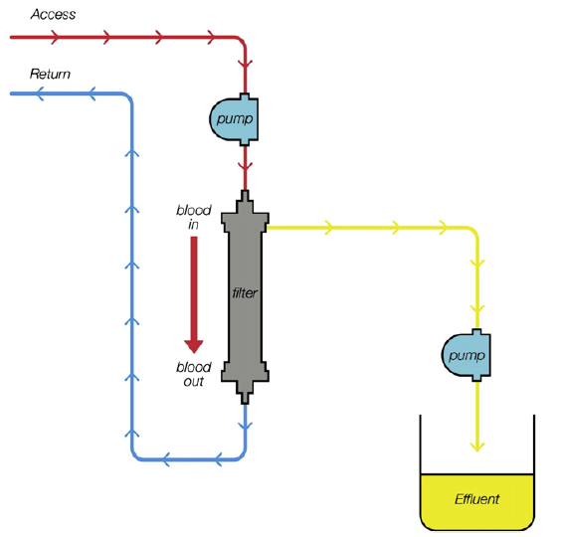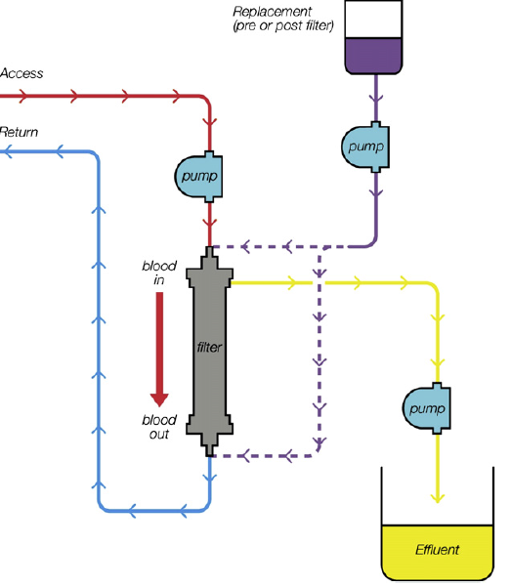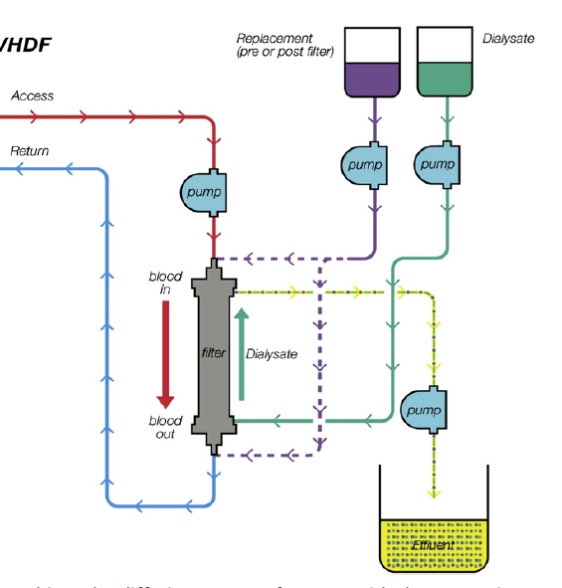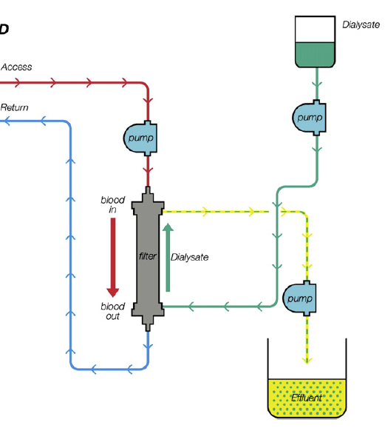

A
D
C
B
- Which of the following is a complication of dialysis unique to peritoneal dialysis?
  - Electrolyte abnormalities
  - Catheter related complications
  - Bleeding
  - Peritonitis

- Identify criteria for discontinuing dialysis.

Answers:

- Which sized molecules are more efficiently removed via convection?
  - Small molecules (<500 Da)
  - Medium sized molecules (500-5000 Da)
  - Large sized molecules (>5000 Da)

Amswer: B - Convective clearance removes solutes by removing the water in which they are dissolved, a process also called solute drag. Middle molecules (500-5000 Da) are more efficiently cleared with convection compared to diffusion. Diffusion is very efficient method for removing small molecules such as urea, sodium, creatinine. (Ch 28 Hemodialysis)

- Name other uses for dialysis therapy other than to treat renal diseases
Ultrafiltration to treat diuretic resistant CHF
Removal of cytokines and inflammatory mediators in sepsis/SIRS
Therapeutic plasmapheresis
Removal of toxins such as ethylene glycol – see tables below

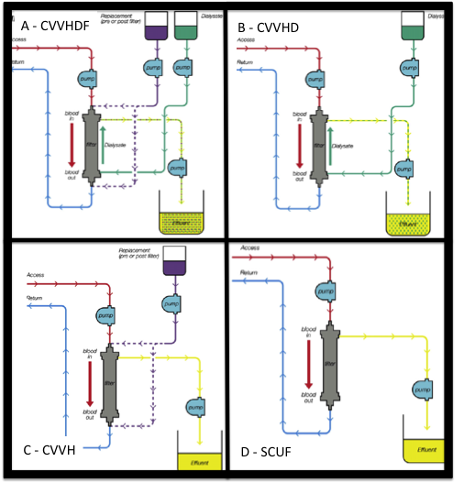
- Identify the mode of continuous renal replacement therapy (CRRT) pictured in the following diagrams:

- Which of the following is a complication of dialysis unique to peritoneal dialysis?
  - Electrolyte abnormalities
  - Catheter related complications
  - Bleeding
  - Peritonitis
Answer – D peritonitis.

- Identify criteria for discontinuing dialysis.
Urine production noted/normalizing
Renal function improved/adequate
Patient clinically improving

