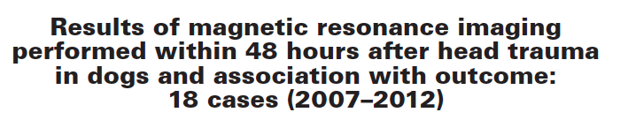
JAVMA, Vol 246, No. 11, June 1, 2015
- 16 had CNS deficit on presentation; GCS from 4-18.
- 18 dogs underwent MRI w/in 48 hours after TBI; 17/18 had evidence of intracranial trauma on MRI.
- Small magnet (0.4T)
- 1/18 dog had intracranial decompression (epidural hemorrhage)
- 3/18 died: recovery from anesthesia for imaging, euthanasia (no improvement), euthanasia (head injuries and spinal fracture).
- 15/18 survived: 1 with major persistent neuro deficits, 9 had full recovery, 5 had minor neuro deficits.
- 13 had intra-axial changes; 13 had extra-axial hemorrhage (*subdural, coup side); epidural hemorrhages were more extensive.
- T2 and FLAIR for intra-axial changes; FLAIR for extra-axial changes.
- Lesions affecting caudal fossa or both rostral and caudal fossae – poorer outcome.

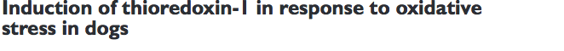
AJVR, Vol 76, No. 6, June 2015
- TRX = small redox protein; present in all cells; defensive protein: antioxidative, antiapoptotic and anti-inflammatory properties.
- Utility: diagnostic (biomarker), prognosis, therapeutic response, treatment.
- 5/10 dogs: 100% O2 for 3 hours; 5/10 : 21% oxygen for 3 hours
- TRX-1 in plasma and in urine and 8-OHdG in urine (compared to creatinine).
- 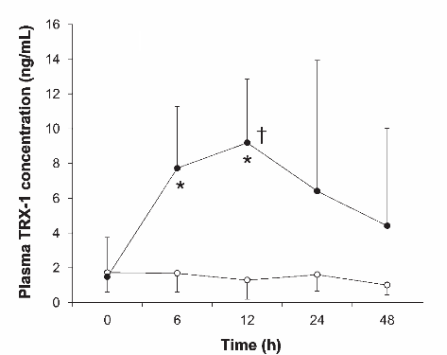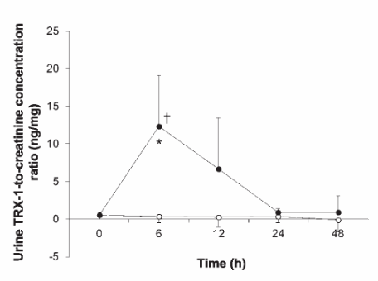
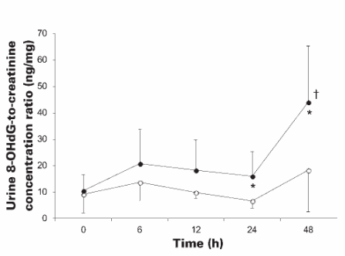
- 100% for 3 hours enough to induce oxidative stress

