QUESTIONS

- Although some patients die during the initial, hyperinflammatory phase of sepsis, most patients succumb at later time points that are associated with a prolonged immunosuppressive state. Which of the following is NOT associated with this immunosuppressive state?
  - Diversion from an initial TH1-cell response to a TH2-cell response
  - Apoptosis of lymphocytes and dendritic cells
  - Apoptosis of neutrophils and macrophages
  - Effect of apoptotic cells

- During sepsis, there is a full-blown, systemic activation of immune responses due to the release of very high levels of _________ , which are recognized by __________

- Which of the following acts as a central mediator in sepsis by modulating other systems?
  - C1a
  - C2a
  - C3a
  - C4a
  - C5a

- What makes MIF unique?
  - It links the immune system with the endocrine system
  - It links the immune system with the coagulation system
  - It links the immune system with the ANS
  - It links the immune system with the complement system

- When does occur the peak of HMGB1 release?
  - During earlier stage of sepsis
  - During mid-stage of sepsis
  - During later-stage of sepsis
  - During the recovery period

- C5a contributes to all of these, EXCEPT one:
  - Multi-organ failure
  - Increased apoptosis
  - Neutrophils dysfunction
  - Hypocoagulability
  - Cardiomyopathy

- Which does not contribute to the development of DIC?
  - Upregulation of the expression of tissue factor
  - Consumption of ATIII
  - Consumption of protein C
  - Consumption of tissue factor pathway activator

- Which one is FALSE regarding protein C?
  - It is activated by thrombin bound to thrombomodulin and by endothelial
protein C receptor (EPCR) on endothelial-cell membranes.
  - Activated protein C binds to its co-factor, protein S, which then results in the inactivation of
clotting factors Xa and Xia
  - It has profound anti-apoptotic and anti-inflammatory properties
  - It exerts pro-fibrinolytic effects by inhibiting PAI1

- A well-known interaction between the complement and coagulation systems is the activation of the
classical complement pathway by coagulation Factor ______, which can activate the complement
component C1.

- Activation of α7-nicotinic acetylcholine
receptors (α7nAChRs), either by vagus-nerve stimulation or by α7nAChR agonists, _______________
intracellular cytokine synthesis by macrophages.

- The early phase of sepsis is characterized by high
concentrations of circulating catecholamines, which boost the initial inflammatory response.
Later in septic shock, the production and release of endogenous catecholamines can become
insufficient for maintaining equilibrium of the cardiovascular system. The depletion of endogenous
catecholamine sources might be caused by the apoptosis of _______________________.

- True or False. Catecholamines are only produced by the neuronal cells of the sympathetic branch of the ANS.

- Complete : ______________ of the cholinergic
vagus nerve and/or _____________of adrenergic pathways might help to restore homeostasis during sepsis

QUESTIONS

- Although some patients die during the initial, hyperinflammatory phase of sepsis, most patients succumb at later time points that are associated with a prolonged immunosuppressive state. Which of the following is NOT associated with this immunosuppressive state?
  - Diversion from an initial TH1-cell response to a TH2-cell response
  - Apoptosis of lymphocytes and dendritic cells
  - Apoptosis of neutrophils and macrophages
  - Effect of apoptotic cells

During sepsis, the adaptive immune response diverts from an initial TH1-cell response (characterized by interferon-γ (IFNγ) and IL-12) production) to a TH2-cell response (characterized by IL-4, IL-5, IL-10 and IL-13 production), which can result in profound immunosuppression. Increased levels of apoptosis in lymphocytes and dendritic cells (DCs) further contribute to the suppression of immune responses during sepsis (by a marked decrease in cell numbers and immunosuppressive effects of apoptotic cells). In contrast to lymphocytes and DCs, the apoptosis of macrophages and neutrophils seems to be unaffected or even decreased during sepsis. Whereas the increased apoptosis of lymphocytes and DCs results in severe immunosuppression, decreased neutrophil apoptosis increases the bystander damage caused by their pro-inflammatory activity.

- During sepsis, there is a full-blown, systemic activation of immune responses due to the release of very high levels of DAMPs , which are recognized by PRRs

During sepsis, there is a full-blown, systemic activation of immune responses due to the release of very high llevels of DAMPs, which leads to the overstimulation of immune cells. As a result, sepsis is accompanied by a markedly imbalanced cytokine response (known as a ‘cytokine storm’), which converts responses that are normally beneficial for fighting infections into excessive, damaging inflammation
DAMPs = damage associated molecular patterns.
PRRs = pattern recognition receptors

- Which of the following acts as a central mediator in sepsis by modulating other systems?
  - C1a
  - C2a
  - C3a
  - C4a
  - C5a

C5a acts as a central mediator in sepsis by modulating other systems — including the coagulation cascade, TLR4-mediated responses and the release of cytokines, such as macrophage migration-inhibitory factor (MIF) and HMGB1.

- What makes MIF unique?
  - It links the immune system with the endocrine system
  - It links the immune system with the coagulation system
  - It links the immune system with the ANS
  - It links the immune system with the complement system

MIF is unique among cytokines in that it links the immune system with the endocrine system. In response to stress, MIF is secreted by the hypothalamus, the anterior pituitary gland and the adrenal glands. Importantly, MIF antagonizes and overrides the anti-inflammatory effects of endogenous steroids, which might have consequences for the well-established use of corticosteroids as a therapy for sepsis. Endogenous corticosteroids induce the release of MIF from immune cells, and so the inhibitory effect of MIF on the action of corticosteroids is a negative-feedback loop. Excessive production of MIF is harmful in the acute phase of sepsis and plasma levels of MIF correlate with sepsis severity.

- When does occur the peak of HMGB1 release?
  - During earlier stage of sepsis
  - During mid-stage of sepsis
  - During later-stage of sepsis
  - During the recovery period

In contrast to other sepsis-associated cytokines, the peak of HMGB1 release occurs during later stages of the disease, and the levels of HMGB1 do not always decrease in patients who have recovered from sepsis.

- C5a contributes to all of these, EXCEPT one:
  - Multi-organ failure
  - Increased apoptosis
  - Neutrophils dysfunction
  - Hypocoagulability
  - Cardiomyopathy

The effects of C5a contribute to immunoparalysis,
multi-organ failure, the apoptosis of thymocytes and adrenal medullary cells, and
imbalances in the coagulation system (tissue factor expression). In addition, C5a is involved in the
development of septic cardiomyopathy. C3a might have anti-inflammatory properties in addition to acting as a pro-inflammatory
anaphylatoxin.

- Which does not contribute to the development of DIC?
  - Upregulation of the expression of tissue factor
  - Consumption of ATIII
  - Consumption of protein C
  - Consumption of tissue factor pathway activator

In sepsis, the pro-inflammatory environment causes mononuclear
cells to upregulate the expression of tissue factor on their cell surface, leading to the systemic
activation of coagulation.The consumption of
various factors that normally regulate the generation of thrombin, such as antithrombin III,
protein C and tissue-factor pathway inhibitor (TFPI), contributes to the development of
DIC.

- Which one is FALSE regarding protein C?
  - It is activated by thrombin bound to thrombomodulin and by endothelial
protein C receptor (EPCR) on endothelial-cell membranes.
  - Activated protein C binds to its co-factor, protein S, which then results in the inactivation of
clotting factors Xa and Xia
  - It has profound anti-apoptotic and anti-inflammatory properties
  - It exerts pro-fibrinolytic effects by inhibiting PAI1

Activated protein C binds to its co-factor, protein S, which then results in the inactivation of
clotting factors Va and VIIIa

- A well-known interaction between the complement and coagulation systems is the activation of the
classical complement pathway by coagulation Factor XIIa , which can activate the complement
component C1.
More recently, it has been shown that thrombin can function as a C5
convertase in a C3-independent manner. This crosstalk is particularly interesting, not only
because thrombin and C5a are central factors in their respective cascades, but also because this
indicates that C5a and the MAC can be generated in the absence of upstream complement activation.

- Activation of α7-nicotinic acetylcholine
receptors (α7nAChRs), either by vagus-nerve stimulation or by α7nAChR agonists, decreases/increases
intracellular cytokine synthesis by macrophages.

Inflammation is under neuronal control by the ANS, which can
reflexively modulate the inflammatory response by inhibiting the production of pro-inflammatory cytokines. This concept has therefore been termed the ‘inflammatory reflex’.
The efferent arm of the inflammatory reflex is the cholinergic anti-inflammatory pathway,
which is a robust regulator of cytokine production.

- The early phase of sepsis is characterized by high
concentrations of circulating catecholamines, which boost the initial inflammatory response.
Later in septic shock, the production and release of endogenous catecholamines can become
insufficient for maintaining equilibrium of the cardiovascular system. The depletion of endogenous
catecholamine sources might be caused by the apoptosis of adrenal medullary cells.

- True or FALSE. Catecholamines are only produced by the neuronal cells of the sympathetic branch of the ANS.

It has now been shown that leukocytes are an abundant source of catecholamines. Recent research has shown that the gut can produce large amounts of catecholamines during
sepsis, which are released into intestinal blood.

- Complete : stimulation of the cholinergic
vagus nerve and/or suppression of adrenergic pathways might help to restore homeostasis during sepsis

Sepsis is a heterogeneous, dynamic syndrome caused by imbalances in the “inflammatory network”.

After being triggered by an overwhelming initial stimulus, neutrophils and macrophages produce and respond to cytokines, chemokines, complement-activation products and other mediators. This pro-inflammatory environment causes the release of powerful secondary mediators (such as lipid factors and reactive oxygen species) that further amplify the inflammatory process. The malfunction of regulatory mechanisms during sepsis can result in a loss of control of inflammation, eventually leading to host damage due to overzealous activation of the inflammatory response.

Although some patients die during the initial, hyperinflammatory phase of sepsis, most patients succumb at later time points that are associated with a prolonged immunosuppressive state. Neutrophils can undergo ‘immune paralysis’ during sepsis, which involves a complete shut-down of important intracellular signaling pathways, and dysfunction of the adaptive immune system is also an important contributing factor to the immunosuppression that is observed in the later stages of sepsis. T cells are thought to orchestrate the inflammatory response, particularly CD4+ T helper 1 (TH1) cells and TH2 cells, which have distinct cytokine profiles. During sepsis, the adaptive immune response diverts from an initial TH1-cell response (characterized by interferon-γ (IFNγ) and IL-12) production) to a TH2-cell response (characterized by IL-4, IL-5, IL-10 and IL-13 production), which can result in profound immunosuppression. TH17 cells, a subset of TH cells that produces IL-17 has recently been discovered. TH17 cells are thought to be important for immunity to microorganisms that are not eliminated by TH1- or TH2-cell-mediated immune responses.

Increased levels of apoptosis in lymphocytes and dendritic cells (DCs) further contribute to the suppression of immune responses during sepsis (by a marked decrease in cell numbers and immunosuppressive effects of apoptotic cells). In contrast to lymphocytes and DCs, the apoptosis of macrophages and neutrophils seems to be unaffected or even decreased during sepsis. Whereas the increased apoptosis of lymphocytes and DCs results in severe immunosuppression, decreased neutrophil apoptosis increases the bystander damage caused by their pro-inflammatory activity. Recent data indicate that T-cell-mediated suppression of the early innate immune response is required to minimize damage to the host and maximize the host defense response.

None of the promising therapeutic approaches for sepsis that targets the inflammatory response has been successfully translated to the clinical setting, and rates of sepsis mortality have not decreased. In addition, it is now clear that the belief that a single key mediator causes sepsis, and that neutralization of such a factor could be a cure for all patients with sepsis, is erroneous. Instead, we now understand that sepsis is a complex, dynamic syndrome with great heterogeneity, and not a distinct disease.

Initiation of the inflammatory response
The early phase of sepsis, which is caused by the excessive activation of the host pathogen-recognition system by large-scale tissue damage and/or severe infection, leads to severe dysregulation of various body systems as a result of the pro-inflammatory environment.

Patterns recognition receptors (PRRs) – which include TLRs – detect tissue damage or microbial infection and initiate host defense responses. PRRs recognized pathogen-associated molecular patterns (PAMPs) – associated with microorganisms - and intracellular proteins or mediators (alarmins) - released from dying cells. PAMPS + alarmins = DAMPs = damage associated molecular patterns.
During sepsis, there is a full-blown, systemic activation of immune responses due to the release of very high levels of DAMPs, which leads to the overstimulation of immune cells. As a result, sepsis is accompanied by a markedly imbalanced cytokine response (known as a ‘cytokine storm’), which converts responses that are normally beneficial for fighting infections into excessive, damaging inflammation
LPS recognized by TLR4 and MD2 receptor complex –TLR4-MD2-CD14 inflammatory response

Important crosstalk between TLR4 and the complement system.

Activation of TLR4 in platelets initiates the formation of neutrophil extracellular traps to ensnare bacteria in the vasculature further demonstrates the intricate interplay between innate immunity and the clotting system in sepsis.

Harmful central hubs in sepsis
Not only invading microorganisms are involved in the pathogenesis of sepsis – inflammatory mediators are also involved.

C5a acts as a central mediator in sepsis by modulating other systems — including the coagulation cascade, TLR4-mediated responses and the release of cytokines, such as macrophage migration-inhibitory factor (MIF) and HMGB1.

MIF: Bacterial endo- and exotoxins, and pro-inflammatory mediators — such as tumour-necrosis factor (TNF), IFNγ and C5a — are strong inducers of MIF secretion by leukocytes. MIF is constitutively expressed by leukocytes and stored intracellularly. MIF functions as a classical pro-inflammatory cytokine and promotes innate and adaptive immune responses by activating macrophages and T cells. MIF also induces and amplifies the production of other pro-inflammatory cytokines and upregulates the expression of TLR4 by phagocytes. MIF prevents the p53-dependent apoptosis of activated macrophages. MIF is unique among cytokines in that it links the immune system with the endocrine system. In response to stress, MIF is secreted by the hypothalamus, the anterior pituitary gland and the adrenal glands. Importantly, MIF antagonizes and overrides the anti-inflammatory effects of endogenous steroids, which might have consequences for the well-established use of corticosteroids as a therapy for sepsis. Endogenous corticosteroids induce the release of MIF from immune cells, and so the inhibitory effect of MIF on the action of corticosteroids is a negative-feedback loop. Excessive production of MIF is harmful in the acute phase of sepsis and plasma levels of MIF correlate with sepsis severity. Promising therapeutic target.

HMGB1: pro-inflammatory cytokine. HMGB1 is expressed by almost all cell types, except those lacking a nucleus (such as erythrocytes), and the main sources of HMGB1 in inflammation are macrophages, monocytes and neutrophils. Secreted by immune cells or released by necrotic cells. Active secretion of HMGB1 is regulated by nuclear factor-κB (NF-κB) activation. Apoptotic cells are not a source of extracellular HMGB1 but they cause macrophages to release HMGB1 during sepsis. Extracellular HMGB1 specifically interacts with PRRs, including the receptor for advanced glycation end-products (RAGE), TLR2 and TLR4. In addition to the activation of PRRs, HMGB1 increases the pro-inflammatory activity of cytokines (such as IL-1β) through binding to these mediators, which supports the idea that HMGB1 might not act solely as a pro-inflammatory mediator, but might also function as a carrier or DAMP. Although HMGB1 is released systemically during sepsis, plasma levels do not necessarily correlate with outcome or survival. In contrast to other sepsis-associated cytokines, the peak of HMGB1 release occurs during later stages of the disease, and the levels of HMGB1 do not always decrease in patients who have recovered from sepsis. Pathogen-derived molecules and pro-inflammatory stimuli (such as TNF, IL-1β and IFNγ) induce the secretion of HMGB1 during inflammation. Interaction between C5a and its other receptor, C5a-like receptor 2 (C5L2), also triggers the release of HMGB1 in sepsis. Interestingly, HMGB1 secretion is under the influence of the ANS. Activation of the cholinergic anti-inflammatory pathway suppresses HMGB1 secretion by macrophages in sepsis and improves survival. Promising therapeutic target.

IL17a : pro-inflammatory cytokine that is mainly produced by TH17 cells. IL-17A is also secreted by various other types of immune cell. In brief, IL-17A is involved in mediating pro-inflammatory responses by triggering the production of many other cytokines (such as IL-1β, IL-6 and TNF) and provides crosstalk between lymphocytes and phagocytes. Because the production of IL-17 is important for directing the immune response against some specific infections, the blockade of IL-17A under certain conditions might cause more harm than good. Therefore, it remains to be determined whether IL-17A is a useful target for therapeutic intervention in sepsis.

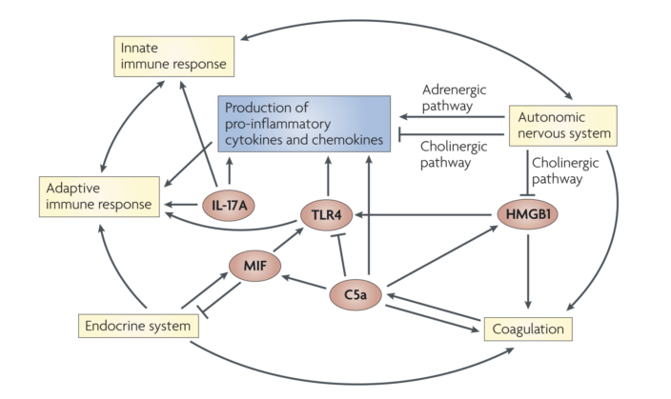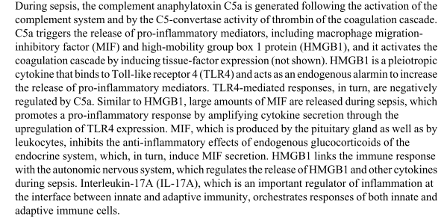

Dysregulation of plasmatic cascades

Complement:
The complement system can be activated through three different pathways, which converge
on the generation of the anaphylatoxins C3a and C5a, C4a and the membrane-attack complex
(MAC; also known as C5b–C9).
In clinical studies of sepsis, increased concentrations of C3a, C4a and C5a in the plasma have been linked to poor outcome and survival.Interestingly,
C3a might have anti-inflammatory properties in addition to acting as a pro-inflammatory
anaphylatoxin.
Binding of C3a to C3AR can trigger the secretion of anti-inflammatory hormones by
the pituitary gland, which might account for the anti-inflammatory properties of C3a.
The effects of C5a contribute to immunoparalysis,
multi-organ failure, the apoptosis of thymocytes and adrenal medullary cells, and
imbalances in the coagulation system. In addition, C5a is involved in the
development of septic cardiomyopathy. Decreased pressure in the left ventricle of the heart
has been observed following sepsis, accompanied by defective contractility of cardiomyocytes;
both of these effects were reversed by administration of a C5a-specific blocking antibody.
In addition to C5AR, C5a can bind specifically to a
second receptor, C5L2. In human sepsis, the expression of C5L2 was downregulated on the surface of neutrophils
during septic shock. The extent of this downregulation correlated with the development of
multi-organ failure, which indicates that C5L2 contributes to the pathogenesis of sepsis.
There is now evidence that C5AR and C5L2 cooperatively enhance the inflammatory response
during sepsis, although each receptor might have specific and distinct functional roles. For
example, C5a-induced release of MIF depends on C5AR signalling, whereas C5L2 mediates the C5a-dependent release of HMGB1 from phagocytes. Importantly, blockade of either
receptor protects against lethality in moderate forms of sepsis, but only the inhibition of both
C5a receptors provides protection in severe sepsis.
C5a might be a
promising target for pharmaceutical intervention in sepsis. The advantage of this strategy is
that the inhibition of the harmful effects of C5a does not interfere with the assembly of the
MAC, which is essential for defense against invading microorganisms.
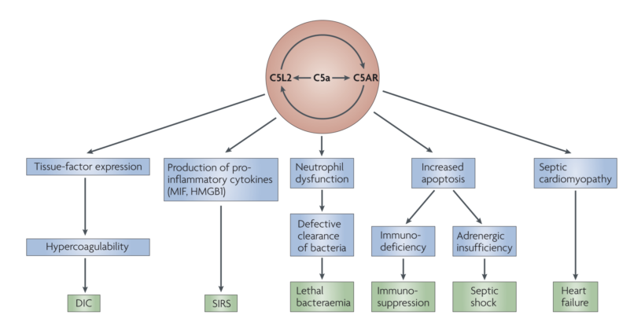
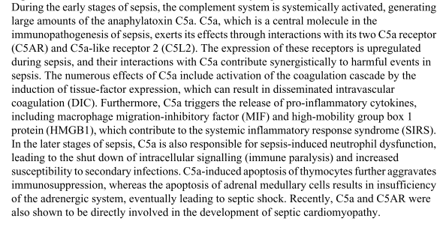
Coagulation:
Activated thrombin can promote the
activation of various pro-inflammatory pathways — including the production of pro-inflammatory cytokines (such as TNF, IL-1β and IL-6) and the generation of C5a — and cytokines, in turn, can stimulate coagulation. Tissue factor, which is a central molecule
in the initiation of DIC, is expressed by activated endothelial cells and by cells that are not
normally exposed to blood flow, such as sub-endothelial cells and fibroblasts, and also by
circulating immune cells. In sepsis, the pro-inflammatory environment causes mononuclear
cells to upregulate the expression of tissue factor on their cell surface, leading to the systemic
activation of coagulation.

Another consequence of DIC is the inhibition of fibrinolysis:
increased levels of plasminogen-activator inhibitor 1 (PAI1) and thrombin-activatable
fibrinolysis inhibitor (TAFI) lead to impaired removal of fibrin. Also, the consumption of
various factors that normally regulate the generation of thrombin, such as antithrombin III,
protein C and tissue-factor pathway inhibitor (TFPI), contributes to the development of
DIC

Recombinant activated protein C is currently the only approved drug for the treatment of sepsis
that targets the inflammatory response. Protein C is activated by thrombin bound to thrombomodulin and by endothelial
protein C receptor (EPCR) on endothelial-cell membranes. After dissociation from EPCR,
activated protein C binds to its co-factor, protein S, which then results in the inactivation of
clotting factors Va and VIIIa. Activated protein C
has profound anti-apoptotic and anti-inflammatory properties. It markedly decreases the
apoptosis of endothelial cells and lymphocytes and exerts pro-fibrinolytic effects by inhibiting PAI1. The anti-inflammatory effects of activated protein C are mediated by EPCR
apoptosis of endothelial cells and lymphocytes and exerts pro-fibrinolytic effects by inhibiting PAI1. The anti-inflammatory effects of activated protein C are mediated by EPCR
and the cleavage of protease-activated receptor 1 (PAR1), which has a central role in linking coagulation and inflammation.
The protein-C pathway is particularly susceptible to inhibition by inflammatory responses in
sepsis-associated DIC. In addition to a decrease in the level of protein C, the downregulation,
shedding and cleavage of thrombomodulin and EPCR are the main causes of dysfunction of
the protein-C pathway. HMGB1 inhibits the protein-C pathway by interfering with the
thrombin–thrombomodulin complex and it also promotes coagulation by stimulating tissue-factor expression and inhibiting tissue plasminogen activator (TPA).
The administration of activated protein C in sepsis suppresses pro inflammatory cytokine
production and decreases the adhesion of phagocytes to injured endothelium through EPCR- and PAR1-dependent signaling. However, the anticoagulant activity of activated protein
production and decreases the adhesion of phagocytes to injured endothelium through EPCR- and PAR1-dependent signaling. However, the anticoagulant activity of activated protein
C might exacerbate bleeding complications in patients who usually have a compromised
clotting system.

THE LINK BETWEEN COMPLEMENT AND COAGULATION
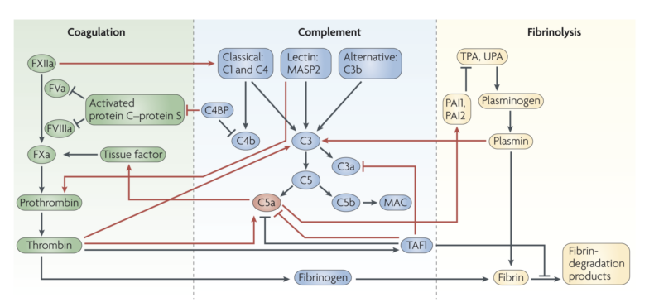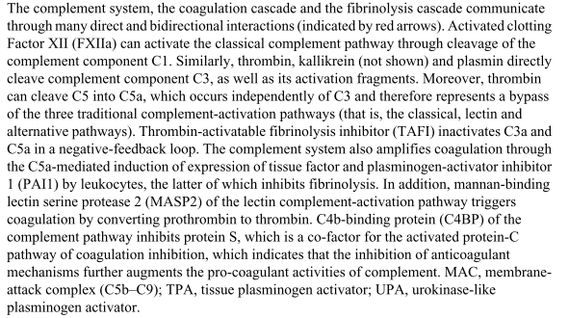
A well-known interaction between the complement and coagulation systems is the activation of the
classical complement pathway by coagulation Factor XIIa, which can activate the complement
component C1. More recently, it has been shown that thrombin can function as a C5
convertase in a C3-independent manner. This crosstalk is particularly interesting, not only
because thrombin and C5a are central factors in their respective cascades, but also because this
indicates that C5a and the MAC can be generated in the absence of upstream complement activation.
Kallikrein and plasmin directly cleave C3 and its activation fragments. In an indirect negative-feedback loop, thrombin-activated TAFI inactivates
activation.

The complement system amplifies coagulation by modification of phospholipid membranes, by activating platelets and by inducing the expression of tissue factor and PAI1 by leukocytes. In
addition, mannan-binding lectin serine protease 2 (MASP2), a protease that is characteristic
of the lectin pathway of complement activation, can activate coagulation by cleaving
prothrombin into active thrombin. The pro-coagulant activities of complement are increased
when anticoagulant mechanisms are inhibited; for example, the formation of a complex
between C4b-binding protein and protein S results in a decrease in the availability of protein
S to act as a co-factor for the anticoagulant protein-C pathway.

THE AUTONOMIC NERVOUS SYSTEM
Communication between the nervous system and the immune system during inflammation.
Main pathways:
hypothalamic–pituitary–adrenal axis and the ANS
Immune
cells can also synthesize and release neurotransmitters and express receptors for these mediators.

Parasympathetic system
Inflammation is under neuronal control by the ANS, which can
reflexively modulate the inflammatory response by inhibiting the production of pro-inflammatory cytokines. This concept has therefore been termed the ‘inflammatory reflex’.
The efferent arm of the inflammatory reflex is the cholinergic anti-inflammatory pathway,
which is a robust regulator of cytokine production.
The spleen is an important source
of TNF during sepsis and splenectomy significantly decreases systemic and hepatic levels of TNF in septic mice.

Sympathetic system
The early phase of sepsis is characterized by high
concentrations of circulating catecholamines, which boost the initial inflammatory response.
Later in septic shock, the production and release of endogenous catecholamines can become
insufficient for maintaining equilibrium of the cardiovascular system (as indicated by the need
for catecholamine administration during septic shock). The depletion of endogenous
catecholamine sources might be caused by the apoptosis of adrenal medullary cells. It has now been shown that leukocytes are an abundant source of catecholamines. Leukocytes also express adrenergic
receptors, which indicates that catecholamines might have autocrine and/or paracrine effects on immune cells. The activation of adrenergic receptors on immune cells triggers distinct and finely tuned cytokine responses through NF-κB-dependent mechanisms.
During sepsis, catecholamines exert immunomodulatory effects through α- and β-adrenergic receptors that are expressed by immune cells. Stimulation of these receptors alters
lymphocyte trafficking, vascular perfusion and cell proliferation and apoptosis, thereby
affecting the functional responses of leukocytes. The response of neutrophils and
macrophages in particular underlies adrenergic regulation by catecholamines, as the release of
pro-inflammatory cytokines by these cells is tightly regulated by α-adrenergic receptors. Catecholamines might also contribute to the deleterious effects of sepsis through direct
stimulation of bacterial growth in the gastrointestinal system, which might contribute to
bacteraemia through the translocation of enteric bacteria into the lymphatic and blood
compartments.

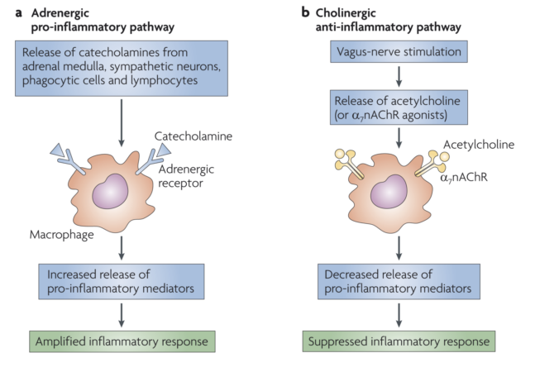
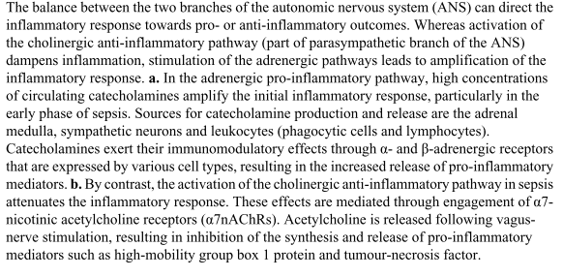
Enteric system
Recent research has shown that the gut can produce large amounts of catecholamines during
sepsis, which are released into intestinal blood. Catecholamines that drain from the
intestines through the portal vein into the liver can alter the functional state of Kupffer cells
and hepatocytes through α2-adrenergic receptor signaling, ultimately contributing to the release of pro-inflammatory cytokines, hepatocellular dysfunction and liver failure.
Catecholamine-induced activation of Kupffer cells might also be an important source of the
cytokine storm during sepsis.

ANS-TARGETED THERAPY
Given that an imbalance between these two
branches of the ANS contributes to the development of sepsis, stimulation of the cholinergic
vagus nerve and/or suppression of adrenergic pathways might help to restore homeostasis.
