Questions:
1. True or False: Cats falling 7 stories or more flex their limbs leading to less limb fractures and more thoracic trauma.
2. The terminal velocity of a cat falling with its limbs extended is
a. 20 mph (33 km/h)
b. 40 mph (65 km/h)
c. 60 mph (100 km/h)
d. 100 mph (130km/h

3. The leading cause of death of dogs killed in action from GSWs was
a. Head wound
b. Thoracic wound
c. Abdominal wound
d. Sepsis
4. True or False: There was a strong correlation between the Animal Trauma Triage Score and the time to Return to Duty (RTD).

5. What percentage of dogs received crystalloids prior to arrival to veterinary care
a. 0%
b. 30%
c. 70%
d. 90%

6. In dogs involved in motor vehicle accidents the most commonly traumatized abdominal organ is
a. Spleen
b. Kidney
c. Bladder
d. Liver

Questions and answers:
1. True or False: Cats falling 7 stories or more flex their limbs leading to less limb fractures and more thoracic trauma.
2. The terminal velocity of a cat falling with its limbs extended is
a. 20 mph (33 km/h)
b. 40 mph (65 km/h)
c. 60 mph (100 km/h)
d. 100 mph (130km/h

3. The leading cause of death of dogs killed in action from GSWs was
a. Head wound
b. Thoracic wound
c. Abdominal wound
d. Sepsis
4. True or False: There was a strong correlation between the Animal Trauma Triage Score and the time to Return to Duty (RTD).

5. What percentage of dogs received crystalloids prior to arrival to veterinary care
a. 0%
b. 30%
c. 70%
d. 90%

6. In dogs involved in motor vehicle accidents the most commonly traumatized abdominal organ is
a. Spleen
b. Kidney
c. Bladder
d. Liver
SACCM Chapter on Abdominal and Thoracic Trauma

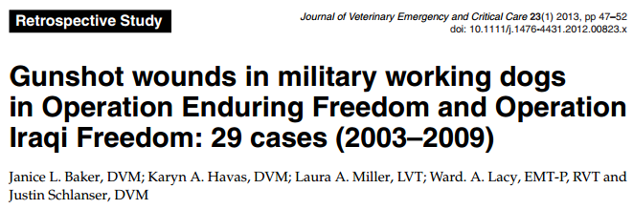
- Twenty-nine dogs were injured between 2003 and 2009
- All but one of the injuries were from high caliber, high velocity weapons
- Of the 29 injured dogs, 11 survived the injuries and 18 died (38% survival rate)
- All but 1 died from catastrophic nonsurvivable injuries before treatment or evacuation could be instituted
- The thorax was the most common site of injury (50%) followed by extremity wounds (46%)
- The leading cause of death from GSWs was from thoracic wounds, followed by head wounds
- This initial data suggest that dogs that incur serious, but potentially survivable GSW injury in combat that receive immediate and appropriate treatment at the point of injury are likely to survive and return to full duty
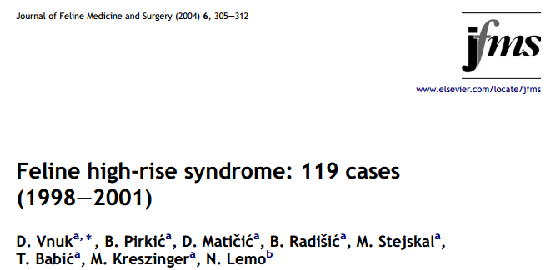
- 96.5% of the presented cats, survived after the fall
- 46.2% of cats had fractured limbs
- 38.5% of fractures were of the forelimb, 61.5% of the hindlimb
- Thoracic trauma was diagnosed in 33.6% of cats
- Pneumothorax was diagnosed in 20% of cats, and pulmonary contusions in 13.4%
- Falls from the seventh or higher stories, are associated with more severe injuries and with a higher incidence of thoracic trauma
- In 6 cats euthanasia was carried out; in 2 cases because of the poor prognosis (vertebral fractures/luxations), and in 4 cases because of the cost of treatment
- 4 cats died within first 36 hours
- Fractures of the mandible were diagnosed in 4 cats, and all were fractures of the symphysis
- Hard palate fractures were recorded in 6 cats
- In a previous study the severity of injuries rises linearly up to the seventh storey, after that height, the severity of injuries does not rise and and the incidence of fractures decreases

