Liu et Silverstein (2014) Feline secondary spontaneous pneumothorax: A retrospective study of 16 cases (2000–2012). JVECC 24(3): 316-325
-Retrospective study of 16 client owned cats.

Main Points
- The existence of primary spontaneous (idiopathic) pneumothorax has not been documented in cats. Most commonly a single underlying etiology leading to secondary spontaneous pneumothorax (SSP) has been reported in cats. The leakage of air is thought to occur from ruptured bullae or porous diseased pulmonary parenchyma and pleural surfaces.
  - Documented cases in cats include asthma, heartworm infection, neoplasia, PTE, pulmonary abscess, pneumonia secondary to Aelurostrongylus abstrusus and salmonellosis, and ruptured bullae

In contrast, canine spontaneous pneumothorax is most commonly caused by bullous emphysema, and mortality is reduced following surgery.

- Asthma was the most common cause of feline spontaneous secondary pneumothorax (25%). This finding is similar in other studies. Cats with AASSP had good short term prognosis (discharge from hospital).

- Cats that were not immediately euthanized (2) or discharged AMA (2) were treated medically.
  - 83% of cats with SSP survived to discharge from hospital, 25% had recurrence of SSP.
  - Treated with thoracocentesis, glucocorticoids, bronchodilators, antimicrobials, anthelmintics, analgesics, and sedatives.

- Most common findings
  - Most predominant presenting complaint: dyspnea > coughing > sneezing.
  - Most predominant physical exam finding: dyspnea and abnormal lung sounds
  - Bloodwork: AST activity increased in 90% of cats – skeletal or cardiac muscle damage secondary to hypoxia and associated peripheral vasoconstriction most likely cause
  - Thoracic radiographs: distribution pattern diffuse in 88% of cats. All cats had pneumothorax with associated atelectasis. Pulmonary alveolar infiltrates present in 75% of cats.
  - Cytological evaluation (5 cats): most common was neutrophilic or suppurative inflammation
  - Gross inspection of lung at necropsy or during surgery: 4/5 cats had disease affecting multiple lung lobes

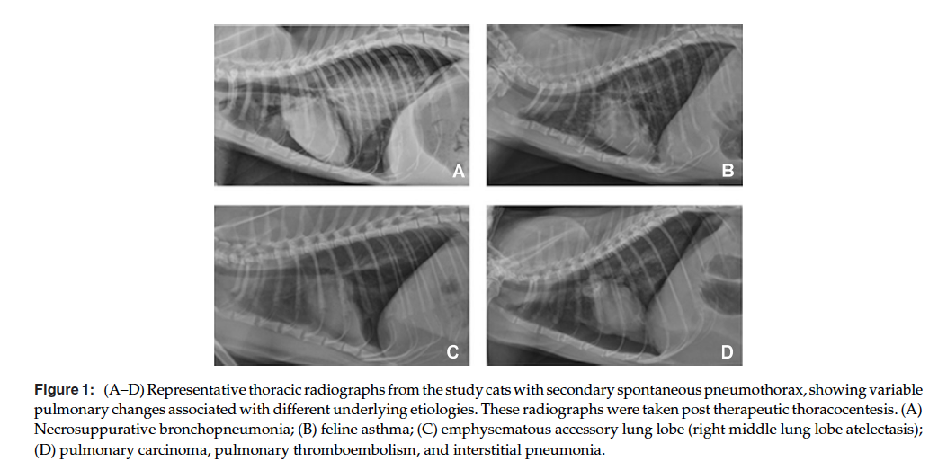
Questions
- Documented cases leading to secondary spontaneous pneumothorax in cats include:
  - Blunt trauma
  - Capillaria aerophila infection
  - General anesthesia
  - Heart worm infection

- True or False. Asthma is the most common cause of feline spontaneous secondary pneumothorax.

- What was the most common presenting complaint in cats with secondary spontaneous pneumothorax
  - Dyspnea
  - Lethargy
  - Ocular discharge
  - Coughing

- Spontaneous pneumothorax was most common during the months of
  - January -April
  - April - July
  - August - December
  - June – September

- What was the most common acid base disturbance found in cats with secondary spontaneous pneumothorax
  - Metabolic acidosis
  - Respiratory acidosis
  - Metabolic alkalosis
  - Respiratory alkalosis

- True or False. Cats with AASSP had different clinical signs and physical exam findings that those with NAASSP.

Questions and Answers
- Documented cases leading to secondary spontaneous pneumothorax in cats include:
  - Blunt trauma
  - Capillaria aerophila infection
  - General anesthesia
  - Heart worm infection

- True or False. Asthma was the most common cause of feline spontaneous secondary pneumothorax
Thoracic radiographs, cytology of airway fluid sample, or close observation of clinical response to glucocorticoids were necessary adjuncts to the diagnosis of asthma associated SSP as similar clinical signs and physical exam findings occurred in non asthma-associated SSP.

- What was the most common presenting complaint in cats with secondary spontaneous pneumothorax
  - Dyspnea
  - Lethargy
  - Ocular discharge
  - Coughing

- Spontaneous pneumothorax was most common during the months of
  - January -April
  - April - July
  - August - December
  - June – September
Besides the natural progression of underlying pulmonary pathology individually, environmental factors (eg, changes in ambient temperature, humidity, pollen concentration, atmospheric pressure and wind speed, and thunderstorm events) have been suggested to contribute to the cluster occurrence of spontaneous pneumothorax in people.
The link of these environmental conditions to the initiation of spontaneous pneumothorax is not well understood. Some of these environment factors elicit increased airway mucus secretion or retention, bronchospasm, bronchiolitis, and coughing; they are shared contributors to the seasonality of asthma attacks in people.
In this study was not statistically analyzed so incidence in cats remains unknown.

- What was the most common acid base disturbance found in cats with secondary spontaneous pneumothorax
  - Metabolic acidosis
  - Respiratory acidosis
  - Metabolic alkalosis
  - Respiratory alkalosis

- True or False. Cats with AASSP had very different clinical signs and PE findings that those with NAASSP.
Thoracic radiographs, cytology or airway fluid sample, or close observation of clinical response to glucocorticoids were necessary adjuncts to the diagnosis of asthma associated SSP as similar clinical signs and PE findings occurred in NAASSP

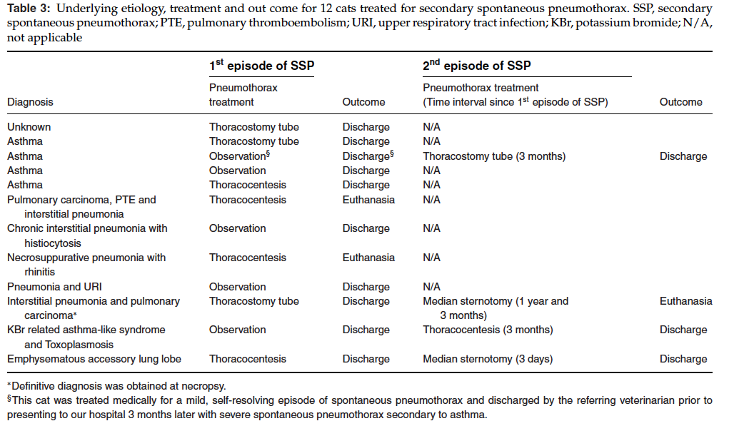

Nakamura et al (2008) Non-coagulopathic spontaneous hemothorax in dogs. JVECC 18(3): 292-297
-Retrospective study of 16 client owned dogs

Main Points
- Traumatic injuries and coagulopathies appear to be the most common causes of hemothorax in the dog.

- The most common cause of non-coagulopathic spontaneous hemothorax in dogs was neoplasia (88%). The development of non-coagulopathic spontaneous hemothorax warrants a high-index suspicion for neoplasia, in particular thoracic wall neoplasia.
- Histologic diagnosis (7/14): Hemangiosarcoma, malignant mesothelioma, metastatic ovarian carcinoma, osteosarcoma, and pulmonary carcinoma.
- An intrathoracic mass was visualized in other 7 dogs (50%) - histopathology was not obtained.
  - Thoracic masses involved ribs and sternum; right atrial mass
  - Surgical therapy may be curative or result in a lengthy remission
  - MST reported for conservative management: 15 days for rib OSA; 5 weeks for rib sarcomas.
- 2 non neoplastic causes: lung lobe torsion, pancreatitis

- Most common findings
- Presenting signs: tachypnea and lethargy, typically of <1-week duration.
- CBC: anemia (63%), thrombocytopenia (81%)
- Biochemistry: elevated AST, ALP, amylase

- In contrast to human medicine, the bleeding rate appears less catastrophic as only 3 dogs received packed red cell transfusions.
- Rate of blood loss into the pleural cavity was slow or the red cell regeneration was able to compensate.
- Another hypothesis is that intrathoracic hemorrhage increases intrapleural hydrostatic pressure, preventing further bleeding.

Questions
- Most common presenting sign(s) for dogs with non-coagulopathic spontaneous hemothorax was/were:
  - Tachypnea and lethargy
  - Increased respiratory effort and rate
  - Anorexia
  - Weakness and collapse

- Hemothorax is defined as an effusion in the pleural cavity with a packed cell volume (PCV) that is at least ______ of peripheral blood.
  - 15%
  - 25%
  - 50%
  - 60%

- True or False. Pancreatitis has been associated with pleural effusion in dogs.

- True or False. Lung lobe torsion has been commonly reported to cause hemorrhagic effusion in dogs.

Questions and Answers
- Most common presenting sign(s) for dogs with non-coagulopathic spontaneous hemothorax was/were:
  - Tachypnea and lethargy
  - Increased respiratory effort and rate
  - Anorexia
  - Weakness and collapse

- Hemothorax is defined as an effusion in the pleural cavity with a packed cell volume (PCV) that is at least ______ of peripheral blood.
  - 15%
  - 25%
  - 50%
  - 60%

- True or False. Pancreatitis has been associated with pleural effusion in dogs.
In pancreatitis, active pancreatic enzymes and inflammatory mediators are released into pancreatic tissues and blood vessels. Trypsin, which converts proelastin to elastase, is an important mediator in this process. Elastase subsequently digests elastic fibers in pancreatic blood vessels transforming pancreatitis from an edematous to hemorrhagic form. Trypsin also releases bradykinin, which produces a profound local vasodilation and increased vascular permeability further permitting escape of red blood cells into body cavities. Systemic release of elastase and bradykinin may have precipitated the hemothorax that developed in this dog.

- True or False. Lung lobe torsion has been commonly reported to cause hemorrhagic effusion in dogs.
Lung lobe torsion has been uncommonly reported to cause hemorrhagic effusion in dogs

