ECMO in cardiac arrest
- Recover guidelines recommendation: ECMO is not covered in the guidelines.

- How it works:
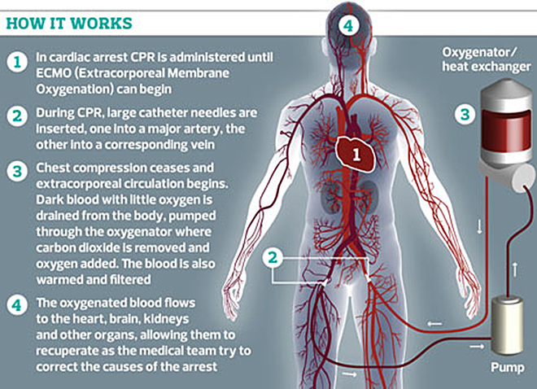
ECMO can be used to restore flow in patients not responding to classical resuscitation procedures.

Stages to placing a patient on ECMO:
Stage I: get catheters into a femoral artery and femoral vein (CPR continues)
Stage II: exchange these catheters for the enormous ECMO catheters via guidewire and serial dilations
Stage III: attach them to the ECMO machine; stop CPR

- Utility of ECMO:
  - Recommended in refractory cardiac arrest secondary to intoxication.
    - 17 patients, 24% survival (very long time before initiation of ECMO)
    - 7 patients, 71% survival (also very long time to ECMO initiation – 101±55 minutes)
  - ECMO for in-hospital cardiac arrest
    - Survival: 50% (initiated within 30 minutes), 30% (30-60 minutes), 18% (60 minutes)
    - vs survival with conventional CPR: 20%, 9%, 0%, respectively
    - The longer the time before initiation of ECMO, the poorer the outcome.
  - ECMO for out-of-hospital cardiac arrest
    - Good outcome in 15-20% of the patients
    - Time from CPA to ECMO: the shorter the better.
  - Recommended for young patients, without co-morbidities, with a reversible problem and high chance of recovery. Patient selection is very important.
  - Good quality CPR before initiation of ECMO is very important – in people they can use mechanical CPR
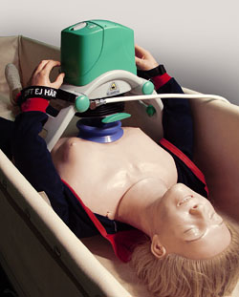I don’t think that kind of device will ever be available for veterinary patients due to the large variation in chest conformation of our patients.
  - Brain protection and prevention of the post-resuscitation syndrome (generation of ROS and IRI): hypothermia and prevention of hyperoxia – ECMO flow can be initiated with a relatively low oxygen fraction.

- My recommendation:
  - ECMO in cardiac arrest seems to be useful in selected patients when they have reversible cause of CPA. High incidence of acute coronary syndrome in cardiac arrest patients, which have good outcome with postresuscitation percutaneous coronary intervention (not a common cause of CPA in dogs and cats). After initiation of ECMO: need to identify the cause of the arrest and treat it; treat the underlying disease
  - Median duration of ECMO support was 2 days (1-5 days) = long duration, $$; will our clients want that kind of intervention for their animals?
  - Expertise and equipment.

