Clinical Physiology of Acid-Base and Electrolyte Disorders – chapters 1&2

Questions

1. Please name the 3 layers through which the filtrate must pass (3 layers of the glomerular capillary wall)

2. Angiotensin II constricts the ______________(afferent or efferent) arteriole more than the ____________(afferent or efferent) arteriole. The net effect is _____________(an elevation or a reduction or no change) in renal blood flow and ________________ (an elevation or a reduction or no change) in the hydraulic pressure in the glomerular capillary, which tends to ___________ (increase or decrease or maintain) the GFR. Excessive renal vasoconstriction is minimized because angiotensin II also stimulates the release of __________________ from the glomerulus.

3. What would be the effect on GFR, P_{gc} and RPF with vasoconstriction of the afferent arteriole?
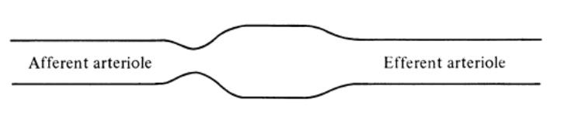

4. Please choose the correct statement.
A. Tubuloglomerular feedback is mediated by the change in delivery and reabsorption of sodium.
B. With regard to glomerular filtration, smaller and anionic substances are more easily filtered.
C. Creatinine is freely filtered, not metabolized, not reabsorbed and not secreted.
D. It is the rise in capillary oncotic and not permeability that limits the filtration of small solutes and water.

5. TRUE or FALSE: When chloride delivery to the macula densa is increased due to increase in GFR, the tubuloglomerular feedback will respond by causing afferent arteriolar constriction.

Questions & Answers

1. Please name the 3 layers through which the filtrate must pass (3 layers of the glomerular capillary wall)
Fenestrated endothelial cells
Glomerular basement membrane
Epithelial cell.

2. Angiotensin II constricts the efferent arteriole more than the afferent arteriole. The net effect is a reduction in renal blood flow and an elevation in the hydraulic pressure in the glomerular capillary, which tends to maintain the GFR. Excessive renal vasoconstriction is minimized because angiotensin II also stimulates the release of prostaglandins from the glomerulus.

3. What would be the effect on GFR, P_{gc} and RPF with vasoconstriction of the afferent arteriole?
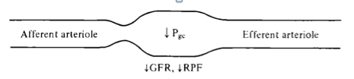

4. Please choose the correct statement.
A. Tubuloglomerular feedback is mediated by the change in delivery and reabsorption of sodium. Of chloride
B. With regard to glomerular filtration, smaller and anionic substances are more easily filtered. Smaller and cationic
C. Creatinine is freely filtered, not metabolized, not reabsorbed and not secreted. Secretion also occurs.
D. It is the rise in capillary oncotic and not permeability that limits the filtration of small solutes and water.

5. TRUE - When chloride delivery to the macula densa is increased due to increase in GFR, the tubuloglomerular feedback will respond by causing afferent arteriolar constriction.

