Circulatory shock chapter

Questions:

- Fill in the chart – effects of the following drugs on heart rate and contractility (+, 2+, etc)
 | Heart rate | Contractility
Dopamine
Norepi
Epi
Dobutamine
Vasopressin

- Which of the following are potential explanations for an increase in mixed venous oxygen saturation level during therapy in a critically ill patient?
  - Hyperthermia
  - Hypoxia
  - pRBC transfusion
  - Reversal of sedatives
- True/False: Lactate, as an early indicator of tissue oxygen debt, can predict outcome in shock.

- What is DO_{2crit}?

- True of False: Although one hemodynamic category of shock predominates, most forms of shock involve some cardiovascular characteristics of several categories.

Answers:
Questions:

- Fill in the chart – effects of the following drugs on heart rate and contractility (+, 2+, etc)
 | Heart rate | Contractility
Dopamine | 1-2+ | 1-2+
Norepi | 2+ | 2+
Epi | 4+ | 4+
Dobutamine | 1-2+ | 3+
Vasopressin | 0 | 0

- Which of the following are potential explanations for an increase in mixed venous oxygen saturation level during therapy in a critically ill patient?
  - Hyperthermia
  - Hypoxia
  - pRBC transfusion
  - Reversal of sedatives

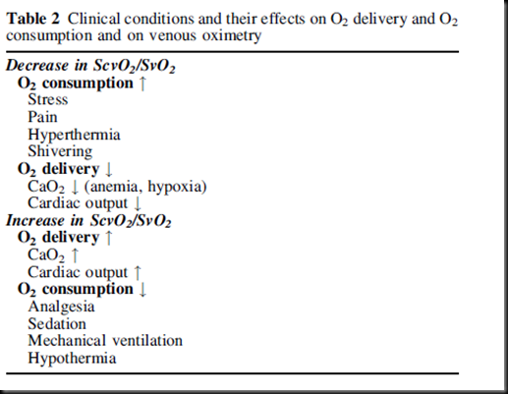
- True/False: Lactate, as an early indicator of tissue oxygen debt, can predict outcome in shock.
False – it is a LATE indicator, and while it is a predictor of shock, the late timing if its increase limits its usefulness in prognostication.

- What is DO_{2crit}?
Inflection point on the DO2 vs VO2 curve, where in below this point VO2 becomes dependent on DO2 and lactate production occurs. Above this point VO2 is independent of DO2. Oxygen extraction ratio varies to maintain constant VO2.

- True of False: Although one hemodynamic category of shock predominates, most forms of shock involve some cardiovascular charactistics of several categories.
True

