Chapter Five - Functions of the Distal Nephron

- True or False: Proximal tubular reabsorption of filtered bicarbonate involves a pair of transporters: one that imports bicarbonate across the apical membrane and another that exports bicarbonate across the basolateral membrane.
- What is the mechanism of action of hydrochlorothiazide?

- What cell am I?
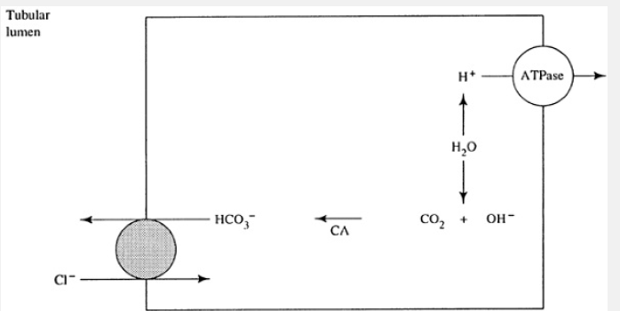
  - Type A intercalated cell
  - Type B intercalated cell
  - Principal cell
  - Principle cell
- The intercalated cells are primarily involved in the Na+-______________ (dependent/independent) regulation of acid-base balance

Chapter Five - Functions of the Distal Nephron

- True or False: Proximal tubular reabsorption of filtered bicarbonate involves a pair of transporters: one that imports bicarbonate across the apical membrane and another that exports bicarbonate across the basolateral membrane.
- What is the mechanism of action of hydrochlorothiazide?
  - Inhibits sodium chloride symporter in the distal convoluted tubule
- What cell am I?
  - Type A intercalated cell
  - Type B intercalated cell
  - Principal cell
  - Principle cell
- The intercalated cells are primarily involved in the Na+-______________ (dependent/independent) regulation of acid-base balance

