Cardiac Physiology and Venous Return – Guyton at the bedside

Key Point 1
The total vascular volume (Vt) is made up of the unstressed volume (Vo) and the stressed volume (Vs)
- Vs is defined as the Difference between Vt and Vo
  - Makes up 30% of total blood volume
- Vo is defined as the intravascular volume that remains when the vascular circuit is equalized to atmospheric pressure
  - i.e., the volume remaining after passive exsanguination
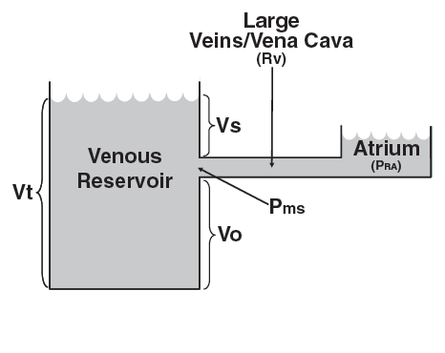

Key Point 2
Venous return = (Pmc – Pra)/Rv
- Pmc is the mean circulatory pressure
- Rv is the venous resistance
- Pra is the right atrial pressure

Pmc = Vs/C
- Vs is stressed volume
- C is vascular compliance
- Compliance refers to the total elastic properties of the entire cardiovascular circuit inclusive of the heart and vasculature

Key Point 3
Rapid alterations of venous return are typically mediated by changes of Pmc or Rv.
- Pmc is acutely influenced by changes of Vs, either directly through alterations of venous capacitance, which primarily involves changes of small vein and venular tone (exogenous vasopressors or vasodilators, sympathetic stimulation), or indirectly by changes of Vt (volume depletion or infusion).
- Venous resistance (Rv) to flow is acutely altered by changes of the caliber of large diameter veins, particularly the vena cava and great veins of the thorax.
- Alterations of venous tone therefore, tend to induce opposing changes in Pmc and Rv with respect to venous return.
- Vasodilatation decreases Pmc by decreasing stressed volume but also decreases Rv.
- Vasoconstriction results in increases of both Pmc and Rv.
- Only alterations in Vt alter Pmc without affecting Rv
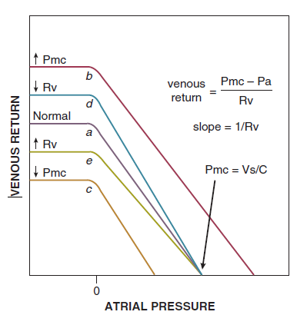
- Atrial contraction is particularly important in those with impaired ventricular function. Although it accounts for only 5% to 10% of cardiac output in healthy humans, synchronized atrial contraction contributes as much as 40% to 50% of the cardiac output in patients with severe left ventricular dysfunction

Questions:
1. True or False: alterations of myocardial compliance render CVP and PAOP unreliable as estimates of preload in critically ill patients

2. True or False: Nitrovasodilators such as nitroglycerin may decrease cardiac output
Why or why not?
3. What has happened in this patient
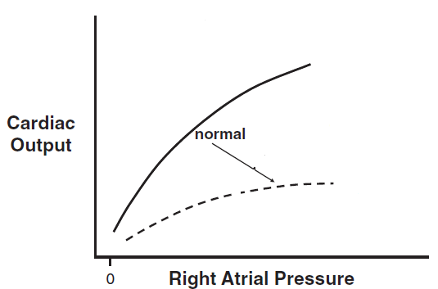
a. Started dobutamine
b. Fluid bolus
c. Massive loss of blood
d. Bolus of phenylephrine

4) What has happened in this patient
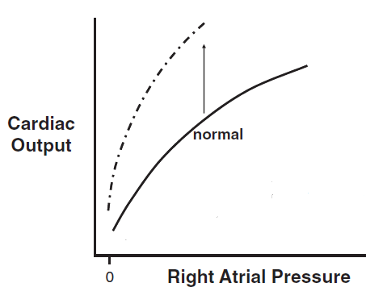
a. Started dobutamine
b. Fluid bolus
c. Massive loss of urine
d. Bolus of phenylephrine

5) What has happened in this patient
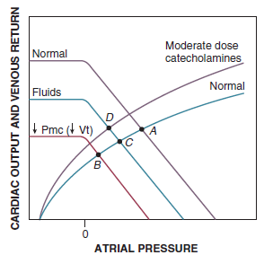
a. Hypovolemic shock
b. Distributive shock
c. Cardiogenic shock
d. Obstructive Shock

6)

