Bronchoscopic findings in 48 cats with Spontaneous Lower Respiratory Tract Disease (2002-2009)

Prospective study - to describe the nature and frequency of endobronchial lesions in cats with lower respiratory disease and to correlate these with bronchoalveolar lavage (BAL) findings
- 38 cats, presented for cough and/or respiratory distress
- Cats were evaluated for airway hyperemia, stenosis, or collapse, mucus accumulation, bronchiectasis, and epithelial irregularities.
- Cats were placed into groups of bronchitis/‘‘asthma,’’ pneumonia, or neoplasia based on BAL findings, histopathology, and response to appropriate medical therapy.

Main Points
- No differentiating features (on endobronchial exam) were found between groups (bronchitis/’asthma’, pneumonia or neoplasia). Total bronchoscopic score and total cell count did not differ among groups, although differential cell counts were significantly different.
  - Neutrophils were a greater percentage of the total cell count in cats with pneumonia compared with those with bronchitis/ asthma or neoplasia.
  - Eosinophils were more prevalent in cats with bronchitis/asthma and neoplasia than those with pneumonia.
This suggests that clinical, radiographic, and histopathologic correlations with disease status are needed to distinguish neoplasia from inflammatory disease

- Bronchoscopic abnormalities are common in cats with lower respiratory tract disease. Excessive mucus accumulation was common (83%), followed by stenosis of bronchial openings and nodular epithelial irregularities (56%), airway hyperemia (54%), airway collapse (48%), and bronchiectasis (27%).
- Collapse of bronchi was relatively common in cats examined in this study, and the left cranial lobar bronchus was most commonly affected.

- Interpretation of epithelial cell cytologic characteristics is problematic in the presence of inflammation, which can induce changes in epithelial cells that mimic neoplasia.

Questions
- Name 2 reasons why bronchoschopic evaluation of feline lower respiratory tract challenging?

- True or False. Airway collapse has been reported in canine chronic bronchitis and in eosinophilic bronchopneumopathy

- Match the image to description
- 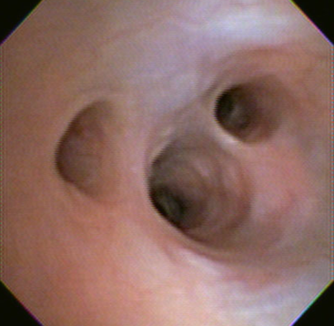 C. 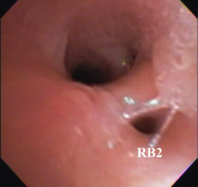
1. Bronchiectasis
2. Normal feline airway
3. Mucus accumulation
4. Airway Stenosis
- 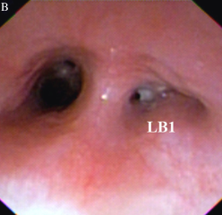 D. 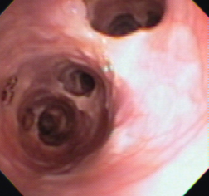

- What was the most common bronchoscopic finding in cats?
- Airway stenosis
- Mucus accumulation
- Airway collapse
- Airway hyperemia

- Fill in the blanks. _________________(Eosinophils/Neutrophils/macrophages) were a greater percentage of the total cell count in cats with pneumonia compared with those with bronchitis/ asthma or neoplasia. ________________(Eosinophils/Neutrophils/macrophages) were more prevalent in cats with bronchitis/asthma and neoplasia than those with pneumonia.

- True or False. Collapse of bronchi was relatively common in cats examined in this study, and the right middle lobar bronchus was most commonly affected.

Questions and Answers
- Name 2 reasons why bronchoschopic evaluation of feline lower respiratory tract challenging?
- Small size of feline airways
- Tendency for bronchoconstriction and airway hyperresponsiveness

- True or False. Airway collapse has been reported in canine chronic bronchitis and in eosinophilic bronchopneumopathy

- Match the image to description
- C.
1. Bronchiectasis (D)
2. Normal feline airway (A)
3. Mucus accumulation (B)
4. Airway Stenosis (C)
- D.

- What was the most common bronchoscopic finding in cats?
- Airway stenosis
- Mucus accumulation
- Airway collapse
- Airway hyperemia

- Fill in the blanks. _________________(Eosinophils/Neutrophils/macrophages) were a greater percentage of the total cell count in cats with pneumonia compared with those with bronchitis/ asthma or neoplasia. ________________(Eosinophils/Neutrophils/macrophages) were more prevalent in cats with bronchitis/asthma and neoplasia than those with pneumonia.

- True or False. Collapse of bronchi was relatively common in cats examined in this study, and the right middle lobar bronchus was most commonly affected.
left cranial lobar bronchus

Chronic Bronchial Disorders in Dogs
Most common diagnosis
- Infectious bronchitis
- Chronic bronchitis (airway inflammation in the absence of specific cause)
- Bronchomalacia

Diagnosis
- Radiography is relatively insensitive for chronic bronchitis.
- Fluoroscopy might be considered gold standard for identification of tracheal and bronchial collapse
- Bronchoscopy is often required to document more subtle degrees of bronchomalacia or small airway collapse
  - Chronic bronchitis – airway hyperemia, airway mucosa has cobblestone or irregular appearance, increased mucus lining airway
- Cytologically chronic bronchitis is characterized by the presence of nondegenerate neutrophils. Some dogs have increased eosinophils or mixed inflammation which might indicate parasites, bronchitis or eosinophilic lung disease. Increased mucus and Curschmann’s spirals (bronchial casts of airway mucus) present.
- Infectious bronchitis characterized by septic suppurative inflammation
- True bacterial infections of the lower respiratory tract are characterized by quantitative cultures of BAL fluid yielding more than 1.7x10³ colony forming units/ml, lack of squamous cells or the oropharyngeal Simonsiella spp. on cytologic examination and a variably increased % of neutrophils.

Treatment
- Goal – to control inflammation and limit clinical signs
- Treatment with glucocorticoids is successful in resolving clinical signs in majority of dogs
  - Early – 0.5-1 mg/kg q12 PO for 5-10 days, then decreased by half every 10-14 days, then on alternate day basis
  - Long term therapy (2-3 months) should be anticipated
  - Some dogs with bronchomalacia will not benefit from steroid therapy as they may not have substantial airway inflammation
- When airway sampling is not possible a trial of doxycycline (3-5mg/kg q12h PO) is reasonable therapeutic option
- Inhaled steroids bronchodilators or antitussive agents can be added
  - Fluticasone proprionate (Flovent) 110 ug/puff or 220 ug/puff administered at 1 puff 2-4 times a day
  - Adequate drug delivery when dog has nose and lips enclosed by mask during actuation of drug and breathes normally for 8-10 breaths
- Bronchodilators – helpful in reducing signs in dogs with bronchitis or bronchomalacia or can allow a reduction in glucocorticoid dose.
  - Methylxanthine derivatives and beta agonists seem to act synergistically with glucocorticoids in control of inflammatory lung disease
  - Bronchodilators improve pulmonary perfusion, reduce respiratory effort, stimulate mucociliary clearance and improve expiratory airflow
- Antibiotics – when infection documented. Choice based on culture and sensitivity results. Drug selected should have broad spectrum of activity against bacteria commonly found in lung (Pasteurella, Staph, Strep), and should be lipophilic to facilitate penetration of airway.
  - If enrofloxacin in needed – drug inhibits metabolism of theophylline and concurrent use can result in toxic plasma levels. 30% reduction in theophylline levels recommended.
  - 7 – 10 days of treatment usually resolves signs related to bronchial colonization
- Infection plays predominant role in dogs with concurrent bronchiectasis (dilation of lower airways with suppuration usually present). Long term antibiotic therapy often required.
- Antitussive agents – suppression of cough reflex before resolution of inflammation can be deleterious because mucus can become trapped in small airways.
  - When clinical signs suggest inflammation is resolving by cough persists or when airway collapse is present: dextromethorphan –containing compounds, hydrocodone or butorphanol
- Mucolytic therapy – saline nebulization or oral NAC (help thin respiratory secretions by breaking sulfur-sulfur bonds in mucus).
- Weight loss

Prognosis
- Presence of fibrosis and chronic inflammation or presence of bronchiectasis or bronchomalacia indicated irreversibility of airway disease

Questions
- True or False. Normal appearing chest radiographs are found relatively often in dogs with chronic bronchitis.

- What are Curschmann’s spirals?

- True or False. Dogs with bronchomalacia can have normal findings on cytologic exam of bronchoalveolar lavage fluid

- Which organism is uncommonly seen on cytological evaluation of BAL fluid?
  - Staphylococcus spp.
  - Mycoplasma spp.
  - Simonsiella spp.

- When airway sampling is not possible which antimicrobial is recommended as a reasonable therapeutic option prior to treatment with glucocorticoids?
  - Doxycycline
  - Potentiated amoxicillin
  - TMS
  - Enrofloxacin

- How many days of treatment is required to resolve signs related to bronchial colonization
  - 5-7days
  - 7-10days
  - 10-14days

- True or False. Long acting glucocorticoids have a therapeutic advantage over prednisone.

Questions and Answers
- True or False. Normal appearing chest radiographs are found relatively often in dogs with chronic bronchitis.

- What are Curschmann’s spirals? bronchial casts of airway mucus

- True or False. Dogs with bronchomalacia can have normal findings on cytologic exam of bronchoalveolar lavage fluid

- Which organism is uncommonly seen on cytological evaluation of BAL fluid?
  - Staphylococcus spp.
  - Mycoplasma spp.
  - Simonsiella spp.

- When airway sampling is not possible which antimicrobial is recommended as a reasonable therapeutic option prior to treatment with glucocorticoids?
  - Doxycycline
  - Potentiated amoxicillin
  - TMS
  - Enrofloxacin

- How many days of treatment is required to resolve signs related to bronchial colonization
  - 5-7days
  - 7-10days
  - 10-14days

- True or False. Long acting glucocorticoids have a therapeutic advantage over prednisone.

