BR October 21.14 D Hernia RPE

Traumatic Diaphragmatic Herniation: Pathophysiology and Management
Andrew J. Worth, BVSc, MACVSc, PGDVCS Roslyn G. Machon, BVSc(Hons), MVSc, MS, MACVSc, DACVA
Compendium 2005
Summary:
Intro:
A rapid rise in intraabdominal pressure following a forceful blow and failure of the glottis to remain closed, allowing the stabilizing effect of the air- filled lungs to be lost acutely, is the classic explanation for diaphragmatic rupture.
Other authors have suggested that development of an acute and severe pressure gradient between the thoracic and abdominal cavities is more important with respect to rupture than whether the glottis is open or closed at the time of impact.
The actual rupture or tear(s) is thought to occur in the area of the diaphragm least protected by the viscera at the time of impact and therefore depends on the position of the animal and abdominal viscera when impact occurs
Because the central tendinous area is stronger than the paired costal, lumbar, and sternal muscles of the diaphragm, tears usually occur along the fiber orientation of the muscles (i.e., radial tears) or at their attachment to the ribs (i.e., circumferential tears).
In one clinical series, 50% (27 of 54) of all tears were circumferential, with radial tears being the second most typical in dogs.
Cats had predominantly (13 of 24) circumferential tears, with radial tears occurring at a similar incidence as for combined or multiple tears
The liver is the most commonly herniated organ, with the stomach, small intestine, and spleen often involved in left-sided hernias and the small intestine and pancreas in right- sided tears
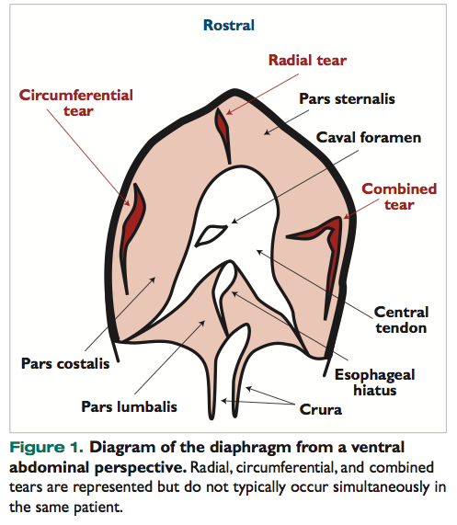
PATHOPHYSIOLOGY OF TRAUMATIC DIAPHRAGMATIC HERNIA–ASSOCIATED RESPIRATORY COMPROMISE
Contributing factors have been reported and include loss of the mechanical function of the diaphragm, the pleural space-occupying effect of abdominal organ herniation (which may be further exacerbated by accumulation of air or fluid), and compression of lung lobes by herniated organs with resultant atelectasis.
Additional factors include ventilatory impairment arising from trauma- associated injury to the chest wall (e.g., rib fractures) and intrathoracic structures (e.g., pulmonary contusion) as well as the generalized effects of pain, hemorrhage, and hypovolemic shock.
These factors combine to produce hypoventilation, significant alveolar ventilation:perfusion mismatch, and shunting (i.e., delivery of poorly oxygenated blood to the arterial side of the circulatory system), resulting in potentially life-threatening hypoxia.
Accessory inspiratory muscles such as the external intercostal and abdominal muscles assist the process of inspiration, particularly during exercise. During normal, quiet breathing, however, inspiration primarily depends on contraction of the diaphragm.
An intact diaphragm is not essential for ventilation; however, rupture of the diaphragm results in loss of abdominal and thoracic mechanical coupling, inability to generate transdiaphragmatic pressure, and a shift in the work of inspiration to the less efficient intercostal and abdominal musculature.
Atelectasis, with or without pleural effusion, may result in significant loss of functional lung capacity and development of ventilation:perfusion mismatch and shunting.
The addition of venous blood to the arterial side of the sys- tem results in marked reductions in arterial oxygen tension (PaO2) because of the low oxygen content of shunted blood.
The presence of pulmonary contusions and interstitial pulmonary edema may magnify the degree of ventilation:perfusion mismatch and further impair arterial oxygenation.
Fluid accumulation may occur because of intrathoracic hemorrhage (which is often self-limiting) or organ entrapment and accumulation of transudate due to impaired venous drainage and increased capillary hydrostatic pressure within the entrapped organ. In addition, the actual mechanics of breathing are reduced by pain, pleural space-filling defects, and concurrent chest wall trauma, further reducing effective alveolar ventilation.
In addition to the detrimental effects on normal ventilatory function, herniation of abdominal viscera into the thoracic cavity may result in compression of the caudal vena cava, thereby decreasing venous return and reducing cardiac output.
Cardiac arrhythmia has been reported in 12% of dogs with traumatic diaphragmatic hernias; a third of those affected died
Diagnosis:
X-rays:
The most commonly reported radiographic findings are loss of the cupula and masking of the cardiac shadow
Pleural effusion is present in 20% to 25% of cases and is usually associated with chronic liver herniation
About 2% of dogs that presented with fractures after motor vehicle trauma had traumatic diaphragmatic hernias.
Treatment:
Most postsurgical deaths occur within the first 24 hours after intervention (irrespective of the chronicity of the herniation) and have been attributed to hemothorax, pneumothorax (in dogs), pulmonary edema (in cats), or pleural effusion

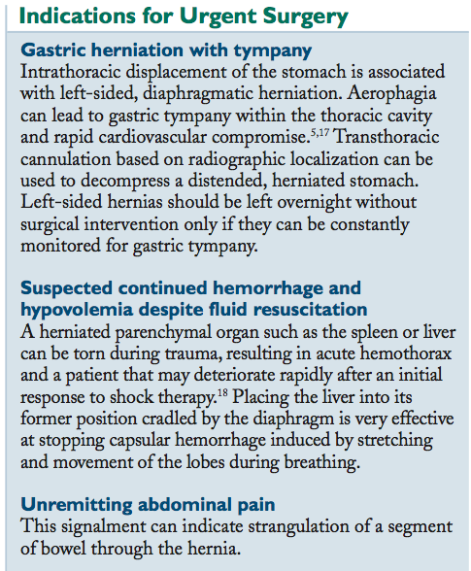
Reperfusion injury
Is a syndrome associated with temporary ischemia of tissue. Herniated abdominal organs can be strangulated at the level of a diaphragmatic defect. Returning these organs to the abdomen allows reperfusion of stagnant capillary beds and sinusoids. This may liberate potentially toxic by-products of anaerobic metabolism, such as unbuffered acids, potassium, and lysosomal enzymes
The pathogenesis of reexpansion pulmonary edema is poorly understood. Available evidence suggests that the rapidity and force of reexpansion of collapsed lung tissue are important con- siderations in managing patients undergoing herniorrhaphy for traumatic diaphragmatic herniation. It has been recommended that reinflation of atelectic lung lobes should not be attempted, particularly in long- standing ruptures, because reexpansion pulmonary edema can result.
Improved survival rates for patients with traumatic diaphragmatic hernias that were treated surgically have been attributed to abandoning forceful evacuation of all pleural air at the point of closure of the diaphragm (via the use of high airway inflation pressures) in favor of gradual drainage of the thorax with a chest tube or indwelling catheter after closure.
Airway manometry should be used to ensure that IPPV pressures do not exceed an air pressure of 15 to 20 cm H2O. A thoracostomy tube should be placed before closing the diaphragm and the pneumothorax reduced until the patient is ventilating easily; however, no attempt should be made to fully reestablish negative intrathoracic pressure. The pneumothorax should then be gradually alleviated over the following 8 to 12 hours.

Key points:

- Types of tears in diaphragmatic hernias:

- Because the central tendinous area is stronger than the paired costal, lumbar, and sternal muscles of the diaphragm, tears usually occur along the fiber orientation of the muscles (i.e., radial tears) or at their attachment to the ribs (i.e., circumferential tears). Combined tears may also occur.

- Circumferential tears are the most typical type of tears in dogs and cats.

- The liver is the most commonly herniated organ, with the stomach, small intestine, and spleen often involved in left-sided hernias and the small intestine and pancreas in right- sided tears
- Pathophysiology of traumatic diaphragmatic hernia associated respiratory compromise:

- Contributing factors include loss of the mechanical function of the diaphragm, the pleural space-occupying effect of abdominal organ herniation (which may be further exacerbated by accumulation of air or fluid), and compression of lung lobes by herniated organs with resultant atelectasis.

- Additional factors include ventilatory impairment arising from trauma- associated injury to the chest wall (e.g., rib fractures) and intrathoracic structures (e.g., pulmonary contusion) as well as the generalized effects of pain, hemorrhage, and hypovolemic shock.

- These factors combine to produce hypoventilation, significant alveolar V:Q mismatch, and shunting, resulting in potentially life-threatening hypoxia.

- Rupture of the diaphragm results in loss of abdominal and thoracic mechanical coupling, inability to generate transdiaphragmatic pressure, and a shift in the work of inspiration to the less efficient intercostal and abdominal musculature

- Treatment:
- When anesthetizing a patient, place the affected side down, to prevent a large mediastinal shift and compression of the functional lung

- Timing of surgery is controversial. Indications for emergency surgery include gastric herniation with tympany, inability to stabilize the patient, umremitting abdominal pain (may reflect organ strangulation).

Questions:

1. List and describe the 3 types of tears that can occur with a diaphragmatic hernia.

2. What is the most common tear in the dog? In the cat?

3. What is the most common abdominal organ to herniate into the thorax in dogs?

4. Briefly describe the pathophysiology of traumatic diaphragmatic hernia associated respiratory compromise.

5. List 3 indications for emergency surgery in a patient suffering from a traumatic diaphragmatic hernia.

Questions with answers:

1. List and describe the 3 types of tears that can occur with a diaphragmatic hernia

- Radial tears - tears that occur along the fiber orientation of the muscles
- Circumferential tears – tears that occur or at their attachment to the ribs
- Combined tears

2. What is the most common tear in the dog? In the cat?
- Circumferential in both

3. What is the most common abdominal organ to herniate into the thorax in dogs?
- Liver

4. Briefly describe the pathophysiology of traumatic diaphragmatic hernia associated respiratory compromise.

- Contributing factors include loss of the mechanical function of the diaphragm, the pleural space-occupying effect of abdominal organ herniation (which may be further exacerbated by accumulation of air or fluid), and compression of lung lobes by herniated organs with resultant atelectasis.

- Additional factors include ventilatory impairment arising from trauma- associated injury to the chest wall (e.g., rib fractures) and intrathoracic structures (e.g., pulmonary contusion) as well as the generalized effects of pain, hemorrhage, and hypovolemic shock.

- These factors combine to produce hypoventilation, significant alveolar V:Q mismatch, and shunting, resulting in potentially life-threatening hypoxia.

- Rupture of the diaphragm results in loss of abdominal and thoracic mechanical coupling, inability to generate transdiaphragmatic pressure, and a shift in the work of inspiration to the less efficient intercostal and abdominal musculature

5. List 3 indications for emergency surgery in a patient suffering from a traumatic diaphragmatic hernia.

- Indications for emergency surgery include gastric herniation with tympany, inability to stabilize the patient, umremitting abdominal pain (may reflect organ strangulation).

Prevention of Reexpansion Pulmonary Edema and Ischemia–Reperfusion Injury in the Management of Diaphragmatic Herniation
Compendium

Summary:

Intro:

Reexpansion pulmonary edema (RPE) and ischemia–reperfusion (IR) injury are now recognized as potentially fatal complications of surgical correction of TDH.
Potentially fatal RPE appears to be a greater risk in patients with chronic lung collapse, and cats are affected more often than dogs.
To prevent RPE, no attempt should be made to fully or rapidly reinflate collapsed lung lobes during surgery to minimize barotrauma.
Resection of ischemic tissue before reperfusion prevents metabolites of anaerobic metabolism from initiating a cascade of cellular injury and may be valuable in certain cases of abdominal organ entrapment occurring with diaphragmatic herniation.
During herniorrhaphy, the injury- associated lung collapse is exacerbated by surgically induced pneumothorax, but intubation and delivery of intermittent positive pressure ventilation (IPPV ) main- tain effective ventilation. However, IPPV may play a role in the development of RPE
Ischemia–reperfusion (IR) injury is a syndrome associated with temporary ischemia of tissue.
When oxygenated blood ceases to flow through tissue, cell metabolism switches from the aerobic pathway to the anaerobic pathway to continue to supply the energy needs of the cells. Returning these organs to the abdomen allows reperfusion of stagnant capillary beds and sinusoids. This may liberate potentially toxic by-products of anaerobic metabolism, such as unbuffered acids, potassium, and lysosomal enzymes.
Liberation of metabolites that damage endothelial linings is a potential secondary cause of pulmonary edema in patients with TDH (traumatic diaphragmatic hernia). The collapsed lung lobes are also subjected to IR injury.
ISCHEMIA–REPERFUSION INJURY
“oxygen paradox” refers to the relatively minor damage caused by initial ischemia of tissue compared with severe cellular damage resulting when oxygen is reintroduced by the return of circulation
Reactive oxygen species (ROS), such as superoxide anions, hydroxy radicals, and hydrogen peroxide (H2O2), are generated in tissues as the result of ischemia and incomplete reduction of molecular oxygen.
ROS may be derived from marginating neutrophils or via xanthine oxidase pathways in hypoxic cells. Neutrophils produce various oxidizing agents by reducing molecular oxygen in a process called the respiratory burst, which is accompanied by increases in super- oxide anion and H2O2 (i.e., ROS). During periods of tissue ischemia, hypoxanthine accumulates from the degradative pathway of ATP
Following reperfusion and return of oxygen to the tissue, xanthine oxidase oxidizes hypoxanthine, generating superoxide radicals (O2–). In turn, these radicals are dismutated to H2O2 by superoxide dismutase. H2O2 is not a free radical, but with rapid reduction in the presence of iron, it is further metabolized by the Haber-Weiss reaction to form reactive hydroxyl radicals (OH–).
Many ROS are free radicals—molecules with unpaired electrons in their outer orbits. Through interaction with membrane lipids, ROS can form self-perpetuating chains of toxic hydroperoxides that damage cell membranes, leading to cell death.
Xanthine oxidase, an intracellular enzyme that produces superoxide during reoxygenation injuries

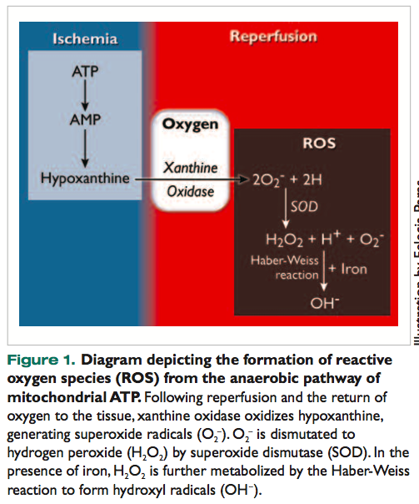
- The Haber–Weiss reaction generates •OH (hydroxyl radicals) from H₂O₂ (hydrogen peroxide) and superoxide (•O₂⁻)

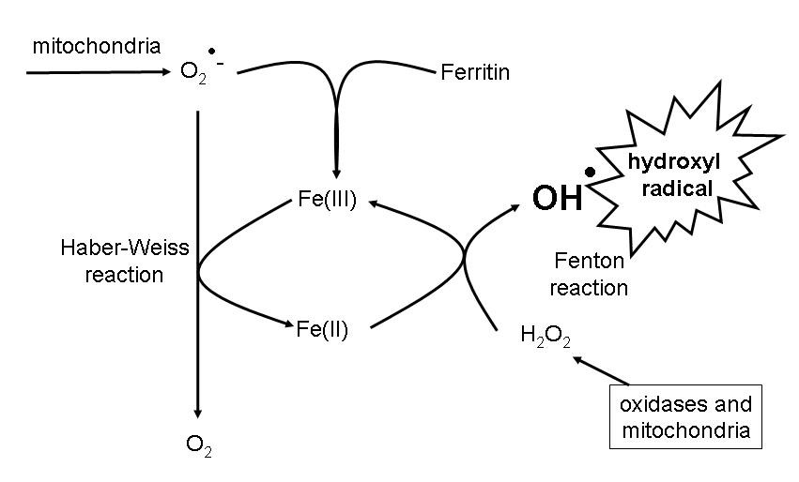

REEXPANSION PULMONARY EDEMA
Pathogenesis:
Various mechanisms have been proposed for the formation of protein-rich, noncardiogenic pulmonary edema in RPE.
These mechanisms include mechanical disruption of vessels resulting from negative intrapleural suction pressures used for reexpansion of the collapsed lung, surfactant abnormalities, changes in pulmonary artery pressures as a result of lung reexpansion, and a direct effect of hypoxia on vascular permeability.
Most of these proposals focus on mechanisms by which fluid filtration from alveolar capillaries is increased as a direct result of negative interstitial pressure, resulting in edema. However, although the generation of large, negative intrapleural pressures has been shown to result in RPE under experimental conditions (thereby supporting the concept of mechanical disruption of alveolar capillaries), clinical cases of RPE have been reported following lung reexpansion in the absence of pleural suction.
Abnormalities in surfactant production or function may contribute to the phenomenon of RPE.
Mechanical stresses, surfactant abnormalities, neutrophil accumulation, ventilator-induced injury, and ischemia–reperfusion injury may all contribute.
The mechanical stimulus of alveolar inflation is thought to be a major stimulant of surfactant production. In the absence of ventilation, insufficient surfactant may result in in- creased airway pressure necessary to achieve alveolar inflation during reexpansion; thus damage to the epithelial cells may result. Barotrauma from assisted ventilation is traditionally associated with extraalveolar air accumulation and tension pneumothorax but has been shown to increase wet-lung weights in experimental studies.
Current thought focuses on the importance of increased alveolar capillary permeability as the common pathologic endpoint in RPE, suggesting that this increased permeability results from a combination of capillary membrane disruption and IR-mediated injury. Reperfusion injury may be linked to the development of ROS following reoxygenation of previously ischemic lung tissue.
Current recommendations call for chronically atelectatic lungs to be reinflated only by gradual reexpansion. Airway pressure should not exceed 15 to 20 cm of water pressure, particularly when there is evidence of lung damage. If lungs don’t re-expand with these pressures, a chest drain should be placed and the remainder of the penumo should be removed slowly over a 8-12hr period.
Therapy for Ischemia–Reperfusion Injury
Research has centered on blocking ROS formation, identifying ROS scavengers, blocking neutrophils, and preventing platelet activation.
Only some of the numerous agents that have undergone evaluation are mentioned here; a more in-depth discussion was recently provided by McMichael and Moore.
Dimethyl sulfoxide is a hydroxyl scavenger that inhibits prostaglandins, reduces platelet aggregation, and interferes with neutrophil chemotaxis and arachidonate metabolism. However, it also readily forms methyl radicals, which lead to harmful chain reactions and undesirable side effects.
Allopurinol (a free radical inhibitor) has shown benefit in several rodent models but was not shown to significantly affect outcome in an experimental canine GDV model.
Pretreatment with deferoxamine (desferrioxamine), an iron chelator, increased survival in dogs in a GDV model.
The lazaroid (21-aminosteroid) tirilazad mesylate is a novel inhibitor of lipid membrane peroxidation induced by ROS
In a porcine pulmonary reperfusion model, vitamins C and E inhibited neutrophil activation but were not able to prevent oxygen radical production. A combined approach using preconditioning with ascorbate, vitamins A and E, and lecithinized superoxide dismutase has been suggested for use in human transplant surgery to decrease ischemic damage
Key points:
1. General concept of IR-RPE in TDH:
- When oxygenated blood ceases to flow through tissue, cell metabolism switches from the aerobic pathway to the anaerobic pathway to continue to supply the energy needs of the cells. Returning these organs to the abdomen allows reperfusion of stagnant capillary beds and sinusoids.
- This may liberate potentially toxic by-products of anaerobic metabolism, such as unbuffered acids, potassium, and lysosomal enzymes.
- Liberation of metabolites that damage endothelial linings is a potential secondary cause of pulmonary edema in patients with TDH
- The collapsed lung lobes are also subjected to IR injury.
- Current recommendations call for chronically atelectatic lungs to be reinflated only by gradual reexpansion. Airway pressure should not exceed 15 to 20 cm of water pressure, particularly when there is evidence of lung damage. If lungs don’t re-expand with these pressures, a chest drain should be placed and the remainder of the penumo should be removed slowly over a 8-12hr period.
2. Ischemia Reperfusion injury:

- ROS, such as superoxide anions, hydroxy radicals, and hydrogen peroxide (H2O2), are generated in tissues as the result of ischemia and incomplete reduction of molecular oxygen.
- ROS may be derived from marginating neutrophils or via xanthine oxidase pathways in hypoxic cells.
- Neutrophils produce various oxidizing agents by reducing molecular oxygen in a process called the respiratory burst, which is accompanied by increases in super- oxide anion and H2O2.
- During periods of tissue ischemia, hypoxanthine accumulates from the degradative pathway of ATP.
- Following reperfusion and return of oxygen to the tissue, xanthine oxidase oxidizes hypoxanthine, generating superoxide radicals (O2–). In turn, these radicals are dismutated to H2O2 by superoxide dismutase. H2O2 is not a free radical, but with rapid reduction in the presence of iron, it is further metabolized by the Haber-Weiss reaction to form reactive hydroxyl radicals (OH–).
- Many ROS are free radicals—molecules with unpaired electrons in their outer orbits. Through interaction with membrane lipids, ROS can form self-perpetuating chains of toxic hydroperoxides that damage cell membranes, leading to cell death.
- Leukocyte infiltration is a crucial component of the cascade of IR injury. Platelet-activating factor, ROS, and xanthine oxidase are all chemotactic for neutrophils. Adhesion molecules are upregulated on pulmonary endothelial cells during ischemia.

3. Reexpansion pulmonary edema:
- Various mechanisms have been proposed for the formation of protein-rich, noncardiogenic pulmonary edema in RPE.
- These mechanisms include mechanical disruption of vessels resulting from negative intrapleural suction pressures used for reexpansion of the collapsed lung, surfactant abnormalities, changes in pulmonary artery pressures as a result of lung reexpansion, and a direct effect of hypoxia on vascular permeability
- Mechanical stresses, surfactant abnormalities, neutrophil accumulation, ventilator-induced injury, and ischemia–reperfusion injury may all contribute.
- Current thought focuses on the importance of increased alveolar capillary permeability as the common pathologic endpoint in RPE, suggesting that this increased permeability results from a combination of capillary membrane disruption and IR-mediated injury.
- The intracellular hydroxyl and H2O2 scavenger dimethylthiourea has been found to be effective in reducing RPE in a rabbit model.
- Superoxide dismutase was subsequently found to delay neutrophilic effusion but ultimately did not prevent RPE.
- Lodoxamide tromethamine, which reduces infarct size after reperfusion of ischemic myocardium, reduced the degree of both proteinaceous and neutrophilic exudation in a rabbit RPE model.
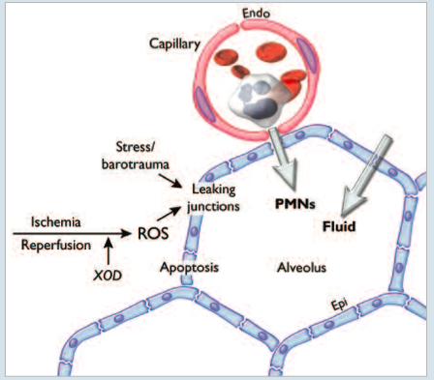

Questions:

1. List 3 major ROS.

2. ROS may be derived from ____________________________or via ______________________ pathways in hypoxic cells

3. Neutrophils produce various oxidizing agents by reducing molecular oxygen in a process called the___________________________, which is accompanied by increases in ___________________ and_____________________.

4. Explain or diagram the production of reactive oxygen species production via the xanthine oxidase pathway.

Questions with answers:

1. List 3 major ROS.

Answer:
- Superoxide anions
- Hydroxy radicals
- Hydrogen peroxide (H2O2)

2. ROS may be derived from ____________________________or via ___________________ pathways in hypoxic cells

Answer: marginating neutrophils, xanthine oxidase

3. Neutrophils produce various oxidizing agents by reducing molecular oxygen in a process called the___________________________, which is accompanied by increases in ___________________ and_____________________.
Answer: Respiratory burst, superoxide anion, H2O2
4. Explain or diagram the production of reactive oxygen species production via the xanthine oxidase pathway.
Answer:
During periods of tissue ischemia, hypoxanthine accumulates from the degradative pathway of ATP.
Following reperfusion and return of oxygen to the tissue, xanthine oxidase oxidizes hypoxanthine, generating superoxide radicals (O2–). In turn, these radicals are dismutated to H2O2 by superoxide dismutase. H2O2 is not a free radical, but with rapid reduction in the presence of iron, it is further metabolized by the Haber-Weiss reaction to form reactive hydroxyl radicals (OH–).

