BR Oct 14/14 PAH
Pulmonary hypertension in canine degenerative mitral valve disease
Journal of Veterinary Cardiology (2012) 14, 149-164
Abstract:
Pulmonary hypertension secondary to degenerative mitral valve disease has been recognized clinically for many years in veterinary medicine, and clinical diagnosis of this syndrome in dogs has been enhanced greatly by widespread use of echocardiography and Doppler echocardiography. Medical therapy is now avail- able to treat this clinical complication of mitral valve disease, making timely diagnosis even more important to patient longevity and quality of life.
Intro:
In veterinary medicine, pulmonary hypertension (PH) has been described as echocardiographically- estimated pulmonary arterial systolic pressure (based on a peak systolic tricuspid regurgitation gradient) greater than ~ 30 mmHg
Pulmonary hypertension can be further classified as pulmonary arterial hypertension (PAH) (i.e. pre-capillary, resulting from abnormalities on the arterial side of the pulmonary vascular system, also described as “active”) or pulmonary venous hypertension (PVH) (i.e. post-capillary, resulting from pulmonary venous hypertension associated with left-sided heart disease and leading to pulmonary capillary hypertension, also described as “passive”)
Pulmonary arterial pressure (PAP) is influenced by pulmonary blood flow, pulmonary vascular resistance (PVR) and pulmonary venous pressure.
By definition, PAH or pre-capillary PH occurs when there is an elevation in PAP (i.e. increased mPAP) as a result of an increased PVR with a normal left atrial pressure (i.e. normal pulmonary artery wedge pressure [PAWP]). Diseases that result in PAH or pre- capillary PH include idiopathic PAH, heartworm disease, congenital systemic-to-pulmonary shunts (i.e. atrial septal defect, ventricular septal defect and patent ductus arteriosus) and necrotizing vasculitis/arteritis.
Other etiologies causing elevated PAP but not considered as causes of PAH include chronic lung disease/hypoxia and thrombotic disease.
In contrast, the definition of PVH or post-capillary PH is an elevated PAP as a result of increased PAWP with a normal PVR. The phenomenon of PVH or post-capillary PH occurs most commonly in dogs with mitral valve (MV) disease and myocardial disease (i.e. dilated cardiomyopathy).
Pulmonary arterial hypertension and PVH may occur concurrently in patients with left-sided heart disease. Hypoxia-induced PAH may occur in the setting of left-heart failure when pulmonary artery (PA) vascular narrowing secondary to acute hypoxia (e.g. due to pulmonary edema), or potentially irreversible PA vascular narrowing (e.g. secondary to vascular remodeling due to chronic PVH secondary to chronic hypoxia) augment the post-capillary PH.
Pathophysiology and pathology
Pathophysiology of pulmonary venous hypertension
Pulmonary venous hypertension with left-sided heart disease is due to a combination of hypertension from increased left atrial pressures, and reactive pulmonary arterial vasoconstriction associated with acute or chronic hypoxia.
The pathophysiologic changes associated with PVH are not fully understood but in addition to increased left atrial pressure, an increase in PVR due to loss of endothelium- dependent vasodilation and the effects of chronic neurohormonal activation likely contribute to reactive PH.
In addition, RV performance influences the degree of PH that is associated with left-heart disease through a variety of mechanisms.
Mediators of pulmonary vascular tone
Endogenous pulmonary arterial vasoconstrictors and vasodilators influence vascular tone in the acute setting. Chronically, they may cause pulmo- nary arterial intimal proliferation, medial hyper- trophy, and thrombosis, thereby influencing PAP.
Endothelin pathway
Endothelin-1, as described in people, is released by pulmonary vascular endothelium and causes potent PA and vein vasoconstriction, smooth muscle cell proliferation and increased collagen synthesis
ET-1 release is increased in canine heart failure and leads to sodium and water retention, potentiation of other neurohormonal systems and promotion of myocardial hypertrophy, fibrosis and remodeling.

Prostanoid pathway
Prostacyclin and thromboxane A2 are endogenous and counterbalancing arachidonic acid metabolites produced from membranes of PA endothelial cells and platelets and are involved in maintenance of vascular tone in normal physiologic and pathophysiologic states. Prostacyclin is a vasodilator, inhibitor of platelet activation and has antiproliferative effects on the PA. In contrast, thromboxane A2 is a potent vasoconstrictor and promotor of platelet activation. In cases of PH, the balance of prostacyclin and thromboxane A2 formation favors thromboxane A2 leading to vasoconstriction, cellular proliferation and thrombosis.
Nitric oxide pathway
Nitric oxide (NO) is synthesized endogenously from L-arginine and oxygen by nitric oxide synthase isoenzymes in the PA vascular endothelium. Nitric oxide activates guanylate cyclase and the formation of cyclic guanosine monophosphate (cGMP) which results in a reduction of intracellular calcium concentration in vascular smooth muscle cells. The NO pathway enhances smooth muscle cell relaxation, inhibits smooth muscle cell proliferation and hypertrophy, and inhibits platelet aggregation and adhesion. cGMP is rapidly inactivated by phosphodiesterase (PDE), particularly PDE-5 isoenzymes.
In experimental models and clinical studies of heart failure in people, a deficiency in basal NO synthesis as well as a decrease in endothelial release and response to NO has been found, suggesting that the loss of NO-dependent vasodilation may contribute to the production of PH through vascular remodeling
Natriuretic peptides
Pulmonary artery vasodilation is thought to be NO- cGMP mediated in normal people. In contrast, in people with heart disease, it has been found that PA vasodilation is linked to a natriuretic peptide (NP)-cGMP pathway, independent of the NO-cGMP pathway. In the presence of advanced heart failure, this NP-cGMP-mediated PA vasodilation is attenuated and may contribute to the production of PH.
The influence of the right ventricle on pulmonary hypertension in heart failure
The degree of PH associated with left-sided heart disease is partially dependent on the performance of the right ventricle (RV)
If the RV is chronically exposed to a high afterload, RV hypertrophy will occur and allows the generation of the elevated peak systolic pressures required to maintain forward flow. However, if RV systolic function is impaired, ability to generate adequate peak systolic pressures is limited, and overt signs of right-sided congestive heart failure or clinical signs of low output (exertional syncope, lethargy, or weakness) may be observed. In this situation, although the PVR is unchanged, echocardiographic diagnosis of PH may underestimate true PAP because the peak systolic RV pressure used to estimate PAP using the tricuspid insufficiency jet is decreased.
If the RV becomes severely dilated in response to increased afterload, pericardial restriction of diastolic filling can result. Although this restriction from the pericardium limits further RV dilation, displacement of the interventricular septum toward the left ventricular (LV) lumen affects LV filling and reduces LV ejection fraction.
Both of these changes result in a net decrease in cardiac output and can exacerbate progressive ventricular failure, eventually leading to development of systemic hypotension, decreased RV perfusion and RV ischemia. This downward spiral may ultimately result in hemodynamic collapse.
Histopathologic changes of pulmonary venous hypertension
The most prominent change seen with PVH and MV disease is medial hypertrophy of the muscular pulmonary arteries (arterial muscularization)
Clinical characteristics of pulmonary venous hypertension
In general, MV disease-related PVH appears to be the most common cause of PH in dogs and the severity is typically mild to moderate.
NOTE: A fixed splitting of the second heart sound or an accentuated second heart sound may be present in dogs with severe PVH but difficult to hear in dogs with advanced mitral insufficiency.
Diagnostic strategy
Invasive hemodynamic assessment
****** Right heart catheterization (RHC) is the gold standard for diagnosis of PH in people****** The PAP in systole and diastole can be measured directly, and the mean PAP calculated.
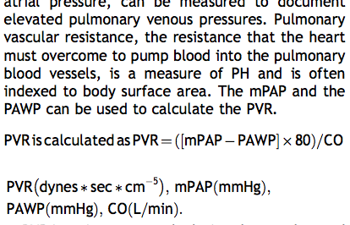
PVR is an important calculation that can be used to distinguish PVH from PAH. When PVR is normal and PAWP is elevated, the elevated PAP is considered to be due to PVH. If PVR and PAWP are simultaneously elevated in a PH patient with the mPAP disproportionately increased more than the PAWP, the patient may be diagnosed with “reactive PH”, an additive situation in which PA vasoconstriction secondary to acute hypoxia augments PVH
Echocardiographic estimates of pulmonary arterial pressure:
Systolic pulmonary artery pressure (sPAP)
Estimation of sPAP by echocardiographic examination relies on the presence of tricuspid regurgitation (TR)
The interrogation of a TR jet, in the absence of a RV outflow tract obstruction, allows for a non-invasive estimation of peak systolic PAP.
The systolic trans-tricuspid pressure gradient (mmHg) is estimated using the peak systolic TR velocity (m/sec) in the modified Bernoulli equation
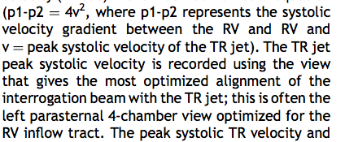
The peak systolic TR velocity and gradient reflect, although not equal to, the estimated peak systolic RV pressure and is used to arbitrarily classify systolic PH as mild (>=2.8 to <3.5 m/s, >= 31.4 to <50 mmHg), moderate (3.5- 4.3 m/s, 50-75 mmHg) or severe (>4.3 m/s, >75 mmHg)
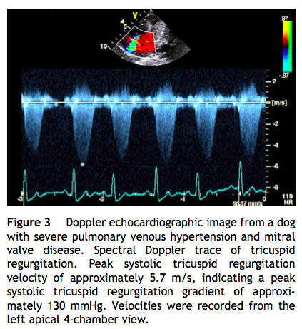

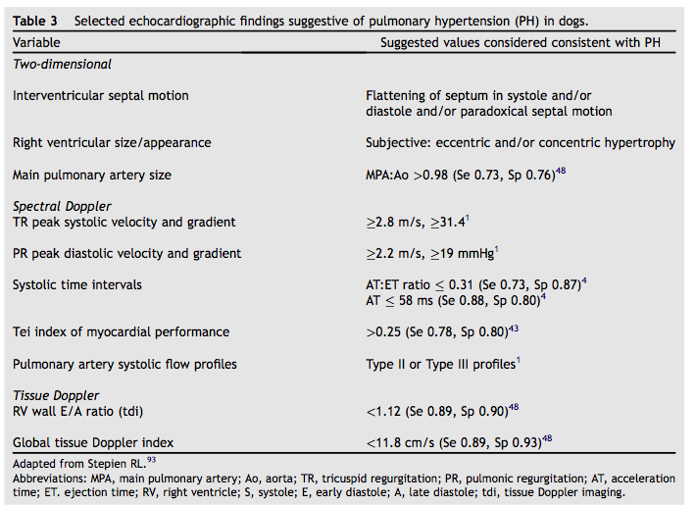

Other important limitations of use of TR jet systolic velocity to estimate PAP include: availability of views allowing optimal TR (i.e. angle of interrogation beam to TR jet must be <20 degrees), inadequate signal strength of the TR jet, inadequate patient compliance during the echocardiogram and limitations in image quality that may be present secondary to pulmonary pathology, body condition and body conformation.
Because estimated peak systolic PAP is based on peak systolic TR velocity, the accuracy of these estimates is also dependent on RV function. If RV systolic dysfunction is present, the peak systolic RA-RV pressure gradient may indicate relatively “normal” PAPs despite elevated PVRI and the diagnosis of PH may be missed.
Diastolic pulmonary artery pressure (dPAP)
Diastolic PAP can be estimated echocardiographically by assessment of end-diastolic pulmonary regurgitant jet velocity using the modified Bernoulli equation
Supportive echocardiographic findings in pulmonary hypertension
Pulmonary artery systolic flow profiles:
Normally, the systolic PA flow profile has a “domed” appearance indicating an equal accel- eration and deceleration time (Type I). Mild and moderate PH may result in an altered systolic PA flow profile (Type II) where the acceleration time is decreased and deceleration time is prolonged. Severe PH often results in a systolic PA flow profile similar to Type II with a “mid-systolic notch” in the deceleration phase (Type III), indicating a high PAP resulting in flow reversal.
Tei index of myocardial performance of the right ventricle
Tei index (myocardial performance index [MPI] or right ventricular index of myocardial performance [RIMP]) is a global index of systolic and diastolic RV performance and has been described in both dogs and people
The pulsed-wave Doppler of the tricuspid inflow measurements and the pulmonic valve ejection measurements are used to calculate this index (Fig. 6). An increase in Tei index is potentially supportive of a diagnosis of PH.

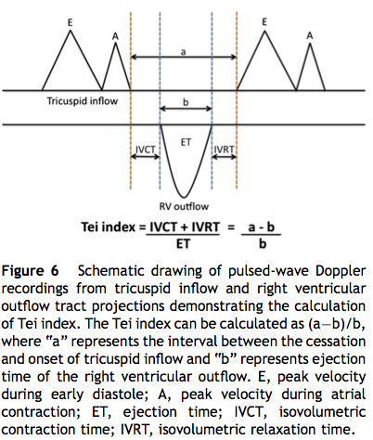

Treatment
Successful therapy of PH related to MV disease is aimed at decreasing PAP by decreasing LA pressure, improving LV systolic and diastolic function, and direct pulmonary artery vasodilation.
The goal of treating elevated left atrial pressures and LV dysfunction associated with MV disease typically involves the use of diuretics (e.g. furosemide or torsemide), balanced vasodilators (e.g. angiotensin-coverting enzyme [ACE] inhibitors, pimobendan), neurohormonal blockers (e.g. ACE inhibitors, aldosterone antagonists) and positive inotropes (e.g. pimobendan). In addition to the standard therapies used to treat MV disease in dogs, medications that directly affect abnormali- ties in the PA endothelin pathway, prostanoid pathway and NO pathway have been described as possible PH therapies.
Calcium-sensitizing PDE-3 inhibitors (e.g. pimobendan) and PDE-5 inhibitors (e.g. sildenafil) represent the most often used pulmonary vasodilators in dogs
Calcium sensitizers and phosphodiesterase- III inhibitors
Calcium-sensitizing and phosphodiesterase-III (PDE- 3) inhibiting agents, such as pimobendan and levosimendan, improve PAP through their direct actions on the heart and pulmonary vasculature, treating both heart failure due to MV disease and PVH in dogs.
PDE-3 inhibition causes PA vasodilation at the level of the large and small pulmonary arteries via potassium channel activation and enhancement of cAMP dependent/adrenergic vasorelaxation.
The calcium-sensitizing properties enhance left and right ventricular inotropic function, which may result in decreased left and right atrial pressures, ultimately improving left- and right-sided CHF.
Phosphodiesterase V inhibitors
Phosphodiesterase V (PDE-5) inhibitors are pulmonary arterial vasodilators and include sildenafil, tadalafil, vardenafil, udenafil and avanafil. The usefulness of PDE-5 inhibitors in PH therapy is based on the interaction of PDE-5 and NO.

Key points:
- Types of PH:
- Pulmonary arterial pressure (PAP) is influenced by pulmonary blood flow, pulmonary vascular resistance (PVR) and pulmonary venous pressure. In veterinary medicine, pulmonary hypertension (PH) has been described as echocardiographically- estimated pulmonary arterial systolic pressure (based on a peak systolic tricuspid regurgitation gradient) greater than ~ 30 mmHg
- By definition, PAH or pre-capillary PH occurs when there is an elevation in PAP (i.e. increased mPAP) as a result of an increased PVR with a normal left atrial pressure (i.e. normal pulmonary artery wedge pressure [PAWP]). Diseases that result in PAH or pre- capillary PH include idiopathic PAH, heartworm disease, congenital systemic-to-pulmonary shunts (i.e. atrial septal defect, ventricular septal defect and patent ductus arteriosus) and necrotizing vasculitis/arteritis.
- Other etiologies causing elevated PAP but not considered as causes of PAH include chronic lung disease/hypoxia and thrombotic disease.
- In contrast, the definition of PVH or post-capillary PH is an elevated PAP as a result of increased PAWP with a normal PVR. The phenomenon of PVH or post-capillary PH occurs most commonly in dogs with mitral valve (MV) disease and myocardial disease (i.e. dilated cardiomyopathy).

- Pulmonary venous hypertension with left-sided heart disease is due to a combination of hypertension from increased left atrial pressures, and reactive pulmonary arterial vasoconstriction associated with acute or chronic hypoxia.
- ET-1 release is increased in canine heart failure and leads to sodium and water retention, potentiation of other neurohormonal systems and promotion of myocardial hypertrophy, fibrosis and remodeling.
- Prostacyclin is a vasodilator, inhibitor of platelet activation and has antiproliferative effects on the PA. In contrast, thromboxane A2 is a potent vasoconstrictor and promotor of platelet activation. In cases of PH, the balance of prostacyclin and thromboxane A2 formation favors thromboxane A2 leading to vasoconstriction, cellular proliferation and thrombosis
- In experimental models and clinical studies of heart failure in people, a deficiency in basal NO synthesis as well as a decrease in endothelial release and response to NO has been found, suggesting that the loss of NO-dependent vasodilation may contribute to the production of PH through vascular remodeling
- Pulmonary artery vasodilation is thought to be NO- cGMP mediated in normal people. In contrast, in people with heart disease, it has been found that PA vasodilation is linked to a natriuretic peptide (NP)-cGMP pathway, independent of the NO-cGMP pathway. In the presence of advanced heart failure, this NP-cGMP-mediated PA vasodilation is attenuated and may contribute to the production of PH.
3. Measurement of PH
- Right heart catheterization (RHC) is the gold standard for diagnosis of PH in people. The PAP in systole and diastole can be measured directly, and the mean PAP calculated.
- Estimation of sPAP by echocardiographic examination relies on the presence of tricuspid regurgitation (TR). The interrogation of a TR jet, in the absence of a RV outflow tract obstruction, allows for a non-invasive estimation of peak systolic PAP. The systolic trans-tricuspid pressure gradient (mmHg) is estimated using the peak systolic TR velocity (m/sec) in the modified Bernoulli equation.

Questions:
1. List 3 determinants of pulmonary artery pressure.

2. In veterinary medicine, pulmonary hypertension (PH) has been described as echocardiographically- estimated pulmonary arterial systolic pressure (based on a peak systolic tricuspid regurgitation gradient) greater than ____________?
A. 25mmHg
B. 30mmHg
C. 35mmHg
D. 40mmHg

3. By definition, PAH or pre-capillary PH occurs when there is an elevation in PAP) as a result of an increased PVR with a (normal/abnormal)__________________________left atrial pressure (i.e. normal pulmonary artery wedge pressure [PAWP])
4. Pulmonary venous hypertension with left-sided heart disease is due to a combination of hypertension from increased left atrial pressures, and reactive pulmonary arterial vasoconstriction associated with acute or chronic hypoxia. T or F?
5. List the mediators of vascular tone and their effects on the pulmonary artery pressure as outlined in this review.

Questions with answers:
1. List 3 determinants of pulmonary artery pressure.
Answer:
- pulmonary blood flow
- pulmonary vascular resistance
- pulmonary venous pressure
2. In veterinary medicine, pulmonary hypertension (PH) has been described as echocardiographically- estimated pulmonary arterial systolic pressure (based on a peak systolic tricuspid regurgitation gradient) greater than ____________?
A. 25mmHg
B. 30mmHg
C. 35mmHg
D. 40mmHg

3. By definition, PAH or pre-capillary PH occurs when there is an elevation in PAP) as a result of an increased PVR with a (normal/abnormal)__________________________left atrial pressure (i.e. normal pulmonary artery wedge pressure [PAWP])
Answer: Normal
4. Pulmonary venous hypertension with left-sided heart disease is due to a combination of hypertension from increased left atrial pressures, and reactive pulmonary arterial vasoconstriction associated with acute or chronic hypoxia. T or F?
Answer: True
5. List the mediators of vascular tone and their effects on the pulmonary artery pressure as outlined in this review.
Answer:
- ET-1 release is increased in canine heart failure and leads to sodium and water retention, potentiation of other neurohormonal systems and promotion of myocardial hypertrophy, fibrosis and remodeling.
- Prostacyclin is a vasodilator, inhibitor of platelet activation and has antiproliferative effects on the PA.
- Thromboxane A2 is a potent vasoconstrictor and promotor of platelet activation
- NO - a deficiency in basal NO synthesis as well as a decrease in endothelial release and response to NO has been found
- Natriuretic peptide (NP)-cGMP pathway - In the presence of advanced heart failure, this NP-cGMP-mediated PA vasodilation is attenuated and may contribute to the production of PH.

NT-proBNP, NT-proANP and cTnI concentrations in dogs with pre-capillary pulmonary hypertension
Journal of Veterinary Cardiology (2011) 13, 171-182
Abstract
Objectives: To compare [NT-proBNP], [NT-proANP] and [cTnI] between control dogs with respiratory disease without pulmonary hypertension (PH) and dogs with pre-capillary PH, and to assess the accuracy of [NT-proBNP], [NT-proANP], [cTnI] to predict Doppler-derived peak tricuspid regurgitation (TR) gradient.
Animals: 20 dogs. 8 control dogs with respiratory disease with no PH and 12 with pre- capillary PH.
Methods: [NT-proBNP], [NT-proANP] and [cTnI] were compared between the 2 groups and simple linear regression analysis was used to predict peak TR gradients from various blood biomarkers.
Results: Median [NT-proBNP] was higher in the dogs with PH (2011 pmol/L, 274-7713 pmol/L) compared to control dogs (744 pmol/L; 531-2710 pmol/L) (p = 0.0339). [NT-proBNP] was associated with peak TR gradient (R2 = 0.7851, p 1⁄4 0.0001). Median [NT-proANP] did not differ between dogs with PH (1747 fmol/ L; 894-2884 fmol/L) and control dogs (1209 fmol/L; 976-1389 fmol/L (p = 0.058). [NT-proANP] was not associated with peak TR gradient (R2 = 0.2780, p 1⁄4 0.0781). Median [cTnI] did not differ between dogs with PH (0.2850 ng/mL; 0.19-1.13 ng/ mL) and control dogs (0.2 ng/mL; 0.19-0.82 ng/mL, p = 0.3051). Median [TnI] was not associated with peak TR gradient (R2 = 0.024, p = 0.6307).
Conclusions: [NT-proBNP] concentration is significantly higher in dogs with pre- capillary PH when compared to dogs with respiratory disease without PH, and [NT- proBNP] may be useful to predict the severity of estimated PH. Elevations in [NT- proBNP] due to pre-capillary PH may complicate the interpretation of [NT-proBNP] elevations in patients presenting with cardiorespiratory abnormalities. [NT- proANP] and [cTnI] were not elevated in dogs with pre-capillary PH.
In veterinary medicine, pulmonary hypertension (PH) has been reported in dogs when echocardiographic estimates of systolic pulmonary arterial pressure (SPAP) exceed ~ 30 mm Hg.
Pre- capillary PH is defined as PH which results from abnormalities on the arterial side of the pulmonary vascular system. In dogs, this type of PH occurs secondary to idiopathic primary arterial PH, heart- worm disease, left-to-right cardiovascular shunts, vascular occlusive disease, hypoxemia and various pulmonary diseases.
In contrast, post-capillary PH is typically associated with left-sided heart disease and is defined as PH that occurs as a result of pulmonary venous hypertension, which leads to pulmonary capillary hypertension and subsequent pulmonary arterial hypertension.
The gold standard of PH diagnosis is a right-heart catheterization directly measuring the SPAP, but in the clinical setting of veterinary medicine, tricuspid regurgitation (TR) interrogation by Doppler echocardiography is more frequently used to estimate right ventricular systolic pressure, which reflects peak SPAP.
There are several limitations associated with this measurement in people and in dogs. Firstly, in people, there is conflicting data regarding the correlation of peak systolic TR gradients to invasively measured SPAP. Secondly, although the diagnosis of TR is usually straightforward the actual measurement of the peak velocity TR jet may be affected by patient compliance during the exam, the degree of TR present, the position of the TR jet in relation to the Doppler cursor and experience of the echocardiographer. Thirdly, in some instances of PH, TR may not be present, precluding the clinician from definitively diagnosing and quantifying PH.
Brain natriuretic peptide (BNP) exists as a pro- hormone that is cleaved into the inactive N-terminal fragment (N-terminal proBNP [NT-proBNP]) and biologically active hormone BNP prior to release into the blood circulation primarily in response to ventricular myocyte stretch. NT-proBNP is more stable in vivo and is typically used as a surrogate marker for the biologically active form
Pro-atrial natriuretic peptide (proANP), another blood-based cardiac biomarker, is released primarily from the atrial myocytes in response to stretch. ProANP is then cleaved into N-terminal proANP (NT-proANP) and C-terminal ANP (CT-ANP).
Cardiac troponin I (cTnI) plasma concentration elevation indicates the presence of myocardial damage and reflects the severity of myocardial injury.
Azotemia, systemic hypertension and anemia are known to affect NT-proBNP concentrations. These concurrent abnormalities may falsely elevate NT-proBNP concentration and result in inaccurate interpretations.
Additional echocardiographic indices suggestive of PH (i.e. right ventricular hypertrophy, septal flattening, increased peak diastolic pulmonic insufficiency, pulmonary artery dilation, abnormal pulmonary artery systolic flow profiles, right ventricular systolic time intervals).
The modified Bernoulli equation was applied to the peak systolic TR flow velocity to calculate the instantaneous right ventricular to right atrial pressure gradient.
Doppler flow interrogations of TR jets provided estimates of SPAP, allowing diagnosis of PH and estimation of severity. A peak systolic TR flow velocity >= 2.8 m/s (peak systolic TR flow gradient >= 31 mm Hg) was considered to be indicative of PH in this setting.
Right atrial (RA) pressures were not measured or estimated based on recent human data suggesting that the addition of estimated RA pressure may lead to overestimation of PH severity
Key points:

1. Objectives:
- To compare [NT-proBNP], [NT-proANP] and [cTnI] between control dogs with respiratory disease without pulmonary hypertension (PH) and dogs with pre-capillary PH
- To assess the accuracy of [NT-proBNP], [NT-proANP], [cTnI] to predict Doppler-derived peak tricuspid regurgitation (TR) gradient.
2. Results:
- Median [NT-proBNP] was higher in the dogs with PH compared to control dogs.
- [NT-proBNP] was associated with peak TR gradient.
- Median [NT-proANP] did not differ between dogs with PH and control dogs.
- [NT-proANP] was not associated with peak TR gradient.
- Median [cTnI] did not differ between dogs with PH and control dogs.
- Median [TnI] was not associated with peak TR gradient.

3. Conclusions:
- [NT-proBNP] concentration is significantly higher in dogs with pre- capillary PH when compared to dogs with respiratory disease without PH, and [NT- proBNP] may be useful to predict the severity of estimated PH.
- Elevations in [NT- proBNP] due to pre-capillary PH may complicate the interpretation of [NT-proBNP] elevations in patients presenting with cardiorespiratory abnormalities. (In dogs with abnormal respiratory signs, NT- proBNP concentration has been a proposed way to differentiate left-sided heart disease or heart failure from pulmonary disease. This study suggests elevated NT-proBNP concentration is also seen in pre-capillary PH and may obscure the diagnosis of left-sided heart disease in dogs with clinical signs of cough or dyspnea).
- [NT- proANP] and [cTnI] were not elevated in dogs with pre-capillary PH.

Questions:

1. Median [NT-proBNP] was higher in the dogs with PH compared to control dogs. T or F?

2. NT-proBNP was associated with peak TR gradient. T or F?

