BR July 29 2014 HMGB
The role of high mobility group box-1 protein in severe sepsis
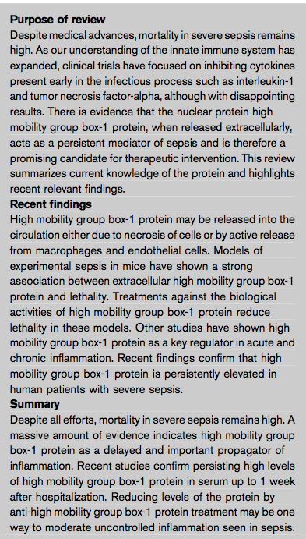
Summary:
In 1999, in an experiment designed to identify possible late mediators of sepsis, Wang et al. found that macrophages stimulated with lipopolysaccharide (LPS) secreted a protein beginning at 16 h – long after the peaks of previously studied proinflammatory cytokines. The protein was identified as the nuclear protein high mobility group box-1 protein (HMGB1), and it was further demonstrated that administrating anti- HMGB1 antibodies, in an experimental model of murine endotoxemia, could reduce lethality from 100 to 30%
High mobility group box-1 protein: the intranuclear protein
HMGB1 is a 215 amino acid protein, encoded on chromosome 13q12, which is highly conserved between species. There is 99% species homology between rodents and humans, the proteins differing by only two amino acids.
It has three domains: two internal repeats of positively charged residues, the A-box and B-box, and a negatively charged terminal COOH terminus. The two boxes bind to the minor groove of chromatin thus modifying the DNA architecture. This facilitates the binding of regulatory proteins, including various gene transcription factors, to form stable complexes with the DNA. It is likely to play a role in DNA repair and replication.
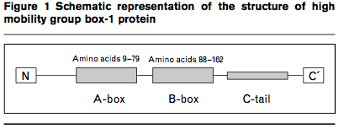

High mobility group box-1 protein: the extracellular protein
The extracellular functions of HMGB1 have long been recognized, particularly concerning its role in the differentiation of cells, in neurite outgrowth and in the governing of cell motility.
As a cytokine, HMGB1 is released from endotoxin stimulated monocytes and, in itself, has proinflammatory properties, inducing other cytokines and chemokines, including TNF-a, IL-1a, IL-1b, IL-1RA, macrophage inflammatory protein (MIP)-1a, MIP-1b, IL-6 and IL-8.
It activates endothelial cells, inducing the release of chemokines and cytokines and the upregulation of adhesion molecules, thereby increasing the adhesion of neutrophils and monocytes to stimulated endothelia.
It induces epithelial-cell barrier leakage in the gut through the downregulation of cell-surface proteins responsible for the adhesion between adjacent epithelial cells.
HMGB1 also mediates migration of monocytes and smooth muscle cells.
Interestingly, it stimulates dendritic cell maturation which implicates a role in the switch from the innate to the adaptive immune system.
The pro-inflammatory activity of HMGB1 mainly derives from the B-box while the A-box only has limited pro-inflammatory activity.
The receptor for advanced glycated end-products (RAGE) has been identified as a major receptor for HMGB1.
RAGE antibodies, as well as soluble RAGE, which acts as a competitive inhibitor, reduce the pro-inflammatory activities of HMGB1.
RAGE knockout mice show a significantly reduced inflammatory response in tissues compared with wild-type animals, when injected intraperitoneally with HMGB1.
HMGB1 binding to RAGE leads to activation of the nuclear factor-kB (NF-kB) pathway and also activation of extracellular signal- regulated kinase and P38. HMGB1 also binds to Toll-like receptors (TLR)-2 and TLR-4, both of which leads to a MyD88-dependent activation of NF-kB
Release of high mobility group box-1 protein
Release of HMGB1 is stimulated by Toll signaling. Thus most bacterial antigens, for example LPS, can trigger HMGB1 release. Release is also triggered by endogenous proinflammatory signals such as the cytokines TNF-a, IL-1b or interferon (IFN)-gamma. Released from monocytes, macrophages, endothelial cells, enterocytes, activated NK cells, mature myeloid dendritic cells. Other sources of extracellular HMGB1 are cells undergoing necrosis. Not released in cells undergoing apoptosis.
High mobility group box-1 protein in experimental sepsis
The kinetics of HMGB1 release and accumulation has been studied in murine models of endotoxemia and also in so-called cecal ligation and puncture (CLP), an experimental setup intended to mimic spontaneous peritonitis.
In the study by Wang et al., animals were injected intraperitoneally with a LD50 dose of endotoxin after which HMGB1 rose in the circulation, starting at 8 h, increased until 16 h, and thereafter remained stable until 36 h.
In a CLP model, HMGB1 started to rise approximately 18 h after induction of peritonitis, and remained elevated for more than 72 h. The kinetics of HMGB1 release in these animal models is delayed compared to other well-studied proinflammatory cytokines such as TNF-a, IL-1b and IL-6. The death of animals parallels the accumulation of HMGB1 in sera or plasma.
Treatment
In the endotoxemia model, passive immunization with anti-HMGB1 antibodies significantly protected against lethal doses of LPS, even if treatment was delayed until 2h after exposure.
A similar effect was demonstrated in the CLP model in which both anti-HMGB1 and A-box of HMGB1 effectively improved survival even after a delay of 24 h. The A- box segment of the protein has only weak pro-inflammatory activity and is a competitive inhibitor of the much more active B-box.
Ethyl pyruvate, a non-toxic food additive and an experimental anti-inflammatory agent that in vitro inhibits the release of HMGB1 from macrophages, also decreases lethality when given to mice in these animal models.
It has recently been demonstrated that treatment with anti-interferon (IFN)-g reduces mortality in a rat CLP model, an effect that the authors attribute to the reduced levels of HMGB1 achieved with treatment.
Other ways to ameliorate the effects of HMGB1 may be to develop treatments that focus on its receptors.
High mobility group box-1 protein in organ disorders and diseases other than sepsis
Elevated levels of HMGB1 are seen in several organ disorders and diseases characterized by inflammatory responses
High mobility group box-1 protein in human sepsis
HMGB1 were found in 25 critically ill patients with sepsis, and significantly higher levels in those that suc- cumbed to disease compared to those that survived.
Another study found no correlation between levels of HMGB1 and severity of disease as measured by acute physiology and chronic health evaluation (APACHE) II and sepsis-related organ failure assessment (SOFA)- scores. In fact, there was a tendency to higher levels of HMGB1 in those with severe sepsis compared to those with septic shock, and also significantly lower levels in those who perished within 28 days compared to those who survived, at least with one of the Western blot methods used.
An important point to stress is that in all studies healthy controls have had low (< 2 ng/ml) or non-detectable levels of circulating HMGB1.
NOTE: Can use western blot or ELISA techniques to measure levels of HMGB1
Key points:
HMGB was first identified in 1999, in an experiment designed to identify possible late mediators of sepsis. HMGB1 is a 215 amino acid protein, which is highly conserved between species. There is 99% species homology between rodents and humans. It normally functions as an intra-nuclear protein that facilitates the binding of regulatory proteins, including various gene transcription factors. There is evidence that HMGB 1, when released extracellularly, acts as a persistent mediator of sepsis and is therefore a promising candidate for therapeutic intervention. High mobility group box-1 protein may be released into the circulation either due to necrosis of cells or by active release from macrophages and endothelial cells. Models of experimental sepsis in mice have shown a strong association between extracellular high mobility group box-1 protein and lethality.
When released extracellularly, it acts as a cytokine, HMGB1 that has pro-inflammatory properties, inducing other cytokines and chemokines, including TNF-a, IL-1a, IL-1b, IL-1RA, macrophage inflammatory protein (MIP)-1a, MIP-1b, IL-6 and IL-8. It activates endothelial cells, inducing the release of chemokines and cytokines and the upregulation of adhesion molecules, thereby increasing the adhesion of neutrophils and monocytes to stimulated endothelia. It induces epithelial-cell barrier leakage in the gut through the downregulation of cell-surface proteins responsible for the adhesion between adjacent epithelial cells. HMGB1 also mediates migration of monocytes and smooth muscle cells. The pro-inflammatory activity of HMGB1 mainly derives from the B-box while the A-box only has limited pro-inflammatory activity.
Release of HMGB1 is stimulated by Toll signaling. Thus most bacterial antigens, for example LPS, can trigger HMGB1 release. Release is also triggered by endogenous proinflammatory signals such as the cytokines TNF-a, IL-1b or interferon (IFN)-gamma. Released from monocytes, macrophages, endothelial cells, enterocytes, activated NK cells, mature myeloid dendritic cells. Other sources of extracellular HMGB1 are cells undergoing necrosis.
Therapeutic targets: anti-HMGB1 antibodies, A-box of HMGB1, RAGE, Ethyl pyruvate, anti-interferon (IFN)-g

Questions:
- HMGB-1 protein normally functions as an _________________________ protein that facilitates______________________.
Answer: intra-nuclear, the binding of regulatory proteins (including various gene transcription factors, to form stable complexes with the DNA).

- There is evidence that HMGB 1, when___________________, acts as a persistent mediator of sepsis.
Answer: released extracellularly

- What are triggers of HMGB-1 release, and what are its effects?
Answer:
Released via:
- Release of HMGB1 is stimulated by Toll signaling. Thus most bacterial antigens, for example LPS, can trigger HMGB1 release.
- Release is also triggered by endogenous proinflammatory signals such as the cytokines TNF-a, IL-1b or interferon (IFN)-gamma.
- Released from monocytes, macrophages, endothelial cells, enterocytes, activated NK cells, mature myeloid dendritic cells.
- Other sources of extracellular HMGB1 are cells undergoing necrosis.
Actions:
- HMGB-1 has proinflammatory properties, inducing other cytokines and chemokines, including TNF-a, IL-1a, IL-1b, IL-1RA, macrophage inflammatory protein (MIP)-1a, MIP-1b, IL-6 and IL-8.
- It activates endothelial cells, inducing the release of chemokines and cytokines and the upregulation of adhesion molecules, thereby increasing the adhesion of neutrophils and monocytes to stimulated endothelia.

- The pro-inflammatory activity of HMGB1 mainly derives from the B-box while the A-box only has limited pro-inflammatory activity. T or F?
Answer: True

- The _______________________________has been identified as a major receptor for HMGB1.
Answer: receptor for advanced glycated end-products (RAGE)

- List some therapeutic targets discussed in this article.
Answer: anti-HMGB1 antibodies, A-box of HMGB1, RAGE, Ethyl pyruvate, anti-interferon (IFN)-g

Lactate clearance as a target of therapy in sepsis: a flawed paradigm
Abstract:
An increased blood lactate level is widely believed to be a marker of inadequate oxygen delivery and anaerobic metabolism. Furthermore, the rate of decline in lactate concentration (lactate clearance) has been recommended as an end-point of early goal directed therapy in critical ill patients with sepsis. We provide compelling data that an elevated lactate concentration is a consequence of increased aerobic glycolysis as part of the stress response and that titrating therapy to the rate of decline in lactate concentration is a potentially harmful endeavour. Furthermore, an increased lactate concentration may be an important adaptive survival response in critical illness.
Conclusion: An elevated lactate level in patients with sepsis is a marker of disease severity and not an indication of anaerobic metabolism. Increasing oxygen delivery to treat a non-existent oxygen debt may be a harmful under- taking. ‘Lactate clearance’ should not be used as the end-point of resuscitation in patients with sepsis

Summary:

Lactate is produced by glycolysis and metabolized by the liver and to a lesser degree by the kidney. Lactate is produced in the cytoplasm according to the following reaction.

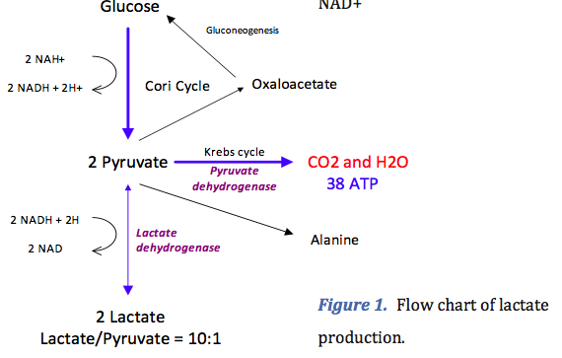

In physiological conditions, lactate is produced by muscles (25%), Skin (25%), Brain (20%), Intestines (10%), RBCs (20%).
Arterial lactate concentration is dependent on the balancebetween its production and consumption.
In general, this concentration is less than 2mmol/L, although daily lactate production is ~1500mmol/L.
Generated lactate can be transformed into oxaloacetate oralanine via the pyruvate pathway or can be utilized directly by periportal hepatocytes (60%) to produce glycogen and glucose (glycogenesis and glucogenesis; Cori cycle).
The kidney also participates in the metabolism of lactate (30%), with the cortex classically acting as the metabolizer by glucogenesis and the medulla as a producer of lactate.
Pyruvate is metabolized by the mitochondrial aerobic oxidation pathway via the Krebs cycle. This reaction leads to the production of large quantities of ATP (36 molecules of ATP for one molecule of pyruvate)
Close examination of glycolysis reveals that complete metabolism of glucose to lactate results in no net release of protons and, thus, does not contribute to acidosis. In fact, during the production of lactate from pyruvate, protons are consumed, thus inhibiting acidosis. Furthermore lactate oxidation and consumption via gluconegenosis consume hydrogen ions and is an alkalinizing process. This implies that lactic acidosis is a condition that does not exist.
It has been well established that an increased blood lactate concentration is a powerful predictor of mortality in critically ill patients.
Lactate as a marker of metabolic stress:
Cytosolic glycolytic flux is functionally divided into two distinct compartments. There are two distinctive glycolytic pathways utilizing separate glycolytic enzyme pools. The first pathway participates in oxidative metabolism via the Krebs cycle; the second pathway is linked to the activity of a Na⁺/K⁺ ATPase pump. ATP produced by this pathway is used to fuel the pump.

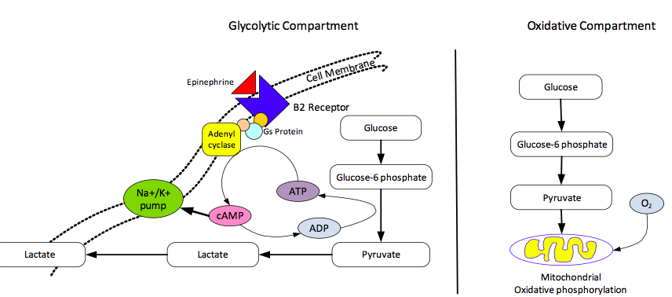

Studies have demonstrated that that epinephrine (via B2 stimulation) increases cAMP production, inducing the stimulation of glycogenolysis (ATP production) as well as activation of the Na⁺/K⁺ ATPase pump, which in turn consumes this ATP and produces ADP. This generated ADP via phosphofructokinase stimulation will reactivate glycogenolysis and hence will generate more pyruvate and subsequent lactate formation.

Some studies have demonstrated that hyperlactiacidemia accompanying hemorrhage could largely be prevented by pre-treatment with combined apha and beta adrenergic receptor blockade.

It has now been well established that epinephrine released as part of the stress response in patients with shock stimulates the Na⁺/K⁺ ATPase pump, which leads to increased lactate production in well oxygenated conditions in various cells including erythrocytes, vascular smooth mucles cells, neurons, glia and skeletal muscle.
Several studies have demonstrated that increased anaerobic glycolysis in skeletal muscle is secondary to epinephrine stimulated Na⁺/K⁺ ATPase activity (and not due to anerobic glycolysis due to tissue hypoxia) as the major source of lactate in patients with sepsis.

The hypermetabolic state with increased Na⁺/K⁺ ATPase activity results in accelerated glycolysis and generates pyruvate and lactate at an increased rate. If glycolysis occurs at a rate that exceeds that of oxidative metabolism, some pyruvate may not be oxidatively metabolized in the Krebs cycle and will be converted to lactate. This will result in a concommitant increase in pyruvate and lactate, without alteration of the pyruvate:Lactate ratio.

This paper suggested that both an increased lactate production and hyperglycemia are consequences of activation of the stress response, and are likely an essential conserved evolutionary survival response.

Normally under stable conditions, the heart oxidizes fatty acids for 70-90% of its bioenergetic needs. However the heart subjected to shock undergoes a shift in substrate utilization, such that it oxidizes lactate for the majority of its energetic needs. An accelerated lactate clearance during therefore could compromise cardiac performance during shock.

In a rat endotoxin model, they showed that inhibition of lactate via Beta2 adrenergic blockade was associated with cardiovascular collapse and early death.

In another study, infusion of sodium lactate increased cardiac performance in patients with cardiogenic and septic shock.

They also note that although glucose is the major energy source of the brain, lactate oxidation may occur in acute stress.

Increasing oxygen delivery may be harmful:
Current evidence suggests that most of the increase in blood lactate levels in patients with severe sepsis is unrelated to poor tissue perfusion and is therefore unlikely to respond to iatrogenic attempts to increase oxygen delivery. Driving up oxygen delivery in patients without an oxygen debt will not increase oxygen consumption, and it is likely to be harmful.
The authors believe that a fall in lactate concentration following the initiation of treatment for sepsis is due to an attenuation of the stress response and not due to correction of an oxygen debt. Furthermore, while a failure of blood lactate levels to decline after the initiation of treatment is an ominous sign, adequate lactate clearance does not guarantee survival.

Key points:

It is widely believed that in critically ill patients, when oxygen delivery fails to meet oxygen demands an oxygen debt with global tissue hypoxia ensues. This results in anaerobic metabolism and increased lactate production. This paper contradicts that theory and provides evidence that suggests that blood lactate is a reflection of the severity of illness and the degree of the activation of the stress response (and release of epinephrine), rather than being a marker of anaerobic metabolism. Furthermore an increased lactate concentration may be an important adaptive survival response in critical illness.

Several studies have demonstrated that increased anaerobic glycolysis in skeletal muscle is secondary to epinephrine stimulated Na⁺/K⁺ ATPase activity (and not due to anaerobic glycolysis due to tissue hypoxia) as the major source of lactate in patients with sepsis. Studies have demonstrated that that epinephrine (via B2 stimulation) increases cAMP production, inducing the stimulation of glycogenolysis (ATP production) as well as activation of the Na⁺/K⁺ ATPase pump, which in turn consumes this ATP and produces ADP. The epinephrine induced hypermetabolic state with increased Na⁺/K⁺ ATPase activity results in accelerated glycolysis and generates pyruvate and lactate at an increased rate. If glycolysis occurs at a rate that exceeds that of oxidative metabolism, some pyruvate may not be oxidatively metabolized in the Krebs cycle and will be converted to lactate. This will result in a concommitant increase in pyruvate and lactate, without alteration of the pyruvate:Lactate ratio.

Normally under stable conditions, the heart oxidizes fatty acids for 70-90% of its bioenergetic needs. However the heart subjected to shock undergoes a shift in substrate utilization, such that it oxidizes lactate for the majority of its energetic needs. An accelerated lactate clearance during therefore could compromise cardiac performance during shock.

The authors believe that a fall in lactate concentration following the initiation of treatment for sepsis is due to an attenuation of the stress response and not due to correction of an oxygen debt. Furthermore, while a failure of blood lactate levels to decline after the initiation of treatment is an ominous sign, adequate lactate clearance does not guarantee survival.
Questions:

- What is the authors explanation for the presence of hyperlactatemia in patients with sepsis or septic shock?

Answer: The hyperlactatemia is due to an epinephrine induced hypermetabolic state (due to B2 adrenergic stimulation of the glycolytic pathway, which results in pyruvate and lactate production at an increased rate, that exceeds that of oxidative metabolism). This is thought to be part of the stress response, and NOT due to decreased oxygen delivery to the tissues.

- Why may attempts at decreasing lactate levels in these patient’s may be harmful?
Answer: Normally under stable conditions, the heart oxidizes fatty acids for 70-90% of its bioenergetic needs. However the heart subjected to shock undergoes a shift in substrate utilization, such that it oxidizes lactate for the majority of its energetic needs. An accelerated lactate clearance during therefore could compromise cardiac performance during shock

- What is the authors explanation for the fall in lactate concentration following the initiation of treatment for sepsis?
Answer: The authors believe that a fall in lactate concentration following the initiation of treatment for sepsis is due to an attenuation of the stress response and not due to correction of an oxygen debt.

