Positive impact of an emergency department protocol on time to antimicrobial administration in dogs with septic peritonitis
Journal of Veterinary Emergency and Critical Care 23(5) 2013, pp 551–556
Amanda L. Abelson, DVM, DACVECC; Gareth J. Buckley, MA, VetMB, DACVECC and Elizabeth A. Rozanski, DVM, DACVIM, DACVECC

Key Points:
- Median time from diagnosis to antimicrobial administration was 6 hours (range 1–10 h) in the PRE, and 1 hour (range 1–2 h) in the POST which was significantly different (P = 0.001). In the PRE, 5 of 20 dogs (25%) received antimicrobials within 2 hours of diagnosis of septic peritonitis versus 40 of 40 dogs (100%) in the POST. Within 1 hour of diagnosis was 2 of 20 dogs (10%) in the PRE, versus 35 of 40 dogs (87.5%) in the POST.
- Creation of a specific antimicrobial protocol for the treatment of canine abdominal sepsis significantly improves time to antimicrobial administration, which improves outcome/mortality
- Give Abx early, don’t fuck around, if you are concerned then just give them.

Comparison of Peritoneal Fluid and Peripheral Blood pH,
Bicarbonate, Glucose, and Lactate Concentration as a Diagnostic
Tool for Septic Peritonitis in Dogs and Cats
Veterinary Surgery 32:161-166, 2003

Key Points:
- In dogs, with septic effusion, peritoneal fluid glucose concentration was always lower than the blood glucose concentration. A blood-to-fluid glucose (BFG) difference > 20 mg/dL was 100% sensitive and 100% specific for the diagnosis of septic peritoneal effusion in dogs. Peritoneal fluid cytology has been reported to be 57%-87% accurate in the diagnosis of septic peritonitis.
- In 7 dogs in which it was evaluated, a blood-to-fluid lactate (BFL) difference >2.0 mmol/L was also 100% sensitive and specific for a diagnosis of septic peritoneal effusion. In cats, the BFG difference was 86% sensitive and 100% specific for a diagnosis of septic peritonitis.
- It is hypothesized that the glucose concentrations decrease in the abdominal fluid as bacterial invasion increases. This may be because of glucose use by bacteria and phagocytic cells, glycolysis in the peritoneal fluid, or low blood to fluid glucose transport.
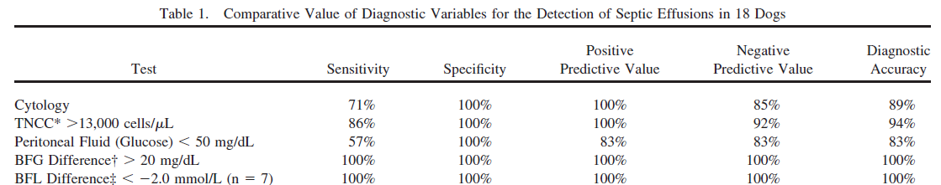
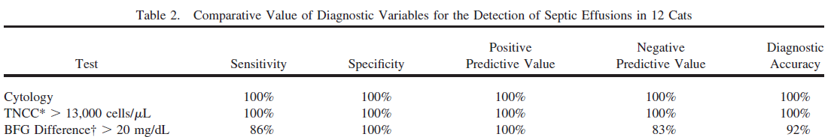

Questions:

- What is the most important part of antimicrobial therapy in septic peritonitis
  - Give as many as possible
  - Matt Damon
  - Use multiple drugs
  - Give early
- True or false: The blood to fluid glucose (BFG) difference is more useful in cats than dogs
- Which of the following had 100% sensitivity and specificity for diagnosis of septic peritonitis in dogs.
  - Cytology
  - BFG difference > 20 mg/dL
  - BFL difference < -2 mmol/L
  - Peritoneal fluid cell count >15,000 cells/µL
  - Peritoneal fluid glucose < 50 mg/dL

- Which of the following had 100% sensitivity and specificity for diagnosis of septic peritonitis in cats.
  - Cytology
  - BFG difference > 20 mg/dL
  - BFL difference < -2 mmol/L
  - Peritoneal fluid cell count >15,000 cells/µL
  - Peritoneal fluid glucose < 50 mg/dL

Questions with answers:

- What is the most important part of antimicrobial therapy in septic peritonitis
  - Give as many as possible
  - Matt Damon
  - Use multiple drugs
  - Give early
- True or false: The blood to fluid glucose (BFG) difference is more useful in cats than dogs
- Which of the following had 100% sensitivity and specificity for diagnosis of septic peritonitis in dogs.
  - Cytology
  - BFG difference > 20 mg/dL
  - BFL difference < -2 mmol/L
  - Peritoneal fluid cell count >13,000 cells/µL
  - Peritoneal fluid glucose < 50 mg/dL

- Which of the following had 100% sensitivity and specificity for diagnosis of septic peritonitis in cats.
  - Cytology
  - BFG difference > 20 mg/dL
  - BFL difference < -2 mmol/L
  - Peritoneal fluid cell count >13,000 cells/µL
  - Peritoneal fluid glucose < 50 mg/dL

