Toxin | Species | Basic MOT (kidney) | CS | Dx findings | Tx | Lit review
Lily (Lilium spp) | Feline | Unknown | Vomiting, anorexia | Having eaten a lily. Any part of the plant is toxic | Maintain vascular volume and fluid support.
Ethylene glycol | Canine and Feline | Deposition of calcium oxalate crystals  The COM crystals  adhere to renal tubular cell membranes, and are then internalized by the cells, where they  alter cell membrane structure and function and increase reactive oxygen species and produce mitochondrial dysfunction, resulting in cell death. | Vomiting, abdominal pain, anuria, ataxia | High AG acidosis  Positive ethylene glycol test  Calcium oxalate crystals (Monohydrate> dehydrate) | Fomepizole  Ethanol  Fluid support  B vitamins  diuresis
Mercury | Cats and Dogs | Damage to pars recta in the kidney  Damage to tubular epithelial cells | GI signs, vomiting | Blood mercury testing | IV fluids  Decontamination  Chelation
Chromium and Cadmium | Cats and Dogs | Renal tubular necrosis | GI signs, vomiting, anorexia | Blood metal testing | IV fluids  Possible chelation
Carbon tetrachloride | Cats and dogs | Tubular necrosis | GI signs, vomiting, anorexia, liver disease | None | IV fluids, supportive care
Questions

1. Fill in the blanks
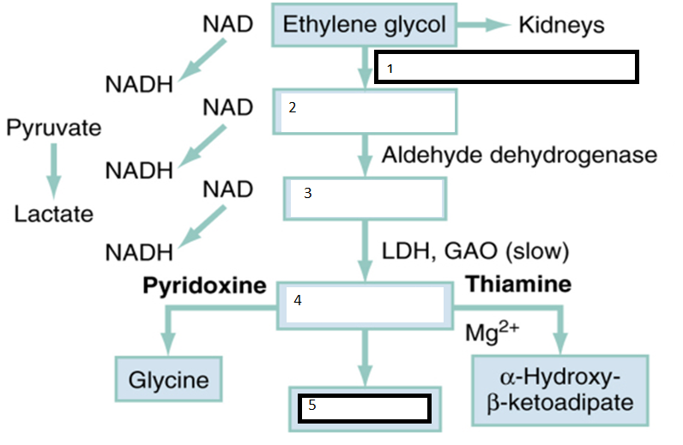

2. Which of the following compounds will cause AKI (renal failure) in cats
a. Easter lily
b. Lily of the valley
c. Blood Lily
d. Calla Lily
e. Tiger Lily
f. Peace Lily
g. Day Lily

3. Which part of the plant of a Lilium spp plant is toxic to cats?

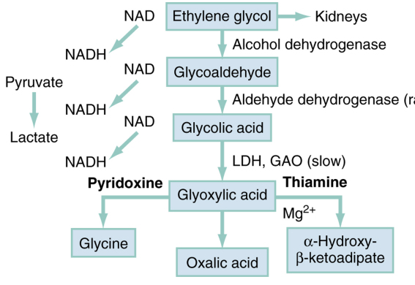
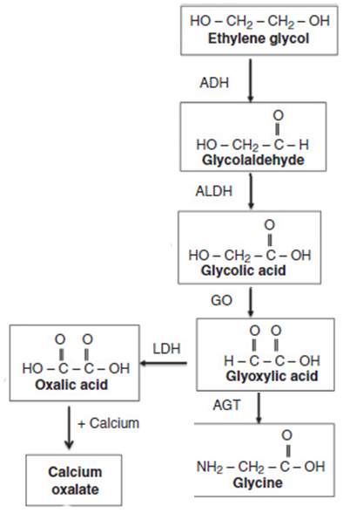

2. Which of the following compounds will cause AKI (renal failure) in cats
a. Easter lily
b. Lily of the valley
c. Blood Lily
d. Calla Lily
e. Tiger Lily
f. Peace Lily
g. Day Lily

