Tidal Breathing Flow-Volume Loop Analysis for the Diagnosis and Staging of Tracheal Collapse in Dogs

Key Points:
- Two types of TBFVL shapes were identified: Type I, representative of the 10 healthy controls, and Type II, representative of the 28 dogs with TC
- Statistical analysis showed the dogs could be differentiated into healthy or affected by TC by 3 indices, TE/TI (expiratory time divided by inspiratory time), TI/TTOT (inspiratory time divided by total respiratory time), and EF75/IF75 (expiratory flow at end tidal volume plus 75% end tidal volume divided by inspiratory flow at end tidal volume plus 75% end tidal volume). The TC could also be graded as mild-moderate (grades I and II) or severe (grade III), showing a diagnostic value of 97.4%.
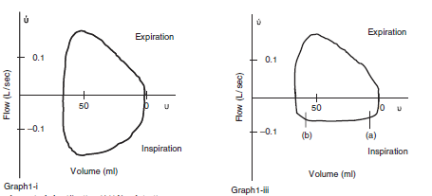

Effects of oxygen insufflation rate, respiratory rate, and tidal volume on fraction of inspired oxygen in cadaveric canine heads attached to a lung model

Key Points:
- Each cadaver head was instrumented with a nasal insufflation catheter through which oxygen was delivered. The trachea was attached to a sample collection port connected by means of corrugated tubing to a lung model. Eight treatment combinations that varied in respiratory rate (10 or 20 breaths/min), tidal volume (10 or 15 mL/kg), and oxygen insufflation rate (50 or 100 mL/kg/min). Gas samples were manually collected, and inspired oxygen concentrations were analyzed. The FIO2 and end-tidal CO2 concentration were determined and compared among sample groups.
- The FIO2 was significantly increased at the higher insufflation rate (estimated marginal least squares mean, 48.7% vs 38.6% for 100 and 50 mL/kg/min, respectively), lower respiratory rate (48.9% vs 38.3% for 10 and 20 breaths/min, respectively), and smaller tidal volume (46.8% vs 40.0% for 10 and 15 mL/kg, respectively).
Useful reference:
Dunphy ED, Mann FA, Dodam JR, et al. Comparison of unilateral versus bilateral nasal catheters for oxygen administration in dogs. J Vet Emerg Crit Care 2002;12:245–251.

Questions:
1. True or False: Tidal breathing flow-volume loop analysis can be used for diagnosis of tracheal collapse in dogs.

2. True or false: Respiratory rate in patients with nasal oxygen cannulas can affect the FiO2.

