Toxin | Species | Basic MOT (kidney) | CS | Dx findings | Tx
Vitis sp.  Grapes  Raisins  Zante currants | Dogs  Cats? Ferrets? | Mechanism of action unknown.  Nephrosis (renal tubular  degeneration + necrosis)  Sloughing of proximal tubule epithelium results in extensive necrotic debris within tubular lumens.  Nephrotoxic agent or idiosyncratic reaction leading to renal ischemia  Toxicity observed with consumption of varying amounts of fresh grapes (all types and colors) | Rapid onset (12-24hrs)  -vomiting +/- diarrhea  -anorexia  -lethargy  -abd pain  -polyuria, oliguria, anuria | -⇑ BUN  -⇑ creatinine  -Hyperphosph  -Hypercalcemia  -Hyperkalemia  -Isosthenuria | -Induce emesis (>2 hrs following ingestion warranted as Vitis fruits remain in gut for some time)  -Activated charcoal + cathartic  -IV fluid therapy for a minimum of 48-72hrs to support blood pressure, maintain hydration and urine output  -antiemetics  -peritoneal dialysis  Monitor chemistry values for ≥72 hrs  Px: ataxia, weakness, and oliguric or anuric renal failure in dogs poor prognosis.  -Severely affected can die within 23-289hrs  - DIC has occurred in some dogs during the treatment phase.
Radiocontrast  CIN – contrast induced nephropathy | Cats Dogs | Dose dependent  -Transient renal ischemia  -Preferentially vasoconstricts glomerular afferent arterioles by depleting endothelial nitric oxide bioavailability.  Potentiates an exaggerated afferent arteriolar vasoconstricting response to angiotensin II  -Direct tubular toxicity  -Changes in glomerular capillary permeability  Renal damage and decreased renal clearance, especially in dogs with heart failure. | - CIN ranges in severity  Most cases asymptomatic, nonoliguric transient  Less common form is oliguric, severe ARF necessitating dialysis.  Permanent kidney damage uncommon. | -CIN defined as an acute deterioration of renal function = an increase of ≥25%, or an absolute increase of ≥0.5 mg/dL (44.2 μmol/L), in serum creatinine from the baseline value that occurs within 3 days after the administration of iodinated contrast | Most cases transient, asymptomatic and reversible without treatment  Self-limited and resolve in 1-2 weeks.  Nonionic agents with lower osmolarity (i.e., iopamidol) have decreased risks of toxicity  Mostly prevention  No prophylaxis found that eliminates nephropathy after contrast medium. Hydration reduces the likelihood  Patients at high risk of CIN should receive the smallest possible dose of either nonionic isosmolar dimeric contrast media or nonionic low osmolar monomeric contrast media.  Oral hydration and intravenous infusion of 0.9% saline, provided no contraindication to volume expansion  Effectiveness of pharmacologic manipulation in the prevention of CIN is controversial. Sodium bicarbonate infusion in combination with NAC shows promise and would be suitable for outpatients because it can be given 1 hour before the procedure and continued for 6 hours afterward.  Investigation of AT II  -After iodixanol reduces the bioavailability of nitric oxide in the afferent arteriole, minor events stimulating angiotensin  II trigger profound constriction of the afferent arteriole, thereby massively and paradoxically reducing GFR.  N-acetylcysteine appears to be effective in preventing renal failure
Aminoglycosides | Cats Dogs | Proximal tubular injury  Reabsorbed by PT epithelial cells. Accumulate in lysosomes, Golgi apparatus and endoplasmic reticulum leaks into cytosol and activates the intrinsic apoptotic pathway, increases production of RO intermediates, and interacts with mitochondria dysfunction in protein synthesis and packaging.  Alters tubular reabsorption and leads to cellular necrosis.  Cellular residues in tubular lumen cause obstruction increases hydrostatic pressure leakage of ultrafiltrate into the interstitium and peritubular capillaries reduces GFR (by decreasing glomerular filtration gradient)  Also has some direct glomerular effects (mesangial contraction, mesangial cell proliferation, alteration of filtration barrier selectivity) | -polyuria  -proteinuria  -hematuria  -cylindruria  -azotemia | -hyposthenuria  -enzymuria  -glucosuria  -proteinuria  -Serum creatinine can be increased after a few days of administration  -HypoMg | -Reversible once the drug is withdrawn  -Can become irreversible if administration is prolonged.  -Silymarin or Vitamin E  Prevention - hydration maintained, co-administration with other nephrotoxic or diuretic drugs (antiinflammatory drugs, furosemide) should be avoided, and TDM should be used. TDM dose adjustment is related to the patient’s pharmacokinetic parameters and minimal inhibitory concentration (MIC) of the causative bacteria. Goal is to provide a dosage regimen that produces a peak concentration 8 to 10 times more than the MIC and a trough concentration of less than 2 mcg/mL, and preferably less than 1 mcg/mL.  -Prostaglandin analogue (misoprostol) not effective for prevention or treatment
Amphotericin B | Cats Dogs | Dose-dependent  Drug binds to cholesterol in proximal tubule causing Renal arteriolar vasoconstriction results in decrease in GFR  Directly cytotoxic in relation with its ability to bind cholesterol and form membrane pores, leading to tubular necrosis. | -pyrexia  -vomiting  -nausea  -may cause thrombosis or phlebitis | -Urinalysis abnormalities (protein, blood, casts) before  ⇑ BUN  -HypoMg  -Hyperphosph  -Hypokalemia | Withdraw drug  Use of safer azole antifungals is preferred to amphotericin B wherever possible.  Administration of fluids containing NaCl prior to treatment may lessen nephrotoxicity  Administer in dextrose-containing IV fluid (precipitates in saline)  New lipid-based formulations have lowered the toxic events related to amphotericin B administration in human medicine
Beta-lactams (imipenem) | Dogs | Administered in combination with cilastatin to inhibit its metabolism by dehydropeptidase I on the brush borders of renal tubular cells to minimize its uptake into renal tubular cells and subsequent nephrotoxicity
Tetracyclines | Dogs | Tubular nephropathy  High doses of oxytetracycline (25 mg/kg IV)  Renal damage has also been described with the use of outdated or degraded tetracycline. | vomiting  diarrhea  dehydration isosthenuria | -azotemia  -hyperphosph
Sulfonamides | Dogs | Idiosyncratic toxicity  Glomerulonephritis | Renal toxicity less common than some other signs (i.e., fever, arthropathyand blood dyscrasias). | -Proteinuria  -Crystalluria with high doses or if dehydrated

Literature Review

Amphotericin B

Expert Opinion on Drug Safety, November 2013, Vol. 12, No. 6 : Pages 881-895
Toxicokinetic and mechanistic basis for the safety and tolerability of liposomal amphotericin B
Angela S Loo , Saif A Muhsin , Thomas J Walsh
(doi: 10.1517/14740338.2013.827168)

Introduction: Amphotericin B (AmB) was first approved by the US Food and Drug Administration in 1959 with sodium deoxycholate (DAmB, Fungizone®). Extensive toxicities associated with the drug led to the development of lipid formulations of AmB, including liposomal amphotericin B (L-AmB, AmBisome®). Phase I studies as well as comparative Phase III clinical trials indicate that L-AmB is associated with less nephrotoxicity and reduced infusion-related toxicity. There is, however, no recent comprehensive review of the safety and tolerability of L-AmB.

Areas covered: This article reviews the safety, tolerability and the mechanisms of the major toxicities associated with L-AmB, including nephrotoxicity, infusion-related reactions (IRRs), anemia and thrombocytopenia, and hepatic abnormalities. The article further discusses the mechanism of action and pharmacokinetics of L-AmB.

Expert opinion: L-AmB is a broad-spectrum antifungal agent that has significantly reduced toxicities compared to its predecessor, DAmB.

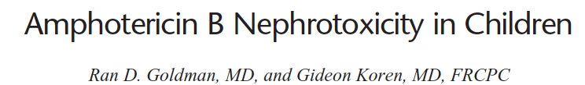
Amphotericin B is the treatment of choice for severe systemic fungal infections. Nephrotoxicity is the most clinically significant adverse effect, but studies examining nephrotoxicity in children are scarce. Nephrotoxicity includes decreased glomerular filtration rate and distal tubulopathy with urinary loss of potassium and magnesium, renal tubular acidosis, loss of urine concentrating ability, and sometimes Fanconi's syndrome. The mechanisms involved in nephrotoxicity include the use of deoxycholate, the vehicle for amphotericin, reduction in renal blood flow and glomerular filtration rate, increased salt concentrations at the macula densa, interaction of amphotericin with ergosterol in the cell membrane, and apoptosis in proximal tubular cells and medullary interstitial cells. Some risk factors for amphotericin nephrotoxicity have been determined over the years. Cumulative dosage, treatment duration, and dosing schedule as well as the combination of amphotericin with other nephrotoxic drugs, such as diuretics and cyclosporine, are important risk factors. Mechanisms to prevent nephrotoxicity include the use of lipid formulations such as amphotericin B lipid complex, amphotericin B colloidal dispersion, and liposomal amphotericin B and the concurrent use of volume repletion. Amiloride can be considered in serious potassium loss.

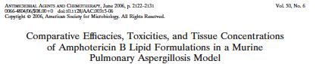
Invasive aspergillosis, an important cause of morbidity and mortality in immunosuppressed (IS) patients, is often treated with amphotericin B lipid formulations. In the present study, liposomal amphotericin B (L-AMB) and amphotericin B lipid complex (ABLC) were compared in treatment of murine pulmonary aspergillosis. Uninfected, IS mice were treated for 4 days with 1, 4, 8, or 12 mg L-AMB or ABLC/kg of body weight, and their lungs were analyzed by high-performance liquid chromatography for drug concentrations. IS mice intranasally challenged with Aspergillus fumigatus were treated with 12, 15, or 20 mg/kg L-AMB or ABLC and monitored for survival, fungal burden (CFU), and tissue drug concentration. Blood urea nitrogen (BUN) levels and kidney histopathology were determined for uninfected and infected mice given 15 or 20 mg/kg L-AMB or ABLC. The results showed that both drugs had therapeutic levels of drug (>3.0 μg/g) in the lungs of uninfected or infected mice, and 24 h after the last dose, ABLC levels were significantly higher than L-AMB levels (P < 0.02). L-AMB and ABLC at 12 mg/kg both produced 57% survival, but only L-AMB at 15 or 20 mg/kg further increased survival to 80 to 90%, with BUN levels and kidney morphology similar to those of controls. Survival at 15 or 20 mg/kg ABLC was not significantly different than that of controls, and BUN levels were significantly elevated, with tubular alterations in uninfected animals and acute necrosis in kidney tubules of infected animals. In conclusion, although both drugs were effective in prolonging survival at 12 mg/kg, the reduced nephrotoxicity of L-AMB increased its therapeutic index, allowing for its safe and effective use at 15 or 20 mg/kg.

Aminoglycosides

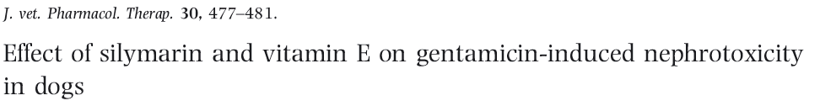
Drug-induced nephrotoxicity is an important cause of renal failure in dogs. Aminoglycoside antibiotics, such as gentamicin, can produce nephrotoxicity in dogs, due to in part to an imbalance of pro- and antioxidants (oxidative stress). Silymarin (the mixture of flavonolignans extracted from Silybum marianum ) has potentially beneficial antioxidant properties. A control group (saline, group 1,n . 5) was compared with dogs that were administrated gentamicin by intramuscular injection, at dosage of 20 mg/kg, once daily for 9 days (groups 2–5, n . 5 per group). The effects of vitamin E (group 3) and silymarin (group 4) alone and in combination (group 5) were compared for induced nephrotoxicity. Renal function was assessed using serum biochemical markers (creatinine and urea). Malondialdehyde (MDA) concentration were measured as a marker of lipid peroxidation. The activity of total serum antioxidants (TSAO) was assessed as a marker of antioxidant defences. Serum creatinine and urea concentrations were increased significantly and TSAO was decreased significantly in group 2 compared with group 1. Serum creatinine concentrations but not urea concentrations were significantly lower in groups 3 and 4 than in group 2 (P . 0.001). SerumMDA concentrations was significantly different between groups 2 and 3 (P . 0.01), 2 and 4 (P < 0.001) and 4 and 5 (P . 0.01). TSAO activity was significantly in group 4 (silymarin) than in group 2 (P . 0.002). Silymarin and vitamin E decreased gentamicin-induced nephrotoxicity in dogs.

Grapes/Raisins

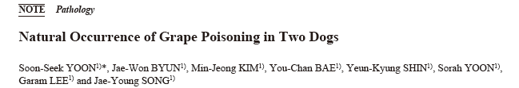
ABSTRACT. Clinical grape poisoning in two dogs (a 1.6-year-old male Shih Tzu and a 5-year-old female Yorkshire Terrier) was described in the present study. Clinical signs included decreased urine output in the Shih Tzu and ataxia in the Yorkshire Terrier after grape ingestion.
The Shih Tzu died 5 days post-grape ingestion, while the Yorkshire Terrier died 3 days post-grape ingestion. Erythematous serosae and mucosae, multifocal red small intestinal foci, and blood and grape seeds were identified in the intestinal lumen. Brownish-yellow crystals were bilaterally identified in the renal pelvis. The primary histological findings were acute tubular necrosis of the proximal convoluted tubules, severe necrosis, and mineralization in the renal cortical tubules. Blood urea nitrogen, creatinine, and alanine aminotransferase were increased in the dogs. Many Korean veterinary clinicians have suspected clinical grape poisoning. However, to our knowledge, grape poisoning has not been identified by pathologic and clinicopathologic basis until this writing in Korea. Education and knowledge about the risks of grape poisoning is necessary for the prevention of accidental exposures.
KEY WORDS: biochemistry, canine, grape, pathology, poisoning

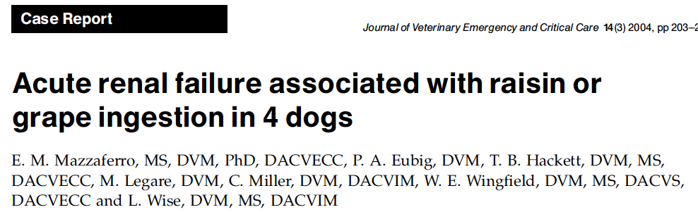

Objective: Description of a case series of 4 dogs with acute renal failure after ingestion of raisins or grapes.
Case summary: Four dogs were presented with acute oliguric or anuric renal failure after a known ingestion of varying quantities of raisins or grapes. Prior to the onset of vomiting, all dogs were healthy, had no previous history of renal insufficiency, and had no exposure to other potentially nephrotoxic agents. This case series describes the clinical course and various treatment modalities used in the 4 dogs.
New or unique information provided: This is the first report of clinical signs, treatment, and clinical outcome in dogs that developed renal failure after ingestion of raisins or grapes. The pathogenesis of nephrotoxicity associated with raisins and grapes remains unknown. Outcome was favorable in 2 out of the 4 cases of acute renal failure associated with raisin or grape ingestion in these dogs.

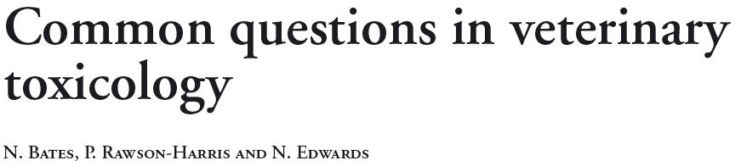’
Toxicology is a vast subject. Animals are exposed to numerous drugs, household products, plants, chemicals, pesticides and venomous animals. In addition to the individual toxicity of the various potential poisons, there is also the question of individual response and, more importantly, of species differences in toxicity. This review serves to address some of the common questions asked when dealing with animals with possible poisoning, providing evidence where available. The role of emetics, activated charcoal and lipid infusion in the management of poisoning in animals, the toxic dose of chocolate, grapes and dried fruit in dogs, the use of antidotes in paracetamol poisoning, timing of antidotal therapy in ethylene glycol toxicosis and whether lilies are toxic to dogs are discussed.
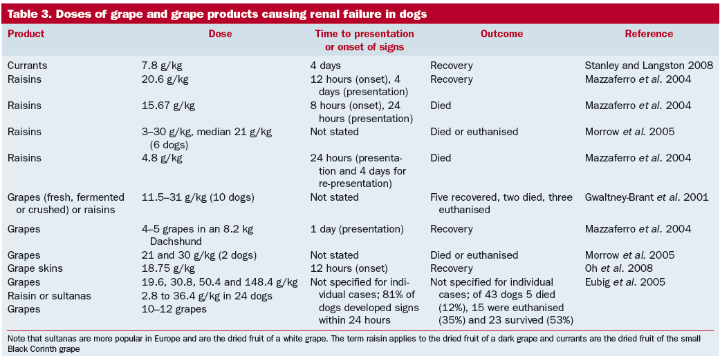

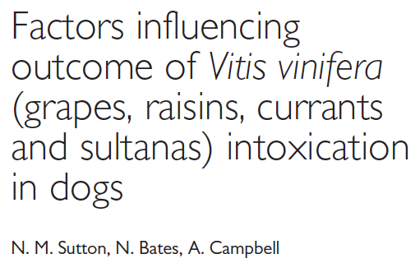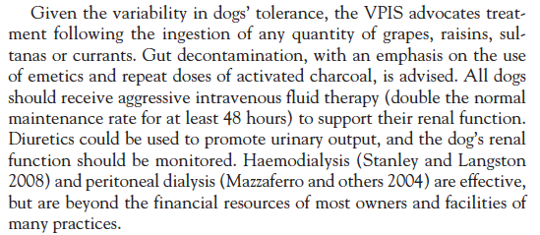
Radiocontrast

-Ozgur et al. The Protective Effect of Ebselen on Radiocontrast-Induced Nephrotoxicity
Renal Failure, 2012;34(8):991-997. (doi: 10.3109/0886022X.2012.706880)
Aim: Radiocontrast-induced nephropathy has become one of the most important causes of renal acute failure. The most effective management of reducing the incidence of contrast nephropathy is to understand and prevent its causes. We aimed to investigate the protective role of ebselen against radiocontrast-induced nephrotoxicity in terms of tissue oxidant/antioxidant parameters and light microscopy in rats. Methods: Albino Wistar rats were randomly separated into four groups. The Group 1 rats were treated with sodium chloride as the control group, Group 2 with radiocontrast, Group 3 with radiocontrast plus ebselen, and Group 4 with ebselen alone. After 24 h, the animals over the experimental period were euthanized and blood samples were analyzed for blood urea nitrogen (BUN) and serum creatinine (Cr) levels. Kidney sections were analyzed for malondialdehyde (MDA) levels and superoxide dismutase (SOD), catalase (CAT), and glutathione peroxidase (GSH-Px) activities, as well as histopathological changes. Results: In the radiocontrast group, BUN, MDA, and GSH-Px levels increased while SOD activity decreased compared with the control group. These decays were improved by ebselen administration in the radiocontrast group. Significant histological deteriorations were observed in the radiocontrast group. We noted improvement in the histologic findings with ebselen administration. Conclusion: These results indicate that ebselen might produce a protective mechanism against radiocontrast-induced nephrotoxicity.

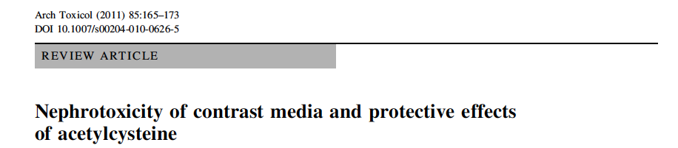

Abstract Contrast-induced acute kidney injury (CI-AKI) accounts for approximately 10% of all causes of hospital acquired renal failure, causes a prolonged in-hospital stay, and represents a powerful predictor of poor early and late outcome. N-acetylcysteine (NAC) is a thiol compound classically known as a mucolytic agent, which is a potent antioxidant that scavenges a wide variety of oxygen-derivedfree- radicals and may be capable of preventing acute kidney injury. In the present study, we will review (1) the pathophysiology of the CI-AKI and (2) the experimental and clinical data on the effects of NAC in preventing CI-AKI.



Liu et al have shown that iodinated contrast medium preferentially vasoconstricts the glomerular afferent arterioles by depleting endothelial nitric oxide bioavailability. This potentiates an exaggerated afferent arteriolar vasoconstricting response to angiotensin II and opens possibilities for new methods to prevent or treat nephrotoxicity after contrast medium administration.

Haaga, John. Computed Tomography and Magnetic Resonance Imaging Of The Whole Body (5th Edition). Philadelphia, PA, USA: Elsevier Health Sciences, 2008. ProQuest ebrary. Web. 23 March 2015.
Copyright © 2008. Elsevier Health Sciences. All rights reserved.

Questions
- True or False. Ochratoxin, flavonoids, tannins, polyphenolics, and monosaccharides have all been associated with grapes and raisins as potential toxic principles.

- A described mechanism of toxicity by which Amphotericin B causes nephrotoxicity is the following:
  - Binds to cholesterol in proximal tubule causing renal arteriolar vasocontriction
  - Depletes endothelial nitric oxide bioavailability leading to renal arteriolar vasoconstriction
  - Direct glomerular effects including mesangial contraction, mesangial cell proliferation, and alteration of filtration barrier selectivity)

- True or False. Aminoglycosides can result in reversible damage to the proximal tubule.

- What is the most common form of contrast induced nephropathy?

- What is the most sensitive portion of the nephron to toxicosis and hypoxia?
  - Glomerulus
  - Proximal tubule
  - Loop of Henle
  - Distal tubule
  - Collecting duct

- Cytochrome P-450s and other enzymes that metabolize xenobiotics are found in highest concentrations in the _________________
  - Medullary collecting ducts
  - Loop of Henle
  - Distal tubule
  - Proximal convoluted tubule

Answers
- True or False. Ochratoxin, flavonoids, tannins, polyphenolics, and monosaccharides have all been associated with grapes and raisins as potential toxic principles.

- One mechanism of toxicity by which Amphotericin B causes nephrotoxicity is the following:
  - Binds to cholesterol in proximal tubule causing renal arteriolar vasocontriction
  - Depletes endothelial nitric oxide bioavailability leading to renal arteriolar vasoconstriction
  - Direct glomerular effects including mesangial contraction, mesangial cell proliferation, and alteration of filtration barrier selectivity)

- True or False. Aminoglycosides can result in reversible damage to the proximal tubule.

- What is the most common form of contrast induced nephropathy?

  - Most cases are asymptomatic, nonoliguric transient form

- What is the most sensitive portion of the nephron to toxicosis and hypoxia?
  - Glomerulus
  - Proximal tubule
  - Loop of Henle
  - Distal tubule
  - Collecting duct

- Cytochrome P-450s and other enzymes that metabolize xenobiotics are found in highest concentrations in the _________________
  - Medullary collecting ducts
  - Loop of Henle
  - Distal tubule
  - Proximal convoluted tubule

