The Pathophysiology of Septic shock. Crit Care Clin 25 (2009)

- The events that occur in septic shock can be broadly divided into microorganism related components and host related components
- Septic shock characterized by dysfunction involving all aspects of immune response (involves cellular and humoral components of innate and adaptive immune response systems).

The role of the pathogen
- Bacterial and nonbacterial pathogens possess virulence factors that confer the ability to evade host defense mechanisms and proliferate in host tissues

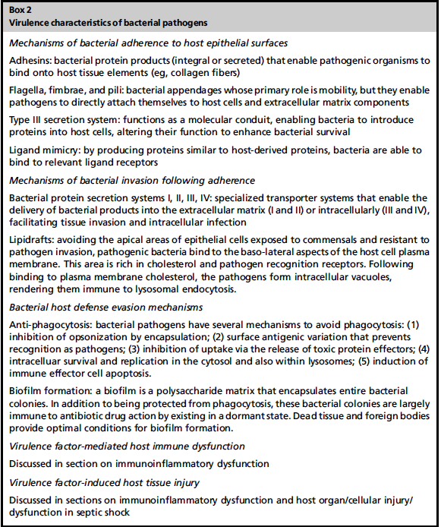

Quorum-sensing, cell to cell signaling and coordinated gene expression
- Quorum – critical bacterial density needed to initiate infectious process
- Quorum sensing systems – bacterial cell to cell signaling systems resulting in coordinated gene activation and expression of high concentrations of extracellular virulence factors by the entire bacterial population
  - Involve secretion autoinducers signaling molecules linked to regulation of genetic expression
  - 2 main bacterial QSSs
    - Gram positive – synthesize cytosolic autoinducers transported to extracellular environment bind to receptor proteins on neighbor bacteria initiate signal cascade
    - Gram negative – synthesize acyl-homoserine lactones (AHL) diffuse passively between intra and extracellular environments bind to intracellular LuxR enzymes
  - Play a major role in regulation of biofilm synthesis
  - Capable of facilitating host pathogen communication leading to pathogen mediated modulation of host immune responses
Virulence gene upregulation and increased expression of virulence factors
- Pathogenicity islands represent unstable DNA regions, may possess gene capture systems that facilitate incorporation and dissemination by lateral transfer of antibiotic resistance genes

Immunoinflammatory dysfunction leading to severe sepsis
Normal immune response
- Temporal variation
- Biologic redundancy
- Interaction with other biologic systems (Cross talk)
- Heterogeneity (genetic and nongenetic)

Pathogen recognition
Pattern recognition receptors, pathogen-associated molecular patterns, and danger associated molecular patterns
- Pathogen associated molecular patterns (PAMPs), or microbial associated molecular patterns (MAMPs) are molecular structures not shared with host, common to related pathogens, invariant
- Intracellular proteins released or expressed following host tissue injury are called alarmins and are the endogenous equivalent to PAMPs
- DAMPs (damage associated molecular patterns) – collective term referring to PAMPs and alarmins
- Immune cells express pattern recognition receptors (PRRs) that can recognize and bind to DAMPs
  - 4 families recognized
    - Toll like receptors (TLR)
    - Nucleotide oligomerization domain leucine-rich repeat (NOD-LRR) proteins
    - Cytoplasmic caspase activation and recruiting domain helicases such as retinoic acid inducible gene I (RIG-I)-like helicases (RLH)
    - C-type lectin receptors expressed on dendritic and myeloid cells
  - TLR interaction with DAMPs from host tissue injury primes innate immune system for enhanced TLR reactivity resulting in excess LPS-induced mortality
  - Gram positive pathogens exclusively express lipoteichoic acid
  - Gram negative bacteria exclusively express LPS

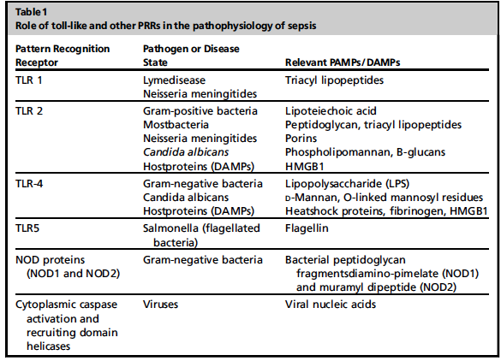

Pro and anti-inflammatory cellular signaling/ signal transduction
- All intracellular signaling pathways have as their initial event activation by phosphorylation of a target protein
- Activation typically accomplished by binding of enzyme (kinase) to the target protein and can leads to
  - Activation or alteration of enzymatic activity
  - Changes in stability of target protein
  - Subcellular localization of protein
  - Interactions with other proteins
- Many signaling pathways involve a cascade of 2 or more kinases in series (signaling cascades)
- Kinase cascades activated following engagement of ligand specific receptors (i.e. LPS + TLR-4)
- Kinases are able to phosphorylate other kinases, leading to signal amplification
- Cross talk refers to interactions that occur between kinase cascades that results in suppression of activity in opposite cascade, in response to increased activity of a given cascade
- Binding of TLRs activates intracellular signal transduction pathways that lead to the activation of transcriptional activators
  - Interferon regulator factorsp13K/Akt
  - Activator protein 1
  - Cystolic nuclear factor kappa (NF-[κ][β])

NF-[κ][β]
- Prototypical transcription factor involved in modulating expression of many of the inflammatory responses associated with severe sepsis and septic shock
- The degree of NF-[κ][β] activation in septic patients seems to correlate with patient survival and outcome in septic shock.
- Excess activation, especially early in the disease course, or excessive negative regulation in sepsis may produce either excess inflammation with collateral host tissue damage or immunoparalysis and consequent direct tissue damage

The caspases
- Family of cysteine proteases synthesized as proenzymes and activated by proteolysis
- Involved in cellular processes of inflammation and apoptosis following PAMP/DAMPs-PRRs interactions
- Produce many of the phenotypic changes seen in apoptosis – cytoskeletal disintegration, DNA fragmentation, disruption of cellular DNA repair molecular machinery
- Inflammasomes (NALP1, NALP3) are muticentric complexes that serve as molecular platforms for activation of caspases 1 and 5 resulting in activation and secretion of proinflammatory cytokines IL-1β and IL-18

Phosphoinositide 3-kinases
- Group of enzymes that catalyze production of membrane phosphatidylinositol triphosphate (PIP3)
- PIP3 can act as positive or negative regulator of TLR signaling
  - Can activate NFKB or mitogen activated protein kinase (MAPK) signaling pathways
  - MAPK consists of 3 pathways described in leukocytes:
    - p38 – plays a tile in neutrophil cytokine production, adhesion, chemotaxis, respiratory burst, apoptosis
    - Extracellular signal regulated kinase (ERK) – regulator of cellular proliferation and differentiation. Involved in cytokine (TNF-a) production and chemotaxis to C6a and IL-8
    - c-jun NH2-terminal kinase (JNK) – important in cellular proliferation and apoptosis

Rho GTPases
- G-protein-linked family of receptors referred to as GTPases
- Rho and Rac GTPases regulate aspects of innate immune system – cellular migration, pathogen uptake, phagocytosis, maintenance of endothelial integrity
Release of pro and anti-inflammatory mediators
- Immediate consequence of cellular signaling in severe sepsis is synthesis and release of increased amount of mediators (referred to as cytokine cascade) into systemic circulation in an attempt to activate more immune effector cells and recruit them to site of infection
- TNF-a and IL-1b responsible for earliest clinical events in sepsis
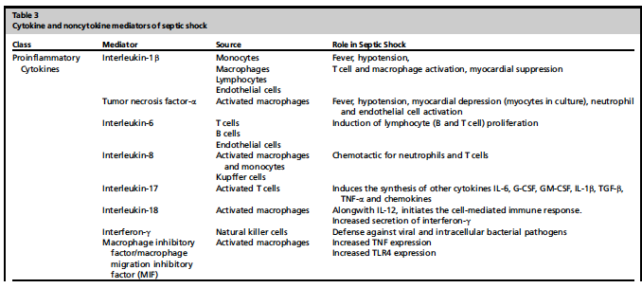

Immune and non-immune effector cell dysfunction
- In severe sepsis the tight regulation of neutrophil function is lost leading to excessive neutrophil activation and prolonged survival
- Activated neutrophils induce endothelial dysfunction, release cytotoxic molecules and lead to inflammatory host organ injury
- In severe sepsis accelerated apoptotic death of lymphocytes occur leading to lymphocyte depletion and less of T lymphocyte regulatory function

Interactions with other biologic systems in sepsis
Coagulation
- Almost all patients with septic shock have coagulation abnormalities. Nature and degree of dysfunction varies.
- Current understanding of hemostasis describes coagulation pathway as a 3 phase process
  - Initiation: occurs shortly after vascular injury and is the result of increased tissue factor expression by platelets. TF binds and activates factor VII. TF-FVIIa complex produce thrombin
  - Amplification: release of prothrombin (factor X) with platelets + other coag factors prothrombinase complex (factor Xa and coagulation factors bound to activated platelets) burst of thrombin production
  - Thrombin action: thrombin dependent recruitment of coagulation factors into coagulation process facilitates fibrinogen conversion to fibrin
- In sepsis the interaction between coagulation and inflammatory systems is bidirectional
- Endothelial cells respond to cytokines expressed and released by activated leukocytes
- Endothelial cells can express adhesion molecules and growth factors that promote inflammatory response and affect coagulation response
- Endothelial cells play role in all 3 major pathways associated with coagulopathy in sepsis: TF mediated thrombin generation, dysfunctional anticoagulant pathways and inhibition of fibrinolysis
- Activated protein C (APC) inhibits inflammation by inhibiting cytokine production , preventing neutrophil activation and inhibiting leukocyte adhesion and rolling
- Key mediators in hypercoagulable cascade in sepsis: APC, antithrombin, TF pathway inhibitor

Neural regulation
- Inhibition of TNF expression following vagal stimulation
- Cytokine suppressive effects of vagal stimulation mediated by release of neurotransmitter Ach and interaction with Ach receptors expressed by macrophages and other immune cells (i.e. Alpha-7)
  - best characterized receptor

Cardiocirculatory dysfunction
- Reduced left and right ventricular ejection fractions, increased end diastolic and end systolic volumes of both ventricles (biventribular dilatation) and normal stroke volume
  - Occurs 24-48 hours after onset of sepsis
  - Reversible with restoration of myocardial function
- Heart rate and cardiac output elevated
- Systemic vascular resistance reduced
- TNF-a and IL-1 associated with myocyte dysfunction and may explain early myocardial depression seen in sepsis
- Sepsis is associated with increased Nitric Oxide production
  - Nitric oxide interferes with myocyte calcium metabolism and impairs contractile function
  - NO primarily responsible for vascular alterations in septic shock. Causes hyperpolarization of smooth muscle plasma membranes rendering them unresponsive to catecholamines and causing vasodilation

Questions

- Name three virulence characteristics of bacterial pathogens

- What is a quorum?

- Intracellular proteins released or expressed following host tissue injury are called ________________ and are the endogenous equivalent to PAMPs

- Which substance(s) does DAMPs (damage associated molecular patterns) refer to?

- TRUE OR FALSE. TLR interaction with DAMPs from host tissue injury primes innate immune system for enhanced TLR reactivity resulting in reduced LPS-induced mortality

- Name the TLR exclusively expressed by gram positive bacteria vs gram negative bacteria

- What are some common PAMPs shared by gram positive and negative pathogens?

- Name the prototypical transcription factor involved in modulating expression of many of the inflammatory responses associated with severe sepsis and septic shock

- TRUE OR FALSE . The degree of NF-[κ][β] activation in septic patients seems to correlate with patient survival and outcome in septic shock.

- Which cytokine(s) are responsible for the earliest clinical events in sepsis
  - TNF-a, IL-8
  - IL-6, IL-8
  - Interferon-γ, MIF
  - TNF-a, IL-18

- TRUE OR FALSE. HMGB1 and MIMIF play significant roles in the development of septic shock.

- In severe sepsis the tight regulation of neutrophil function is lost leading to excessive neutrophil activation and prolonged survival. What is the normal amount of time neutrophils spend in systemic circulation?

- TRUE OR FALSE. In sepsis cardiac output is reduced.

- Which cytokines are associated with early myocardial depression seen in sepsis?

- What is the process by which NO interferes with contractile function?

- Which substance is primarily responsible for vascular alterations in septic shock?

Answers

- Name three virulence characteristics of bacterial pathogens

- What is a quorum?
Answer: Quorum – critical bacterial density needed to initiate infectious process

- Intracellular proteins released or expressed following host tissue injury are called ________________ and are the endogenous equivalent to PAMPs
Answer: alarmins

- Which substance(s) does DAMPs (damage associated molecular patterns) refer to?
Answer: collective term referring to PAMPs and alarmins

- TRUE OR FALSE. TLR interaction with DAMPs from host tissue injury primes innate immune system for enhanced TLR reactivity resulting in reduced LPS-induced mortality
Answer: FALSE – results in excess

- Name the TLR exclusively expressed by gram positive bacteria vs gram negative bacteria
Answer: Gram positive - lipoteichoic acid; Gram negative – LPS

- What are some common PAMPs shared by gram positive and negative pathogens?
Answer: peptidoglycan, lipoproteins, flagellin, bacterial DNA

- Name the prototypical transcription factor involved in modulating expression of many of the inflammatory responses associated with severe sepsis and septic shock
Answer: NF-[κ][β]

- TRUE OR FALSE . The degree of NF-[κ][β] activation in septic patients seems to correlate with patient survival and outcome in septic shock.
Answer: TRUE. Excess activation, especially early in the disease course, or excessive negative regulation in sepsis may produce either excess inflammation with collateral host tissue damage or immunoparalysis and consequent direct tissue damage

- Which cytokine(s) are responsible for the earliest clinical events in sepsis
  - TNF-a, IL-8
  - IL-6, IL-8
  - Interferon-γ, MIF
  - TNF-a, IL-18

- TRUE OR FALSE. HMGB1 and MIMIF play significant roles in the development of septic shock.
Answer: FALSE

- In severe sepsis the tight regulation of neutrophil function is lost leading to excessive neutrophil activation and prolonged survival. What is the normal amount of time neutrophils spend in systemic circulation?
Answer: 7 hours

- TRUE OR FALSE. In sepsis cardiac output is reduced.
Answer: FALSE

- Which cytokines are associated with early myocardial depression seen in sepsis?
Answer: TNF-a, IL-1

- What is the process by which NO interferes with contractile function?
Answer: interferes with myocyte calcium metabolism and interferes with contractile function

- Which substance is primarily responsible for vascular alterations in septic shock?
Answer: NO is primarily responsible for vascular alterations in septic shock. Causes hyperpolarization
of smooth muscle plasma membranes rendering them unresponsive to catecholamines and causing
vasodilation

