NEJM 369;9. August 2013. Angus et al. Severe Sepsis and Septic Shock

- Most common causes of sepsis is pneumonia; followed by intraabdominal and urinary tract infections.
- Clinical manifestation of sepsis is highly variable
- Acute organ dysfunction most commonly affects the respiratory and cardiovascular systems.
  - Respiratory compromise is classically manifested as ARDS.
  - Cardiovascular compromise is manifested as hypotension or an elevated serum lactate level.

Pathophysiology of sepsis
- Host response is characterized by proinflammatory (excessive inflammation causing cell injury) and anti-inflammatory mechanisms (immunosuppression with enhanced susceptibility to secondary infections)
  - Specific response depends on causative pathogens and the host
- Innate Immunity: pathogens activate immune cells through interaction with pattern-recognition receptors expressed by host cells at the cell surface
  - Toll like receptors (TLR), C-type lectin receptors (CLR), retinoic and acid inducible gene 1-like receptors (RLR), nucleotide binding oligomerization domain like receptor (NLR).
  - Also sense alarmins (endogenous molecules released form injured cells)
- Coagulation abnormalities: frequently leading to DIC.
  - Associated with microvascular thrombosis
  - Excess fibrin deposition driven by 1- action of tissue factor (transmembrane glycoprotein), 2- impaired anticoagulant mechanisms (protein C system and antithrombin), 3- compromised fibrin removal owing to depression of fibrinolytic system
- Antiinflammatory mechanisms and immune suppression
  - Phagocytes, regulatory T cells and myeloid derived suppressor cells reduce inflammation
  - Neural mechanisms inhibit inflammation
    - Neuroinflammatory reflex: sensory input relayed through vagus nerve NE release in the spleen and acetylcholine secretion by CD4+ T cells targets alpha7 cholingergic receptors on macrophages suppress proinflammatory cytokines
  - Enhanced apoptosis (of B cells, CD4+, T cells, follicular dendritic cells) implicated in sepsis associated immunosuppression
- Organ dysfunction in sepsis:
  - Hypotension, reduced red blood cell deformability, and microvascular thrombosis contribute to diminished oxygen delivery in septic shock
  - Inflammation – causes disruption of vascular endothelium edema
  - Mitochondrial damage – impairs cellular oxygen use, and can release alarmins which can activate neutrophils tissue injury

Treatment of Sepsis
- Initial management – cardiorespiratory resuscitation and control infection
  - Inappropriate or delayed antibiotic treatment associated with increased mortality
  - It has NOT been determined whether combination antimicrobial therapy produces better outcomes than adequate single agent antibiotic therapy
  - Current guidelines recommend combination antimicrobial therapy only for neutropenic sepsis and sepsis caused by pseudomonas species

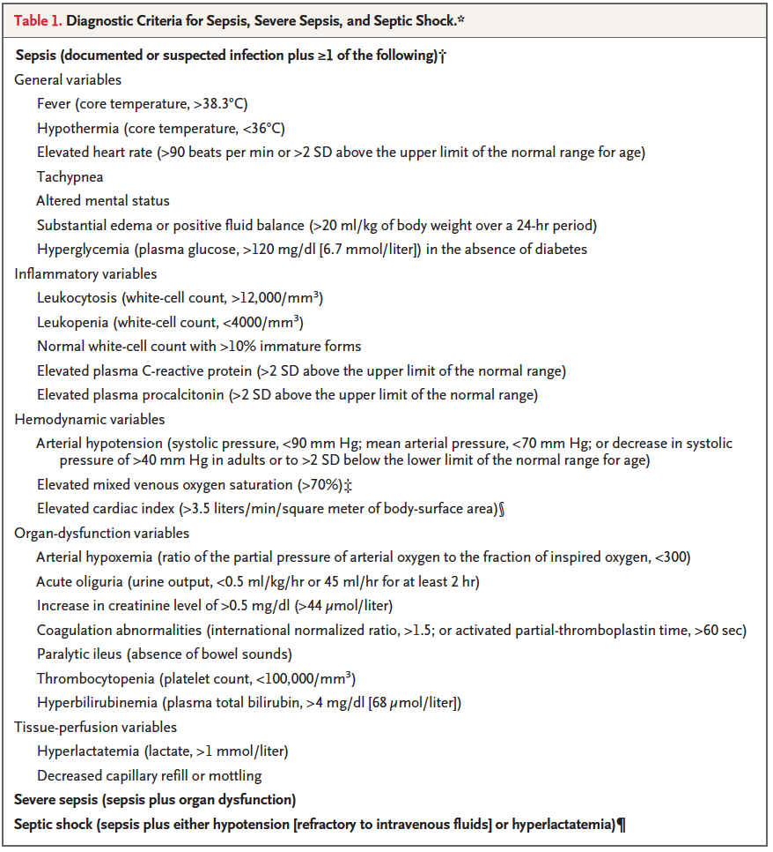

Questions

1. What is the most common cause of severe sepsis in humans?

Answer: Pneumonia is the most common cause, accounting for ~ half of all cases, followed by intraabdominal and urinary tract infections

2. Acute organ dysfunction most commonly affects which systems/organs?
- Renal
- Brain
- Respiratory
- Cardiovascular systems

Answer: C, D.

3. In neuroinflammatory reflex (protective neural response), sensory input Is relayed through which nerve to the brain stem then to the splenic nerve, resulting in NE release in the spleen and acetylcholine secretion.

Answer: vagus nerve

4. Which factors contribute to diminished oxygen delivery to organs in septic shock?

Answer: Reduced rbc deformability, decrease in cardiac output, microvascular thrombosis

5. Combination antimicrobial therapy has been shown to produce better outcomes that single agents therapy in sepsis. True or false.

Answer: FALSE.

