Modeling a Cantilever Beam using 1D, 2D and 3D Elements

The learning goals of this exercise are to:
- Study the relative efficiency and accuracy of 1D, 2D and 3D elements in modeling a cantilever beam
- Study the effect of the stress singularity at the fixed end of the beam

Consider the cantilever beam shown below. This beam is modeled using 1D elements in the tutorial at https://confluence.cornell.edu/x/9L9-Bw. The beam is clamped at the left end and has a force of 8kN acting downward at the right end. This 8 kN force acts over the entire cross-section at the right end. The beam has a length of 4 meters, width of 0.346 meters and height of 0.346 meters (the cross-section is a square). Additionally, the beam is composed of a material which has a Young's Modulus of 28 GPa and a Poisson’s ratio of 0.3.
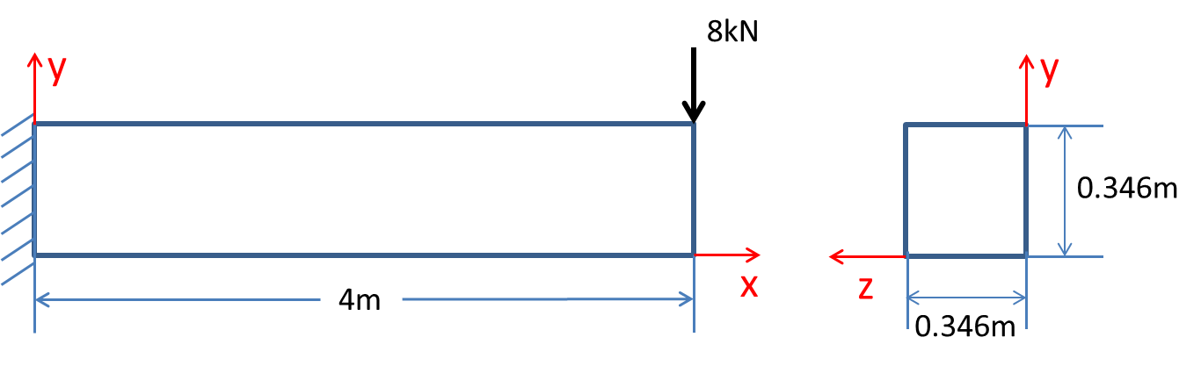

Model this beam using 1D, 2D and 3D elements in ANSYS.

Use the following meshes: 2x2x2, 4x4x4, 8x8x8, 16x16x8, 64x64x8. For instance, in the case of the mesh denoted as 4x4x4, you’ll have:
- 4 divisions for the line in the 1D model (4 line elements)
- 4 divisions in each direction for the area in the 2D model (4x4=16 area elements)
- 4 divisions in each direction for the volume in the 3D model (4x4x4 = 64 volume elements)
Note that for the 3D model, the number of divisions in the z-direction is not increased beyond 8 to keep the mesh size reasonable.

For each model and mesh, determine:
- Displacement in the y direction at the right end of the beam in the middle of the cross-section (x = 4 m, y = 0.346/2 m, z = 0.346/2 m). Let’s denote this displacement as $v_{1}$.
- Stress $σ_{xx}$ distribution at the left end ($x=0$) and in the middle ($x=2 m$). Note the maximum value of $σ_{xx}$ over the cross-section at each location.

Summarize the total number of degrees of freedom (DOF) and the displacement $v_{1}$ in the form of the following table:

Mesh | DOF (1D) | $v_{1}$ (1D) | DOF (2D) | $v_{1}$ (2D) | DOF (3D) | $v_{1}$ (3D)
2x2x2
4x4x4
8x8x8
16x16x8
64x64x8

For 1D elements, while calculating the total degrees of freedom, you can ignore the z-displacement DOF and the rotational DOF about x and y axes that ANSYS puts in. These are identically zero for this case.

Summarize the results for the maximum value of $σ_{xx}$ at x=2m and x=0m in the form of the following table:

Mesh | Max. $σ_{xx}$ at x=2m (1D) | Max. $σ_{xx}$ at x=2m (2D) | Max. $σ_{xx}$ at x=2m (3D) | Max. $σ_{xx}$ at x=0m (1D) | Max. $σ_{xx}$ at x=0m (2D) | Max. $σ_{xx}$ at x=0m (3D)
2x2x2
4x4x4
8x8x8
16x16x8
64x64x8

Report the displacements and stresses to four significant digits. For units, use meters for displacement and MPa for stresses.

Using the filled-in tables, respond to the following questions:
- How many degrees of freedom do you need to use with 1D, 2D and 3D elements to get the above displacement and stress values at x = 2m to an accuracy of three significant digits?
- How well do the above displacement and stress values agree between the 1D, 2D and 3D models?
- Which converges faster on refining the mesh: displacement or stress? Why?
- What is the effect of the stress singularity at the fixed end (x=0m) on the above displacement and stress values as the mesh is refined? What is the difference in results at the fixed end between the 1D, 2D and 3D models?
- What are your conclusions about the relative efficiency and accuracy of the 3 different modeling approaches?

For tips on how to plot the stress distribution in any beam cross-section and how to determine the displacements at any location, see the video at https://youtu.be/Nq1qLWIqICU

