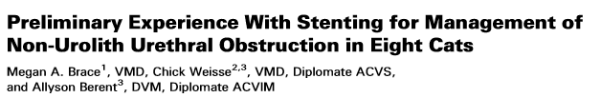
Objective: To describe minimally invasive transurethral antegrade and retrograde techniques for the placement of self-expanding metallic stents to reestablish urethral patency in cats with non urolith urethral obstructions and to report the procedural complications, incontinence rates, and long term effectiveness in maintaining a patent urethra.
Animals: Cats (n=8).
Methods: Signalment, history, clinical signs, physical examination, severity of stranguria and incontinence, clinicopathologic data, diagnostic procedures performed, diagnosis, interventional technique, type and dimensions of stent placed, complications and final outcome of 8 cats treated with SEMS for the management of urethral strictures or masses are presented. Each cat was followed for 12 months. Follow up information was obtained from the medical record or by telephone interview of the owner and/or referring veterinarian.
Results: Four cats were continent after stent placement, 2 were moderately incontinent, and 2 were severely incontinent. Long term follow up (median, 462 days) was available. At follow up, 5 cats were alive and 3 had been euthanatized at 88, 233, and 305 days.
Long term outcome, as assessed by the authors, was good (1) to excellent (3) in 4 cats, and fair (2) to poor (2) in 4 cats. Owner reported outcomes were excellent in 3/8, good to excellent in 1/8, good in 2/8, and poor in 2/8.
Conclusion: Palliative stenting of urethral obstructions is a minimally invasive method to reestablish urethral patency in cats.

Key Points:
- 50% were incontinent, 25% of owners felt outcome was poor
- Traumatic (benign) strictures and malignant obstructions of the trigone, prostatic urethra, and intrapelvic membranous urethra are more difficult to treat and PU will not help
- Retrograde access when available, when not available percutaneous antegrade urethral access was obtained
- Palliative stenting for malignant urethral obstructions in dogs results in an overall range of survival time from 6 to 105 days in 12 dogs (mean 32 days; median 20 days) *No Chemo*
- Median survival time of dogs with urethral stents placed for malignant urothelial carcinoma has been reported to be 78 days (range: 7–536 days) and 251 days (range: 8–536 days) for those receiving chemotherapy.
- Post‐stent placement severe incontinence rates were similar across dogs and cats with 21% (4/19) to 26% (11/42) dogs severely incontinent and 25% (2/8) of these cats severely incontinent

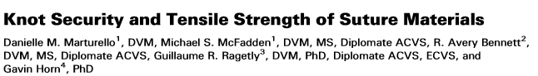
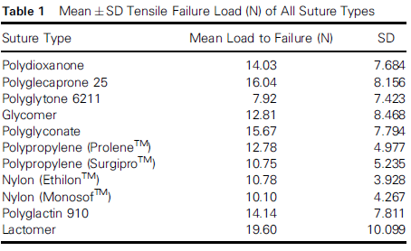
Objective: To evaluate knot security and tensile failure load of suture tied in simple interrupted, beginning continuous, and ending continuous patterns for 11 suture materials commonly used in small animal surgery.

Methods: For each of 11 suture material types, and 5 knot sizes (2, 3, 4, 5, and 6 throws) 2 surgeons each tied 6 knots (n¼12 for each knot size in 11 suture materials). Three types of patterns were evaluated: a simple interrupted square knot, a square knot beginning a simple continuous pattern, and the knot ending a simple continuous pattern. All knots were incubated in healthy canine donor plasma at 40°C for a minimum of 24 hours. Sutures were evaluated for knot security (knots untied, suture failed by breaking, suture slipped from the clamps, or suture untied before testing) and maximum load carried before knot slippage or knot failure (termed tensile failure load).

Results: Significant differences were found in knot security and tensile failure load among suture types. There was no significant difference between the simple interrupted knots and the knots at the beginning of a simple continuous pattern; however, both were significantly less likely to fail than the knots tied at the end of a simple continuous pattern.

Conclusions: Suture type, number of throws per knot (knot size), suture pattern, and surgeon experience play an important role in knot security and should be considered when performing surgery.
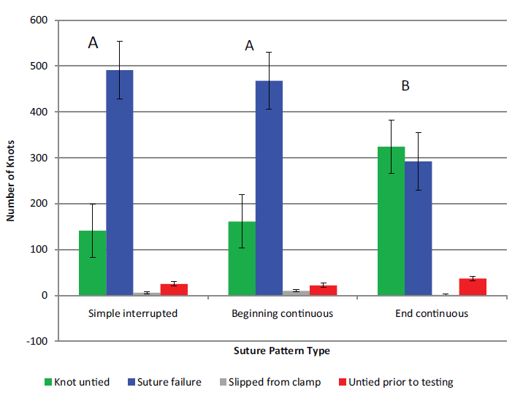
Key Points:
- Knot security is influenced by type of suture, the number of throws used in knot construction and the type of pattern used
- Significant differences in knot security between suture material types
- In 5 of 11 sutures, 3 throws created a knot that was as secure as a knot with 6 throws
  - Polyglactin 910, Ethilon, polyglytone 6211, Surgipro, and Monosof
- When knot failure or suture breakage occurred, it did so immediately adjacent to the knot itself in 74% of cases
- Factors found to influence knot security were suture type, number of throws used to create the knot, pattern type, and surgeon experience

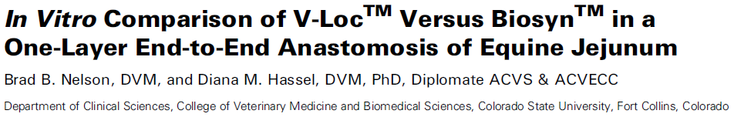
Objective: To compare a unidirectional barbed suture (V‐Loc) to its suture material equivalent (Biosyn) in a single‐layer end‐to‐end anastomosis of equine jejunum.
Study Design: Experimental in vitro study.
Animals: Jejunal sections from adult horses (n=5) without gastrointestinal disease.
Methods: Jejunal end‐to‐end anastomoses (n=9) were performed for each group (V‐Loc, Biosyn) with a continuous Lembert pattern with an interruption every 120°. Anastomosis construction time, luminal diameter, and number of suture bites were recorded. Anastomosis constructs were distended with fluid at 1 L/min until failure. Location and intraluminal pressure at failure were recorded and all measurements were compared between groups.
Results: V‐Loc anastomoses were significantly faster to perform (13.1+/-0.35 minutes) when compared to the Biosyn group (15.6+/-0.72 minutes; P=.0004). No differences were observed for anastomotic index or number of suture bites. V‐Loc anastomosis constructs had a significantly decreased bursting pressure (160+/-11.6 mmHg) compared to Biosyn constructs (184+/-16.9mmHg; P=.01).
Conclusions: V‐Loc allowed faster construction time and did not cause a decreased anastomosis luminal diameter when compared with Biosyn. V‐Loc had adecreased bursting strength compared with Biosyn, albeit well above pathologic pressures encountered clinically. Use of V‐Loc may be beneficial for decreasing the amount of exposed suture material because of the absence of knots after construction and has the potential to result in decreased adhesions.

