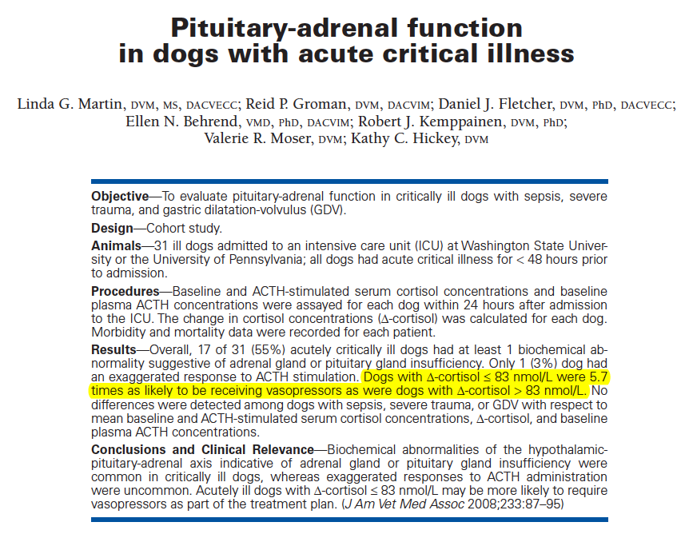

Hypothesis – pituitary-adrenal-insufficiency exists in some populations of critically ill dogs, such as those with acute sepsis
Purpose – to evaluate pituitary-adrenal function in acutely critically ill dogs with sepsis and in dogs with other types of nonseptic critical illnesses that were likely to result in similar degree of illness and to determine the incidence of pituitary-adrenal insufficiency in these populations.
M&M – N=31 dogs with sepsis, severe trauma, GDV of <48 hours duration. Exclusion: steroids, etomidate, ketoconazole within 4 weeks of illness; dogs with adrenal gland disease.
N=10 healthy dogs used to assess the correlation between baseline plasma concen. of endogenous ACTH and cortisol.
Each dog received 5 ug/kg for the ACTH stimulation test
Results-
No correlation was found between mean baseline endogenous ACTH and mean baseline cortisol. NSD in testing pre or post-op. NSD in mean baseline serum cortisol, endogenous ACTH, and ACTH stim-cortisol or delta-cortisol between groups (trauma/sepsis/GDV).
55% of dogs had at least 1 biochemical abnormality consistent with adrenal or pituitary gland insufficiency. 61% had at least 1 biochemical abnormality consistent with pituitary or adrenal gland overactivity.
Sepsis dogs – 5 had ACTH stimulated serum cortisol concentrations less than reference range, 1 had plasma endogenous ACTH concentrations less than the reference range. Two had no apparent response to ACTH stim.
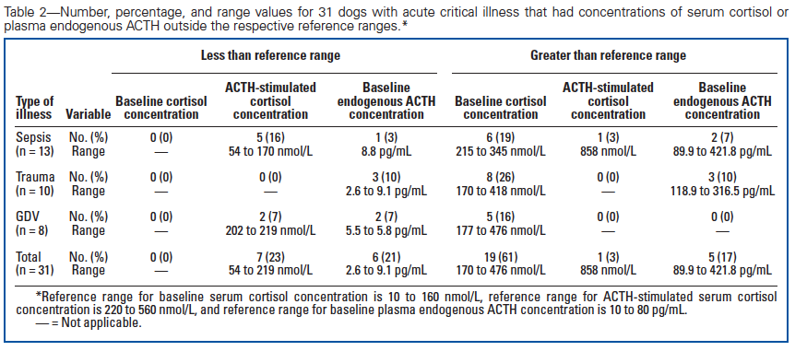
Trauma – 4 had no response to ACTH stimulation, 3 had endogenous ACTH less than the reference range. One had both (flat ACTH stim and low endog. ACTH).
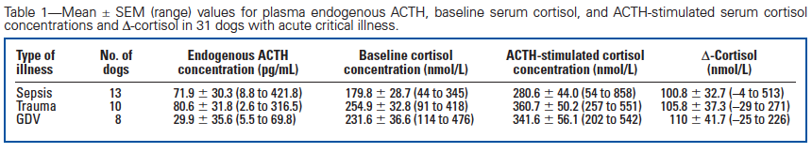
Dogs with a delta-cortisol <83 nmol/L were 5.7 times more likely to need pressors.
NSD in outcome from those with normal ACTH stim vs abnormal

Discussion
Results suggest that there may be impaired adrenal gland or pituitary gland function in some critically ill dogs.
Delta-cortisol <83nmol/L was associated with hypotension and decrease in survival, more likely to receive pressors.

Questions:
- Draw a schematic of the hypothalamic-pituitary-adrenal gland axis. Indicate feedback loops.

- According to this study, dogs with what delta-cortisol were found to be more likely to need pressors?
  - ≤ 65 nmol/L
  - ≤ 83nmol/L
  - ≤ 102 nmol/L
  - ≤ 145 nmol/L

- True or False: More than half of the dogs in this study had one or more biochemical abnormality suggestive of adrenal gland or pituitary gland insufficiency.
- True or False: Dogs with sepsis were more likely than dogs with trauma or GDV to have abnormal post-ACTH stimulation cortisol levels.

Answers:
1.
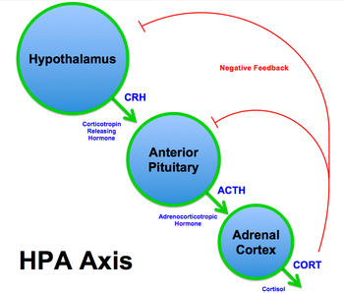

2. B
3. True
4. False

